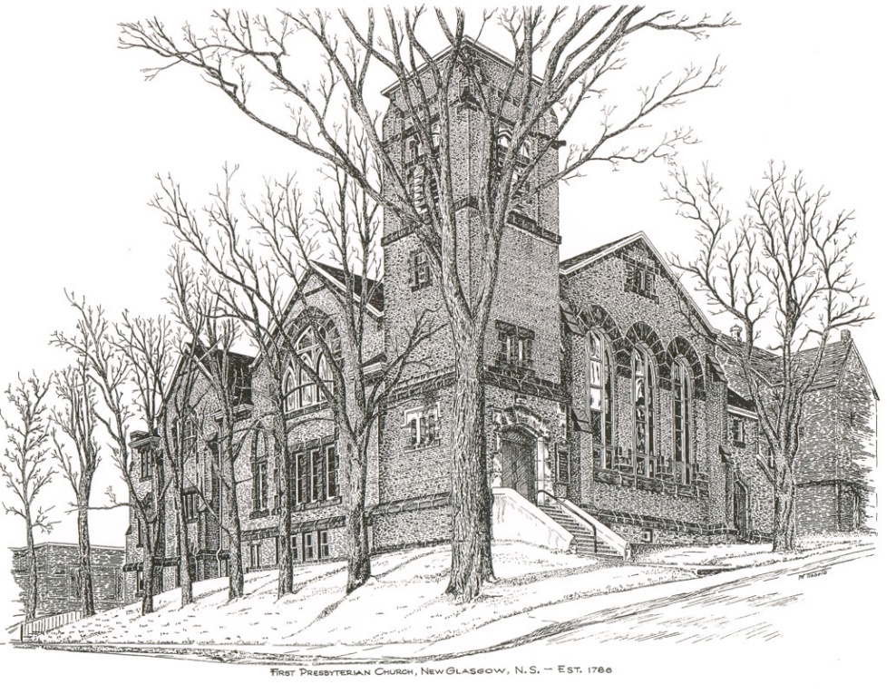

FIRST PRESBYTERIAN CHURCH
208 MacLean St., New Glasgow, NS
902-752-5691
First.church@ns.aliantzinc.ca
Reverend Andrew MacDonald
902-331-0322
yick96@hotmail.com

May 22nd, 2022
Sixth Sunday of Easter
Healing and Reconciliation Sunday

THE APPROACH

Musical Prelude
Welcome and Announcements
Lighting the Christ Candle: (Please rise if you are able)
ONE: May this candle be a light for you to enlighten us. May it be a fire for you to burn out of us all pride, selfishness and impurity. May it be a flame for you to bring warmth into our hearts; warmth towards our family, our neighbours and all whom we meet.
All: Come, Lord, and grant us peace.
(LIGHT CANDLE)
Let us now prepare our hearts to worship almighty God.
Musical Introit - # 640 "Softly and tenderly" (vs 1)
Call to Worship
Hymn #436 – “God, we praise you in the morning”
Prayer of Adoration, Confession and Lord’s Prayer
Assurance of Pardon
Passing the Peace
Hymn: #39 – “God of mercy, God of grace”
Time for the children
Prayer of Illumination

First Lesson: Acts 16:9-15
Second Lesson: Revelation 21:10,22-27
Gospel Lesson: John 14:23-29
Anthem
Sermon: "Let Not Your Hearts Be Troubled"
Hymn: #380 - “Spirit, come, dispel our sadness”

Offertory Prayer

Reaffirmation of Faith – Apostles’ Creed – Please rise

Prayer of the People

Hymn: #721 - “All who love and serve your city”

Benediction

Recessional

Scripture Reader: Clarice Campbell

* * * * * * * * * * * * *

ANNOUNCEMENTS

FAIR HEARTS UPDATE - GREAT NEWS!
The Al Qass Matte family now have final approval to come to Nova Scotia! Travel arrangements still need to be made but we anticipate they will arrive within a month. We have secured a house for the family to rent on Cowan St., Westville. Thanks to a great group of volunteers and several people with trucks, over the past week all the donated furnishings and household items stored in the church nursery, were moved to the house in Westville; it will be ready for them to occupy when they arrive. Thank you to all who assisted with this move!

We have one final need for this family and are asking for donations to purchase new bedding (sheets, mattress covers and 6 pillows) for 1 queen, 1 double, and 3 single beds. If you have any of these new items to donate or wish to make a financial donation to purchase them, please contact one of the FAIR Hearts members: Rev. Andrew MacDonald (902-331-0322), Sharon Mason (902-752-0724), Sara Fullerton (902-754-2142), and Brent MacQuarrie (902) 616-7787).

Thank you again to all who have contributed furnishings, household goods, and financial assistance for our family. The happy end to their long journey is in sight.

UPCOMING EVENTS & NEWS
- Sunday School - We welcome the children back to Sunday School today!
- May 24th-27th – Rev. Andrew will be away on study leave. For pastoral emergencies, contact Rev. Dr. Joon Ki Kim at 902-759-5961.
- Sun., May 29th – Communion Sunday
- June 3-4, 2022 – New Glasgow Music Festival and the Federation of Music Festivals of Nova Scotia presents the Provincial Music Festival. For full schedule of events see fmfns.ca. Stars of the Festival and Awards Concert, Sat., June 4th, 7:00 p.m. at Trinity United Church
- Sat., June 4 – Sharon St. John United are hosting a Yard Sale and Bake Sale - 9a.m.-noon. Baked beans and brown bread also available. $2.00 for adults, children free.
- Sat., June 4th, 10 a.m. - Workday at Camp Geddie - If you’re available, please join us at Camp Geddie for a workday. Bring your equipment/tools along with a lunch. Jobs needing to be completed include putting the docks in the water; painting; minor repairs to cabins; clearing brush etc. Your support is always appreciated! Chris MacDonald, Property Committee.
- Sun., June 5th – An English Tea will be served following service to celebrate the Queen’s Platinum Jubilee.
- Thurs, June 16th - The Pictou AMS Presbyterial will be holding their Annual Meeting - 9:30- 12:00. The Burning Bush Auxiliary will be hosting at Bethel Presbyterian Church, Pictou Landing. The theme for the morning is “Together Again”. Statistical forms need to be passed in to Carol MacKay; General Society requires they be submitted for Fall. Light refreshments will be served.
- June 26th, 7 p.m. - The DeCoste Entertainment Centre presents Camp Geddie Talent Show and Silent Auction in support of the children of the Geddie Community. Viewing/Bidding at 6 p.m.

USHERS
Ushers today are Sherry Green and Evelyn MacLellan. If you would be interested in ushering, please contact Sharon Mason (902-752-0724) or leave your name at the office.
REQUEST FOR ASSISTANCE
The Trustees of Riverside Cemetery Company, Administrator of the Riverside, Lorne St. and the Pioneer Cemeteries, New Glasgow, are seeking assistance with the spring clean up of the cemeteries. We also welcome financial donations to help operating expenses. For further information regarding clean up or donations, please contact Murray Biggar at 902-752-4378.
PAR
Pre-Authorized Remittance Plan (PAR), is a convenient option for making regular, uninterrupted donations to the church, ensuring your donations continue when you are away, or, as we learned this past 2 years, when the church is closed due to COVID. Forms are available on Sundays or through the office. If you are interested and have any questions, contact the office for more information.
Minister: Rev. Andrew MacDonald (c) 902-331-0322
Organist: Lloyd MacLean
Office hours: Tues. to Fri. – 10 -1pm
Rev. MacDonald office hours -Tues. to Thurs. 10-2 or by appointment

Mission Statement: But he’s already made it plain how to live, what to do, what God is looking for in men and women. It’s quite simple. Do what is fair and just to your neighbor, be compassionate and loyal in your love, and don’t take yourself too seriously – take God seriously. Micah 6: 8-The Message

Apostles Creed

I believe in God, the Father Almighty, maker of Heaven and earth; and in Jesus Christ, His only Son, Our Lord, who was conceived by the Holy Ghost, born of the Virgin Mary,
suffered under Pontius Pilate, was crucified, died, and was buried. He descended into Hell. On the third day He arose again from the dead; He ascended into Heaven, and sits
at the right hand of God, the Father Almighty; from thence He shall come to judge the quick and the dead.
I believe in the Holy Ghost, the holy Catholic Church,
the communion of saints, the forgiveness of sins, the resurrection of the body, and the life everlasting. Amen.

The Lord’s Prayer

Our Father which art in heaven,

Hallowed be thy name.

Thy kingdom come,

Thy will be done in earth,

as it is in heaven.

Give us this day our daily bread.

And forgive us our debts,

as we forgive our debtors.

And lead us not into temptation,

but deliver us from evil:

For thine is the kingdom,

and the power, and the glory,

forever. Amen.

