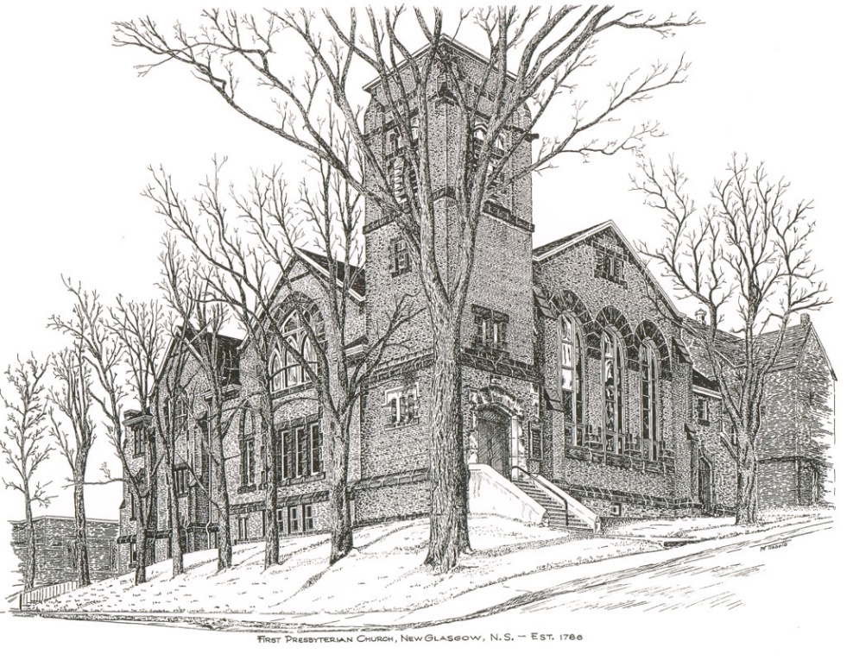

FIRST PRESBYTERIAN CHURCH
208 MacLean St., New Glasgow, NS
902-752-5691
First.church@ns.aliantzinc.ca
Reverend Andrew MacDonald
902-331-0322
yick96@hotmail.com

May 29th, 2022
Seventh Sunday of Easter

THE APPROACH

Musical Prelude
Welcome and Announcements
Lighting the Christ Candle: (Please rise if you are able)
ONE: O Blessed Lord, accept this burning candle as a sign of our faith and love for you. Like this candle, WE are ready to be used in your service, without asking why and to what purpose. Even as this candle, WE wish to stand in your presence to be consumed in the light and warmth of your love. Please hear our prayers and, if it be your will, grant our petitions. Above all, make us loyal and faithful to you in all circumstances of our life.
All: Come, Lord, and grant us peace.
(LIGHT CANDLE)
Let us now prepare our hearts to worship almighty God.
Musical Introit - # 437 "First of the week and finest day" (vs 4)
Call to Worship
Hymn #268 – “All hail King Jesus”
Prayer of Adoration, Confession and Lord’s Prayer
Assurance of Pardon
Passing the Peace
Hymn: #262 – “Come to us, blessed Stranger”
Time for the children
Prayer of Illumination
First Lesson: Acts 1:1-11
Epistle Lesson: Ephesians 1:15-23
Gospel Reading: Luke 24:44-53
Anthem
Sermon: “Stop Staring at the Sky!”
Hymn: #719 - “God in great love for us lent us this planet”

Offertory Prayer

Sacrament of Holy Communion

HOLY COMMUNION

Invitation to the Lord’s Supper
The Invitation
Communion Hymn #722 - “Lord, whose love” vs. 1-2
Affirmation of Faith - Apostle’s Creed

I believe in God, the Father Almighty, creator of Heaven and earth; and in Jesus Christ, His only Son, Our Lord, who was conceived by the Holy Ghost, born of the Virgin Mary,
suffered under Pontius Pilate, was crucified, died, and was buried. He descended into Hell. On the third day He arose again from the dead; He ascended into Heaven, and sits
at the right hand of God, the Father Almighty; from thence He shall come to judge the quick and the dead.
I believe in the Holy Ghost, the holy Catholic Church,
the communion of saints, the forgiveness of sins, the resurrection of the body, and the life everlasting. Amen

Great Prayer of Thanksgiving:
ONE: The Lord be with you.
ALL: And also with you.
ONE: Lift up your hearts.
ALL: We lift them to the Lord.
ONE: Let us give thanks to the Lord our God.
ALL: It is right to give God thanks and praise.
ONE: So now, with all the apostles and prophets, and that great cloud of witnesses who live forever with you in the heavenly kingdom, we join our voices in thanksgiving and in praise to you saying:
ALL: Holy, holy, holy Lord, God of power and might,
heaven and earth are full of your glory.
Hosanna in the highest.
Blessed is he who comes in the name of the Lord.
Hosanna in the highest.

ONE: Therefore, today we gather in remembrance of the sacrifice that was made for our sakes. We have set aside this bread and this wine, as a celebration feast, a meal of remembrance. In doing so we also give praise and thanksgiving to you Lord God, as we proclaim the great mystery of faith:

ALL: Christ has died,
Christ is risen,
Christ will come again.

ONE: Let us join together as we lift up our voices and say the prayer that our Lord Jesus Christ taught us to pray when he said:

Our Father which art in heaven,

Hallowed be thy name.

Thy kingdom come,

Thy will be done in earth,

as it is in heaven.

Give us this day our daily bread.

And forgive us our debts,

as we forgive our debtors.

And lead us not into temptation,

but deliver us from evil:

For thine is the kingdom,

and the power, and the glory,

forever. Amen.

The Sacrament of Holy Communion
Communion Hymn #722 - “Lord, whose love” vs. 3-4
Benediction

Recessional
* * * * * * * * * * * * *

ANNOUNCEMENTS

FAIR HEARTS UPDATE - GREAT NEWS!
The Al Qass Matte family now have final approval to come to Nova Scotia! Travel arrangements still need to be made but we anticipate they will arrive within a month. We have secured a house for the family to rent on Cowan St., Westville. All the donated furnishings and household items stored in the church nursery, were moved to the house, it will be ready for them to occupy when they arrive.

We have one final need for this family and are asking for donations to purchase new bedding (sheets, mattress covers and 6 pillows) for 1 queen, 1 double, and 3 single beds. If you have any of these new items to donate or wish to make a financial donation to purchase them, please contact one of the FAIR Hearts members: Rev. Andrew MacDonald (902-331-0322), Sharon Mason (902-752-0724), Sara Fullerton (902-754-2142), and Brent MacQuarrie (902) 616-7787).

UPCOMING EVENTS & NEWS
- Board of Managers will meet Mon., June 6th at 6:30 p.m.
- Session will meet Tues., June 7th at 6 p.m.
- Sunday School - We welcome the children back to Sunday School and ask that you spread that word to any children you know who might be interested in joining us.
- June 3-4, 2022 – New Glasgow Music Festival and the Federation of Music Festivals of Nova Scotia presents the Provincial Music Festival. For full schedule of events see fmfns.ca. Stars of the Festival and Awards Concert, Sat., June 4th, 7:00 p.m. at Trinity United Church
- Sat., June 4 – Sharon St. John United are hosting a Yard Sale and Bake Sale - 9a.m.-noon. Baked beans and brown bread also available. $2.00 for adults, children free.
- Sat., June 4th, 10 a.m. - Workday at Camp Geddie - If you’re available, please join us at Camp Geddie for a workday. Bring your equipment/tools along with a lunch. Jobs needing to be completed include putting the docks in the water; painting; minor repairs to cabins; clearing brush etc. Your support is always appreciated! Chris MacDonald, Property Committee.
- Sun., June 5th – An English Tea will be served following service to celebrate the Queen’s Platinum Jubilee.
- Thurs, June 16th - The Pictou AMS Presbyterial will be holding their Annual Meeting - 9:30- 12:00. The Burning Bush Auxiliary will be hosting at Bethel Presbyterian Church, Pictou Landing. The theme for the morning is “Together Again”. Statistical forms need to be passed in to Carol MacKay; General Society requires they be submitted for Fall. Light refreshments will be served.
- June 26th, 7 p.m. - The DeCoste Entertainment Centre presents Camp Geddie Talent Show and Silent Auction in support of the children of the Geddie Community. Viewing/Bidding at 6 p.m.

USHERS
Ushers today are Sherry Green and Jane Williams. If you would be interested in ushering, please contact Sharon Mason (902-752-0724) or leave your name at the office.

SCRIPTURE READER THIS MORNING
Chet Fleming
CONGRATULATIONS AND BEST WISHES!
We wish Austen Sutton a very happy birthday today! As well, the Suttons will celebrate their 53rd wedding anniversary, Tuesday, May 31st.
We also extend birthday greetings to Roslyn MacDonald. She will celebrate her birthday Tuesday, May 31st.
A Thank You is extended to the congregation from Hendrika VanVeld who celebrated her birthday on May 19th. She had a great day and enjoyed the flowers she received from an anonymous donor!
PAR
Pre-Authorized Remittance Plan (PAR), is a convenient option for making regular, uninterrupted donations to the church, ensuring your donations continue when you are away, or, as we learned this past 2 years, when the church is closed due to COVID. Forms are available on Sundays or through the office. If you are interested and have any questions, contact the office for more information.
* * * * * * * * * * * * *

Minister: Rev. Andrew MacDonald (c) 902-331-0322
Organist: Lloyd MacLean
Office hours: Tues. to Fri. – 10 -1pm
Rev. MacDonald office hours -Tues. to Thurs. 10-2 or by appointment

Mission Statement: But he’s already made it plain how to live, what to do, what God is looking for in men and women. It’s quite simple. Do what is fair and just to your neighbor, be compassionate and loyal in your love, and don’t take yourself too seriously – take God seriously. Micah 6: 8-The Message

