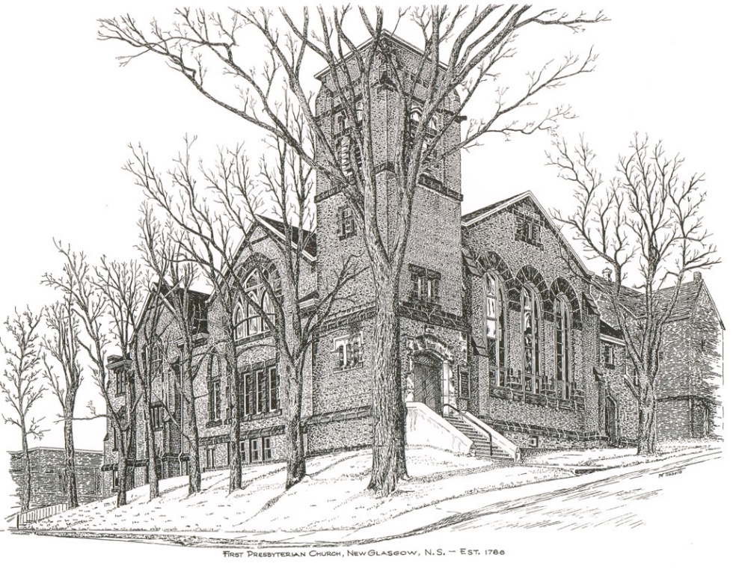

FIRST PRESBYTERIAN CHURCH
208 MacLean St., New Glasgow, NS
902-752-5691
First.church@ns.aliantzinc.ca
Reverend Andrew MacDonald
902-331-0322
yick96@hotmail.com

May 8th, 2022
Fourth Sunday of Easter
Christian Family Sunday
THE APPROACH

Musical Prelude
Welcome and Announcements
Lighting the Christ Candle: (Please rise if you are able)
ONE: Let us light this Christ candle for tolerance, and pray for a unity that respects diversity and enhances the well-being of all the inhabitants of Canada and of the world. Let us pray for a society where it will be easier to live virtuously, where joy will be the lot of many, where all children will be surrounded with love, where prejudice will have no place and where God will be more evident to all.
All: Come, Lord, and grant us peace.
(LIGHT CANDLE)
Let us now prepare our hearts to worship almighty God.
Musical Introit - # 640 "Softly and tenderly" (vs 1)
Call to Worship
Hymn #434 – “For the beauty of the earth”
Prayer of Adoration, Confession and Lord’s Prayer
Assurance of Pardon
Passing the Peace
Hymn: #11 – “The Lord’s my shepherd”
Prayer of Illumination

First Reading: Acts 9:36-43
Second Reading: Revelation 7:9-17
Gospel Reading: John 15:1-8
Anthem – “Song of community” (Carolyn McDade)
Sermon: " God Is Love "
Hymn: #310 - “Bring many names”

Offertory Prayer

Reaffirmation of Faith – Apostles’ Creed – Please rise

Prayer of the People

Hymn: #669 - “And Jesus said, our God is like a shepherd”

Benediction

Recessional

Scripture Reader: Sharon Mason

* * * * * * * * * * * * *

Minister: Rev. Andrew MacDonald (c) 902-331-0322
Organist: Lloyd MacLean
Office hours: Tues. to Fri. – 10 -1pm
Rev. MacDonald office hours -Tues. to Thurs. 10-2 or by appointment

Mission Statement: But he’s already made it plain how to live, what to do, what God is looking for in men and women. It’s quite simple. Do what is fair and just to your neighbor, be compassionate and loyal in your love, and don’t take yourself too seriously – take God seriously. Micah 6: 8-The Message

Apostles Creed

I believe in God, the Father Almighty, maker of Heaven and earth; and in Jesus Christ, His only Son, Our Lord, who was conceived by the Holy Ghost, born of the Virgin Mary,
suffered under Pontius Pilate, was crucified, died, and was buried. He descended into Hell. On the third day He arose again from the dead; He ascended into Heaven, and sits
at the right hand of God, the Father Almighty; from thence He shall come to judge the quick and the dead.
I believe in the Holy Ghost, the holy Catholic Church,
the communion of saints, the forgiveness of sins, the resurrection of the body, and the life everlasting. Amen.

The Lord’s Prayer

Our Father which art in heaven,

Hallowed be thy name.

Thy kingdom come,

Thy will be done in earth,

as it is in heaven.

Give us this day our daily bread.

And forgive us our debts,

as we forgive our debtors.

And lead us not into temptation,

but deliver us from evil:

For thine is the kingdom,

and the power, and the glory,

forever. Amen.

ANNOUNCEMENTS

PASTORAL CARE:
In order to provide support to the people of First Church, when you or a loved one is sick or in hospital, we encourage you to contact the church (902-752-5691), Reverend Andrew (902-331-0322) or Phoebe Fraser, Chair of the Pastoral Care Team (902-752-4728), to inform us directly. It is also important that you inform the hospital that you would welcome a visit from your minister and/or your Elder.
F.A.I.R. HEARTS - UPDATE:

The AlQasseMatte Family completed their interviews with Canadian Immigration officials in Turkey on Jan. 19 and have been approved to come to Canada. This is absolutely wonderful news after their 8 year wait as refugees. There are still several more steps that must be completed such as medicals that must be completed for each family member, passports issued by the Canadian Government and arrangements made for transportation to Canada. Hopefully these steps will be completed in the next few months, however a time frame is unknown at this time.
Fundraising continues in order to meet our commitment of financially supporting the family for their 1st year in Nova Scotia. If you would like to make a monetary donation to FAIR Hearts it would be greatly appreciated. Please contact the church office or a member of FAIR Hearts (Sara Fullerton, Brent MacQuarrie, Sharon Mason or Rev Andrew). Through generous donations of furnishings and other household items from the congregation and the Pictou County community, we now have all that is required for furnishings and household items. Financial donations to support them in their 1st year, however, are still required.
FAIR Hearts members from First Church are: Rev. Andrew MacDonald (902-331-0322), Sharon Mason (902-752-0724), Sara Fullerton (902-754-2142), and Brent MacQuarrie (902) 616-7787).

HAPPY BIRTHDAY!

Best wishes to Edna Fraser as she celebrates her birthday tomorrow, Monday, May 9th.

UPCOMING EVENTS & NEWS

Mon., May 9th - The Board of Managers will meet at 6:30 p.m.
Tues., May 10th - Session will meet at 6 p.m.
Sun., May 15th – Service will be held at Ivy’s Terrace at 2:30 p.m.
May 24th – May 27th – Rev. Andrew will be away on study leave.

May 20, 2022 - Musique Royale will be presenting Capella Regalis Men and Boys Choir from Halifax at First Presbyterian Church on May 20, 2022, at 7pm. Tickets will be available at the door or in advance by calling the church office at 902-752-5691 or by email at first.church@ns.aliantzinc.ca Ticket prices are: $25 at the door ($20 in advance). Students - $10.00.
THANK YOU!
We express our thanks to Edna Fraser for donating 2 new coffee pots for the kitchen.
USHERS
Ushers for the month of May are Gary Baudoux and Colette Condon (May 1, 8 15); Sherry Green and Evelyn MacLellan (May 22) and Sherry Green and Jane Williams (May 29). If you would be interested in ushering, please contact Sharon Mason (902-752-0724) or leave your name at the office.
REQUEST FOR ASSISTANCE
The Trustees of Riverside Cemetery Company, Administrator of the Riverside, Lorne St. and the Pioneer Cemeteries, New Glasgow, are seeking assistance with the spring clean up of the cemeteries. We also welcome financial donations to help operating expenses. For further information regarding clean up or donations, please contact Murray Biggar at 902-752-4378.

