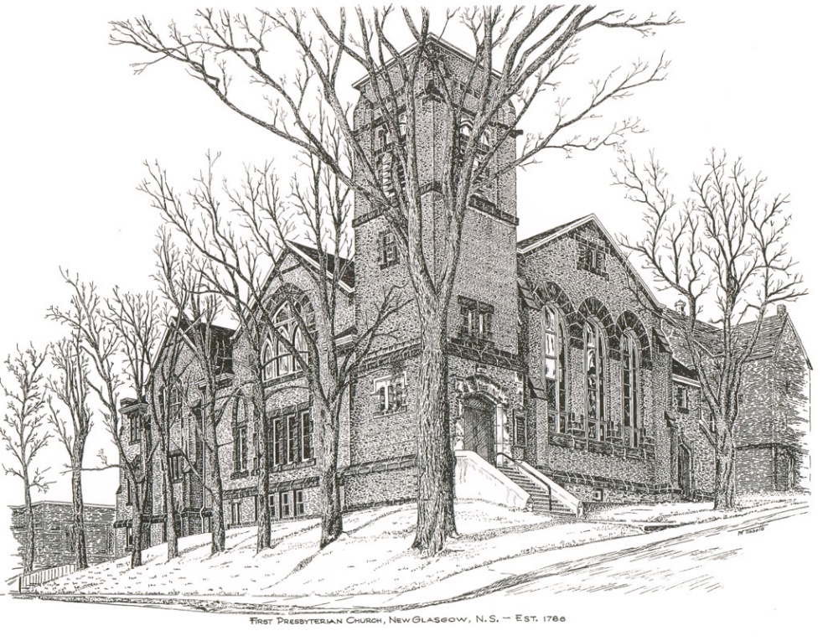

FIRST PRESBYTERIAN CHURCH
208 MacLean St., New Glasgow, NS
902-752-5691
First.church@ns.aliantzinc.ca
Reverend Andrew MacDonald
902-331-0322
yick96@hotmail.com

June 26th, 2022
Fourth Sunday after Pentecost

THE APPROACH

Musical Prelude
Welcome and Announcements
Lighting the Christ Candle: (Please rise if you are able)
One: Do not rejoice over me, O my enemy; when I fall, I shall rise;
when I sit in darkness, the Lord will be a light to me.
I must bear the indignation of the Lord, because I have sinned against him, until he takes my side and executes judgement for me.
He will bring me out to the light; I shall see his vindication.
Then my enemy will see, and shame will cover her who said to me,
‘Where is the Lord your God?’ My eyes will see her downfall;
now she will be trodden down like the mire of the streets.
ALL: O Come Lord, and light our path, show us Your way!
(Light the candle)
One: Let us now prepare our hearts to worship almighty God.
Musical Introit - # 575 "Lead me Lord"
Call to Worship
Hymn #328 – “This is my Father’s world”
Prayer of Adoration, Confession and Lord’s Prayer
Assurance of Pardon
Passing the Peace
Hymn #630 – “When we are living”
Prayer of Illumination

First Lesson: 2 Kings 5:1-14
Epistle Lesson: Galatians 6:1-16
Gospel Lesson: Luke 10:1-12,16-20
Anthem – “I rest in God alone” (Hymn # 36 - John Daniels, arranged - Christopher Norton)
Sermon: “Knocking the dust from your feet!”
Hymn: #710 - “What does the Lord require”
Offertory Prayer

Reaffirmation of Faith – Apostles’ Creed – Please rise

Prayers of the People

Hymn: #687 - “Blessed assurance, Jesus is mine”

Benediction

Recessional

* * * * * * * * * * * * *
Minister: Rev. Andrew MacDonald (c) 902-331-0322
Organist: Lloyd MacLean
Office hours: Tues. to Fri. – 10 -1pm
Rev. MacDonald office hours -Tues. to Thurs. 10-2 or by appointment

Mission Statement: But he’s already made it plain how to live, what to do, what God is looking for in men and women. It’s quite simple. Do what is fair and just to your neighbor, be compassionate and loyal in your love, and don’t take yourself too seriously – take God seriously. Micah 6: 8-The Message
Apostles Creed

I believe in God, the Father Almighty, maker of Heaven and earth; and in Jesus Christ, His only Son, Our Lord, who was conceived by the Holy Ghost, born of the Virgin Mary,
suffered under Pontius Pilate, was crucified, died, and was buried. He descended into Hell. On the third day He arose again from the dead; He ascended into Heaven, and sits
at the right hand of God, the Father Almighty; from thence He shall come to judge the quick and the dead.
I believe in the Holy Ghost, the holy Catholic Church,
the communion of saints, the forgiveness of sins, the resurrection of the body, and the life everlasting. Amen.

The Lord’s Prayer

Our Father which art in heaven,

Hallowed be thy name.

Thy kingdom come,

Thy will be done in earth,

as it is in heaven.

Give us this day our daily bread.

And forgive us our debts,

as we forgive our debtors.

And lead us not into temptation,

but deliver us from evil:

For thine is the kingdom,

and the power, and the glory,

forever. Amen.

ANNOUNCEMENTS

FAIR HEARTS:
The Al Qass Matte family will arrive the end of July. We still need the following items for their new home:
- Mattress covers: 1 queen, 1 double, 1 single
- 8 pillows
- Scissors
- 6+ Placemats
- Garbage can for kitchen
- Recycle bins
- Can opener
Please contact Sara Fullerton (902-754-2142), if you are interested in donating any of these items or making a monetary donation toward the purchase of these items.
UPCOMING EVENTS
No meetings or events scheduled for this week at First Church.
We send our best wishes to John and Betty Gladwin who celebrate their 58th wedding anniversary today, July 3rd.
We also extend our congratulations to Fran and Clarke Savage as they celebrate their 50th anniversary, Friday, July 8th.

VOLUNTEER SCRIPTURE READERS & USHERS
Scripture reader today: Phoebe Fraser
Ushers this month are David Johnstone and Chet Fleming. If you would be interested in ushering, please contact Sharon Mason (902-752-0724) or leave your name at the office.
We are in need of volunteer scripture readers for Sunday services. If you can help, please contact Jane by phone at the office or by email.
PAR
Pre-Authorized Remittance Plan (PAR), is a convenient option for making regular, uninterrupted donations to the church, ensuring your donations continue when you are away, or, as we learned this past 2 years, when the church is closed due to COVID. Forms are available on Sundays or through the office. If you are interested and have any questions, contact the office for more information.

