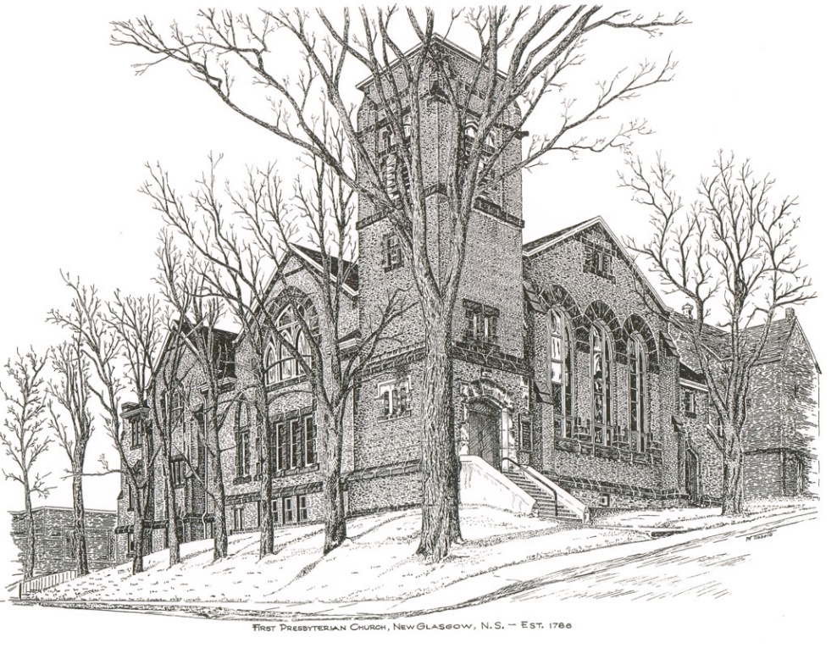

FIRST PRESBYTERIAN CHURCH
208 MacLean St., New Glasgow, NS
902-752-5691
First.church@ns.aliantzinc.ca
Reverend Andrew MacDonald
902-331-0322
yick96@hotmail.com

June 19th, 2022
Second Sunday after Pentecost
National Indigenous Peoples Sunday

THE APPROACH

Musical Prelude
Welcome and Announcements
Lighting the Christ Candle: (Please rise if you are able)
One: Oh, how I love your law! It is my meditation all day long.
Your commandment makes me wiser than my enemies, for it is always with me. I have more understanding than all my teachers, for your decrees are my meditation. I understand more than the aged, for I keep your precepts. I hold back my feet from every evil way, in order to keep your word. I do not turn away from your ordinances, for you have taught me. How sweet are your words to my taste, sweeter than honey to my mouth! Through your precepts I get understanding; therefore I hate every false way.
Your word is a lamp to my feet and a light to my path. I have sworn an oath and confirmed it, to observe your righteous ordinances.
ALL: O Come Lord, and light our path, show us Your way!
(LIGHT CANDLE)
Let us now prepare our hearts to worship almighty God.
Musical Introit - # 437 "First of the week and finest day" (vs 4).
Call to Worship
Hymn #453 – “Oh sing to our God”
Prayer of Adoration, Confession and Lord’s Prayer
Assurance of Pardon
Passing the Peace
Hymn #422 – “Sing a new song unto the Lord”
Time for the children
Prayer of Illumination
Isaiah 65:1-9
Galatians 3:23-29
Luke 8:26-39
Anthem – “Hymn of Promise” (Natalie Sleeth)
Sermon: “Freed From Torment!”
Hymn: #414 - “God, reveal your presence”

Offertory Prayer

Reaffirmation of Faith – Apostles’ Creed – Please rise

Prayer of the People

Hymn: #376 - “Lord, the light of your love is shining”

Benediction

Recessional

* * * * * * * * * * * * *
Minister: Rev. Andrew MacDonald (c) 902-331-0322
Organist: Lloyd MacLean
Office hours: Tues. to Fri. – 10 -1pm
Rev. MacDonald office hours -Tues. to Thurs. 10-2 or by appointment

Mission Statement: But he’s already made it plain how to live, what to do, what God is looking for in men and women. It’s quite simple. Do what is fair and just to your neighbor, be compassionate and loyal in your love, and don’t take yourself too seriously – take God seriously. Micah 6: 8-The Message
Apostles Creed

I believe in God, the Father Almighty, maker of Heaven and earth; and in Jesus Christ, His only Son, Our Lord, who was conceived by the Holy Ghost, born of the Virgin Mary,
suffered under Pontius Pilate, was crucified, died, and was buried. He descended into Hell. On the third day He arose again from the dead; He ascended into Heaven, and sits
at the right hand of God, the Father Almighty; from thence He shall come to judge the quick and the dead.
I believe in the Holy Ghost, the holy Catholic Church,
the communion of saints, the forgiveness of sins, the resurrection of the body, and the life everlasting. Amen.

The Lord’s Prayer

Our Father which art in heaven,

Hallowed be thy name.

Thy kingdom come,

Thy will be done in earth,

as it is in heaven.

Give us this day our daily bread.

And forgive us our debts,

as we forgive our debtors.

And lead us not into temptation,

but deliver us from evil:

For thine is the kingdom,

and the power, and the glory,

forever. Amen.

ANNOUNCEMENTS

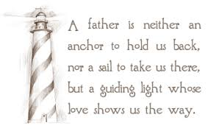
HAPPY FATHER’S DAY – To all the dads, grandads and stepdads. We wish you an enjoyable day!

FAIR HEARTS:
Update: The Al Qass Matte family is tentatively scheduled to arrive in Nova Scotia around the end of July. We are still in need of donations of new bedding or donations to purchase new bedding (sheets, mattress covers and 6 pillows) for 1 queen, 1 double, and 3 single beds. If you have any of these new items to donate or wish to make a financial donation to purchase them, please contact one of the FAIR Hearts members: Rev. Andrew MacDonald (902-331-0322), Sharon Mason (902-752-0724), Sara Fullerton (902-754-2142), and Brent MacQuarrie (902) 616-7787).

CONDOLENCES
The congregation extends condolences to Shirley and Keith Cruickshank on the passing of Shirley’s brother, George F. MacDonald, of Rocky Mountain.

We also extend condolences to Ella Russell on the loss of her sister Rena in Scotland.

UPCOMING EVENTS & NEWS
Today, 4:00 p.m. – Shaun McLean and Friends presents an afternoon of gospel, soul and other music. Tickets $25 – all proceeds in support of the Aberdeen Hospital Palliative Care.

June 26th, 7 p.m. - The DeCoste Entertainment Centre presents Camp Geddie Talent Show and Silent Auction in support of the children of the Geddie Community. Viewing/Bidding at 6 p.m.
CONGRATULATIONS!!
We wish Rev. Dr. Morley Shaw a very happy birthday, Thursday, June 23rd!
We also send our best wishes for a happy anniversary to John and Laura Macumber who will celebrate their 61st wedding anniversary on Friday, June 24th.

VOLUNTEER SCRIPTURE READERS & USHERS
Scripture reader today: Brent MacQuarrie
Ushers today are Evelyn MacLellan and Marilyn Johnstone. If you would be interested in ushering, please contact Sharon Mason (902-752-0724) or leave your name at the office.
We need volunteer scripture readers for Sunday services. If you can help, please contact Jane by phone at the office or by email.
PAR
Pre-Authorized Remittance Plan (PAR), is a convenient option for making regular, uninterrupted donations to the church, ensuring your donations continue when you are away, or, as we learned this past 2 years, when the church is closed due to COVID. Forms are available on Sundays or through the office. If you are interested and have any questions, contact the office for more information.

