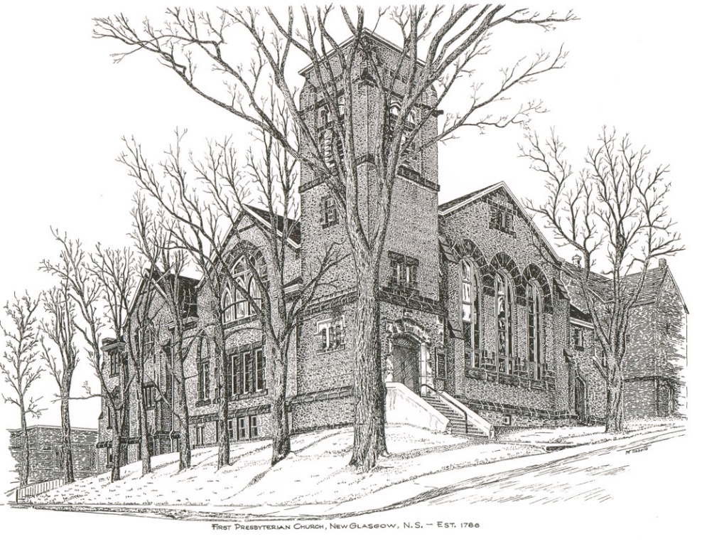

FIRST PRESBYTERIAN CHURCH
208 MacLean St., New Glasgow, NS
902-752-5691
First.church@ns.aliantzinc.ca
Reverend Andrew MacDonald
902-331-0322
yick96@hotmail.com

June 26th, 2022
Third Sunday after Pentecost

THE APPROACH

Musical Prelude
Welcome and Announcements
Lighting the Christ Candle: (Please rise if you are able)
One: This is the message we have heard from him and proclaim to you, that God is light and in him there is no darkness at all. If we say that we have fellowship with him while we are walking in darkness, we lie and do not do what is true; but if we walk in the light as he himself is in the light, we have fellowship with one another, and the blood of Jesus his Son cleanses us from all sin. If we say that we have no sin, we deceive ourselves, and the truth is not in us. If we confess our sins, he who is faithful and just will forgive us our sins and cleanse us from all unrighteousness.
ALL: O Come Lord, and light our path, show us Your way!
(Light the candle)
One: Let us now prepare our hearts to worship almighty God.
Musical Introit - # 437 "First of the week and finest day" (vs 4).
Call to Worship
Hymn #374 – “Oh for a thousand tongues to sing”
Prayer of Adoration, Confession and Lord’s Prayer
Assurance of Pardon
Passing the Peace
Hymn #476 – “Amigos de Cristo/Friends of the Lord”
Time for the children
Prayer of Illumination
First Lesson: 2 Kings 2:1-2,6-14
Epistle Lesson: Galatians 5:1,13-25
Gospel Lesson: Luke 9:51-62
Anthem – “Sweetgrass and Candle” (John Oldman/Ron Klusmeier)
Sermon: “Never look back”
Hymn: #457 - “Now thank we all our God”

Offertory Prayer

Reaffirmation of Faith – Apostles’ Creed – Please rise

Prayers of the People

Sunday School closing ceremony

Hymn: #105 - “I’ll praise my Maker while I’ve breath”

Benediction

Recessional

* * * * * * * * * * * * *
Minister: Rev. Andrew MacDonald (c) 902-331-0322
Organist: Lloyd MacLean
Office hours: Tues. to Fri. – 10 -1pm
Rev. MacDonald office hours -Tues. to Thurs. 10-2 or by appointment

Mission Statement: But he’s already made it plain how to live, what to do, what God is looking for in men and women. It’s quite simple. Do what is fair and just to your neighbor, be compassionate and loyal in your love, and don’t take yourself too seriously – take God seriously. Micah 6: 8-The Message
Apostles Creed

I believe in God, the Father Almighty, maker of Heaven and earth; and in Jesus Christ, His only Son, Our Lord, who was conceived by the Holy Ghost, born of the Virgin Mary,
suffered under Pontius Pilate, was crucified, died, and was buried. He descended into Hell. On the third day He arose again from the dead; He ascended into Heaven, and sits
at the right hand of God, the Father Almighty; from thence He shall come to judge the quick and the dead.
I believe in the Holy Ghost, the holy Catholic Church,
the communion of saints, the forgiveness of sins, the resurrection of the body, and the life everlasting. Amen.

The Lord’s Prayer

Our Father which art in heaven,

Hallowed be thy name.

Thy kingdom come,

Thy will be done in earth,

as it is in heaven.

Give us this day our daily bread.

And forgive us our debts,

as we forgive our debtors.

And lead us not into temptation,

but deliver us from evil:

For thine is the kingdom,

and the power, and the glory,

forever. Amen.

ANNOUNCEMENTS

FAIR HEARTS:
Update: The Al Qass Matte family is tentatively scheduled to arrive in Nova Scotia around the end of July. We are still in need of donations of new bedding or donations to purchase new bedding (sheets, mattress covers and 6 pillows) for 1 queen, 1 double, and 3 single beds. If you have any of these new items to donate or wish to make a financial donation to purchase them, please contact one of the FAIR Hearts members: Rev. Andrew MacDonald (902-331-0322), Sharon Mason (902-752-0724), Sara Fullerton (902-754-2142), and Brent MacQuarrie (902) 616-7787).

CONDOLENCES

We send sincere condolences to Ella Russell on the sudden passing of her son George in Alberta.

UPCOMING EVENTS & NEWS
TONIGHT – Camp Geddie Talent Showcase and Silent Auction at the DeCoste Entertainment Centre with lots of great local talent. Bidding starts at 6 pm. Concert begins at 7 pm. Tickets available at the door.
VOLUNTEER SCRIPTURE READERS & USHERS
Scripture reader today: Lloyd MacLean
Ushers today are Evelyn MacLellan and Clarice Campbell. If you would be interested in ushering, please contact Sharon Mason (902-752-0724) or leave your name at the office.
We need volunteer scripture readers for Sunday services. If you can help, please contact Jane by phone at the office or by email.

PAR
Pre-Authorized Remittance Plan (PAR), is a convenient option for making regular, uninterrupted donations to the church, ensuring your donations continue when you are away, or, as we learned this past 2 years, when the church is closed due to COVID. Forms are available on Sundays or through the office. If you are interested and have any questions, contact the office for more information.

