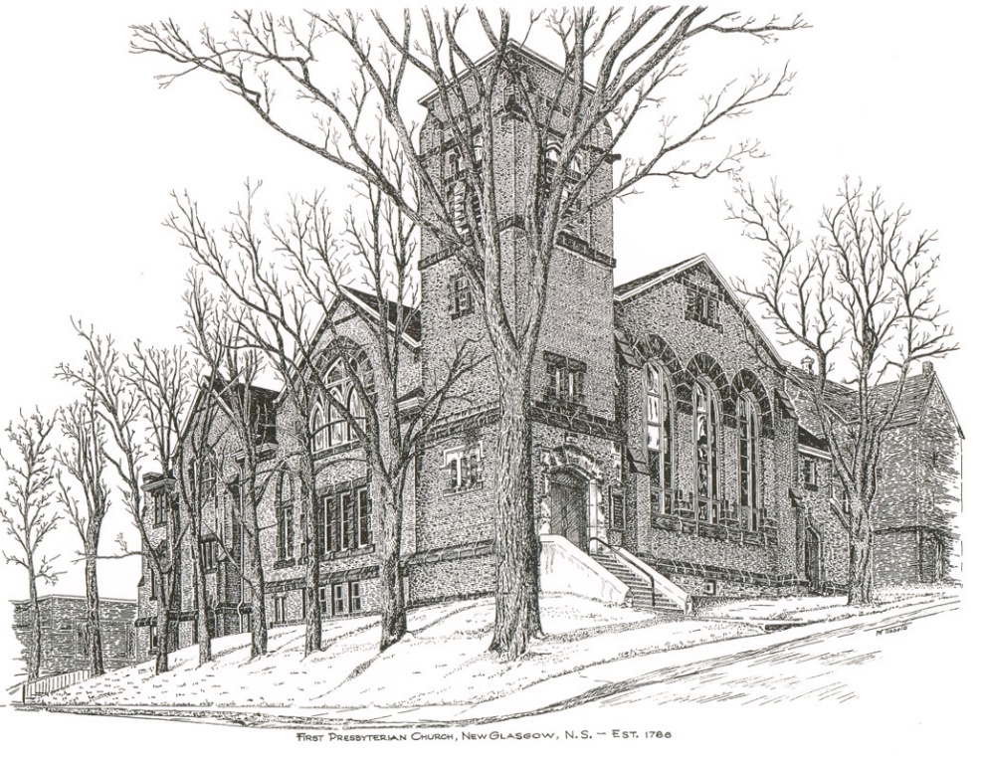

FIRST PRESBYTERIAN CHURCH
208 MacLean St., New Glasgow, NS
902-752-5691
First.church@ns.aliantzinc.ca
Reverend Andrew MacDonald
902-331-0322
yick96@hotmail.com

July 17th, 2022
Sixth Sunday after Pentecost

THE APPROACH

Musical Prelude
Welcome and Announcements
Lighting the Christ Candle: (Please rise if you are able)
One: Where can I go from your spirit? Or where can I flee from your presence? If I ascend to heaven, you are there; if I make my bed in Sheol, you are there. If I take the wings of the morning and settle at the farthest limits of the sea, even there your hand shall lead me, and your right hand shall hold me fast. If I say, ‘Surely the darkness shall cover me, and the light around me become night’, even the darkness is not dark to you; the night is as bright as the day, for darkness is as light to you.
ALL: O Come Lord, and light our path, show us Your way!
(Light the candle)
One: Let us now prepare our hearts to worship almighty God.
Musical Introit - # 575 "Lead me Lord"
Call to Worship
Hymn #481 – “Blest be the tie that binds”
Prayer of Adoration, Confession and Lord’s Prayer
Assurance of Pardon
Passing the Peace
Hymn #390 – “Spirit divine, attend our prayers”
Prayer of Illumination
First Lesson: Amos 8:1-12
Epistle Lesson: Colossians 1:15-28
Gospel Lesson: Luke 10:38-42
Anthem – “Spirit, Spirit of gentleness, (BoP 399, James K. Manley, arr. Andrew Donaldson)
Sermon: “Seeking the Word of the Lord”
Hymn: #635 - “Brother, sister, let me serve you”
Offertory Prayer

Reaffirmation of Faith – Apostles’ Creed – Please rise

Prayers of the People

Hymn: #634 - “Will you come and follow me”

Benediction

Recessional

* * * * * * * * * * * * *
Minister: Rev. Andrew MacDonald (c) 902-331-0322
Organist: Lloyd MacLean
Office hours: Tues. to Fri. – 10 -1pm
Rev. MacDonald office hours -Tues. to Thurs. 10-2 or by appointment

Mission Statement: But he’s already made it plain how to live, what to do, what God is looking for in men and women. It’s quite simple. Do what is fair and just to your neighbor, be compassionate and loyal in your love, and don’t take yourself too seriously – take God seriously. Micah 6: 8-The Message
Apostles Creed

I believe in God, the Father Almighty, maker of Heaven and earth; and in Jesus Christ, His only Son, Our Lord, who was conceived by the Holy Ghost, born of the Virgin Mary,
suffered under Pontius Pilate, was crucified, died, and was buried. He descended into Hell. On the third day He arose again from the dead; He ascended into Heaven, and sits
at the right hand of God, the Father Almighty; from thence He shall come to judge the quick and the dead.
I believe in the Holy Ghost, the holy Catholic Church,
the communion of saints, the forgiveness of sins, the resurrection of the body, and the life everlasting. Amen.

The Lord’s Prayer

Our Father which art in heaven,

Hallowed be thy name.

Thy kingdom come,

Thy will be done in earth,

as it is in heaven.

Give us this day our daily bread.

And forgive us our debts,

as we forgive our debtors.

And lead us not into temptation,

but deliver us from evil:

For thine is the kingdom,

and the power, and the glory,

forever. Amen.

ANNOUNCEMENTS

FAIR HEARTS:
The Al Qass Matte family will arrive the end of July.
UPCOMING EVENTS
July 31st – We will celebrate our rich Scottish heritage with a “Kirkin’ O’ the Tartan”. We ask you to wear or bring a piece of your Clan tartan to show your Scottish pride.
July 31st – We will celebrate Holy Communion
VOLUNTEER SCRIPTURE READERS & USHERS
Scripture Reader: Clarice Campbell
Organist: Janice Alcorn
Ushers: David Johnstone and Chet Fleming.
We have lots of special birthdays this month! Best wishes to:
July 19th – Marion Johnstone and Gerald Thompson
July 20th – Ed Tremblett
July 21 – Gerald Wadden
July 23 – Hank Vanveld
July 26th – Vivian MacDonald
July 27th – Gerald Bellefontaine
July 28th – Doug Guthro

PAR
Pre-Authorized Remittance Plan (PAR), is a convenient option for making regular, uninterrupted donations to the church, ensuring your donations continue when you are away, or, as we learned this past 2 years, when the church is closed due to COVID. Forms are available on Sundays or through the office. If you are interested and have any questions, contact the office for more information.

