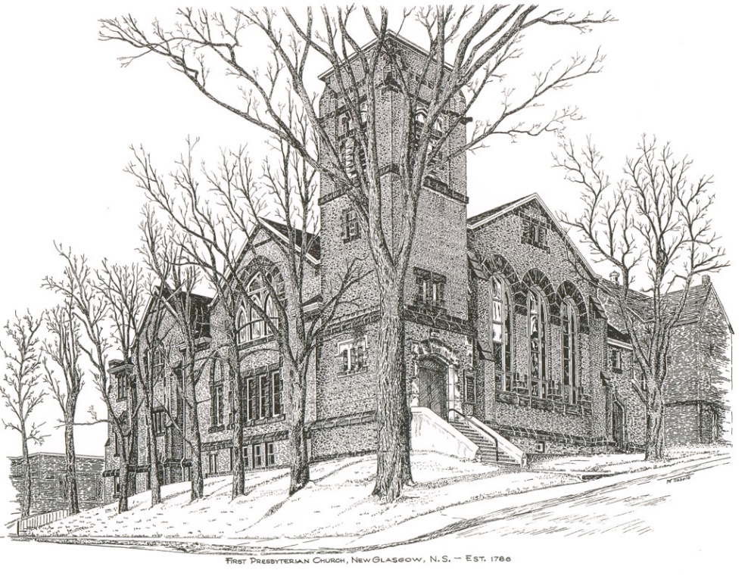

FIRST PRESBYTERIAN CHURCH
208 MacLean St., New Glasgow, NS
902-752-5691
First.church@ns.aliantzinc.ca
Reverend Andrew MacDonald
902-331-0322
yick96@hotmail.com

September 4th, 2022
Seventh Sunday after Pentecost
THE APPROACH

Musical Prelude
Welcome and Announcements
Lighting the Christ Candle: (Please rise if you are able)
One: Joy comes to those who follow the ways of the Lord. We will follow the Lord with joyful hearts! Those who follow the Lord are like trees planted by the river, bearing fruit each season. May our lives be fruitful and blessed by God! Worship the Lord who leads us to joy and abundance.
ALL: O Come Lord, and light our path, show us Your way!
(Light the candle)
One: Let us now prepare our hearts to worship almighty God.
Musical Introit - # 575 "Lead me Lord"
Call to Worship
Hymn #435 – “All Things Bright And Beautiful”
Prayer of Adoration, Confession and Lord’s Prayer
Assurance of Pardon
Passing the Peace
Hymn #500 – “Open My Eyes”
Prayer of Illumination
First Lesson: Jeremiah 18:1-11
Epistle Lesson: Philemon 1-21
Gloria Patri (#684)
Gospel Reading: Luke 14:25-33
Anthem –
Sermon: “Clay In the Potters Hands”
Hymn: #645 - “Follow Me, The Master Said”
Offertory Prayer

Reaffirmation of Faith – Apostles’ Creed – Please rise

Prayers of the People

Hymn: #634 - “Will you come and follow me?”

Benediction

Recessional

ANNOUNCEMENTS

UPCOMING EVENTS

The Board of Managers will meet Monday, Sept. 12th at 6 p.m.

Congregant and author, Clyde Macdonald has published his 20th book on Pictou County history entitled " More Pictonians At Home And Afar". Due to Covid-19 there will be no formal book launch. Starting September 13,2022 this book is available for purchase, cost $20 each ( no tax).If you are interested in purchasing a copy, please contact Clyde at 902-755-4738 or by email at clydefinlay@me.com All proceeds from the book sale will go to the Multiple Sclerosis Society.
Sept. 16th - Plan to attend a Variety Concert at Middle River Church in Rocklin on Friday, Sept 16th at 7 pm. Admission is $5. Homemade fudge and water will be available to purchase. Hope to see you all there.
Belated greetings to those who celebrated milestone anniversaries and birthdays in August:
August birthdays:
Aug. 1 - Wayne Withers
Aug. 6 – Dorothy Holmes
Aug. 9 – Frances Kennedy

August anniversaries:

Aug. 16 – Marion and Donald Johnstone
Aug. 22 – Brenda and John Zinck
Aug. 23 – Marilyn & David Johnstone
Aug. 25 – Shirley & Keith Cruickshank
Aug. 29 – Robyn and Larry MacLeod
Aug. 31 – Joy and Rev. Dr. Morley Shaw

Celebrating birthdays this week:

Sept. 3 – Barry Fraser
Sept. 7 – Eunice Wood

VOLUNTEER SCRIPTURE READERS & USHERS
Scripture Reader: Lynne-Ann MacLellan
Ushers: Phoebe Fraser and Phyllis O’Brien

PAR
Pre-Authorized Remittance Plan (PAR), is a convenient option for making regular, uninterrupted donations to the church, ensuring your donations continue when you are away, or, as we learned this past 2 years, when the church is closed due to COVID. Forms are available on Sundays or through the office. If you are interested and have any questions, contact the office for more information.

* * * * * * * * * * * * *
Minister: Rev. Andrew MacDonald (c) 902-331-0322
Organist: Clare Grieves
Office hours: Tues. to Fri. – 10 -1pm
Rev. MacDonald office hours -Tues. to Thurs. 10-2 or by appointment

Mission Statement: But he’s already made it plain how to live, what to do, what God is looking for in men and women. It’s quite simple. Do what is fair and just to your neighbor, be compassionate and loyal in your love, and don’t take yourself too seriously – take God seriously. Micah 6: 8-The Message
Apostles Creed

I believe in God, the Father Almighty, maker of Heaven and earth; and in Jesus Christ, His only Son, Our Lord, who was conceived by the Holy Ghost, born of the Virgin Mary,
suffered under Pontius Pilate, was crucified, died, and was buried. He descended into Hell. On the third day He arose again from the dead; He ascended into Heaven, and sits
at the right hand of God, the Father Almighty; from thence He shall come to judge the quick and the dead.
I believe in the Holy Ghost, the holy Catholic Church,
the communion of saints, the forgiveness of sins, the resurrection of the body, and the life everlasting. Amen.

The Lord’s Prayer

Our Father which art in heaven,

Hallowed be thy name.

Thy kingdom come,

Thy will be done in earth,

as it is in heaven.

Give us this day our daily bread.

And forgive us our debts,

as we forgive our debtors.

And lead us not into temptation,

but deliver us from evil:

For thine is the kingdom,

and the power, and the glory,

forever. Amen.

