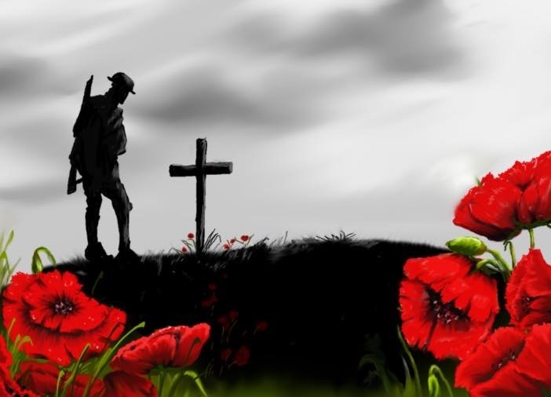

FIRST PRESBYTERIAN CHURCH
208 MacLean St., New Glasgow, NS
902-752-5691
First.church@ns.aliantzinc.ca
Reverend Andrew MacDonald
902-331-0322
yick96@hotmail.com

November 6th, 2022
Remembrance Sunday
Twenty Second Sunday after Pentecost

THE APPROACH
Musical Prelude
Welcome and Announcements
Lighting the Christ Candle: (Please rise if you are able)
One: In the beginning was the Word, and the Word was with God, and the Word was God. He was in the beginning with God. All things came into being through him, and without him not one thing came into being. What has come into being in him was life, and the life was the light of all people. The light shines in the darkness, and the darkness did not overcome it.
ALL: O Come Lord, and light our path, show us Your way!
(Light the candle)
One: Gathered as Spirit filled disciples of Christ, let us quiet our hearts for worship.
National Anthem – “O Canada”
Call to Worship
Hymn #794 – “Abide with me” vs. 1,2,5
1 Abide with me! Fast falls the eventide.
The darkness deepens, Lord, with me abide:
when other helpers fail and comforts flee,
help of the helpless, Oh abide with me.

2 Swift to its close ebbs out life’s little day;
earth’s joys grow dim, its glories pass away;
change and decay in all around I see:
O thou who changest not, abide with me.

5 Hold thou thy cross before my closing eyes,
shine through the gloom,
and point me to the skies;
heave’s morning breaks,
and earth’s vain shadows flee;
in life, in death, O Lord, abide with me.

In Flanders Fields
Last Post and Lament - Brent MacQuarrie
2 Minutes of Silence
Reveille- Brent MacQuarrie
Act of Remembrance
Roll of Honour
Prayer of Adoration, Confession and Lord’s Prayer

Our Father which art in heaven, hallowed be thy name.

Thy kingdom come, thy will be done in earth,

as it is in heaven.

Give us this day our daily bread.

And forgive us our debts, as we forgive our debtors.

And lead us not into temptation, but deliver us from evil:

For thine is the kingdom, and the power, and the glory,

forever. Amen.

Assurance of Pardon
Passing the Peace
Hymn #631 – “Jesus’ hands were kind hands”

- Jesus’ hands were kind hands, doing good to all,
healing pain and sickness, blessing children small,
washing tired feet and saving those who fall;
Jesus’ hands were kind hands, doing good to all.

- Take my hands, Lord Jesus, let them work for you;
make them strong and gentle, kind in all I do.
Let me watch you, Jesus, till I’m gentle too,
till my hands are kind hands, quick to work for you.

Children’s Time
Prayer of Illumination
First Lesson: Isaiah 2:1-9
Epistle Lesson: 1 Corinthians 15:50-58
Gloria Patri

Glory be to the Father, and to the Son, and to the Holy Ghost.

As it was in the beginning, is now and ever shall be, world without end.

Amen, amen.

Gospel Reading: Matthew 5:1-16
Anthem – Choir
Sermon: “Why do we Remember?”
Reaffirmation of Faith – Apostles’ Creed – Please rise

I believe in God, the Father Almighty, maker of Heaven and earth; and in Jesus Christ, His only Son, Our Lord, who was conceived by the Holy Ghost, born of the Virgin Mary,
suffered under Pontius Pilate, was crucified, died, and was buried. He descended into Hell. On the third day He arose again from the dead; He ascended into Heaven, and sits
at the right hand of God, the Father Almighty; from thence He shall come to judge the quick and the dead.
I believe in the Holy Ghost, the holy Catholic Church,
the communion of saints, the forgiveness of sins, the resurrection of the body, and the life everlasting. Amen.

Hymn: #727 - “Let there be peace”

1 Let there be light;
let there be understanding;
let all nations gather;
let them be face to face.

2 Open our lips;
open our minds to ponder;
open the door of concord,
opening into grace.

3 Perish the sword;
perish the angry judgement;
perish the bombs and hunger;
perish the fight for gain.

4 Hallow our love;
hallow the deaths of martyrs;
hallow their holy freedom;
hallowed be your name.

5 Your kingdom come;
your spirit turn to language;
your people speak together,
your spirit never fade.

6 Let there be light;
open our hearts to wonder;
perish the way of terror;
hallow the world God made.

Offertory Prayer
Prayers of the People
Hymn: #325 - “Eternal Father Strong to Save”
1 Eternal Father, strong to save,
whose arm hath bound the restless wave,
who bade the mighty ocean deep
its own appointed limits keep:
oh hear us when we cry to thee
for those in peril on the sea.

2 O Christ, whose voice the waters heard
and hushed their raging at thy word,
who walked upon the foaming deep
and calm amid the storm did sleep:
oh hear us when we cry to thee
for those in peril on the sea.

3 O Holy Spirit, who did brood
upon the waters dark and rude,
and bade their angry tumult cease,
and gave, for wild confusion, peace:
oh hear us when we cry to thee
for those in peril on the sea.

4 O Trinity of love and power,
our kindred shield in dangers hour;
from rock and tempest, fire and foe,
protect them wheresoer they go;
then evermore shall rise to thee
glad hymns of praise from land and sea.

Benediction
Royal Anthem - “God Save The King”
Coral Response: Threefold Amen
Recessional

ANNOUNCEMENTS

All are welcome at First Presbyterian Church. We hope you experience the love of God and of this congregation as we worship, celebrate, and serve one another.

The wreath at the front of the sanctuary has been laid in memory of Private Russell W. MacKenzie, who was killed in action in Italy in 1943, by daughter, Clarice Campbell.

UPCOMING EVENTS

Mon., Nov. 7th – 6:30 p.m. – Board of Managers will meet

Tues., Nov. 8th – 6:30 p.m. – Session will meet

Sun., Nov. 13th – 10:00 a.m. – Mark Thibeau will be leading a video Bible study called "Jesus - The God that Knows Your Name”. This will take place in the Lower Hall beginning at 10 a.m. and will run 4 Sundays beginning, next Sunday, Nov. 13th as noted, the remaining 3 will be in the new year, dates to be announced.
Fri. Dec. 2nd – 11 a.m. – 1 p.m. - Circle of Friends are holding a take-out Soup and Dessert lunch. Choices of soups are beef barley, tomato cheddar, corn chowder, chicken vegetable. Cost $10.00, pick up MacLean Street entrance between 11 am and 1 pm. All ordered must be received before November 25th by calling Edna Fraser 902-752-4096 or Marilyn Johnstone 902-922-2859.

VOLUNTEER SCRIPTURE READERS & USHERS
Scripture reader today: Sharon Mason
Usher: Jackie and Gary Ross
Early Christian Education: Lynne Ann and Lois MacLellan

THANK YOU
The F.A.I.R. Hearts committee would like to thank everyone who attended and contributed to the potluck for the Al Qass Matte family last Sunday. The family was happy to meet everyone and enjoyed this time of fellowship.

THERE WILL BE A BRIEF MEETING OF
SESSION AFTER SERVICE TODAY.

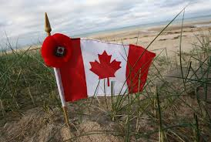
NAMES OF THE FALLEN
1914-1918
FIRST CHURCH
Fraser Betts William Herman Jenkins
Harry Cavanaugh Hal MacCulloch
Frederick Davis Alfred Sutherland MacIntosh
Margaret M. Fraser James Herbert MacIntosh
J. G. Laurier Fraser William Hayward MacIntosh
William Hays Grant Lillas MacKay
F. W. Henchecliffe, M.C. Roderick Porter
Robert Alexander Muir William D. Stewart

WESTMINSTER CHURCH
William T. Beck Ian C. MacGregor
Millard Cameron Harcourt A. Murray
Isabel K. Cummings George Tas
Aubrey E. Grant John H. Rogers
Hugh Ross
NAMES OF THE FALLEN
1939 – 1945
FIRST CHURCH
Kitchener Langille George D. MacDougall
G. Hadley MacAulay Allister W. Porter
Osborne L. Bliss, D.F.C.

WESTMINSTER CHURCH
Dr. William Embree Cameron MacNeil
Jack Ross

