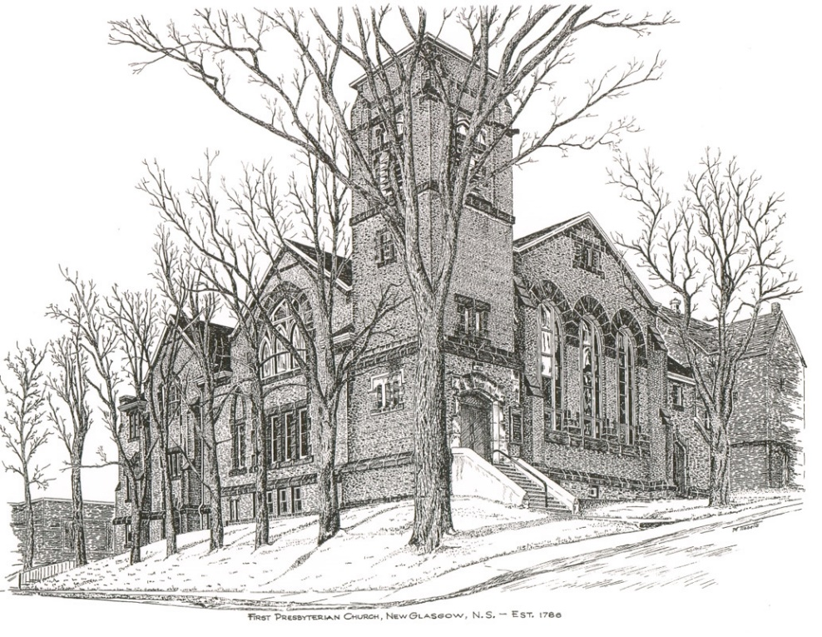

“For unto us a child is born, unto us a son is given; and the government shall be upon his shoulder; and his name shall be called Wonderful, Counsellor, the mighty God, the everlasting Father, the Prince of Peace.” Isaiah 9:6 (KJV)

Once again the world comes together to celebrate and give thanks for the birth of our Lord and savior Jesus Christ. Never in the history of the world has the birth of one child meant so much to so many. The birth of Jesus of Nazareth ushered into the world a time of hope, peace, love, and joy. All throughout his life and ministry, Jesus gave hope to the hopeless, love to the unloved, compassion to those who were suffering, and forgiveness to those who repented and asked for mercy.
I have always looked forward to the Christmas season. The opportunity to spend time with family and make memories. The joy in preparations leading up to Christmas Eve. The decorating of the houses and Christmas trees. The preparations of special food and treats, such as plum pudding, cherry balls, and fruitcake. The celebrations and parties, the parades and carnivals. It was always such hard work, but was really worth it in my opinion. And as I said they were some of the greatest and my favorite memories of my youth.
Christmas is a time for traditions and for family. However as time changes, so too may traditions change. Sometimes we become too focused on the Christmases of the past, that we neglect the Christmas of the present or future. It is great to reminisce about the Christmases of the past, to remember favorite memories, to think fondly of family and friends no longer with us. But we must also build new memories and new traditions.
I am including a list of our church events and activities that are going to carry us into the new year. I'm really looking forward to our Christmas Eve service this year, especially since it was cancelled last year.

On behalf of the Session and my own family, I would like to pray for you the joy of the season, the love of the Christ child, the peace from heaven, and the hope for a healthy and happy year to come.

May God continue to surround you with love and his blessing
Merry Christmas and a blessed new year!


Rev Andrew MacDonald

Upcoming Events

November 27, 2022
Advent 1: The Theme of Hope
December 4, 2022
Advent 2: The Theme of Peace
December 11, 2022
Advent III: The Theme of Joy
December 18, 2022
Advent IV: The Theme of Love
December 21, 2022 7:00PM
Blue Christmas Service
A service of healing and wholeness. For many the Christmas Season is a time of happiness and joy, but for others it is a time of great sorrow and sadness. Christmas may not be a joyous time because they may be alone, they may be suffering from illness, they may also be suffering from a recent loss of family or a loved one. During this time of Christmas even though you may be feeling the Christmas spirit and filled with joy and laughter we have to take time to remember those who are not as fortunate as us and who may be suffering.
Please join us on the longest night of the year for our Blue Christmas service of healing and wholeness.
December 23, 2022
A Presentation of Handel’s Messiah by Musique Royale
December 24, 2022 7:00PM
Christmas Eve Service of Carols and Scripture
December 25, 2022 11:00AM
Christmas Day Sunday Service.
January 1, 2023 11:00AM
First Sunday Service of the New Year. Conducted by Members of the Session.

The annual Christmas Memory Tree fundraiser is taking place again this year. The forms are available inside the sanctuary. Deadline for requests will be December 11th. If you would like to donate a ball(s), fill out the form and leave it, along with your donation, in the collection baskets. (To lessen the chance of missing a name(s), please limit your requests to 5 per form.) The names of those remembered and the donors will be included in the Christmas Eve bulletin.

Coordinating with the New Glasgow Dept. of Community Services, we are doing an outreach project for Christmas. “The Tree of Kindness” at the front of the sanctuary, is decorated with paper ornaments. On each is a note naming a small, practical gift. If you can, please take an ornament, purchase the gift, and place it in one of the 2 baskets under the tree (1 female and 1 male basket). The baskets will be given to 2 clients (more if we have extra items) who are disabled and unable to work and have limited income. Useful items would be: toiletries, laundry or dish detergent, toilet tissue/Kleenex, dish cloths/towels, socks, hats, gloves, any other useful household or personal items. We will collect these gifts during Advent up to Sunday, Dec 19th. For more information, please contact Sara Fullerton (902-754-2142) or the church office.

