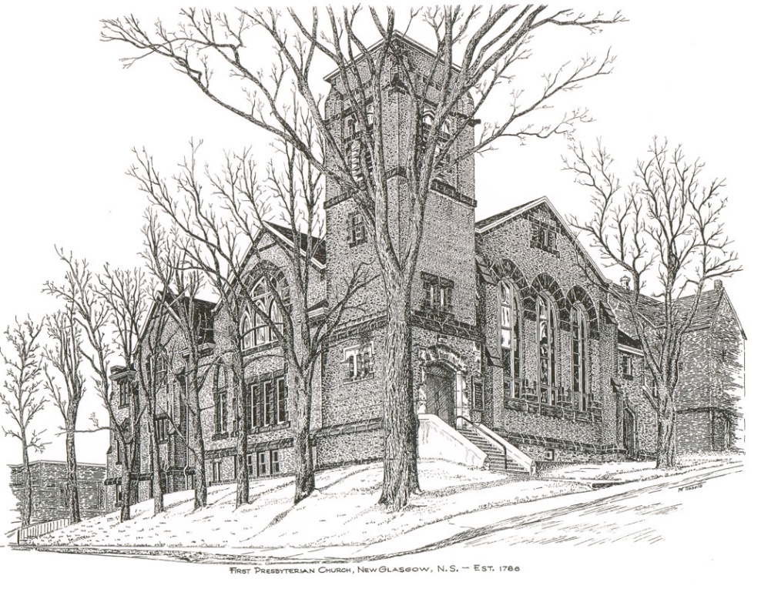

FIRST PRESBYTERIAN CHURCH
208 MacLean St., New Glasgow, NS
902-752-5691
First.church@ns.aliantzinc.ca
Reverend Andrew MacDonald
902-331-0322
yick96@hotmail.com

January 22nd, 2023
Third Sunday after Epiphany
THE APPROACH
Musical Prelude
Welcome and Announcements
Lighting the Christ Candle: (Please rise if you are able)
One: Set our hearts on fire with love for you, O Christ our God
So that in its flame we may love you with all our heart,
With all our mind, with all our soul, and with all our strength,
And our neighbors as ourselves, so that by keeping your commandments we may glorify you, the giver of all good gifts.
ALL: O Come Lord, and light our path, show us Your way!
(Light the candle)
One: Let us now prepare our hearts to worship almighty God.
Musical Introit - #24 "I waited, I waited on you Lord"
Call to Worship
Hymn #290 – “Immortal, invisible, God only wise” vs. 1,3,4
Prayer of Adoration, Confession and Lord’s Prayer
Assurance of Pardon
Passing the Peace
Hymn #177 – “Christ, whose glory fills the skies”
Children’s Time
Prayer of Illumination
First Lesson: Isaiah 49:1-7
Epistle Lesson: 1 Corinthians 1:1-9
Gloria Patri
Gospel Reading: John 1:29-42
Anthem
Sermon: “And then there were two!”
Reaffirmation of Faith – Apostles’ Creed – Please rise

Hymn: #635 - “Brother, sister, let me serve you” vs. 1,3,4,5
Offertory Prayer

Prayers of the People

Hymn: #740 - “Make me a channel of your peace”

Benediction

Coral Response: Threefold Amen

Recessional

* * * * * * * * * * * * *
Minister: Rev. Andrew MacDonald (c) 902-331-0322
Organist: Clare Grieves
Office hours: Tues. to Fri. – 10 -1pm
Rev. MacDonald office hours -Tues. to Thurs. 10-2 or by appointment

Mission Statement: But he’s already made it plain how to live, what to do, what God is looking for in men and women. It’s quite simple. Do what is fair and just to your neighbor, be compassionate and loyal in your love, and don’t take yourself too seriously – take God seriously. Micah 6: 8-The Message

Apostles Creed

I believe in God, the Father Almighty, maker of Heaven and earth; and in Jesus Christ, His only Son, Our Lord, who was conceived by the Holy Ghost, born of the Virgin Mary,
suffered under Pontius Pilate, was crucified, died, and was buried. He descended into Hell. On the third day He arose again from the dead; He ascended into Heaven, and sits
at the right hand of God, the Father Almighty; from thence He shall come to judge the quick and the dead.
I believe in the Holy Ghost, the holy Catholic Church,
the communion of saints, the forgiveness of sins, the resurrection of the body, and the life everlasting. Amen.

The Lord’s Prayer

Our Father which art in heaven, hallowed be thy name.

Thy kingdom come, thy will be done in earth,

as it is in heaven.

Give us this day our daily bread.

And forgive us our debts, as we forgive our debtors.

And lead us not into temptation, but deliver us from evil:

For thine is the kingdom, and the power, and the glory,

forever. Amen.

Gloria Patri

Glory be to the Father, and to the Son, and to the Holy Ghost. As it was in the beginning, is now and ever shall be, world without end. Amen, amen.

