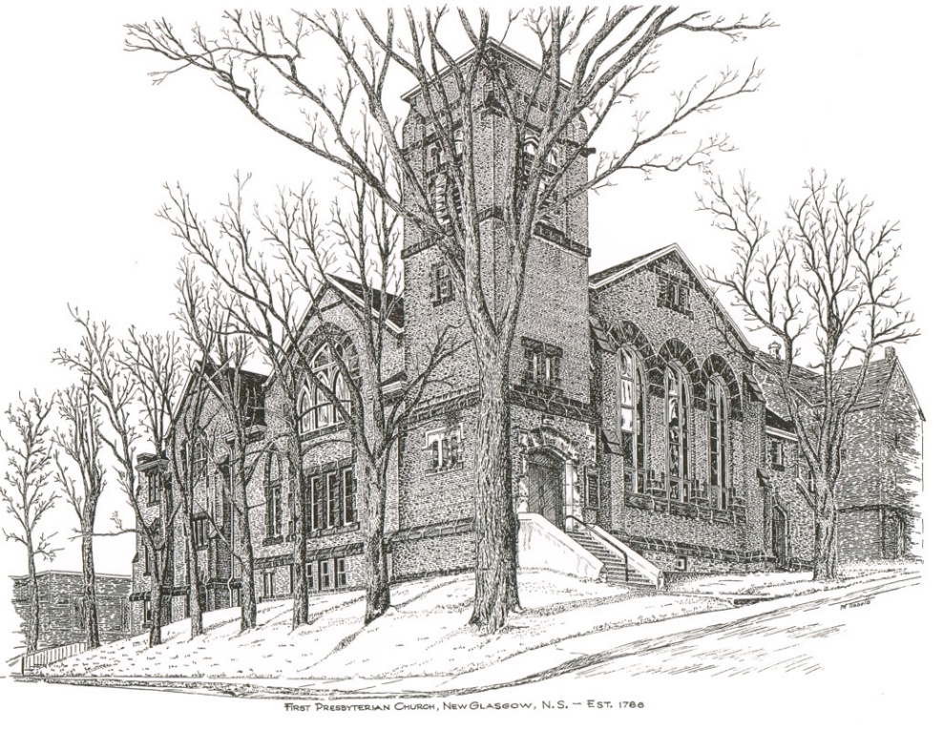

FIRST PRESBYTERIAN CHURCH
208 MacLean St., New Glasgow, NS
902-752-5691
First.church@ns.aliantzinc.ca
Reverend Andrew MacDonald
902-331-0322
yick96@hotmail.com

February 12th, 2023
Sixth Sunday after Epiphany

THE APPROACH

Musical Prelude
Welcome and Announcements
Lighting the Christ Candle: (Please rise if you are able)
One: You are the light of the world. A city built on a hill cannot be hidden. No one after lighting a lamp puts it under the bushel basket, but on the lampstand, and it gives light to all in the house. In the same way, let your light shine before others, so that they may see your good works and give glory to your Father in heaven.
ALL: O Come Lord, and light our path, show us Your way!
(Light the candle)
One: Let us now prepare our hearts to worship almighty God.
Musical Introit - #27 "As the Deer" vs 1
Call to Worship
Hymn #496 – “Thy Word is a lamp unto my feet”
Prayer of Adoration, Confession and Lord’s Prayer

Our Father which art in heaven, hallowed be thy name.

Thy kingdom come, thy will be done in earth,

as it is in heaven.

Give us this day our daily bread.

And forgive us our debts, as we forgive our debtors.

And lead us not into temptation, but deliver us from evil:

For thine is the kingdom, and the power, and the glory,

forever. Amen.
Assurance of Pardon
Passing the Peace
Hymn “O How I Love Jesus” – Angela Cromwell
Children’s Time
Prayer of Illumination
First Lesson: Deuteronomy 30:15-20
Epistle Lesson: 1 Corinthians 3:1-9
Gloria Patri

Glory be to the Father, and to the Son, and to the Holy Ghost. As it was in the beginning, is now and ever shall be, world without end. Amen, amen.

Gospel Reading: Matthew 5:21-37

Anthem: “His Eye Is On The Sparrow” Angela Cromwell
Sermon: “Are you ready for solid food?”
Reaffirmation of Faith – Apostles’ Creed – Please rise

I believe in God, the Father Almighty, maker of Heaven and earth; and in Jesus Christ, His only Son, Our Lord, who was conceived by the Holy Ghost, born of the Virgin Mary,
suffered under Pontius Pilate, was crucified, died, and was buried. He descended into Hell. On the third day He arose again from the dead; He ascended into Heaven, and sits
at the right hand of God, the Father Almighty; from thence He shall come to judge the quick and the dead.
I believe in the Holy Ghost, the holy Catholic Church,
the communion of saints, the forgiveness of sins, the resurrection of the body, and the life everlasting. Amen.

Hymn: #626 - “Lord of all power”
Offertory Prayer

Prayers of the People

Hymn: #763 - “To show by touch and word”

Benediction

Coral Response: Threefold Amen

Recessional

ANNOUNCEMENTS

All are welcome at First Presbyterian Church. We hope you experience the love of God and of this congregation as we worship, celebrate, and serve one another.

Our condolences are extended to Marsha Sutton and her family on the loss of her uncle, Norman MacLeod, a long-time member of First Presbyterian.

UPCOMING EVENTS

Today – 12:15 – Session will meet after church.
Sun., Feb. 19th – Coffee hour will be hosted by Brent and Sara. Please plan to join us for a time of fellowship.
Annual Meeting - To be re-scheduled; date to be announced.
We send birthday wishes to Marion MacNeil and Bill MacDonald who celebrate their birthdays February 14th and to Lee Searle as she celebrates her birthday February 15th. Happy Birthday!
PAR
Pre-Authorized Remittance (PAR), is a convenient option for making regular, uninterrupted donations to the church, ensuring your donations continue when you are away or when the church is closed. Forms are available on Sundays or through the office. If you are interested and have any questions, contact the office for more information.
SCRIPTURE READERS & USHERS
Guest soloist this morning: Angela Cromwell
Scripture reader: Clarice Campbell
Ushers: Brenda and John Zinck
Early Christian Educators: Lynne Ann and Lois MacLellan

* * * * * * * * * * * * *
Minister: Rev. Andrew MacDonald (c) 902-331-0322
Organist: Clare Grieves
Office hours: Tues. to Fri. – 10 -1pm
Rev. MacDonald office hours -Tues. to Thurs. 10-2 or by appointment

Mission Statement: But he’s already made it plain how to live, what to do, what God is looking for in men and women. It’s quite simple. Do what is fair and just to your neighbor, be compassionate and loyal in your love, and don’t take yourself too seriously – take God seriously. Micah 6: 8-The Message

