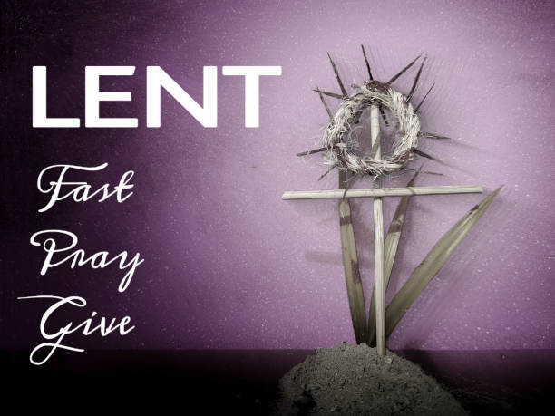

March 12th, 2023
3rd Sunday In Lent

THE APPROACH

Musical Prelude
Welcome and Announcements
Lighting the Christ Candle: (Please rise if you are able)
One: The people who walked in darkness have seen a great light;
those who lived in a land of deep darkness—on them light has shined. You have multiplied the nation, you have increased its joy;
they rejoice before you as with joy at the harvest.
ALL: Your word is a lamp to my feet and a light to my path!
(Light the candle)
One: Let us now prepare our hearts to worship almighty God.
Musical Introit - “Jesus, remember me”
Call to Worship
Hymn #671 – “I heard the voice of Jesus say”

1 I heard the voice of Jesus say,
Come unto me and rest;
lay down, thou weary one, lay down
they head upon my breast!
I came to Jesus as I was,
weary and worn and sad;
I found in him a resting place,
and he has made me glad.

2 I heard the voice of Jesus say,
Behold, I freely give
the living water; thirsty one,
stoop down, and drink and live!
I came to Jesus, and I drank
of that life-giving stream;
my thirst was quenched,
my soul revived
and now I live in him.

3 I heard the voice of Jesus say,
I am this dark world’s light;
look unto me, thy morn shall rise,
and all thy day be bright.
I looked to Jesus, and I found
in him my star, my sun,
and in that light of life I’ll walk
till traveling days are done.

Prayer of Adoration, Confession and Lord’s Prayer

Our Father which art in heaven, hallowed be thy name.

Thy kingdom come, thy will be done in earth,

as it is in heaven.

Give us this day our daily bread.

And forgive us our debts, as we forgive our debtors.

And lead us not into temptation, but deliver us from evil:

For thine is the kingdom, and the power, and the glory,

forever. Amen.
Assurance of Pardon
Passing the Peace
Hymn #378 – “Jesus, Jesus, Jesus in the morning” vs. 1,2,4,5
1 Jesus, Jesus, Jesus in the morning,
Jesus in the noontime,
Jesus, Jesus, Jesus when the sun goes down!

2 Love him . . .
4 Thank him . . .
5 Praise him . . .
Children’s Time
Prayer of Illumination
First Lesson: Exodus 17:1-7
Epistle Lesson: Romans 5:1-11
Lenten Insert
Gloria Patri

Glory be to the Father, and to the Son, and to the Holy Ghost. As it was in the beginning, is now and ever shall be, world without end. Amen, amen.

Gospel Reading: John 4:5-42
Anthem: “Who’s goin’ to tell the story” - Natalie Sleeth
Sermon: “Justified by Faith Alone”
Reaffirmation of Faith – Apostles’ Creed – Please rise

I believe in God, the Father Almighty, maker of Heaven and earth; and in Jesus Christ, His only Son, Our Lord, who was conceived by the Holy Ghost, born of the Virgin Mary,
suffered under Pontius Pilate, was crucified, died, and was buried. He descended into Hell. On the third day He arose again from the dead; He ascended into Heaven, and sits
at the right hand of God, the Father Almighty; from thence He shall come to judge the quick and the dead.
I believe in the Holy Ghost, the holy Catholic Church,
the communion of saints, the forgiveness of sins, the resurrection of the body, and the life everlasting. Amen.

Hymn #190 – “You thirsty ones” vs. 1,3,4,5

1. You thirsty ones! Come to the spring!
Have you no money? Come,
buy wine and milk! Come, buy and eat
without a price or sum.

3. This food delights and satisfies,
the food your God can give;
incline your ear and come to me;
oh hear that you may live.

4. Return while God may still be found
and call while God will hear;
now let the wicked quit their ways,
while yet the Lord is near.

5. My word like heaven’s snow descends:
it falls like heaven’s rain;
it waters all the thirsty earth
and shall not go in vain.

Offertory Prayer

Prayers of the People

Hymn #193 – “Out of my bondage, sorrow and night” vs. 1,3,4

1 Out of my bondage, sorrow and night,
Jesus, I come; Jesus, I come;
into thy freedom, gladness and light,
Jesus, I come to thee;
out of my sickness into thy health,
out of my want and into thy wealth,
out of my sin and into thyself,
Jesus, I come to thee.

3 Out of unrest and arrogant pride,
Jesus, I come; Jesus, I come;
into thy blessed will to abide,
Jesus, I come to thee;
out of myself to dwell in thy love,
out of despair into raptures above,
upward for aye on wings like a dove,
Jesus, I come to thee.

4 Out of the fear and dread of the tomb,
Jesus, I come; Jesus, I come;
into the joy and light of thy home,
Jesus, I come to thee;
out of the depths of ruin untold,
into the peace of thy sheltering fold,
ever thy glorious face to behold,
Jesus, I come to thee.

Benediction

Coral Response: Threefold Amen

Recessional

ANNOUNCEMENTS

All are welcome at First Presbyterian Church. We hope you experience the love of God and of this congregation as we worship, celebrate, and serve one another.
UPCOMING EVENTS

Today – 12:15 p.m. – Session will meet after service.

Mar. 19th - The Annual Meeting has been re-scheduled for Mar. 19th following the morning service. Light lunch will be provided.
DOORS NOW OPEN! - The James St. door and the stairs at the main entrance on MacLean St. are now accessible for those wishing to enter the church at those locations.

BEST WISHES!!
Birthday wishes are extended to Marie Withers and Marion Hayden. Happy Birthday ladies!
We also extend congratulations to Sandy and Marion MacIntosh as they celebrate their 60th wedding anniversary, Wednesday, March 15th. Congratulations Sandy and Marion!
Monthly coffee time – As we resume some of our regular activities, we will once again host coffee hour the third Sunday of the month. The next date will be Sun., Mar. 19th. For anyone who would like to host, please contact Cathy Lewis at 902-759-9649. If you need help setting up the coffee maker or have any questions, contact Cathy.
SCRIPTURE READERS & USHERS
Scripture reader: Kevin Reid
Ushers: Sherry Green and Phillip Blackwood
Early Christian Educators: Lynne Ann and Lois MacLellan

Minister: Rev. Andrew MacDonald (c) 902-331-0322
Organist: Clare Grieves
Office hours: Tues. to Fri. – 10 -1pm
Rev. MacDonald office hours -Tues. to Thurs. 10-2 or by appointment

Mission Statement: But he’s already made it plain how to live, what to do, what God is looking for in men and women. It’s quite simple. Do what is fair and just to your neighbor, be compassionate and loyal in your love, and don’t take yourself too seriously – take God seriously. Micah 6: 8-The Message

