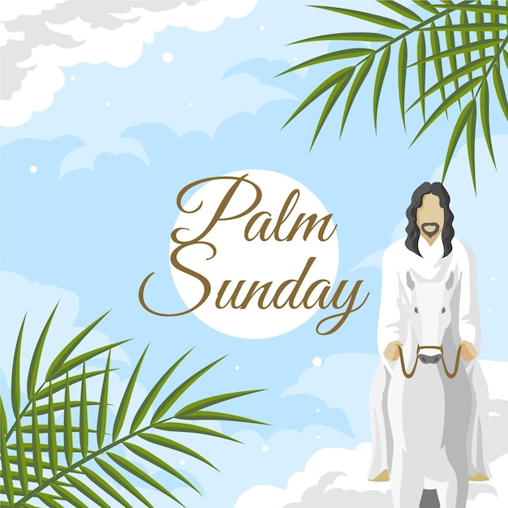

FIRST PRESBYTERIAN CHURCH
208 MacLean St., New Glasgow, NS
902-752-5691
First.church@ns.aliantzinc.ca
Reverend Andrew MacDonald
902-331-0322
yick96@hotmail.com

April 2nd, 2023
Palm Sunday
THE APPROACH
Musical Prelude
Welcome and Announcements
Lighting the Christ Candle: (Please rise if you are able)
One: Jesus Said: ‘Those who walk during the day do not stumble, because they see the light of this world. But those who walk at night stumble, because the light is not in them.’
ALL: Lord, keep my lamp burning; my God turns my darkness into light!
(Light the candle)
One: Let us now prepare our hearts to worship almighty God.
Musical Introit - #216 - “Hosanna”
Call to Worship
Hymn #214 – “All Glory, laud and honour”
Prayer of Adoration, Confession and Lord’s Prayer
Assurance of Pardon
Passing the Peace
Hymn #78 – “This is the day”
Children’s Time & Passing of the Palm Crosses
Prayer of Illumination
First Lesson: Isaiah 50:4-9
Epistle Lesson: Philippians 2:5-11
Palm Sunday Responsive Insert
Gloria Patri
Gospel Reading: Matthew 21:1-11
Anthem: “Filled With Excitement”
Sermon: “The White Hats Will Win!”
Reaffirmation of Faith – Apostles’ Creed – Please rise

Hymn #643 – “Lift high the cross”

Offertory Prayer

Prayers of the People: The People Respond
Leader: Lord in Your mercy,
All: Hear Our Prayer.

Hymn #218 – “Hosanna, loud Hosanna”

Benediction

Coral Response: Threefold Amen

Recessional

* * * * * * * * * * * * *
Minister: Rev. Andrew MacDonald (c) 902-331-0322
Organist: Clare Grieves
Office hours: Tues. to Fri. – 10 -1pm
Rev. MacDonald office hours -Tues. to Thurs. 10-2 or by appointment

Mission Statement: But he’s already made it plain how to live, what to do, what God is looking for in men and women. It’s quite simple. Do what is fair and just to your neighbor, be compassionate and loyal in your love, and don’t take yourself too seriously – take God seriously. Micah 6: 8-The Message

Apostles Creed

I believe in God, the Father Almighty, maker of Heaven and earth; and in Jesus Christ, His only Son, Our Lord, who was conceived by the Holy Ghost, born of the Virgin Mary,
suffered under Pontius Pilate, was crucified, died, and was buried. He descended into Hell. On the third day He arose again from the dead; He ascended into Heaven, and sits
at the right hand of God, the Father Almighty; from thence He shall come to judge the quick and the dead.
I believe in the Holy Ghost, the holy Catholic Church,
the communion of saints, the forgiveness of sins, the resurrection of the body, and the life everlasting. Amen.

The Lord’s Prayer

Our Father which art in heaven, hallowed be thy name.

Thy kingdom come, thy will be done in earth,

as it is in heaven.

Give us this day our daily bread.

And forgive us our debts, as we forgive our debtors.

And lead us not into temptation, but deliver us from evil:

For thine is the kingdom, and the power, and the glory,

forever. Amen.

Gloria Patri

Glory be to the Father, and to the Son, and to the Holy Ghost. As it was in the beginning, is now and ever shall be, world without end. Amen, amen.

ANNOUNCEMENTS

All are welcome at First Presbyterian Church. We hope you experience the love of God and of this congregation as we worship, celebrate, and serve one another.

UPCOMING EVENTS

Mon., Apr. 3rd – 6:30 p.m. – Board of Managers will meet.
Tues., Apr. 11th – 6:30 p.m. – Session will meet.

Holy Week Services:
- Maundy Thursday – 7 p.m. – Agape Feast in the Upper Hall
- Good Friday – 11:00 a.m. – St. Andrew’s “The Kirk”
- Easter Sunrise Service – 9a.m. – Laurie Park (weather permitting, otherwise the Sunrise Service will be in the Upper Hall)
- Easter Sunday Service – 11:00 a.m. – we will celebrate Holy Communion
Fri., Apr. 7th and Sat., Apr. 8th - We will be preparing the Sanctuary for Easter Sunday and are requesting donations of potted Easter lilies, perhaps in memory of or in honor of a loved one. The plants can be dropped off at the church on or before the 7th and 8th. (The office is open 10a.m. to 1p.m. Tues. to Fri.) If you would like to donate but need someone to pick up your plant, please contact Sharon Mason (902-752-0724) or Ruth Anne MacIntosh (902-752-8151). You can take your lily home after the Easter Sunday service or leave it in the sanctuary where it will be donated to someone home bound or in a nursing home.
Fri., Apr. 14 - Middle River Presbyterian Church, 59 E. Fraser Crossroad, Rocklin, is having a takeout dinner (Shepherd’s Pie). Price - $12.00, pick up between 3-4 pm. Orders must be placed on or before Apr. 6th. Contact Mary Chesnutt, 902-396-3798.
The Library is looking for volunteers to deliver and retrieve books for the residents at Highcrest Home (formerly Sunset Haven). A minor commitment is required. Books are picked up at the library at 1 p.m., dropped off at Highcrest Home at a table by the front door. If there are books to be returned, they will be found on the table to be delivered back to the library. Volunteer(s) are required for the following dates: Apr. 6, May 4, June 1, June 29, July 27, Aug. 24, Sept. 21, Oct. 19, Nov. 16 and Dec. 14. If you are interested, please contact Samantha Zuberovic at the Library, 902-755-6031.
Monthly coffee time – As we resume some of our regular activities, we will once again host coffee hour the third Sunday of the month. Next coffee date is April 16th. For anyone who would like to host, please contact Cathy Lewis at 902-759-9649. If you need help setting up the coffee maker or have any questions, contact Cathy.
SCRIPTURE READERS & USHERS
Scripture reader: Clarice Campbell
Ushers: Main Door (by office) – Jackie and Gary Ross
James St. – Ruth Anne MacIntosh
MacLean St. (steps) – Sandra Arthur and Ian Semple
Early Christian Educators: Lynne Ann and Lois MacLellan

