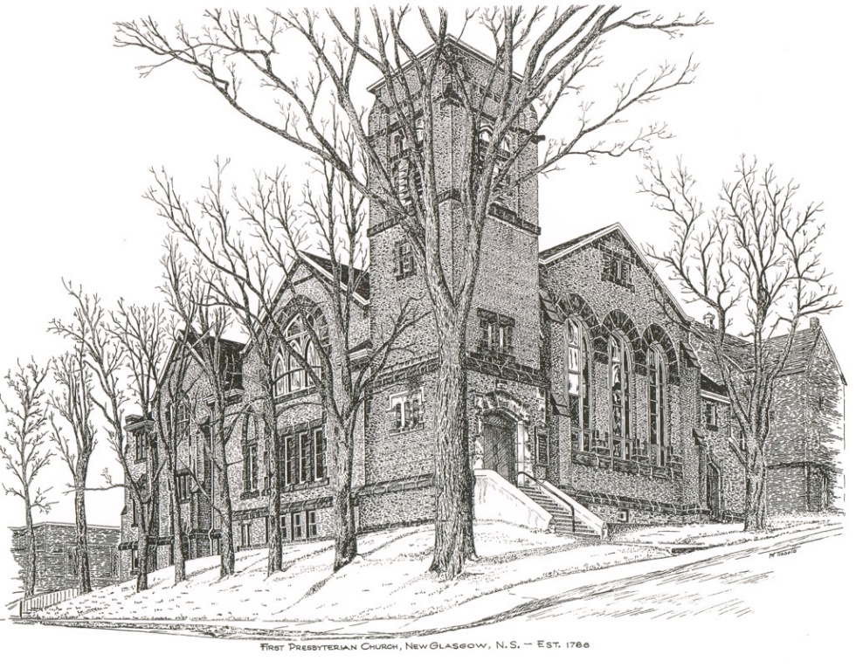

FIRST PRESBYTERIAN CHURCH
208 MacLean St., New Glasgow, NS
902-752-5691
First.church@ns.aliantzinc.ca
Reverend Andrew MacDonald
902-331-0322
yick96@hotmail.com

April 16th, 2023
2nd Sunday of Easter
THE APPROACH
Musical Prelude
Welcome and Announcements
Lighting the Christ Candle: (Please rise if you are able)
One: In the beginning when God created the heavens and the earth, the earth was a formless void and darkness covered the face of the deep, while a wind from God swept over the face of the waters. Then God said, ‘Let there be light’; and there was light. And God saw that the light was good.
ALL: Jesus Christ is the light that shines in our life, and no darkness shall overcome it. Not even the darkness of the tomb.
(Light the candle)
One: Let us now prepare our hearts to worship almighty God.
Musical Introit -#250 - “Lord of the Dance” vs 1
Call to Worship
Hymn #257 – “The strife is o’er, the battle done”
Prayer of Adoration, Confession and Lord’s Prayer
Assurance of Pardon
Passing the Peace
Solo – Shaun McLean – “He touched me” (William Gaither)
Children’s Time
Prayer of Illumination
First Lesson: Acts 2:14a,22-32
Epistle Lesson: 1 Peter 1:3-9
Responsive Psalm Insert
Gloria Patri
Gospel Reading: John 20:19-31
Anthem: “Turn your eye upon Jesus” - Shaun McLean
Sermon: “Blessed are you who have not seen yet still believe!”
Reaffirmation of Faith – Apostles’ Creed – Please rise

Hymn #256 – “Now the green blade rises”

Offertory Prayer

Prayers of the People

Hymn #410 – “Joyful, joyful we adore you”

Benediction

Coral Response: Threefold Amen

Recessional

* * * * * * * * * * * * *
Minister: Rev. Andrew MacDonald (c) 902-331-0322
Organist: Clare Grieves
Office hours: Tues. to Fri. – 10 -1pm
Rev. MacDonald office hours -Tues. to Thurs. 10-2 or by appointment

Mission Statement: But he’s already made it plain how to live, what to do, what God is looking for in men and women. It’s quite simple. Do what is fair and just to your neighbor, be compassionate and loyal in your love, and don’t take yourself too seriously – take God seriously. Micah 6: 8-The Message

Apostles Creed

I believe in God, the Father Almighty, maker of Heaven and earth; and in Jesus Christ, His only Son, Our Lord, who was conceived by the Holy Ghost, born of the Virgin Mary,
suffered under Pontius Pilate, was crucified, died, and was buried. He descended into Hell. On the third day He arose again from the dead; He ascended into Heaven, and sits
at the right hand of God, the Father Almighty; from thence He shall come to judge the quick and the dead.
I believe in the Holy Ghost, the holy Catholic Church,
the communion of saints, the forgiveness of sins, the resurrection of the body, and the life everlasting. Amen.

The Lord’s Prayer

Our Father which art in heaven, hallowed be thy name.

Thy kingdom come, thy will be done in earth,

as it is in heaven.

Give us this day our daily bread.

And forgive us our debts, as we forgive our debtors.

And lead us not into temptation, but deliver us from evil:

For thine is the kingdom, and the power, and the glory,

forever. Amen.

Gloria Patri

Glory be to the Father, and to the Son, and to the Holy Ghost. As it was in the beginning, is now and ever shall be, world without end. Amen, amen.

ANNOUNCEMENTS

All are welcome at First Presbyterian Church. We hope you experience the love of God and of this congregation as we worship, celebrate, and serve one another.

An In Memorium donation has been received in loving memory of Pamela (Smith) Flanagan from Betty Smith and family.

UPCOMING EVENTS

Sat., Apr. 29 at 10a.m. – Workday at Camp Geddie - It's that time of year again! The Property Committee is preparing for another camping season of fun, learning and Christian education for the youth of our communities. Following Fiona, there is lots to do to make this another memorable summer for staff and campers. Cleaning and repairing cabins, painting the nurse's cabin, cleaning brush, setting up the chapels etc. We need your help! Please bring your tools, a lunch and lots of energy and enthusiasm! If you need more information, please feel free to contact Christina MacDonald - 902-485-4011.

Sun., Apr. 30th – 2:00 p.m. – We are hosting our second Bi-annual Memorial Hymn Sing. Details have been distributed via email, delivery by Elders and regular mail. Copies are also available in the sanctuary this morning. If you have any questions, feel free to contact Rev. Andrew or the office.

Sun., May 7 - 7:00 p.m. - St. Andrews Presbyterian Church, Westville presents “An Enjoyable Evening of Music”. Featuring a variety of talent including choirs and brass followed by a social time. Free will offering. Everyone welcome!

Sun., June 11th, 2:30p.m. – “Save the Date” - The Trinitarians and Guests are hosting “A Spring Choral Concert” at Trinity United.

Thank you to everyone who donated lilies or money to purchase lilies for the Sanctuary for Easter Sunday service. Donations are from and in loving memory of:

- Kevin Reid – In memory of his parents Charles “Charlie” and Shirley Reid.
- Ron and Sharon Mason – In memory of their parents Lloyd and Joyce Mason and Bill and Betty Wilson.
- Shirley MacDonald – In memory of Kenny MacDonald
- John and Brenda Zinck – In memory of loved ones.
- Marion MacNeil and family – In memory of Dan and Lottie Fraser.

Celebrating birthdays this week:
- Apr. 10th – Ralph Holmes
- Apr. 11th – Marg Fraser
- Apr. 13th – Jim Battist
- Apr. 16th (today) – Larry Ingham

Monthly coffee time today – Please join us for coffee after service today. For anyone who would like to host, please contact Cathy Lewis at 902-759-9649. If you need help setting up the coffee maker or have any questions, contact Cathy.

SCRIPTURE READERS & USHERS
Scripture reader: Kevin Reid
Guest soloist: Shaun McLean
Ushers: Main Door (Office Entry) – Sandra Arthur and Ian Semple
James St. – Ruth-Anne MacIntosh
MacLean St. (Main Entrance steps)-Jackie and Gary Ross
Early Christian Educators: Lynne Ann and Lois MacLellan

Responsive Psalm
Psalm 16

ONE: Protect me, O God, for in you I take refuge.
ALL: I say to the Lord, ‘You are my Lord; I have no good apart from you.’
ONE: As for the holy ones in the land, they are the noble, in whom is all my delight.
ALL: Those who choose another god multiply their sorrows; their drink-offerings of blood I will not pour out or take their names upon my lips.
ONE: The Lord is my chosen portion and my cup; you hold my lot.
ALL: The boundary lines have fallen for me in pleasant places; I have a goodly heritage.
ONE: I bless the Lord who gives me counsel; in the night also my heart instructs me.
ALL: I keep the Lord always before me; because he is at my right hand, I shall not be moved.
ONE: Therefore my heart is glad, and my soul rejoices; my body also rests secure.
ALL: For you do not give me up to Sheol, or let your faithful one see the Pit.
ONE: You show me the path of life.

ALL: In your presence there is fullness of joy; in your right hand are pleasures for evermore.

