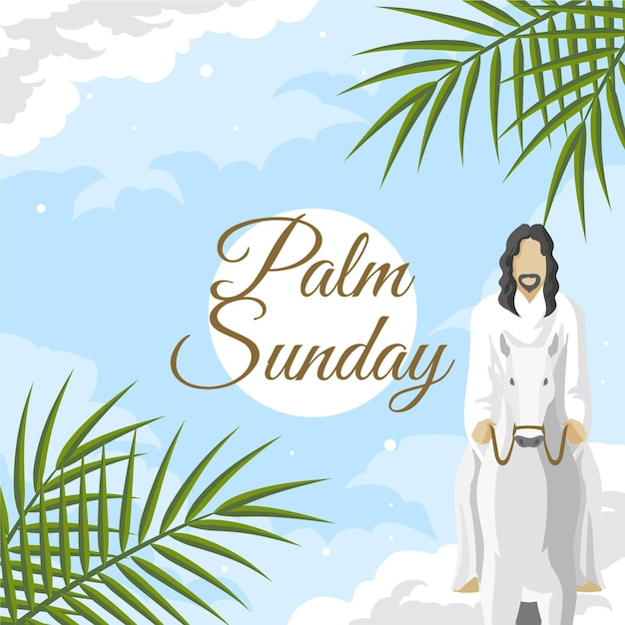

FIRST PRESBYTERIAN CHURCH
208 MacLean St., New Glasgow, NS
902-752-5691
First.church@ns.aliantzinc.ca
Reverend Andrew MacDonald
902-331-0322
yick96@hotmail.com

April 2nd, 2023
Palm Sunday
THE APPROACH
Musical Prelude
Welcome and Announcements
Lighting the Christ Candle: (Please rise if you are able)
One: Jesus Said: ‘Those who walk during the day do not stumble, because they see the light of this world. But those who walk at night stumble, because the light is not in them.’
ALL: Lord, keep my lamp burning; my God turns my darkness into light!
(Light the candle)
One: Let us now prepare our hearts to worship almighty God.
Musical Introit - #216 - “Hosanna”
Call to Worship
Hymn #214 – “All Glory, laud and honour”
Chorus: All glory, laud and honour
to thee, Redeemer, King,
to whom the lips of children
made sweet hosannas ring!

1. Thou art the King of Israel,
thou David’s royal son,
who in the Lord’s name comest,
the King and blessed one.

2 The people of the Hebrews
with palms before thee went;
our praise and prayer and anthems
before thee we present.

3 To thee before thy passion
they sang their hymns of praise;
to thee, now high exalted,
our melody we raise.

4 Thou didst accept their praises;
accept the prayers we bring,
who in all good delightest,
thou good and gracious King.

Prayer of Adoration, Confession and Lord’s Prayer

Our Father which art in heaven, hallowed be thy name.

Thy kingdom come, thy will be done in earth,

as it is in heaven.

Give us this day our daily bread.

And forgive us our debts, as we forgive our debtors.

And lead us not into temptation, but deliver us from evil:

For thine is the kingdom, and the power, and the glory,

forever. Amen.

Assurance of Pardon
Passing the Peace
Hymn #78 – “This is the day”
- This is the day,
this is the day that the Lord has made,
that the Lord has made.
We will rejoice, we will rejoice and be glad in it,
and be glad in it.
This is the day that the Lord has made;
we will rejoice and be glad in it.
This is the day, this is the day that the Lord has made.

- Open to us,
open to us the gates of God,
the gates of God;
we will go in, we will go in and praise the Lord,
and praise the Lord.
Open to us the gates of God;
we will go in and praise the Lord.
Open to us, open to us the gates of God.

- You are our God,
you are our God; we will praise your name,
we will praise your name;
we will give thanks, we will give thanks for your faithfulness,
for your faithfulness.
You are our God; we will praise your name;
we will give thanks for your faithfulness,
You are our God, you are our God; we will praise your name.

Children’s Time & Passing of the Palm Crosses
Prayer of Illumination
First Lesson: Isaiah 50:4-9
Epistle Lesson: Philippians 2:5-11
Palm Sunday Responsive Insert
Gloria Patri

Glory be to the Father, and to the Son, and to the Holy Ghost. As it was in the beginning, is now and ever shall be, world without end. Amen, amen.

Gospel Reading: Matthew 21:1-11
Anthem: “Filled With Excitement”
Sermon: “The White Hats Will Win!”
Reaffirmation of Faith – Apostles’ Creed – Please rise

I believe in God, the Father Almighty, maker of Heaven and earth; and in Jesus Christ, His only Son, Our Lord, who was conceived by the Holy Ghost, born of the Virgin Mary,
suffered under Pontius Pilate, was crucified, died, and was buried. He descended into Hell. On the third day He arose again from the dead; He ascended into Heaven, and sits
at the right hand of God, the Father Almighty; from thence He shall come to judge the quick and the dead.
I believe in the Holy Ghost, the holy Catholic Church,
the communion of saints, the forgiveness of sins, the resurrection of the body, and the life everlasting. Amen.

Hymn #643 – “Lift high the cross”

Refrain:
Lift high the cross, the cross of Christ proclaim
till all the world adore his sacred name.

1 Come, Christians, follow where the Master trod,
our King victorious, Christ the Son of God.

2 Led on their way by this triumphant sign,
the hosts of God in conquering ranks combine.

3 Each newborn servant of the Crucified
bears on the brow the seal of him who died.

4 O Lord, once lifted on the glorious tree,
your death has bought us life eternally.

5 So shall our song of triumph ever be:
praise to the Crucified for victory!

Offertory Prayer

Prayers of the People: The People Respond
Leader: Lord in Your mercy,
All: Hear Our Prayer.

Hymn #218 – “Hosanna, loud Hosanna”

1 Hosanna, loud hosanna,
the little children sang;
through pillared court and temple
the joyful anthem rang.
To Jesus, who had held them
close folded to his breast,
the children sang their praises,
the simplest and the best.

2 From Olivet they followed
amid the shouting crowd,
the victor palm branch waving
the chanting clear and loud;
Messiah, God’s anointed,
rode there in humble state,
Hosanna in the highest!”
rang out their praises great.

3 Hosanna in the highest!”
that ancient song we sing,
for Christ is our Redeemer,
the Lord of heaven our King.
Oh may we ever praise him
with heart and life and voice,
and in God’s joyful presence
eternally rejoice!

Benediction

Coral Response: Threefold Amen

Recessional

ANNOUNCEMENTS

All are welcome at First Presbyterian Church. We hope you experience the love of God and of this congregation as we worship, celebrate, and serve one another.

UPCOMING EVENTS

Mon., Apr. 3rd – 6:30 p.m. – Board of Managers will meet.
Tues., Apr. 11th – 6:30 p.m. – Session will meet.

Holy Week Services:
- Maundy Thursday – 7 p.m. – Agape Feast in the Upper Hall
- Good Friday – 11:00 a.m. – St. Andrew’s “The Kirk”
- Easter Sunrise Service – 9a.m. – Laurie Park (weather permitting, otherwise the Sunrise Service will be in the Upper Hall)
- Easter Sunday Service – 11:00 a.m. – we will celebrate Holy Communion
Fri., Apr. 7th and Sat., Apr. 8th - We will be preparing the Sanctuary for Easter Sunday and are requesting donations of potted Easter lilies, perhaps in memory of or in honor of a loved one. The plants can be dropped off at the church on or before the 7th and 8th. (The office is open 10a.m. to 1p.m. Tues. to Fri.) If you would like to donate but need someone to pick up your plant, please contact Sharon Mason (902-752-0724) or Ruth Anne MacIntosh (902-752-8151). You can take your lily home after the Easter Sunday service or leave it in the sanctuary where it will be donated to someone home bound or in a nursing home.
Fri., Apr. 14 - Middle River Presbyterian Church, 59 E. Fraser Crossroad, Rocklin, is having a takeout dinner (Shepherd’s Pie). Price - $12.00, pick up between 3-4 pm. Orders must be placed on or before Apr. 6th. Contact Mary Chesnutt, 902-396-3798.
The Library is looking for volunteers to deliver and retrieve books for the residents at Highcrest Home (formerly Sunset Haven). A minor commitment is required. Books are picked up at the library at 1 p.m., dropped off at Highcrest Home at a table by the front door. If there are books to be returned, they will be found on the table to be delivered back to the library. Volunteer(s) are required for the following dates: Apr. 6, May 4, June 1, June 29, July 27, Aug. 24, Sept. 21, Oct. 19, Nov. 16 and Dec. 14. If you are interested, please contact Samantha Zuberovic at the Library, 902-755-6031.
Monthly coffee time – As we resume some of our regular activities, we will once again host coffee hour the third Sunday of the month. Next coffee date is April 16th. For anyone who would like to host, please contact Cathy Lewis at 902-759-9649. If you need help setting up the coffee maker or have any questions, contact Cathy.
SCRIPTURE READERS & USHERS
Scripture reader: Clarice Campbell
Ushers: Main Door (by office) – Jackie and Gary Ross
James St. – Ruth Anne MacIntosh
MacLean St. (steps) – Sandra Arthur and Ian Semple
Early Christian Educators: Lynne Ann and Lois MacLellan

* * * * * * * * * * * * *
Minister: Rev. Andrew MacDonald (c) 902-331-0322
Organist: Clare Grieves
Office hours: Tues. to Fri. – 10 -1pm
Rev. MacDonald office hours -Tues. to Thurs. 10-2 or by appointment

Mission Statement: But he’s already made it plain how to live, what to do, what God is looking for in men and women. It’s quite simple. Do what is fair and just to your neighbor, be compassionate and loyal in your love, and don’t take yourself too seriously – take God seriously. Micah 6: 8-The Message

