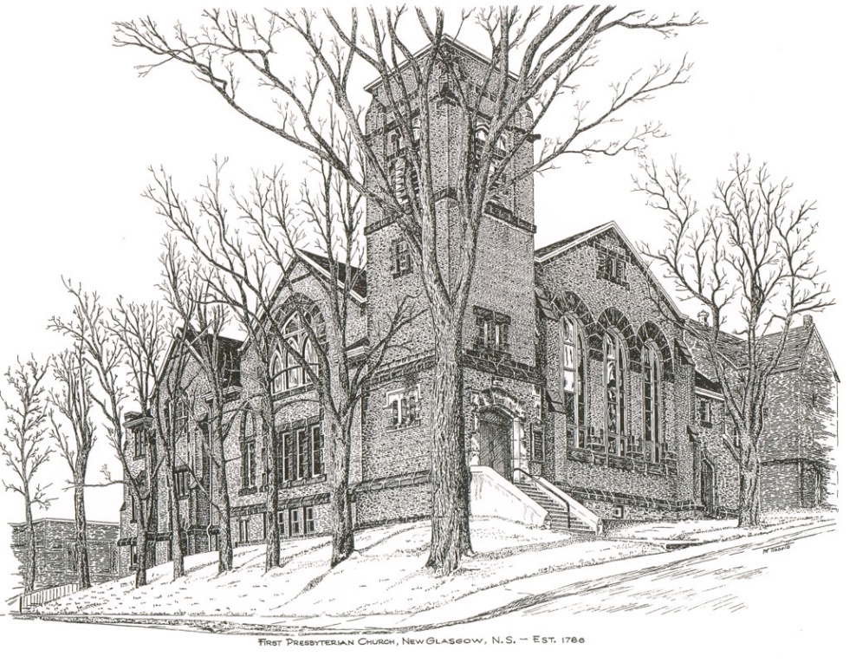

FIRST PRESBYTERIAN CHURCH
208 MacLean St., New Glasgow, NS
902-752-5691
First.church@ns.aliantzinc.ca
Reverend Andrew MacDonald
902-331-0322
yick96@hotmail.com

April 23rd, 2023
3rd Sunday of Easter
THE APPROACH

Musical Prelude
Welcome and Announcements
Lighting the Christ Candle: (Please rise if you are able)
One: Father in heaven, the light of Jesus has dispersed the darkness of hatred and sin. Let the light of your truth guide us to your kingdom. Inflame our hearts with your grace, keep us in the radiance of your truth, fill our lives with your divine love.
ALL: Jesus Christ is the light that shines in our life, and no darkness shall overcome it. Not even the darkness of the tomb.
(Light the candle)
One: Let us now prepare our hearts to worship almighty God.
Musical Introit - # 445 - “Open our eyes, Lord”
Call to Worship
Hymn #530 – “I come with joy” vs.1,2,4,5
- I come with joy, a child of God,
forgiven, loved and free,
the life of Jesus to recall,
in love laid down for me,
in love laid down for me.

- I come with Christians far and near,
to find, as all are fed,
the new community of love
in Christ’s communion bread,
in Christ’s communion bread.

4. The Spirit of the risen Christ.
unseen, but ever near,
it is such friendship better known,
alive among us here,
alive among us here.

5.Together met, together bound
by all that God has done,
we’ll go with joy, to give the world
the love that makes us one,
the love that makes us one.

Prayer of Adoration, Confession and Lord’s Prayer

Our Father which art in heaven, hallowed be thy name.

Thy kingdom come, thy will be done in earth,

as it is in heaven.

Give us this day our daily bread.

And forgive us our debts, as we forgive our debtors.

And lead us not into temptation, but deliver us from evil:

For thine is the kingdom, and the power, and the glory,

forever. Amen.

Assurance of Pardon
Passing the Peace
Hymn #250 – “Lord of the dance” vs.1-4
1 I danced in the morning
when the world was begun,
and I danced in the moon
and the stars and the sun,
and I came down from heaven
and I danced on the earth;
at Bethlehem I had my birth.

Chorus Dance, then, wherever you may be;
I am the Lord of the Dance, said he,
and I’ll lead you all, wherever you may be,
and I’ll lead you all in the dance, said he.

2 I dance for the scribe and the Pharisee,
but they would not dance
and they wouldn’t follow me;
I danced for the fishermen,
for James and John;
they came with me, and the dance went on.

3 I danced on the Sabbath and I cured the lame;
the holy people said it was a shame.
They whipped and they stripped
and they hung me high,
and they left me there on the cross to die.

4 I danced on a Friday when the sky turned black;
it’s hard to dance with the devil on your back.
They buried my body, and they thought I’d gone,
but I am the dance, and I still go on.
Children’s Time
Prayer of Illumination
First Lesson: Acts 2:14a,36-41
Epistle Lesson: 1 Peter 1:17-23
Responsive Pslam Insert
Gloria Patri

Glory be to the Father, and to the Son, and to the Holy Ghost. As it was in the beginning, is now and ever shall be, world without end. Amen, amen.

Gospel Reading: Luke 24:13-35
Anthem: “Upon this rock” (J. Althouse)
Sermon: “Breaking the Bread!”
Reaffirmation of Faith – Apostles’ Creed – Please rise

Hymn #635 – “Brother, sister, let me serve you” vs. 2-5

2 We are pilgrims on a journey,
and companions on the road;
we are here to help each other
walk the mile and bear the load.

3 I will hold the Christ-light for you
in the night-time of your fear;
I will hold my hand out to you,
speak the peace you long to hear.

4 I will weep when you are weeping;
when you laugh I’ll laugh with you;
I will share your joy and sorrow,
till we’ve seen this journey through.

5 When we sing to God in heaven,
we shall find such harmony,
born of all we’ve known together
of Christ’s love and agony.

Offertory Prayer

Prayers of the People: The People Respond
One: God In Your Mercy
ALL: Hear Our Prayer.

Hymn #641 – “One more step around the world I go” vs.1-4

1 One more step along the world I go.
One more step along the world I go.
From the old things to the new
keep me traveling along with you.

Chorus: And its from the old I travel to the new
Keep me traveling along with you.

2 Round the corners of the world I turn.
More and more about the world I learn.
All the new things that I see
you’ll be looking at along with me.

3 As I travel through the bad and good
keep me traveling the way I should.
Where I see no way to go,
you’ll be telling me the way, I know.

4 Give me courage when the world is rough.
Keep me loving though the world is tough.
Leap and sing in all I do.
Keep me traveling along with you.

Benediction

Coral Response: Threefold Amen

Recessional

ANNOUNCEMENTS

All are welcome at First Presbyterian Church. We hope you experience the love of God and of this congregation as we worship, celebrate, and serve one another.

Warm greetings have been sent to everyone at First Church from Rev. Bob Cruickshank and his wife Joan. They now live in Medicine Hat, Alberta, but hope to make a trip back to the Maritimes this summer or fall and look forward to meeting old friends then.

UPCOMING EVENTS

TODAY – There will be a short meeting of Session after service today regarding the possible installation of heat pumps.

Sat., Apr. 29 at 10a.m. – Workday at Camp Geddie - It's that time of year again! The Property Committee is preparing for another camping season of fun, learning and Christian education for the youth of our communities. Following Fiona, there is lots to do to make this another memorable summer for staff and campers. Cleaning and repairing cabins, painting the nurse's cabin, cleaning brush, setting up the chapels etc. We need your help! Please bring your tools, a lunch and lots of energy and enthusiasm! If you need more information, please feel free to contact Christina MacDonald - 902-485-4011.
Sun., Apr. 30th – 2:00 p.m. – We are hosting our second Bi-annual Memorial Hymn Sing. Hymn request forms are available in the sanctuary this morning. If you would like to have your hymn choice and the name of your loved one included in the order of service, please ensure you have your information to Jane no later than Wednesday, April 26th.
Sun., May 7 - 7:00 p.m. - St. Andrews Presbyterian Church, Westville presents “An Enjoyable Evening of Music”. Featuring a variety of talent including choirs and brass followed by a social time. Free will offering. Everyone welcome!
Sun., June 11th, 2:30p.m. – “Save the Date” - The Trinitarians and Guests are hosting “A Spring Choral Concert” at Trinity United.
Monthly coffee time – Coffee hour will be held the third Sunday of the month. Next coffee date is May 21st. For anyone who would like to host, please contact Cathy Lewis at 902-759-9649. If you need help setting up the coffee maker or have any questions, contact Cathy.
SCRIPTURE READERS & USHERS
Scripture reader: Sharon Mason
Ushers: Main Door (Office Entry) – Sandra Arthur and Ian Semple
James St. – Ruth-Anne MacIntosh
MacLean St. (Main Entrance steps)-Jackie and Gary Ross
Early Christian Educators: Lynne Ann and Lois MacLellan

* * * * * * * * * * * * *
Minister: Rev. Andrew MacDonald (c) 902-331-0322
Organist: Clare Grieves
Office hours: Tues. to Fri. – 10 -1pm
Rev. MacDonald office hours -Tues. to Thurs. 10-2 or by appointment

Mission Statement: But he’s already made it plain how to live, what to do, what God is looking for in men and women. It’s quite simple. Do what is fair and just to your neighbor, be compassionate and loyal in your love, and don’t take yourself too seriously – take God seriously. Micah 6: 8-The Message

