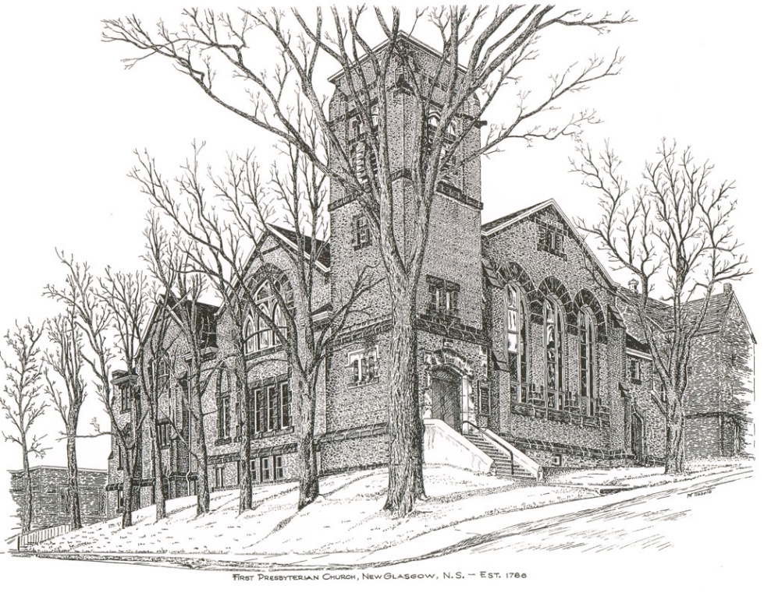

First Presbyterian Church
Memorial Hymn Sing
April 30, 2023

April 30, 2023
FIRST PRESBYTERIAN CHURCH
MEMORIAL HYMN SING

Minister: Rev. Andrew MacDonald

Organist: Clare Grieves

Welcome and Opening Prayer: Rev. Andrew MacDonald

Hymn requests from the Congregation

What A Friend We Have In Jesus –
Keith MacDonald & Justin Savage

In Memory Of: | Requested by:
Melda & Roy MacGregor | Janet & Brian Hiscott
Doris Baudoux & Myrtle Atkins | Gary Baudoux & Colette Condon
Neil & Tressie MacDonald;  Laurel & Kenneth Cruickshank | Keith & Shirley Cruickshank
Parents Ephriam & Marjorie Taylor | Don & Jane Taylor
Deceased family & friends | Clarice Campbell
Dorothy & Ferguson MacDonald; Eileen (MacDonald) Williams; Evelynne & Norman Cuthbertson & Vernon Milligan | Jane & Keith MacDonald
Son Raymond & Husband Stanley | Bella Smith
Family Members | Robyn & Larry MacLeod
Mother & Dad, Daughter and Brother | Betty A. MacDonald
Sister, Marian MacIntosh | L. Shirley McCormick
Grandmother Margaret Oliver | Charles Kennedy
All Through The Night – Doris Mason & Clare Grieves

In Memory Of: | Requested by:
Deceased family & friends | Clarice Campbell
Son Raymond & Husband Stanley | Bella Smith
Parents Lloyd & Joyce Mason and Bill & Betty Wilson | Ron & Sharon Mason

Hymn requests from the Congregation

And the Father will Dance – Choir

In Memory Of: | Requested by:
Son Raymond & Husband Stanley | Bella Smith

Amazing Grace – Andrew Alcorn

In Memory Of: | Requested by:
Doris Baudoux & Myrtle Atkins | Gary Baudoux & Colette Condon
My wife Joan | George Bellefontaine
Son Raymond & Husband Stanley | Bella Smith
Parents Lloyd & Joyce Mason and Bill & Betty Wilson | Ron & Sharon Mason
Family Members | Robyn & Larry MacLeod
My Mother & Dad, Daughter and Brother | Betty A. MacDonald
Fred & Betty Fullerton Graham and Walter Graham | Sara Fullerton
George & Margaret Durning | Helen & Darrel Snortland
Marian MacIntosh | Russell MacIntosh & Family
James & Helen MacLeod | Kevin & Margaret MacLeod
Husband & Son, George & John Russell | Ella Russell
Our parents Margaret & Leslie Robertson and Walter & Charlotte Withers | Wayne & Marie Withers
Gordon & Olla MacNeill | Ralph & Claire Foote
Mother & Father | Chet Fleming
Husband Gerald Kennedy | Frances Kennedy
Parents Charles (Charlie) & Shirley Reid | Kevin Reid

On the Other Side – Don Haggart

In Memory Of: | Requested by:
Grandparents Rannie, Gloria & Raymond | Rev. Andrew, Natalie & Bridget MacDonald
Deceased Family & Friends | Clarice Campbell
Brother, Donald Bagnell | Diane Bagnell
Brother, Jim Haggart | Don Haggart
My Grandmother, Geraldine Guthro | Angie Guthro
Son Raymond & Husband Stanley | Bella Smith
Father Bill Mailman and Brothers, John & Donald Mailman | Patty Henderson
Parents Margaret & Leslie Robertson; Sister, Frances MacIntosh and Husband, Jack Hayden | Marion Hayden
Lottie & Dan Fraser | Marion MacNeil

Freewill offering and prayer

Hymn requests from the Congregation

Jesus Loves Me – Robyn Alcorn and Family

In Memory Of: | Requested by:
Parents Robert & Isabel Fraser | Shirley MacDonald
In honour of my Mom, Charlotte Rhyno | Jane Taylor
Son Raymond & Husband Stanley | Bella Smith
George & Margaret Durning | Helen & Darrel Snortland
My Mother & Dad, Daughter and Brother | Betty A. MacDonald

The Lord’s Prayer – Janice Alcorn

In Memory Of: | Requested by:
Son Raymond & Husband Stanley | Bella Smith
Family Members | Robyn & Larry MacLeod
George & Margaret Durning | Helen & Darrel Snortland
Russell & Mary Ross; Jack, Phyllis & Laura Miller | Gary & Jackie Ross

Deep In My Heart– Choir

In Memory Of: | Requested by:
Son Raymond & Husband Stanley | Bella Smith

His Eye is on the Sparrow – Shaun McLean

In Memory Of: | Requested by:
Grandparents Chrissie & John A. MacMillan | Rev. Andrew, Natalie & Bridget MacDonald
Chrissie & John A. MacMillan | Bob & Agnes MacDonald
Parents John Dan & Rita Fraser; brothers James & Ronnie & Friend, Berma Marshall | Teela Billington
Grandpa Bob Caughey | Daniel, Lori, Natalie & Bridget
My sister, Dawne Mair | Jane Taylor
Deceased Family & Friends | Clarice Campbell
Son Raymond & Husband Stanley | Bella Smith
Family Members | Robyn & Larry MacLeod
Parents Lloyd & Joyce Mason and Bill & Betty Wilson | Ron & Sharon Mason
Russell & Mary Ross; Jack, Phyllis & Laura Miller | Gary & Jackie Ross
Friends & Family | David & Marilyn Johnstone
Husband & Son, George & John Russell | Ella Russell
Husband Bill Mailman; Sons Donald & John Mailman | Helen Mailman
Loved Ones | Mark & Jennifer Thibeau

Hymn requests from the Congregation

How Great Thou Art – Rev. Andrew MacDonald

In Memory Of: | Requested by:
Rannie, Gloria & Raymond | Bob & Agnes MacDonald
Angus MacDonald | Bob & Agnes MacDonald
My wife Joan | George Bellefontaine
Melda & Roy MacGregor | Susan & Chuck Stallard
Neil & Tressie MacDonald;  Laurel & Kenneth Cruickshank | Keith & Shirley Cruickshank
Parents John Dan & Rita Fraser; brothers James & Ronnie & friend, Berma Marshall | Teela Billington
My Dad, Lennie Rhyno | Jane Taylor
Husband Donald MacKenzie | Bonnie MacKenzie
My Grandmother, Geraldine Guthro | Angie Guthro
Family Members | Robyn & Larry MacLeod
Parents Lloyd & Joyce Mason and Bill & Betty Wilson | Ron & Sharon Mason
My Mother & Dad, Daughter and Brother | Betty A. MacDonald
Departed Family Members | Elaine MacDonald
Friends & Family | David & Marilyn Johnstone
Marian MacIntosh | Russell MacIntosh & Family
Husband & Son, George & John Russell | Ella Russell
Parents Margaret & Leslie Robertson; Sister, Frances MacIntosh and Husband, Jack Hayden | Marion Hayden
Vernon Trefry | Ralph & Claire Foote
Robert J. (Bob) Fraser | Edna Fraser
Our parents Margaret & Leslie Robertson and Walter & Charlotte Withers | Wayne & Marie Withers
Loved Ones | Mark & Jennifer Thibeau
Lottie & Dan Fraser | Marion MacNeil
Parents Charles (Charlie) & Shirley Reid | Kevin Reid

Hymn to Freedom – Lloyd MacLean

In Memory Of: | Requested by:
Parents Robert & Isabel Fraser | Fran Savage
Raymond & Audrey MacQuarrie | Brent MacQuarrie & Sara Fullerton
Son Raymond & Husband Stanley | Bella Smith
Husband & Son, George & John Russell | Ella Russell
Mother & Father | Chet Fleming

In remembrance of all those dear to our hearts:

In Memory Of: | Requested by:
In grateful remembrance of all the saints who from their labours rest, especially those who encouraged and supported my ministry at First (1972-1979) | Rev. Dr. Bob & Joan Cruickshank
Loved Ones | John & Brenda Zinck
Sylvia & Garnet Wambck | Karen MacKay

Closing Prayer and Benediction – Rev. Andrew MacDonald

NOTE: Please join us for a time of fellowship and light refreshments in the Upper Hall following the Hymn Sing.

THANK YOU!!

We would like to thank all the performers who participated in this Second Bi-annual Memorial Hymn Sing.

Thank you to the Circle of Friends for providing refreshments following the Hymn Sing.

Thank you to all who have supported us. We hope you enjoyed the performances. God Bless and stay safe!

First Presbyterian Worship and Music Team

Hymn list for Congregation Sing-along requests

Abide With Me (#794)
Battle Hymn of the Republic
(Mine Eyes Have Seen the Glory) - lyrics provided
Be Still My Soul (#749)
Be Thou My Vision (#461)
Breathe on me Breath of God (#389)
Christ the Lord is Risen Today (#247)
Fairest Lord Jesus (#375)
For the Beauty of the Earth (#434)
Gift of Finest Wheat (#538)
Great is Thy Faithfulness (#324)
Guide Me, O Thou Great Redeemer (#651)
He Leadeth Me (#650)
Here I am Lord (I The Lord of Sea and Sky #592)
I Heard The Voice of Jesus Say (#671)
Joyful, Joyful We Adore Thee (#410)
Lift High the Cross (#643)
Love Divine, All Loves Excelling (#371)
O God, Our Help in Ages Past (#330)
O Master, Let Me Walk With Thee (#642)
On Eagle’s Wings (#57)
Praise My Soul, The King of Heaven (#407)
Precious Lord, Take My Hand (#675)
Rock of Ages, Cleft For Me (#240)
Savior, Like a Shepherd Lead Us (#485)
Shall we Gather at the River (#797)
The Lord of the Dance (#250)
The Lord’s My Shepherd (#11)
The Old Rugged Cross (lyrics provided)
There is a Balm in Gilead (#747)
To God be the Glory (#350)

BATTLE HYMN OF THE REPUBLIC

Mine eyes have seen the glory of the coming of the Lord
He is trampling out the vintage where the grapes of wrath are stored;
He hath loosed the fateful lightening of His terrible swift sword.
His truth is marching on.

REFRAIN
Glory, glory hallelujah
Glory, glory hallelujah
Glory, glory hallelujah
His truth is marching on.

In the beauty of the lilies Christ was born across the sea.
With a glory in His bosom that transfigures you and me
As He died to make men holy, let us die to make men free,
While God is marching on.

THE OLD RUGGED CROSS

On a hill, far away, stood an old rugged cross
The emblem of suff’ring and shame;
And I love that old cross, where the dearest and best
For a word of lost sinners was slain.
REFRAIN

So I’ll cherish the old rugged cross
Til my trophies at last I lay down.
I will cling to the old rugged cross,
And exchange it some day for a crown.

Oh the old rugged cross, so despised by the world,
Has a wondrous attraction for me;
For the dear Lamb of God left His glory above
To bear it to dark Calvary.
REFRAIN

