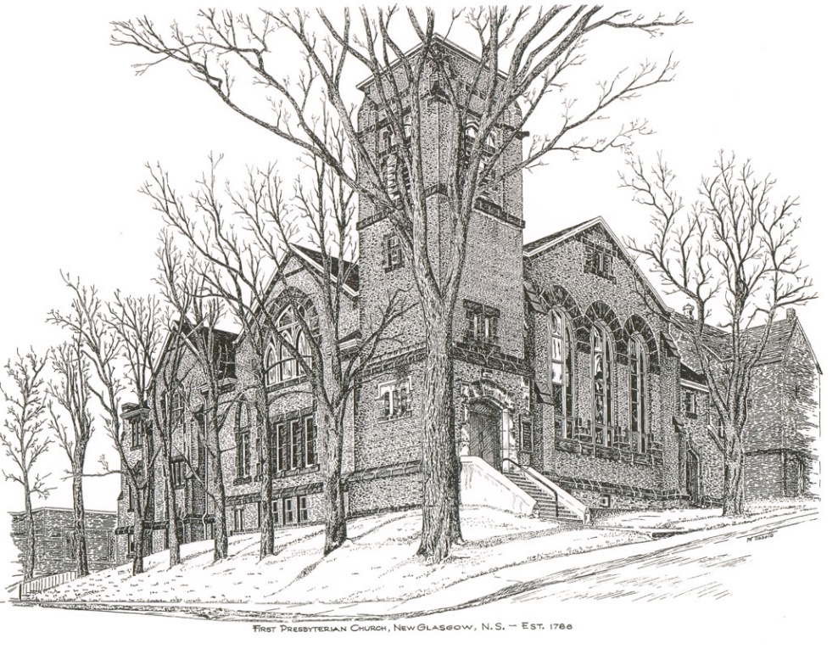

FIRST PRESBYTERIAN CHURCH
208 MacLean St., New Glasgow, NS
902-752-5691
First.church@ns.aliantzinc.ca
Reverend Andrew MacDonald
902-331-0322
yick96@hotmail.com

May 21st, 2023
7th Sunday of Easter
THE APPROACH
Musical Prelude
Welcome and Announcements
Lighting the Christ Candle: (Please rise if you are able)
One: Jesus spoke to them, saying, ‘I am the light of the world. Whoever follows me will never walk in darkness but will have the light of life.’
ALL: Jesus Christ is the light that shines in our life, and no darkness shall overcome it. We shall not be afraid.
(Light the candle)
One: Let us now prepare our hearts to worship almighty God.
Musical Introit #408 - “I will call upon the Lord”
Call to Worship
Hymn #314 – “God is love: come heaven, adoring” vs.1-3
1 God is love: come heaven, adoring;
God is love: come earth, rejoice.
Come creation, voices soaring,
sing exulting with one voice.
God who laid the earth’s foundation,
God who spread the heavens above,
God who breathes through all creation -
God is love, eternal love.

2 God is love, whose arms enfolding
all the world in one embrace,
with unfailing grasp are holding
every child of every race,
and when human hearts are breaking
under sorrow’s iron rod,
all the sorrow, all the aching
wrings with pain the heart of God.

3 God is love, and though with blindness
sin afflicts all human life,
God’s eternal lovingkindness
guides us through all earthly strife.
Sin and death and hell shall never
o’er us final triumph gain;
God is love: so love forever
o’er the universe must reign.

Prayer of Adoration, Confession and Lord’s Prayer

Our Father which art in heaven, hallowed be thy name.

Thy kingdom come, thy will be done in earth,

as it is in heaven.

Give us this day our daily bread.

And forgive us our debts, as we forgive our debtors.

And lead us not into temptation, but deliver us from evil:

For thine is the kingdom, and the power, and the glory,

forever. Amen.

Assurance of Pardon
Passing the Peace
Hymn #370 – “Hallelujah! sing to Jesus” vs.1-3

1 Hallelujah! Sing to Jesus!
His the sceptre, his the throne,
hallelujah! His the triumph,
his the victory alone.
Hark! The songs of peaceful Zion
thunder like a mighty flood;
Jesus out of every nation
has redeemed us by his blood.

2 Hallelujah! Not as orphans
are we left in sorrow now;
hallelujah! He is near us,
faith believes, nor questions how.
Though the cloud from sight received him
when the forty days were o’er,
shall our hearts forget his promise,
I am with you evermore”?

3 Hallelujah! King eternal,
thee the Lord of lords we own;
hallelujah, born of Mary,
earth thy footstool, heaven thy throne.
Thou within the veil has entered,
robed in flesh, our great High Priest,
thou on earth both priest and victim
in the eucharistic feast.

Children’s Time
Prayer of Illumination
First Lesson: Acts 1:1-14
Epistle Lesson: Ephesians 1:15-23
Responsive Psalm 47
One: Clap your hands, all you peoples; shout to God with loud songs of joy.
All: For the LORD, the Most High, is awesome, a great king over all the earth.
One: He subdued peoples under us, and nations under our feet.
All: He chose our heritage for us, the pride of Jacob whom he loves.
One: God has gone up with a shout, the LORD with the sound of a trumpet.
All: Sing praises to God, sing praises; sing praises to our King, sing praises.
One: For God is the king of all the earth; sing praises with a psalm.
All: God is king over the nations; God sits on his holy throne.
One: The princes of the peoples gather as the people of the God of Abraham. For the shields of the earth belong to God; he is highly exalted.
Gloria Patri

Glory be to the Father, and to the Son, and to the Holy Ghost.

As it was in the beginning, is now and ever shall be,

world without end.

Amen, amen.

Gospel Reading: Luke 24:44-53
Anthem: “Forgiving and loving” by Scott Soper
Sermon: “Where or What is Heaven?”
Reaffirmation of Faith – Apostles’ Creed – Please rise

I believe in God, the Father Almighty, maker of Heaven and earth; and in Jesus Christ, His only Son, Our Lord, who was conceived by the Holy Ghost, born of the Virgin Mary,
suffered under Pontius Pilate, was crucified, died, and was buried. He descended into Hell. On the third day He arose again from the dead; He ascended into Heaven, and sits
at the right hand of God, the Father Almighty; from thence He shall come to judge the quick and the dead.
I believe in the Holy Ghost, the holy Catholic Church,
the communion of saints, the forgiveness of sins, the resurrection of the body, and the life everlasting. Amen.

Hymn #438 – “When morning gilds the skies” vs.1-3

1 When morning gilds the skies,
my heart awakening cries:
my Jesus Christ be praised!
Alike at work and prayer
to Jesus I repair;
may Jesus Christ be praised.

2 To God, the Word, on high,
the host of angels cry:
may Jesus Christ be praised!
Let mortals, too, upraise
their voice in hymns of praise;
may Jesus Christ be praised!

3 Let earth’s wide circle round
in joyful notes resound:
may Jesus Christ be praised!
Let earth and sea and sky,
from depth to height reply:
may Jesus Christ be praised!

Offertory Prayer

Prayers of the People: The People Respond

Hymn #410 – “Joyful, joyful we adore thee” vs.1,3,4

1 Joyful, joyful we adore you,
God of glory, God of love.
Hearts unfold like flowers before you,
opening to the sun above.
Melt the clouds of sin and sadness,
drive the dark of doubt away;
giver of immortal gladness,
fill us with the light of day.

3 You are giving and forgiving,
ever blessing, ever blessed,
wellspring of the joy of living,
ocean depth of happy rest.
God Creator, Christ our Saviour,
all are yours who live in love.
Teach us how to love our neighbour;
lift us to your joy above.

4 Morning stars, awake the chorus;
mortals, join with every part,
for what joy is set before us
as Christ’s love joins heart to heart!
Ever singing, march we onward,
victors in the midst of strife;
joyful music leads us sunward,
in the triumph song of life.
Benediction

Coral Response: Threefold Amen

Recessional

* * * * * * * * * * * * *
Minister: Rev. Andrew MacDonald (c) 902-331-0322
Organist: Clare Grieves
Office hours: Tues. to Fri. – 10 -1pm
Rev. MacDonald office hours -Tues. to Thurs. 10-2 or by appointment

Mission Statement: But he’s already made it plain how to live, what to do, what God is looking for in men and women. It’s quite simple. Do what is fair and just to your neighbor, be compassionate and loyal in your love, and don’t take yourself too seriously – take God seriously. Micah 6: 8-The Message

ANNOUNCEMENTS

All are welcome at First Presbyterian Church. We hope you experience the love of God and of this congregation as we worship, celebrate, and serve one another.

An In-Memorium donation has been received in the loving memory of Dorothy Holmes from Ellen Jardine.

A donation has been received from the Committee of the 85th New Glasgow Music Festival along with their thanks for the ongoing support of the Festival by First Church and Michael Fraser.

UPCOMING EVENTS

Today: We will be hosting coffee time following service today. Please join us for a time of fellowship.

Sat., May 27th - 2-4 p.m - Rev. Charles McPherson's is retiring from full-time ministry. A celebration of Charles will be held at the Church Hall of First Presbyterian Church, Foord St., Stellarton. If you are unable to attend but would like to send best wishes, please email the church at sfpc@bellaliant.com.
ANNIVERSARY WEEKEND - St. Andrews Presbyterian, “The Kirk” Church in Pictou, is celebrating 200 years of worship and witness in the community. Come and join us for a Celebration Weekend of music and thanksgiving.
- Saturday, May 27 - 2:00 p.m. “Jazz in the Afternoon” with the Cornerstone jazz quartet.
7:30 p.m. Live in Concert! The Pictou County Brass and Reed Band featuring The Brass United Quintet.
- Sunday, May 28 - 10:00 a.m. “Come Home to The Kirk” morning service with Cold Plate Potluck Brunch following service.
7:00 p.m. Gala Celebration Service of Worship featuring guest performers and choirs plus piper Harold MacDonnell. Refreshments and fellowship following.

Tues., May 30th – 7:00 p.m. - In celebration of their 85th anniversary, the New Glasgow Music Festival is hosting a concert with the Vancouver Orpheus Male Choir at Trinity United Church (151 Temperance St, New Glasgow). Special guests at this concert will be the NNEC Changed Voice Choir, under the direction of Sheila Aucoin; and Katey Aucoin, violinist. Tickets are $25 for adults, $15 for students (under 12 free) and are available at H & R Music, or by calling Sandra Johnson at 902-752-6927.

Fri., June 9th (Shaun’s Place, New Glasgow) & Sat., June 10th (Steinhart Distillery, Arisaig) – 7:30 p.m. – The “Carillon Singers” features “Feathers & Fellas”. The eclectic vocal ensemble of all female musicians, the Carillon Singers, are excited to bring the speakeasy experience to life with 2 nights of jazz inspired music; a cash bar and light hors d’oeuvres. 1920s attire is encouraged. Under the direction of Vivi Chediac and pianist, Karen Crowley this event also features Paul Tupper, Andrew Miller and Tanner MacDonald. Tickets $35.00 – available at Chediac Furniture. LBR Variety and Curious Crow’s Coffee House or by calling 902-771-0250. This is a 19+ event.

Sat., June 10th – Yard Sale - Circle of Friends are requesting donations of used items which you no longer have use for, are in good condition and would be of interest to a yard sale enthusiast. Household items, Christmas decorations, books, etc., NO CLOTHING items please. All donations and help would be appreciated. Hoping to have a fun day!

Thurs., June 15th, 10:00 a.m. –The Pictou Presbyterial AMS will be holding their Annual Meeting at Camp Geddie. We would like to invite all members from disbanded Auxiliaries to be our guests. If you are interested in attending, please contact Mary Condon at marycondon@eastlink.ca or by calling 902-752-0296 by June 7th.
Recognition of Graduates: Parents, grandparents, and students - If you are or have a student graduating this year (high school, college, technical school or graduate school) and would like to share the news with the congregation, please let us know, we’d be happy to spread the word! You can call the church office (902-752-5691) or email the name of the graduate along with details i.e. school graduating from, degree obtained, brief description of future plans etc. We welcome news regarding our young people and their accomplishments. This week we honour Samantha Fagan, daughter of Sheila Fagan. Samantha will be graduating from NSCC with a diploma in Business Administration. She will be going to St. F.X. in the fall to get her degree in Business, majoring in Entrepreneurship. Congratulations Samantha!
SCRIPTURE READERS & USHERS:
Scripture reader: Brent MacQuarrie
Ushers: Main Door (Office Entry) – Chet Fleming and Fran Savage
James St. – Ruth-Anne MacIntosh
MacLean St. (Main Entrance steps) – Clarice Campbell
Early Christian Educators: Lynne Ann and Lois MacLellan

