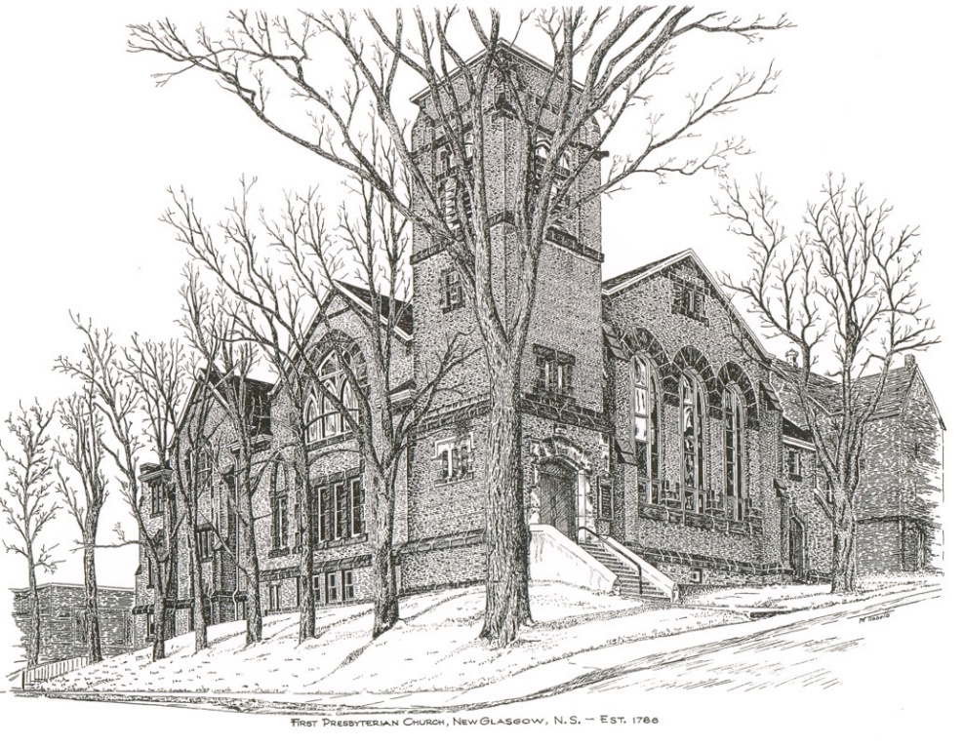

FIRST PRESBYTERIAN CHURCH
208 MacLean St., New Glasgow, NS
902-752-5691
First.church@ns.aliantzinc.ca
Reverend Andrew MacDonald
902-331-0322
yick96@hotmail.com

May 28th, 2023
Pentecost Sunday
THE APPROACH
Musical Prelude
Welcome and Announcements
Lighting the Christ Candle: (Please rise if you are able)
One: How sweet are your words to my taste, sweeter than honey to my mouth! Through your precepts I get understanding; therefore I hate every false way.
ALL: Oh Lord, your word is a lamp to our feet and a light to our path.
(Light the candle)
One: Let us now prepare our hearts to worship almighty God.
Musical Introit 408- “I will call upon the Lord”
Call to Worship
Hymn #764– “There’s a spirit in the air” vs. 1,4,5
- There’s a spirit in the air,
telling Christians everywhere:
“Praise the love that Christ revealed,
living, working, in our world!”

4. Still the Spirit gives us light,
seeing wrong and setting right:
God in Christ has come to stay.
Live tomorrow’s life today!

5. When a stranger’s not alone,
where the homeless find a home,
praise the love that Christ revealed,
living, working, in our world.

Prayer of Adoration, Confession and Lord’s Prayer

Our Father which art in heaven, hallowed be thy name.

Thy kingdom come, thy will be done in earth,

as it is in heaven.

Give us this day our daily bread.

And forgive us our debts, as we forgive our debtors.

And lead us not into temptation, but deliver us from evil:

For thine is the kingdom, and the power, and the glory,

forever. Amen.

Assurance of Pardon
Passing the Peace
Hymn #475 – “I am the church! You are the church” vs. 1,2,5
Refrain:
I am the church! You are the church!
We are the church together!
All who follow Jesus,
all around the world!
Yes, we're the church together!
1. The church is not a building;
the church is not a steeple;
the church is not a resting place;
the church is a people.
(Refrain)
2. We're many kinds of people,
with many kinds of faces,
all colours and all ages, too
from all times and places.
(Refrain)
5. At Pentecost some people
received the Holy Spirit
and told the Good News through the world
to all who would hear it.
(Refrain)
Children’s Time
Prayer of Illumination
First Lesson: Acts 2:1-21
Epistle Lesson: 1 Corinthians 12:3-13
Responsive Psalm 104:24-35
One: O Lord, how manifold are your works! In wisdom you have made them all; the earth is full of your creatures.
All: Yonder is the sea, great and wide, creeping things innumerable are there, living things both small and great.
One: There go the ships, and Leviathan that you formed to sport in it.
All: These all look to you to give them their food in due season;
when you give to them, they gather it up; when you open your hand, they are filled with good things.
One: When you hide your face, they are dismayed; when you take away their breath, they die and return to their dust.
All: When you send forth your spirit, they are created; and you renew the face of the ground.
One: May the glory of the Lord endure for ever; may the Lord rejoice in his works—
All: Who looks on the earth and it trembles, who touches the mountains and they smoke.
One: I will sing to the Lord as long as I live; I will sing praise to my God while I have being.
All: May my meditation be pleasing to him, for I rejoice in the Lord.
One: Let sinners be consumed from the earth, and let the wicked be no more.
All: Bless the Lord, O my soul. Praise the Lord!

Gloria Patri

Glory be to the Father, and to the Son, and to the Holy Ghost. As it was in the beginning, is now and ever shall be, world without end. Amen, amen.

Gospel Reading: John 20:19-23
Anthem
Sermon: “On the Day of Pentecost!”
Reaffirmation of Faith – Apostles’ Creed – Please rise

I believe in God, the Father Almighty, maker of Heaven and earth; and in Jesus Christ, His only Son, Our Lord, who was conceived by the Holy Ghost, born of the Virgin Mary,
suffered under Pontius Pilate, was crucified, died, and was buried. He descended into Hell. On the third day He arose again from the dead; He ascended into Heaven, and sits
at the right hand of God, the Father Almighty; from thence He shall come to judge the quick and the dead.
I believe in the Holy Ghost, the Holy Catholic Church,
the communion of saints, the forgiveness of sins, the resurrection of the body, and the life everlasting. Amen.

Hymn #399 – “Spirit, Spirit of gentleness” vs. 1,3,4

Refrain:
Spirit, Spirit of gentleness,
blow through the wilderness, calling and free.
Spirit, Spirit of restlessness,
stir me with placidness,
Wind, Wind on the sea.

1 You moved on the waters,
you called to the deep;
then you coaxed up the mountains
from the valleys of sleep,
and over the aeons you called to each thing:
wake from your slumbers
and rise on your wings.

3 You sang in the stable, you cried from a hill;
then you whispered in silence when the whole world was still and down in the city you called once again, when you blew through your people on the rush of the wind.

4 You call from tomorrow,
you break ancient schemes;
from the bondage of sorrow
the captives dream dreams;
our women see visions,
our men clear their eyes;
with bold new decisions your people arise.

Offertory Prayer

Prayers of the People: The People Respond
ONE: Spirit of Power and Promise,
ALL: Blow through us and renew our faith.

Hymn #471 – “We are one in the Spirit” vs.1,2,4

1 We are one in the Spirit
we are one in the Lord,
we are one in the Spirit,
we are one in the Lord,
and we pray that all unity
will one day be restored
and they’ll know we are Christians
by our love, by our love
and they’ll know we are Christians by our love.

2 We will walk with each other,
we will walk hand in hand,
we will walk with each other,
we will wall hand in hand,
and together we’ll spread the news
that God is in our land,
and they’ll know we are Christians
by our love, by our love,
and they’ll know we are Christians by our love.

4 All praise to the Father,
from whom all things come,
and all praise to Christ Jesus,
who is God’s only Son,
and all praise to the Spirit,
who makes us one,
and they’ll know we are Christians
by our love, by our love,
and they’ll know we are Christians by our love.

Benediction

Coral Response: Threefold Amen

Recessional

ANNOUNCEMENTS

All are welcome at First Presbyterian Church. We hope you experience the love of God and of this congregation as we worship, celebrate, and serve one another.

UPCOMING EVENTS

Tonight - 7:00 p.m. – As The Kirk Church in Pictou (St. Andrews Presbyterian Church), continues celebrating 200 years of worship and witness in the community, there will be a Gala Celebration Service of Worship tonight featuring guest performers and choirs including piper Harold MacDonnell. Refreshment and fellowship following.
Tues., May 30th – 7:00 p.m. - In celebration of their 85th anniversary, the New Glasgow Music Festival is hosting a concert with the Vancouver Orpheus Male Choir at Trinity United Church (151 Temperance St, New Glasgow). Special guests at this concert will be the NNEC Changed Voice Choir, under the direction of Sheila Aucoin; and Katey Aucoin, violinist. Tickets are $25 for adults, $15 for students (under 12 free) and are available at H & R Music, or by calling Sandra Johnson at 902-752-6927.

Fri., June 9th (Shaun’s Place, New Glasgow) & Sat., June 10th (Steinhart Distillery, Arisaig) – 7:30 p.m. – The “Carillon Singers” features “Feathers & Fellas”. The eclectic vocal ensemble of all female musicians, the Carillon Singers, are excited to bring the speakeasy experience to life with 2 nights of jazz inspired music; a cash bar and light hors d’oeuvres. 1920s attire is encouraged. Under the direction of Vivi Chediac and pianist, Karen Crowley this event also features Paul Tupper, Andrew Miller and Tanner MacDonald. Tickets $35.00 – available at Chediac Furniture. LBR Variety and Curious Crow’s Coffee House or by calling 902-771-0250. This is a 19+ event.

Sat., June 10th - 9 a.m.-1p.m. – Yard Sale - Circle of Friends are requesting donations of used items which you no longer have use for, are in good condition and would be of interest to a yard sale enthusiast. Household items, Christmas decorations, books, etc., NO CLOTHING items please. All donations and help would be appreciated. Hoping to have a fun day!
Sun., June 11th, 2:30p.m. – “Save the Date” - The Trinitarians and Guests are hosting “A Spring Choral Concert” at Trinity United.
Thurs., June 15th, 10:00 a.m. –The Pictou Presbyterial AMS will be holding their Annual Meeting at Camp Geddie. We would like to invite all members from disbanded Auxiliaries to be our guests. If you are interested in attending, please contact Mary Condon at marycondon@eastlink.ca or by calling 902-752-0296 by June 7th.
Recognition of Graduates: Parents, grandparents, and students - If you are or have a student graduating this year (high school, college, technical school or graduate school) and would like to share the news with the congregation, please let us know, we’d be happy to spread the word! You can call the church office (902-752-5691) or email the name of the graduate along with details i.e. school graduating from, degree obtained, brief description of future plans etc. We welcome news regarding our young people and their accomplishments.
Congratulations and Best Wishes!!
Birthday Greetings are extended to Austin Sutton and Rosalyn MacDonald. Austin will celebrate his birthday tomorrow, May 29th; Rosalyn will celebrate her birthday Wednesday, May 31st. Happy Birthday to both of you!!
Along with his birthday, Austin and Marsha will celebrate their 54th wedding anniversary on Wednesday, May 31st.

SCRIPTURE READERS & USHERS:

Scripture reader: Mark Thibeau
Ushers: Main Door (Office Entry) – Chet Fleming and Fran Savage
James St. – Ruth-Anne MacIntosh
MacLean St. (Main Entrance steps) – Clarice Campbell
Early Christian Educators: Lynne Ann and Lois MacLellan

* * * * * * * * * * * * *
Minister: Rev. Andrew MacDonald (c) 902-331-0322
Organist: Clare Grieves
Office hours: Tues. to Fri. – 10 -1pm
Rev. MacDonald office hours -Tues. to Thurs. 10-2 or by appointment

Mission Statement: But he’s already made it plain how to live, what to do, what God is looking for in men and women. It’s quite simple. Do what is fair and just to your neighbor, be compassionate and loyal in your love, and don’t take yourself too seriously – take God seriously. Micah 6: 8-The Message

