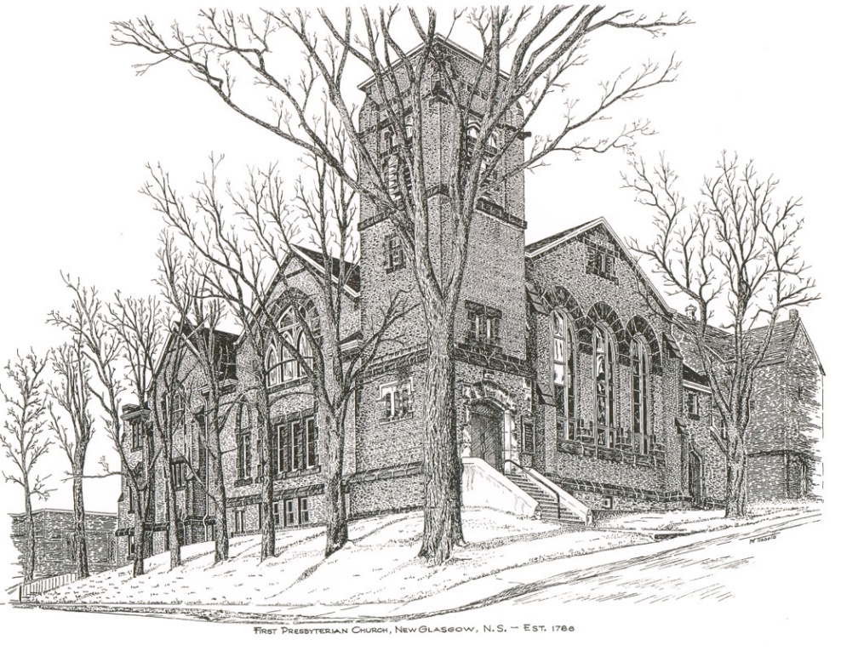

FIRST PRESBYTERIAN CHURCH
208 MacLean St., New Glasgow, NS
902-752-5691
First.church@ns.aliantzinc.ca
Reverend Andrew MacDonald
902-331-0322
yick96@hotmail.com

June 11th, 2023
2nd Sunday After Pentecost
THE APPROACH

Musical Prelude
Welcome and Announcements
Lighting the Christ Candle: (Please rise if you are able)
One: ‘You are the light of the world. A city built on a hill cannot be hidden. No one after lighting a lamp puts it under the bushel basket, but on the lampstand, and it gives light to all in the house.
ALL: In the same way, let our light shine before others, so that they may see our good works and give glory to your Father in heaven.
(Light the candle)
One: Let us now prepare our hearts to worship almighty God.
Musical Introit #571- “Lord, I want to be a Christian” vs. 1
1 Lord, I want to be a Christian
in-a my heart, in-a my heart;
Lord I want to be a Christian in-a my heart.
In-a my heart, in-a my heart,
Lord, I want to be a Christian in-a my heart.

Call to Worship
Hymn #374– “Oh for a thousand tongues to sing” vs. 1-3,5
1 Oh for a thousand tongues to sing
my great Redeemer’s praise,
the glories of my God and King,
the triumphs of God’s grace.

2 Jesus, the name that charms our fears,
and bids our sorrows cease -
‘tis music in the sinner’s ears;
,tis life and health and peace.

3 He speaks, and listening to his voice
new life the dead receive;
the mournful, broken hearts rejoice;
the humble poor believe.

5 My gracious Master and my God,
assist me to proclaim,
and spread through all the earth abroad
the honours of thy name.

Prayer of Adoration, Confession and Lord’s Prayer

Our Father which art in heaven, hallowed be thy name.

Thy kingdom come, thy will be done in earth,

as it is in heaven.

Give us this day our daily bread.

And forgive us our debts, as we forgive our debtors.

And lead us not into temptation, but deliver us from evil:

For thine is the kingdom, and the power, and the glory,

forever. Amen.

Assurance of Pardon
Passing the Peace
Hymn #634 – “Will you come and follow me” vs. 1,2,4,5

1 Will you come and follow me
if I but call your name?
Will you go where you don’t know
and never be the same?
Will you let my love be shown;
will you let my name be known;
will you let my life be grown
in you and you in me?

2 Will you leave yourself behind
if I but call your name?
Will you care for cruel and kind
and never be the same?
Will you risk the hostile stare
should your life attract or scare?
Will you let me answer prayer
in you and you in me?

4 Will you love the “you” you hide
if I but call your name?
Will you quell the fear inside
and never be the same?
Will you use the faith you’ve found
to reshape the world around,
through my sight and touch and sound
in you and you in me?

5 Lord, your summons echoes true
when you but call my name.
Let me turn and follow you
and never be the same.
In your company I’ll go
where your love and footsteps show.
Thus I’ll move and live and grow
in you and you in me.

Children’s Time
Prayer of Illumination
First Lesson: Genesis 12:1-9
Epistle Lesson: Romans 4:13-25
Responsive Psalm 50:7-15

Psalm 50:7-15

ONE: ‘Hear, O my people, and I will speak, O Israel, I will testify against you. I am God, your God.
ALL: Not for your sacrifices do I rebuke you; your burnt-offerings are continually before me.
ONE: I will not accept a bull from your house, or goats from your folds.
ALL: For every wild animal of the forest is mine, the cattle on a thousand hills.
ONE: I know all the birds of the air, and all that moves in the field is mine.
ALL: ‘If I were hungry, I would not tell you, for the world and all that is in it is mine.
ONE: Do I eat the flesh of bulls, or drink the blood of goats?
ALL: Offer to God a sacrifice of thanksgiving, and pay your vows to the Most High.
ONE: Call on me in the day of trouble; I will deliver you, and you shall glorify me.’

Gloria Patri

Glory be to the Father, and to the Son, and to the Holy Ghost. As it was in the beginning, is now and ever shall be, world without end. Amen, amen.

Gospel Reading: Matthew 9:9-13. 18-26
Anthem: “All Thy Glory Lord”
Sermon: “Calling All Sinners!”
Reaffirmation of Faith – Apostles’ Creed – Please rise

I believe in God, the Father Almighty, maker of Heaven and earth; and in Jesus Christ, His only Son, Our Lord, who was conceived by the Holy Ghost, born of the Virgin Mary,
suffered under Pontius Pilate, was crucified, died, and was buried. He descended into Hell. On the third day He arose again from the dead; He ascended into Heaven, and sits
at the right hand of God, the Father Almighty; from thence He shall come to judge the quick and the dead.
I believe in the Holy Ghost, the holy Catholic Church,
the communion of saints, the forgiveness of sins, the resurrection of the body, and the life everlasting. Amen.

Hymn #478 – “To Abraham and Sarah” vs. 1-3

1 To Abraham and Sarah
the call of God was clear:
“Go forth and I will show you
a country rich and fair.
You need not fear the journey
for I have pledged my word:
that you shall be my people,
and I will be your God.”

2 From Abraham and Sarah
arose a pilgrim race,
dependent for their journey
on God’s abundant grace
and in their heart was written
by God this saving word:
“that you shall be my people
and I will be your God.”

3 We of this generation
on whom God’s hand is laid
can journey to the future
secure and unafraid,
rejoicing in God’s goodness
and trusting in this word:
“that you shall be my people
and I will be your God.”

Offertory Prayer

Prayers of the People: The People Respond
ONE: Bring Healing
ALL: Bring Peace!

Hymn #651 – “Guide me, O thou great Redeemer”

1 Guide me, O thou great Redeemer,
pilgrim through this barren land;
I am weak, but thou art mighty;
hold me with thy powerful hand:
bread of heaven, bread of heaven,
feed me now and evermore;
feed me now and evermore.

2 Open now the crystal fountain,
whence the healing stream doth flow;
let the fire and cloudy pillar
lead me all my journey through:
strong deliverer, strong deliverer,
be thou still my strength and shield,
be thou still my strength and shield.

3 When I tread the verge of Jordan,
bid my anxious fears subside;
death of death, and hell’s destruction,
land me safe on Canaan’s side:
songs of praises, songs of praises,
I will ever give to thee;
I will ever give to thee.

Benediction

Coral Response: Threefold Amen

Recessional
ANNOUNCEMENTS

All are welcome at First Presbyterian Church. We hope you experience the love of God and of this congregation as we worship, celebrate, and serve one another.

UPCOMING EVENTS

Mon., June 12th – 6:30 p.m. – The Board of Managers will meet
Tues., June 13th – 6:30 p.m. – Session will meet
Today, 2:30p.m. – The Trinitarians and Guests are hosting “A Spring Choral Concert” this afternoon at Trinity United.
Thurs., June 15th, 10:00 a.m. –The Pictou Presbyterial AMS will be holding their Annual Meeting at Camp Geddie. We would like to invite all members from disbanded Auxiliaries to be our guests. If you are interested in attending, please contact Mary Condon at marycondon@eastlink.ca or by calling 902-752-0296.
Fri., June 16th - 7 p.m. - Middle River Presbyterian Church, 59 E Fraser Crossroad, Rocklin will host a variety concert, featuring local talent & FUDGE! Freewill admission. Hope to see you there.
Recognition of Graduates: Parents, grandparents, and students - If you are or have a student graduating this year (high school, college, technical school or graduate school) and would like to share the news with the congregation, please let us know, we’d be happy to spread the word! You can call the church office (902-752-5691) or email the
name of the graduate along with details i.e. school graduating from, degree obtained, brief description of future plans etc.
Happy Anniversary to Sheila and Emerson Dempster who will celebrate their 50th wedding anniversary Fri., June 16th. Congratulations and many more!
An In Memorium donation has been made by Clarice Campbell in memory of her husband, Bill Campbell.
Monthly coffee time – Coffee hour will be held the third Sunday of the month. Next coffee date is June 18th. For anyone who would like to host, please contact Cathy Lewis at 902-759-9649. If you need help setting up the coffee maker or have any questions, contact Cathy.

SCRIPTURE READERS & USHERS:
Scripture reader: Sharon Mason
Ushers: Main Door (Office) – Brent MacQuarrie and Sara Fullerton
James St. – Ruth-Anne MacIntosh
MacLean St. (Main Entrance steps) – John and Brenda Zinck
Early Christian Educators: Lynne Ann and Lois MacLellan

* * * * * * * * * * * * *
Minister: Rev. Andrew MacDonald (c) 902-331-0322
Organist: Clare Grieves
Office hours: Tues. to Fri. – 10 -1pm
Rev. MacDonald office hours -Tues. to Thurs. 10-2 or by appointment

Mission Statement: But he’s already made it plain how to live, what to do, what God is looking for in men and women. It’s quite simple. Do what is fair and just to your neighbor, be compassionate and loyal in your love, and don’t take yourself too seriously – take God seriously. Micah 6: 8-The Message

