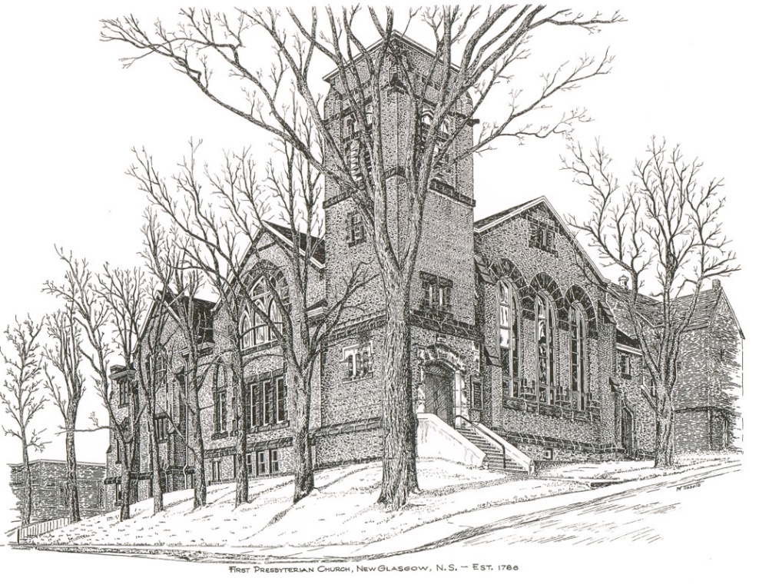

FIRST PRESBYTERIAN CHURCH
208 MacLean St., New Glasgow, NS
902-752-5691
First.church@ns.aliantzinc.ca
Reverend Andrew MacDonald
902-331-0322
yick96@hotmail.com

June 25th, 2023
4th Sunday After Pentecost
THE APPROACH

Musical Prelude
Welcome and Announcements
Lighting the Christ Candle: (Please rise if you are able)
One: The human spirit is the lamp of the Lord
that sheds light on one’s inmost being.
ALL: “No one lights a lamp and puts it in a place where it will be hidden, or under a bowl. Instead they put it on its stand, so that those who come in may see the light.
ONE: In the same way, let your light shine before others, that they may see your good deeds and glorify your Father in heaven.
ALL: For the evildoer has no future hope, and the lamp of the wicked will be snuffed out
(Light the candle)
One: Let us now prepare our hearts to worship almighty God.
Musical Introit - #446 “O Lord, hear my prayer” vs. B
The Lord is my song; the Lord is my praise; all my hope comes from God. The Lord is my song: the Lord is my praise: God, the wellspring of life.
Call to Worship
Hymn #324 – “Great is thy faithfulness”
1 Great is thy faithfulness, O God my Father;
there is no shadow of turning with thee;
thou changest not,
thy compassions, they fail not;
as thou hast been, thou forever wilt be.

Great is thy faithfulness
great is they faithfulness
morning by morning new mercies I see;
all I have needed thy hand hath provide;
great is thy faithfulness, Lord, unto me.

2 Summer and winter and springtime and harvest,
sun, moon and stars in their courses above,
join with all nature in eloquent witness
to thy great faithfulness, mercy and love.

3 Pardon for sin and a peace that endureth,
thine own dear presence to cheer and to guide,
strength for today and bright hope for tomorrow:
blessings all mine, with ten thousand beside!

Prayer of Adoration, Confession and Lord’s Prayer

Our Father which art in heaven, hallowed be thy name.

Thy kingdom come, thy will be done in earth,

as it is in heaven.

Give us this day our daily bread.

And forgive us our debts, as we forgive our debtors.

And lead us not into temptation, but deliver us from evil:

For thine is the kingdom, and the power, and the glory,

forever. Amen.

Assurance of Pardon
Passing the Peace
Hymn #639 – “We Are Marching/Siyahamba”
We are marching in the light of God (sung 4 times)
We are marching in the light of God
We are marching in the light of God
We are marching in the light of God
We are marching, ooo,
We are marching in the light of God. (2x)

(Phonetic pronounciation for African words)
See ya humba coo cah yen quen cos
See ya humba coo cah yen quen cos
See ya humba, humba, see ya humba, humba,
See ya humba coo cah yen quen cos

Children’s Time
Prayer of Illumination
First Lesson: Jeremiah 20:7-13
Epistle Lesson: Romans 6:1-11
Responsive Psalm 69:7-15
ONE: It is for your sake that I have borne reproach, that shame has covered my face.
ALL: I have become a stranger to my kindred, an alien to my mother’s children.
ONE: It is zeal for your house that has consumed me; the insults of those who insult you have fallen on me.
ALL: When I humbled my soul with fasting, they insulted me for doing so.
ONE: When I made sackcloth my clothing, I became a byword to them.
ALL: I am the subject of gossip for those who sit in the gate, and the drunkards make songs about me.
ONE: But as for me, my prayer is to you, O Lord.
ALL: At an acceptable time, O God, in the abundance of your steadfast love, answer me.
ONE: With your faithful help rescue me from sinking in the mire; let me be delivered from my enemies and from the deep waters.
ALL: Do not let the flood sweep over me, or the deep swallow me up, or the Pit close its mouth over me.

Gloria Patri

Glory be to the Father, and to the Son, and to the Holy Ghost. As it was in the beginning, is now and ever shall be, world without end. Amen, amen.

Gospel Reading: Matthew 10:24-39
Anthem: “Sing a New Song unto the Lord”
Sermon: “Speak Into The Daylight!”
Reaffirmation of Faith – Apostles’ Creed – Please rise

I believe in God, the Father Almighty, maker of Heaven and earth; and in Jesus Christ, His only Son, Our Lord, who was conceived by the Holy Ghost, born of the Virgin Mary,
suffered under Pontius Pilate, was crucified, died, and was buried. He descended into Hell. On the third day He arose again from the dead; He ascended into Heaven, and sits
at the right hand of God, the Father Almighty; from thence He shall come to judge the quick and the dead.
I believe in the Holy Ghost, the holy Catholic Church,
the communion of saints, the forgiveness of sins, the resurrection of the body, and the life everlasting. Amen.

Hymn #630 – “When we are living” vs. 1,2,4

- When we are living, it is in Christ Jesus,
and when we’re dying, it is in the Lord.
Both in our living and in our dying,
we belong to God; we belong to God.

- Through all our living, we our fruits must give.
Good works of service are for offering.
When we are giving, or when receiving,
we belong to God; we belong to God.

- Across this wide world, we shall always find
those who are crying with no peace of mind,
but when we help them, or when we feed them,
we belong to God; we belong to God.

Offertory Prayer

Prayers of the People: The People Respond
ONE: Embrace us all with your mercy, O God.
ALL: And give us grace to respond to needs around us.
Hymn #685 – “How firm a foundation” vs 1,3,5

1 How firm a foundation ye saints of the Lord,
is laid for your faith in God’s excellent word!
What more can God say
than to you hath been said,
to you that for refuge to Jesus have fled?

3 When through the deep waters I call thee to go
the rivers of woe shall not thee overflow,
for I will be with thee, they troubles to bless,
and sanctify to thee thy deepest distress.

5 The soul that on Jesus hath leaned for repose
I will not - I will not desert to his foes;
that soul, though all hell
should endeavour to shake,
I’ll never - no, never - no, never forsake!

Sunday School Closing

Benediction

Coral Response: Threefold Amen
Recessional

ANNOUNCEMENTS

All are welcome at First Presbyterian Church. We hope you experience the love of God and of this congregation as we worship, celebrate, and serve one another.

CONDOLENCES

We extend our sincere condolences to the family and friends of Evelyn May MacLeod. Evelyn was an Elder at First Church for many years.

We also extend condolences to Rev. Gerald Thompson on the passing of his niece, Carolyn Thompson.

UPCOMING EVENTS

Wed., June 28th – 6:00-8:00p.m. – St. Andrew’s Presbyterian, (the Kirk), is hosting a fundraiser for Camp Geddie. ‘The Kirk Coffee House’ will feature the Carillon Singers and will be serving tea/coffee and dessert. Admission - $5.00

Recognition of Graduates: Not too late!! - Parents, grandparents, and students - If you are or have a student who graduated this year (high school, college, technical school or graduate school) and would like to share the news with the congregation, we are happy to help you do that. Please provide the details (school graduating from, degree obtained, brief description of future plans etc.) and we’ll make sure it’s announced when church resumes in August.
As the church will be closed for vacation in July, we wish everyone celebrating a milestone birthday or anniversary, our very best wishes. Celebrating are:
Birthdays:
July 19th - Marion Johnstone & Rev. Gerald Thompson
July 21st – Gerry Wadden
July 23rd – Hank VanVeld
July 26th – Vivian MacDonald
July 27th – George Bellefontaine
July 28th – Doug Guthro

Anniversaries:
July 3rd – John & Betty Gladwin
July 8th – Fran & Clark Savage

Monthly coffee time – Coffee hour will be held the third Sunday of the month. Next coffee date is August 20th. For anyone who would like to host, please contact Cathy Lewis at 902-759-9649. If you need help setting up the coffee maker or have any questions, contact Cathy.
SCRIPTURE READERS & USHERS:

Scripture reader: Clarice Campbell
Ushers: Main Door (Office) – Brent and Sara
James St. – Ruth-Anne
MacLean St. (Main Entrance steps) – Ellen
Early Christian Educators: Lynne Ann and Lois MacLellan

* * * * * * * * * * * * *

Minister: Rev. Andrew MacDonald (c) 902-331-0322
Organist: Clare Grieves
Office hours: Tues. to Fri. – 10 -1pm
Rev. MacDonald office hours -Tues. to Thurs. 10-2 or by appointment

