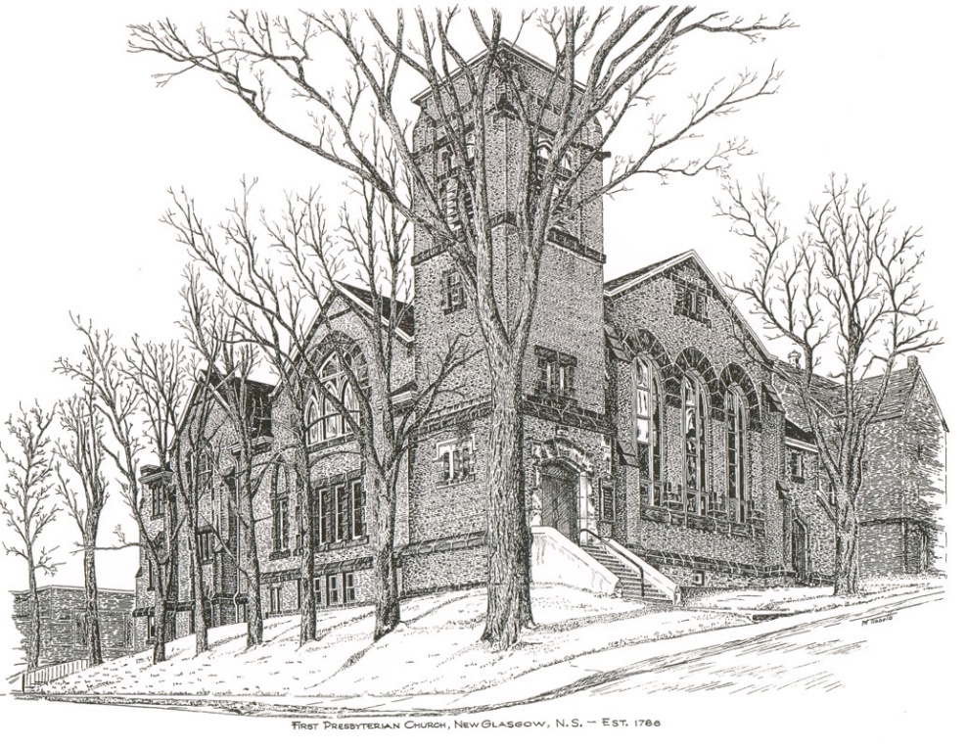

FIRST PRESBYTERIAN CHURCH
208 MacLean St., New Glasgow, NS
902-752-5691
First.church@ns.aliantzinc.ca
Reverend Andrew MacDonald
902-331-0322
yick96@hotmail.com

August 13th, 2023
11th Sunday After Pentecost
THE APPROACH
Musical Prelude
Welcome and Announcements
Lighting the Christ Candle: (Please rise if you are able)
One: O blessed Lord, Lord of light. As we light this candle, let us be mindful of your love for us, and our faith in You. We ask you to help us be a light in this world for You. Our desire is to reflect Your light, be a good witness and point people to the Light. We want to be used in Your service. Cleanse us O Lord and make us ready for Your service. Help us to see what You want us to see and do what You want us to do.
ALL: Let us remember Your Word and to feel surrounded by Your presence. As this light penetrates the darkness, let our light—our life and our witness, impact this darkened world for You. Help us to be ready to serve and share, in season and out, for Your honor and for Your glory.
(Light the candle)
One: Let us now prepare our hearts to worship almighty God.
Musical Introit - #68 “Bless the Lord, O my soul ”
Call to Worship

Hymn #434 – “For the Beauty of the Earth” vs.1,3,5
1 For the beauty of the Earth,
For the beauty of the skies,
For the love which from our birth
Over and around us lies,
Lord of all, to thee we raise
This our sacrifice of praise.

3 For the joy of ear and eye,,
For the heart and mind’s delight,
For the mystic harmony
Linking sense to sound and sight,
Lord of all, to thee we raise
This our sacrifice of praise.

5 For the perfect gift of thine,
To the earth so freely given,
Graces human and divine,
Flowers of earth and buds of heaven,
Lord of all, to thee we raise
This our sacrifice of praise.

Prayer of Adoration, Confession and Lord’s Prayer

Our Father which art in heaven, hallowed be thy name.

Thy kingdom come, thy will be done in earth,

as it is in heaven.

Give us this day our daily bread.

And forgive us our debts, as we forgive our debtors.

And lead us not into temptation, but deliver us from evil:

For thine is the kingdom, and the power, and the glory,

forever. Amen.
Assurance of Pardon
Passing the Peace
Hymn #325 – “Eternal Father Strong to Save” vs.1,2,4

1 Eternal Father, strong to save,
Whose arm hath bound the restless wave,
Who bade the mighty ocean deep
Its own appointed limits keep;
Oh hear us when we cry to thee
For those in peril on the sea.

2 O Christ, whose voice the waters heard
And hushed their raging at thy word,
Who walked upon the foaming deep
And calm amid the storm did sleep;
Oh hear us when we cry to thee
For those in peril on the sea.

4 O Trinity of love and power,
Our kindred shield in danger’s hour;
From rock and tempest, fire and foe,
Protect them wheresoe’er they go;
Then evermore shall rise to thee
Glad hymns of praise from land and sea.

Children’s Time
Prayer of Illumination
First Lesson: 1 King 19:9-18
Epistle Lesson: Romans 10:5-15
Responsive Psalm85:8-13
ONE: Let me hear what God the Lord will speak, for he will speak peace to his people, to his faithful, to those who turn to him in their hearts.
ALL: Surely his salvation is at hand for those who fear him, that his glory may dwell in our land.
ONE: Steadfast love and faithfulness will meet; righteousness and peace will kiss each other.
ALL: Faithfulness will spring up from the ground, and righteousness will look down from the sky.
ONE: The Lord will give what is good, and our land will yield its increase.
ALL: Righteousness will go before him, and will make a path for his steps.

Gloria Patri

Glory be to the Father, and to the Son, and to the Holy Ghost. As it was in the beginning, is now and ever shall be, world without end. Amen, amen.

Gospel Reading: Matthew 14:22-33
Anthem: “I want to be quiet” Solo Justin Savage
Sermon: “Reaching for the Hand of Christ!”

Reaffirmation of Faith – Apostles’ Creed – Please rise

I believe in God, the Father Almighty, maker of Heaven and earth; and in Jesus Christ, His only Son, Our Lord, who was conceived by the Holy Ghost, born of the Virgin Mary,
suffered under Pontius Pilate, was crucified, died, and was buried. He descended into Hell. On the third day He arose again from the dead; He ascended into Heaven, and sits
at the right hand of God, the Father Almighty; from thence He shall come to judge the quick and the dead.
I believe in the Holy Ghost, the holy Catholic Church,
the communion of saints, the forgiveness of sins, the resurrection of the body, and the life everlasting. Amen.

Hymn #642 – “O Master let me walk with Thee”

1 O Master let me walk with Thee
In lowly paths of service free;
Tell me thy secret; help me bear
The strain of toil, the fret of care.

2 Help me the slow of heart to move
By some clear winning word of love;
Teach me they wayward feet to stay,
And guide them in the homeward way.

3 Teach me thy patience; still with thee
In closer, deerer company,
In work that keeps faith sweet and strong,
In trust that triumphs over wrong.

4 In hope that sends a shining ray
Far down the future’s broadening way,
In peace that only thou canst give,
With thee, O Master, let me live.

Presentation and Dedication of the Offering
Doxology
Offertory Prayer

Prayers of the People: The People Respond
One: Steadying God
ALL: Reach out to us in the storms of life.

Hymn #676 – “Jesus, lover of my soul” vs. 1,2,4
1 Jesus, lover of my soul,
Let me to thy bosom fly,
While the nearer waters roll,
While the tempest still is high;
Hide me, O my Saviour, hide,
Till the storm of life is past,
Safe into the haven guide;
Oh receive my soul at last.

2 Other refuge have I none;
Hangs my helpless soul on thee.
Leave, ah! Leave me not alone;
Still support and comfort me.
All my trust on thee is stayed;
All my help from thee I bring;
Cover my defenseless head
With the shadow of thy wing.
4 Plenteous grace with thee is found,
Grace to cover all my sin;
Let the healing streams abound;
Make and keep me pure within;
Thou of life the fountain art,
Freely let me take of thee;
Spring thou up within my heart,
Rise to all eternity.

Benediction

Coral Response: Threefold Amen
Recessional
* * * * * * * * * * * * *

ANNOUNCEMENTS

All are welcome at First Presbyterian Church. We hope you experience the love of God and of this congregation as we worship, celebrate, and serve one another.

UPCOMING EVENTS
Board of Managers:
-Monday August 14th at 6:30 PM

Condolences:
On behalf of the Session and Congregation we would like to express deep condolences to the family of George Bellefontaine on his recent passing. The funeral will be conducted from Eagles Funeral Home on Tuesday Aug.16 at 2pm. There will be no formal visitation, and graveside committal will be for family only.

Monthly coffee time – Coffee hour will be held the third Sunday of the month. Next coffee date is August 20th. For anyone who would like to host, please contact Cathy Lewis at 902-759-9649. If you need help setting up the coffee maker or have any questions, contact Cathy.

2023 Old Home Coming Service:
-All are welcome on August 20th at 3:00PM at the St John’s Presbyterian Church McLennan’s Mountain. The Guest Speaker will be the Rev Grant Johnson. Special Music provided by Organist Kenney Rockey and Guest Singers. A Time of Refreshment and Fellowship to follow.
SCRIPTURE READERS & USHERS:
Scripture reader: Lynne Ann MacLellan
Ushers: Main Door (Office) – Gary and Jackie Ross
James St. – Ruth-Anne MacIntosh
MacLean St. (Main Entrance steps) – Cathy Lewis
Early Christian Educators: Lynne Ann and Lois MacLellan

* * * * * * * * * * * * *

Minister: Rev. Andrew MacDonald (c) 902-331-0322
Organist: Clare Grieves
Office hours: Tues. to Fri. – 10 -1pm
Rev. MacDonald office hours -Tues. to Thurs. 10-2 or by appointment

Mission Statement: But he’s already made it plain how to live, what to do, what God is looking for in men and women. It’s quite simple. Do what is fair and just to your neighbor, be compassionate and loyal in your love, and don’t take yourself too seriously – take God seriously. Micah 6: 8-The Message

