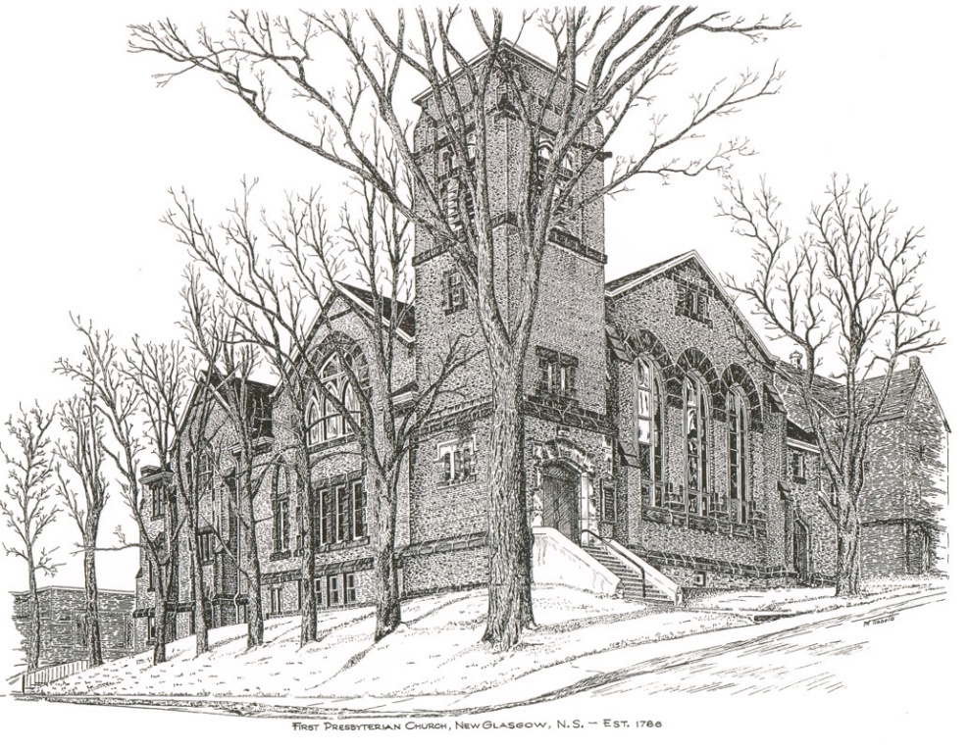

FIRST PRESBYTERIAN CHURCH
208 MacLean St., New Glasgow, NS
902-752-5691
First.church@ns.aliantzinc.ca
Reverend Andrew MacDonald
902-331-0322
yick96@hotmail.com

August 20th, 2023
12th Sunday After Pentecost
THE APPROACH
**Please Rise
Musical Prelude
Welcome and Announcements
**Lighting the Christ Candle: (Please rise if you are able)
One: Light has come into the world, but people loved darkness instead of light because their deeds were evil. Everyone who does evil hates the light, and will not come into the light for fear that their deeds will be exposed. But whoever lives by the truth comes into the light, so that it may be seen plainly that what they have done has been done in the sight of God.
ALL: ‘The light shines in the darkness, and the darkness has not overcome it.
(Light the candle)
One: Let us now prepare our hearts to worship almighty God.
**Musical Introit - #68 “Bless the Lord, O my soul”
Bless the Lord, O my soul, and all within me honour God’s name; bless the Lord, O my soul, and never forget all God’s blessings.
**Call to Worship
**Hymn #65 – “All people that on erth do well” vs. 1,2,4
1 All people that on earth do dwell,
sing to the Lord with cheerful voice.
Him serve with mirth; his praise forth tell.
Come ye before him and rejoice.

2 Know that the Lord is God indeed;
without our aid he did us make;
we are his flock, he doth us feed,
and for his sheep he doth us take.

4 For why, the Lord our God is good;
his mercy is forever sure;
his truth at all times firmly stood,
and shall from age to age endure.

Prayer of Adoration, Confession and Lord’s Prayer

Our Father which art in heaven, hallowed be thy name.

Thy kingdom come, thy will be done in earth,

as it is in heaven.

Give us this day our daily bread.

And forgive us our debts, as we forgive our debtors.

And lead us not into temptation, but deliver us from evil:

For thine is the kingdom, and the power, and the glory,

forever. Amen.

Assurance of Pardon
Passing the Peace
**Hymn – “This little light of mine”
1 This little light of mine,
I'm gonna let it shine.
This little light of mine,
I'm gonna let it shine.
This little light of mine,
I'm gonna let it shine,
let it shine, let it shine, oh let it shine.
2 Ev'rywhere I go,
I'm gonna let it shine.
Ev'rywhere I go,
I'm gonna let it shine.
Ev'rywhere I go,
I'm gonna let it shine,
let it shine, let it shine, oh let it shine.
3 Jesus gave it to me,
I'm gonna let it shine.
Jesus gave it to me,
I'm gonna let it shine.
Jesus gave it to me,
I'm gonna let it shine,
let it shine, let it shine, oh let it shine.
Children’s Time
Prayer of Illumination
First Lesson: Genesis 45:1-15
Epistle Lesson: Romans 11:1-2,29-32
Responsive Psalm 6
ONE: O Lord, do not rebuke me in your anger, or discipline me in your wrath.
ALL: Be gracious to me, O Lord, for I am languishing; O Lord, heal me, for my bones are shaking with terror.
ONE: My soul also is struck with terror, while you, O Lord—how long?
ALL: Turn, O Lord, save my life; deliver me for the sake of your steadfast love.
ONE: For in death there is no remembrance of you; in Sheol who can give you praise?
ALL: I am weary with my moaning; every night I flood my bed with tears; I drench my couch with my weeping.
ONE: My eyes waste away because of grief; they grow weak because of all my foes.
ALL: Depart from me, all you workers of evil, for the Lord has heard the sound of my weeping.
ONE: The Lord has heard my supplication; the Lord accepts my prayer.
ALL: All my enemies shall be ashamed and struck with terror; they shall turn back, and in a moment be put to shame.

Gloria Patri

Glory be to the Father, and to the Son, and to the Holy Spirit. As it was in the beginning, is now and will be forever.

Amen, amen, amen.

Gospel Reading: Matthew 14:13-21
Anthem
Sermon: “Mercy Abounding!”
**Reaffirmation of Faith – Apostles’ Creed

I believe in God, the Father Almighty, maker of Heaven and earth; and in Jesus Christ, His only Son, Our Lord, who was conceived by the Holy Ghost, born of the Virgin Mary,
suffered under Pontius Pilate, was crucified, died, and was buried. He descended into Hell. On the third day He arose again from the dead; He ascended into Heaven, and sits
at the right hand of God, the Father Almighty; from thence He shall come to judge the quick and the dead.
I believe in the Holy Ghost, the holy Catholic Church,
the communion of saints, the forgiveness of sins, the resurrection of the body, and the life everlasting. Amen.

**Hymn #751 – “Forgive our sons as we forgive” vs.1,2,4

1. 'Forgive our sins as we forgive,'
you taught us, Lord, to pray,
but you alone can grant us grace
to live the words we say.
2. How can your pardon reach and bless
the unforgiving heart,
that broods on wrongs and will not let
old bitterness depart?
4. Lord, cleanse the depths within our souls,
and bid resentment cease;
then, bound to all in bonds of love,
our lives will spread your peace.

Offertory

**Doxology

Praise God from whom all blessings flow.
Praise him all creatures, here below.
Praise him above ye heavenly host.
Praise Father, Son, and Holy Ghost.

Offertory Prayer

Prayers of the People:

**Hymn #334 – “God who gives to life its goodness”

- God who gives to life its goodness,
God creator of all joy,
God who gives to us our freedom,
God who blesses tool and toy:
teach us now to laugh and praise you
deep within, or shouted loud,
till the whole creation dances
for your goodness, holy God.

- God who fills the earth with beauty,
God who binds each friend to friend,
God who names us co-creators,
God who wills that chaos end:
grant us now creative spirits,
minds responsive to your mind,
hearts and wills your rule extending,
all our acts by Love refined.

**Benediction
Coral Response: Threefold Amen
Recessional
* * * * * * * * * * * * *
Minister: Rev. Andrew MacDonald (c) 902-331-0322
Organist: Clare Grieves
Office hours: Tues. to Fri. – 10 -1pm
Rev. MacDonald office hours -Tues. to Thurs. 10-2 or by appointment

Mission Statement: But he’s already made it plain how to live, what to do, what God is looking for in men and women. It’s quite simple. Do what is fair and just to your neighbor, be compassionate and loyal in your love, and don’t take yourself too seriously – take God seriously. Micah 6: 8-The Message
ANNOUNCEMENTS

All are welcome at First Presbyterian Church. We hope you experience the love of God and of this congregation as we worship, celebrate, and serve one another.

An In Memorium donation has been received in memory of Evelyn MacLeod from her friend, Margie Fraser.

UPCOMING EVENTS
TODAY – 3:00p.m. – Saint John’s Presbyterian Church, McLennan’s Mountain is holding their annual “Old Home Coming Service”. Guest speaker – Rev. Grant Johnston. Special music provided by organist Kenny Rockey with guest singers. There will be a time of fellowship and refreshments following the service. Everyone welcome.

Monthly coffee time – Please join us for coffee after service today. For anyone who would like to host, please contact Cathy Lewis at 902-759-9649. If you need help setting up the coffee maker or have any questions, contact Cathy.

Sept. 11th - 6:30 p.m. – The Board of Managers will meet.

We extend belated anniversary wishes to Donald and Marion Johnstone who celebrated their 65th wedding anniversary on Wednesday, Aug. 16th.
Keith and Shirley Cruickshank will celebrate their 61st wedding anniversary on Friday, Aug. 25th.
We also send anniversary greetings to John and Brenda Zinck who will celebrate their 53rd anniversary Tuesday, Aug. 22nd and to David and Marilyn Johnstone who will celebrate their 54th anniversary on Wednesday Aug. 23rd.
Happy Anniversary to all of you!!
Request from the Board of Managers - To help with operating expenses, we are seeking donations of the following items:
- paper towels
- toilet tissue
- clear and blue garbage/recycling bags.
Thank you for your consideration. Donations can be left at the office or in the entry at the MacLean St. entrance.
SCRIPTURE READERS & USHERS:
Scripture reader: Mark Thibeau
Ushers: Main Door (Office) – Mark & Jennifer Thibeau
James St. – Ruth-Anne MacIntosh
MacLean St. (Main Entrance steps) – Cathy Lewis
Early Christian Educators: Lynne Ann and Lois MacLellan

