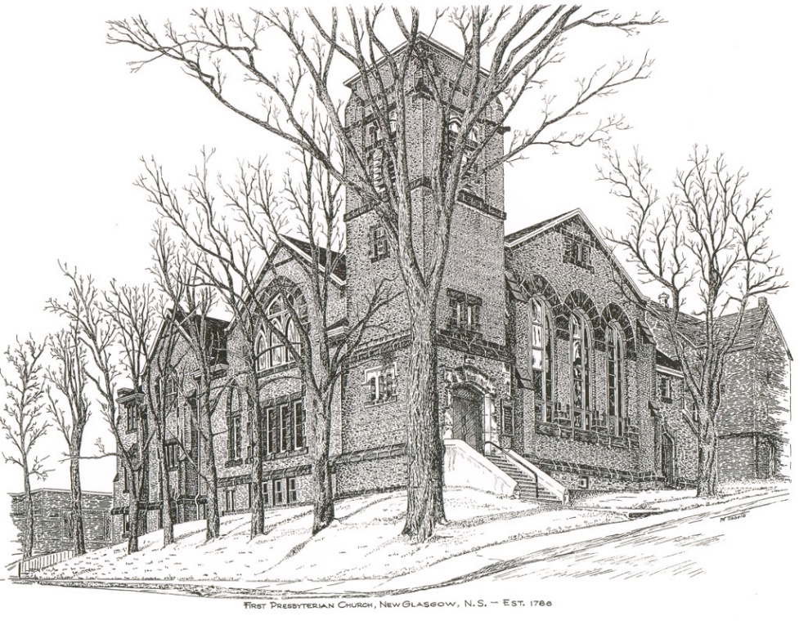

FIRST PRESBYTERIAN CHURCH
208 MacLean St., New Glasgow, NS
902-752-5691
First.church@ns.aliantzinc.ca
Reverend Andrew MacDonald
902-331-0322
yick96@hotmail.com

August 27th, 2023
13th Sunday After Pentecost
THE APPROACH
* * Please Rise
Musical Prelude
Welcome and Announcements
**Lighting the Christ Candle: (Please rise if you are able)
One: Jesus said: “You are going to have the light just a little while longer. Walk while you have the light, before darkness overtakes you. Whoever walks in the dark does not know where they are going. Believe in the light while you have the light, so that you may become children of light.”
ALL: The light shines in the darkness, and the darkness will not overcome it.
(Light the candle)
One: Let us now prepare our hearts to worship almighty God.
**Musical Introit - #68 “Bless the Lord, O my soul ”
Bless the Lord, O my soul, and all within me honour God’s name; bless the Lord, O my soul, and never forget all God’s blessings.
**Call to Worship
**Hymn #321 – “Praise to the Lord, the Almighty” vs. 1,3,4
1 Praise to the Lord,
the Almighty who rules all creation.
My soul, praise God
who alone is your health and salvation.
Come, all who hear,
sisters and brothers draw near,
joining in glad adoration.

3 Praise to the Lord,
who will prosper your work, who defends you;
surely God’s merciful goodness
here daily attends you;
ponder anew
what the Almighty can do,
when in great love God befriends you.

4 Praise to the Lord,
and with all that is in me adoring,
all who have life and breath,
come with glad praises outpouring!
Let the Amen sound from God’s people again:
now and forever adoring!

Prayer of Adoration, Confession and Lord’s Prayer

Our Father which art in heaven, hallowed be thy name.

Thy kingdom come, thy will be done in earth,

as it is in heaven.

Give us this day our daily bread.

And forgive us our debts, as we forgive our debtors.

And lead us not into temptation, but deliver us from evil:

For thine is the kingdom, and the power, and the glory,

forever. Amen.
Assurance of Pardon
Passing the Peace
**Hymn #797 – “Shall we gather at the river” vs. 1,2,3
1 Shall we gather at the river,
where bright angel feet have trod,
with its crystal tide forever
flowing from the throne of God?

Yes, we’ll gather at the river,
the beautiful, the beautiful river,
gather with the saints at the river
that flows from the throne of God.

2 On the bosom of the river,
where the Saviour King we own,
we shall meet, and sorrow never
neath the glory of the throne.

3 Ere we reach the shining river,
lay we every burden down;
grace our spirits will deliver,
and provide a robe and a crown.

Children’s Time
Prayer of Illumination
First Lesson: Exodus 1:8-2:10
Epistle Lesson: Romans 12:1-8
Responsive Psalm 124
ONE: If it had not been the Lord who was on our side—let Israel now say— if it had not been the Lord who was on our side, when our enemies attacked us, then they would have swallowed us up alive, when their anger was kindled against us; then the flood would have swept us away, the torrent would have gone over us; then over us would have gone the raging waters.
ALL: Blessed be the Lord, who has not given us as prey to their teeth.
ONE: We have escaped like a bird from the snare of the fowlers; the snare is broken, and we have escaped.
ALL: Our help is in the name of the Lord, who made heaven and earth.

Gloria Patri:

Glory be to the Father, and to the Son, and to the Holy Ghost.

As it was in the beginning, is now and ever shall be, world without end. Amen, amen.

Gospel Reading: Matthew 16:13-20
Anthem: “Give it all to Jesus”
Sermon: “What is Good and Acceptable, and Perfect?”
**Reaffirmation of Faith – Apostles’ Creed

I believe in God, the Father Almighty, maker of Heaven and earth; and in Jesus Christ, His only Son, Our Lord, who was conceived by the Holy Ghost, born of the Virgin Mary,
suffered under Pontius Pilate, was crucified, died, and was buried. He descended into Hell. On the third day He arose again from the dead; He ascended into Heaven, and sits
at the right hand of God, the Father Almighty; from thence He shall come to judge the quick and the dead.
I believe in the Holy Ghost, the holy Catholic Church,
the communion of saints, the forgiveness of sins, the resurrection of the body, and the life everlasting. Amen.

**Hymn #330 – “O God, our help in ages past ” vs. 1,3,4,6

1 O God, our help in ages past,
our hope for years to come,
our shelter from the stormy blast,
and our eternal home.

3 Before the hills in order stood,
or earth received its frame,
from everlasting thou art God,
to endless years the same.

4 A thousand ages in thy sight
are like an evening gone,
short as the watch that ends the night
before the rising sun.

6 O God, our help in ages past,
our hope for years to come,
still be our guard while troubles last,
and our eternal home.

Offertory

**Doxology

Praise God from whom all blessings flow.
Praise him all creatures, here below.
Praise him above ye heavenly host.
Praise Father, Son, and Holy Ghost.

Offertory Prayer

Prayers of the People

**Hymn #648 – “I’m going to live so God can use me” vs.1,3,4

1 I’m gonna live so God can use
me anywhere, Lord, anytime!
I’m gonna live so God can use me
anywhere, Lord, anytime!

3 I’m gonna pray so God can use me
anywhere, Lord, anytime!
I’m gonna pray so God can use me
anywhere, Lord, anytime!

4 I’m gonna sing so God can use me
anywhere, Lord, anytime!
I’m gonna sing so God can use me
anywhere, Lord, anytime!

**Benediction

Coral Response: Threefold Amen

Recessional
* * * * * * * * * * * * *

ANNOUNCEMENTS

All are welcome at First Presbyterian Church. We hope you experience the love of God and of this congregation as we worship, celebrate, and serve one another.

UPCOMING EVENTS

Monthly coffee time – We will host our next coffee hour on September 17th. As fall approaches, it’s a great time to reconnect with everyone after a busy summer! We keep it simple, cookies or muffins, something easy, with tea and coffee. If you would like to host sometime, please contact Cathy Lewis at 902-759-9649. Cathy will help with set up or answer any questions you have.
We send anniversary greetings to Robyn and Larry MacLeod who will celebrate their anniversary Tues., Aug. 29^{th.}
We also extend best wishes to Rev. Dr. Morley Shaw and Joy Shaw who will celbrate their 60th wedding anniversary Thurs., Aug. 31st. Congratulations to all of you!
Hymn requests: The “Request A Hymn” box has been placed on the piano for suggestions. If you have any special hymns you would like to hear, please leave a note in the box or email your request to Clare at: cgrieves24@gmail.com
SCRIPTURE READERS & USHERS:

Scripture reader: Kevin Reid
Ushers: Main Door (Office) – Mark & Jennifer Thibeau
James St. – Ruth-Anne MacIntosh
MacLean St. (Main Entrance steps) – Cathy Lewis
Early Christian Educators: Lynne Ann and Lois MacLellan

* * * * * * * * * * * * *
Minister: Rev. Andrew MacDonald (c) 902-331-0322
Organist: Clare Grieves
Office hours: Tues. to Fri. – 10 -1pm
Rev. MacDonald office hours -Tues. to Thurs. 10-2 or by appointment

Mission Statement: But he’s already made it plain how to live, what to do, what God is looking for in men and women. It’s quite simple. Do what is fair and just to your neighbor, be compassionate and loyal in your love, and don’t take yourself too seriously – take God seriously. Micah 6: 8-The Message

