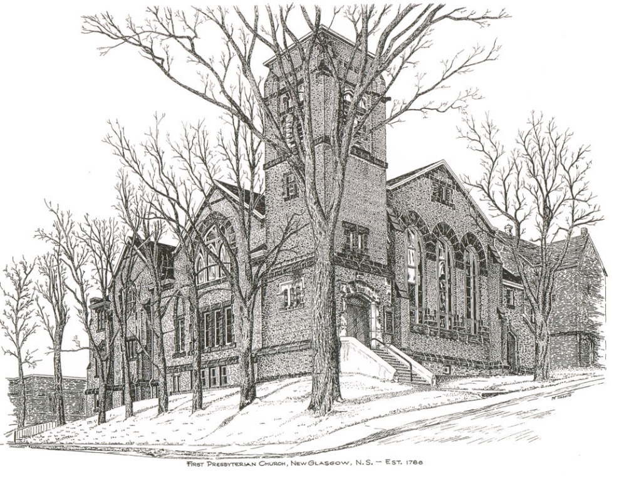

FIRST PRESBYTERIAN CHURCH
208 MacLean St., New Glasgow, NS
902-752-5691
First.church@ns.aliantzinc.ca
Reverend Andrew MacDonald
902-331-0322
yick96@hotmail.com

August 6th, 2023
10th Sunday After Pentecost
THE APPROACH
Musical Prelude
Welcome and Announcements
Lighting the Christ Candle: (Please rise if you are able)
One: In the beginning was the Word, and the Word was with God, and the Word was God. He was in the beginning with God. All things came into being through him, and without him not one thing came into being. What has come into being in him was life, and the life was the light of all people. The light shines in the darkness, and the darkness did not overcome it.
ALL: ‘You are the light of the world. A city built on a hill cannot be hidden. No one after lighting a lamp puts it under the bushel basket, but on the lampstand, and it gives light to all in the house. In the same way, let your light shine before others, so that they may see your good works and give glory to your Father in heaven.
(Light the candle)
One: Let us now prepare our hearts to worship almighty God.
Musical Introit - #68 “Bless the Lord, O my soul ”
Call to Worship
Hymn #371 – “Love Devine, all love’s excelling” vs.1,3,4
1 Love divine, all loves excelling,
joy of heaven, to earth come down;
fix in us thy humble dwelling,
all thy faithful mercies crown.
Jesus, thou art all compassion,
pure, unbounded love thou art;
visit us with thy salvation;
enter every trembling heart.

3 Come, almighty to deliver,
let us all thy grace receive;
suddenly return and never,
never more thy temples leave.
Thee we would be always blessing,
serve thee as thy hosts above,
pray and praise thee, without ceasing,
glory in thy perfect love.

4 Finish now thy new creation;
pure and spotless let us be;
let us see thy great salvation
perfectly restored in thee,
changed from glory into glory
till in heaven we take our place,
till we cast our crowns before thee,
lost in wonder, love and praise.

Prayer of Adoration, Confession and Lord’s Prayer

Our Father which art in heaven, hallowed be thy name.

Thy kingdom come, thy will be done in earth,

as it is in heaven.

Give us this day our daily bread.

And forgive us our debts, as we forgive our debtors.

And lead us not into temptation, but deliver us from evil:

For thine is the kingdom, and the power, and the glory,

forever. Amen.
Assurance of Pardon
Passing the Peace
Hymn #389 – “Breathe on me, breath of God” vs.1,3,4

1 Breathe on me, breath of God;
fill me with life anew,
that I may love what thou dost love
and do what thou wouldst do.

3 Breathe on me, breath of God,
till I am wholly thine,
until this earthly part of me
glows with thy fire divine.

4 Breathe on me, breath of God,
so shall I never die,
but live with thee the perfect life
of thine eternity.
Children’s Time
Prayer of Illumination
First Lesson: Genesis 32:22-31
Epistle Lesson: Romans 9:1-5
Responsive Psalm:
ONE: Hear a just cause, O Lord; attend to my cry; give ear to my prayer from lips free of deceit. From you let my vindication come; let your eyes see the right.
ALL: If you try my heart, if you visit me by night, if you test me, you will find no wickedness in me; my mouth does not transgress. As for what others do, by the word of your lips I have avoided the ways of the violent. My steps have held fast to your paths; my feet have not slipped.
ONE: I call upon you, for you will answer me, O God; incline your ear to me, hear my words. Wondrously show your steadfast love, O saviour of those who seek refuge from their adversaries at your right hand.
ALL: As for me, I shall behold your face in righteousness; when I awake I shall be satisfied, beholding your likeness.
Gloria Patri

Glory be to the Father, and to the Son, and to the Holy Ghost. As it was in the beginning, is now and ever shall be, world without end. Amen, amen.

Gospel Reading: Matthew 14:13-21
Anthem
Sermon: “Looking at the Face of God!”
Reaffirmation of Faith – Apostles’ Creed – Please rise

I believe in God, the Father Almighty, maker of Heaven and earth; and in Jesus Christ, His only Son, Our Lord, who was conceived by the Holy Ghost, born of the Virgin Mary,
suffered under Pontius Pilate, was crucified, died, and was buried. He descended into Hell. On the third day He arose again from the dead; He ascended into Heaven, and sits
at the right hand of God, the Father Almighty; from thence He shall come to judge the quick and the dead.
I believe in the Holy Ghost, the holy Catholic Church,
the communion of saints, the forgiveness of sins, the resurrection of the body, and the life everlasting. Amen.

Hymn #485 – “Savior, like a shepherd lead us”

1 Saviour, like a shepherd lead us:
much we need your tender care;
in your pleasant pastures feed us;
for our use your folds prepare:
blessed Jesus, blessed Jesus!
You have bought us; yours we are.
Blessed Jesus, blessed Jesus!
You have bought us; yours we are.

2 We are yours; in love befriend us;
be the guardian of our way;
keep your flock from sin, defend us;
seek us when we go astray:
blessed Jesus, blessed Jesus!
Hear your children when we pray.
Blessed Jesus, blessed Jesus!
Hear your children when we pray.

3 Let us always seek your favour;
let us always do your will.
Jesus Christ our only Saviour,
with yourself our spirits fill:
blessed Jesus, blessed Jesus!
You have loved us, love us still.
Blessed Jesus, blessed Jesus!
You have loved us, love us still.

Offertory Prayer

Prayers of the People:

Hymn #638 – “Take time to be holy” vs. 1,3,4

1 Take time to be holy; speak oft with thy Lord.
Abide in him always, and feed on his word.
Make friends with God’s children,
help those who are weak,
forgetting in nothing his blessing to seek.

3 Take time to be holy; let him be thy guide,
and run not before him, whatever betide.
In joy and in sorrow, still follow thy Lord,
and, looking to Jesus, still trust in his word.

4 Take time to be holy; be calm in thy soul,
each thought and each motive
beneath his control.
Thus led by his Spirit to fountains of love,
thou soon will be fitted for service above.

Benediction

Coral Response: Threefold Amen
Recessional
* * * * * * * * * * * * *
ANNOUNCEMENTS

All are welcome at First Presbyterian Church. We hope you experience the love of God and of this congregation as we worship, celebrate, and serve one another.

UPCOMING EVENTS
We extend belated birthday greetings to Wayne Withers who celerated his birthday August 1st.
We send our best wishes to June Smith who celebrates her birthday today, August 6th! Finally, we wish Frances Kennedy a happy birthday Wednesday, August 9th.
Monthly coffee time – Coffee hour will be held the third Sunday of the month. Next coffee date is August 20th. For anyone who would like to host, please contact Cathy Lewis at 902-759-9649. If you need help setting up the coffee maker or have any questions, contact Cathy.
SCRIPTURE READERS & USHERS:
Scripture reader: Chet Fleming
Ushers: Main Door (Office) – Mark & Jennifer Thibeau
James St. – Ruth-Anne MacIntosh
MacLean St. (Main Entrance steps) – Cathy Lewis
Early Christian Educators: Lynne Ann and Lois MacLellan
We extend belated birthday greetings to Wayne Withers who celerated his birthday August 1st.
We send our best wishes to June Smith who celebrates her birthday today, August 6th! Finally, we wish Frances Kennedy a happy birthday Wednesday, August 9th.
Monthly coffee time – Coffee hour will be held the third Sunday of the month. Next coffee date is August 20th. For anyone who would like to host, please contact Cathy Lewis at 902-759-9649. If you need help setting up the coffee maker or have any questions, contact Cathy.
SCRIPTURE READERS & USHERS:
Scripture reader: Clarice Campbell
Ushers: Main Door (Office) – Brent MacQuarrie and Sara Fullerton
James St. – Ruth-Anne MacIntosh
MacLean St. (Main Entrance steps) – Ellen Jardine
Early Christian Educators: Lynne Ann and Lois MacLellan

* * * * * * * * * * * * *

Minister: Rev. Andrew MacDonald (c) 902-331-0322
Organist: Clare Grieves
Office hours: Tues. to Fri. – 10 -1pm
Rev. MacDonald office hours -Tues. to Thurs. 10-2 or by appointment

Mission Statement: But he’s already made it plain how to live, what to do, what God is looking for in men and women. It’s quite simple. Do what is fair and just to your neighbor, be compassionate and loyal in your love, and don’t take yourself too seriously – take God seriously. Micah 6: 8-The Message

