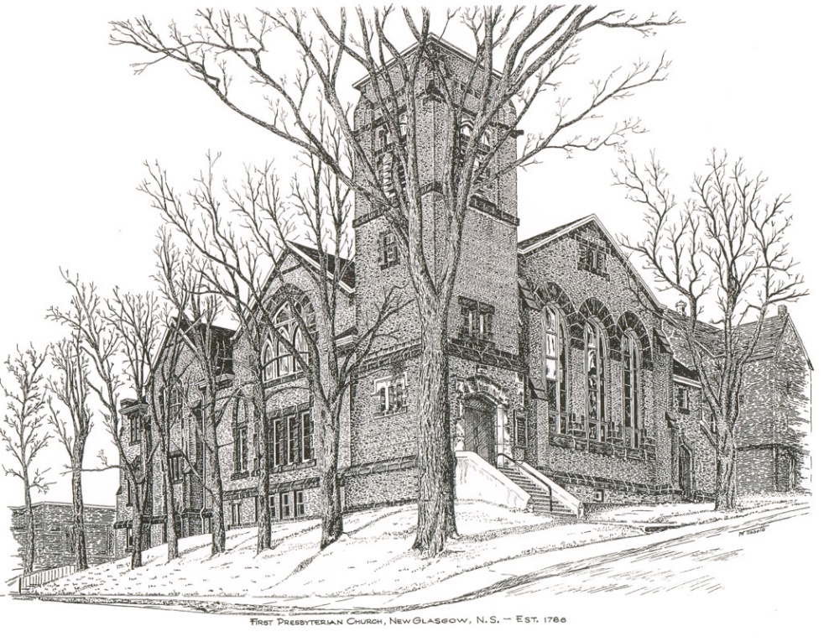

FIRST PRESBYTERIAN CHURCH
208 MacLean St., New Glasgow, NS
902-752-5691
First.church@ns.aliantzinc.ca
Reverend Andrew MacDonald
902-331-0322
yick96@hotmail.com

September 3rd, 2023
14th Sunday After Pentecost
THE APPROACH

** Please Rise **
Musical Prelude
Welcome and Announcements
**Lighting the Christ Candle:
One: The unbelievers have become blinded to the light, to keep them from seeing the light of the gospel of the glory of Christ, who is the image of God. For we do not proclaim ourselves; we proclaim Jesus Christ as Lord and ourselves as your slaves for Jesus’ sake. For it is the God who said, ‘Let light shine out of darkness’, who has shone in our hearts to give the light of the knowledge of the glory of God in the face of Jesus Christ.
ALL: For what do righteousness and wickedness have in common? Or what fellowship can light have with darkness? What harmony is there between Christ and Belial? Or what does a believer have in common with an unbeliever? For you are all children of light, children of the day. We are not of the night or of the darkness.
(Light the candle)
One: Let us now prepare our hearts to worship almighty God.
**Musical Introit
**Call to Worship

**Hymn #510 – “Deep in the shadows of the past” vs1,2,4
1 Deep in the shadows of the past,
far out from settled lands,
some nomads traveled with their God
across the desert sands.
The dawning hope of humankind
by them was sensed and shown;
a promise calling them ahead
a future yet unknown.

2 While others bowed to changeless gods,
they met a mystery,
invisible, without a name:
“I AM WHAT I WILL BE”;
and by their tents, around their fires,
in story, song and law,
they praised, remembered, handed on
a past that promised more.

4 For all the writings that survived,
for leaders long ago,
who sifted, copied and preserved
the Bible that we know,
give thanks, and find its story yet
our promise, strength and call,
the model of emerging faith,
alive with hope for all.

Prayer of Adoration, Confession and Lord’s Prayer

Our Father which art in heaven, hallowed be thy name.

Thy kingdom come, thy will be done in earth,

as it is in heaven.

Give us this day our daily bread.

And forgive us our debts, as we forgive our debtors.

And lead us not into temptation, but deliver us from evil:

For thine is the kingdom, and the power, and the glory,

forever. Amen.

Assurance of Pardon
Passing the Peace
**Hymn #521 – “Child of blessing, child of promise”

- Child of blessing, child of promise,
baptized with the Spirit's sign,
with this water God has sealed you
unto love and grace divine.

- Child of love, our love's expression,
love's creation, loved indeed!
Fresh from God, refresh our spirits,
into joy and laughter lead.

- Child of joy, our dearest treasure,
God's you are; from God you came.
Back to God we humbly give you:

- Child of God, your loving Parent,
learn to know whose child you are.
Grow to laugh and sing and worship,
trust and love God more than all.

Children’s Time
Prayer of Illumination
First Lesson: Exodus 3:1-15
Epistle Lesson: Romans 12:9-21
Responsive Psalm 26

ONE: Vindicate me, O Lord, for I have walked in my integrity, and I have trusted in the Lord without wavering.
ALL: Prove me, O Lord, and try me; test my heart and mind.
ONE: For your steadfast love is before my eyes, and I walk in faithfulness to you.
All: I do not sit with the worthless, nor do I consort with hypocrites; I hate the company of evildoers, and will not sit with the wicked.
ONE: I wash my hands in innocence, and go around your altar, O Lord, singing aloud a song of thanksgiving, and telling all your wondrous deeds.
ALL: O Lord, I love the house in which you dwell, and the place where your glory abides.
ONE: Do not sweep me away with sinners, nor my life with the bloodthirsty, those in whose hands are evil devices, and whose right hands are full of bribes.
ALL: But as for me, I walk in my integrity; redeem me, and be gracious to me.
ONE: My foot stands on level ground; in the great congregation I will bless the Lord.

Gloria Patri

Glory be to the Father, and to the Son, and to the Holy Ghost. As it was in the beginning, is now will be, forever.

Amen, amen, amen.

Gospel Reading: Matthew 16:21-28
Anthem
Sermon: “Living Christian!”
**Reaffirmation of Faith – Apostles’ Creed

I believe in God, the Father Almighty, maker of Heaven and earth; and in Jesus Christ, His only Son, Our Lord, who was conceived by the Holy Ghost, born of the Virgin Mary,
suffered under Pontius Pilate, was crucified, died, and was buried. He descended into Hell. On the third day He arose again from the dead; He ascended into Heaven, and sits
at the right hand of God, the Father Almighty; from thence He shall come to judge the quick and the dead.
I believe in the Holy Ghost, the holy Catholic Church,
the communion of saints, the forgiveness of sins, the resurrection of the body, and the life everlasting. Amen.

**Hymn #712 – “Arise, your light is come”
1 Arise, your light is come!
The Spirit’s call obey;
show forth the glory of your God
which shines on you today.

2 Arise, your light is come!
Fling wide the prison door;
proclaim the captive’s liberty,
good tidings to the poor.

3 Arise, your light is come!
All you in sorrow born,
bind up the broken-hearted ones
and comfort those who mourn.

4 Arise, your light is come!
The mountains burst in song!
Rise up like eagles on the wing;
God’s power will make us strong.

Offertory

**Doxology #830 - “Praise God from whom all blessings flow”
Praise God from whom all blessings Flow. Praise Him all creatures here below. Praise Him above Ye Heavenly Host. Praise Father, Son, and Holy Ghost. Amen.

Offertory Prayer
Prayers of the People:
**Hymn #767 – “Lord, speak to me” vs. 1,2,4
1 Lord, speak to me, that I may speak
in living echoes of your tone;
as you have sought, so let me seek
your erring children lost and lone.

2 Oh lead me, Lord, that I may lead
the wandering and the wavering feet;
oh feed me, Lord, that I may feed
your hungering ones with manna sweet.

4 Oh fill me with your fullness, Lord,
until my heart shall overflow
in kindling thought and glowing word,
your love to tell, your praise to show.

**Benediction
Coral Response: Threefold Amen
Recessional

* * * * * * * * * * * * *

ANNOUNCEMENTS

All are welcome at First Presbyterian Church. We hope you experience the love of God and of this congregation as we worship, celebrate, and serve one another.

UPCOMING EVENTS

Monthly coffee time – We will host our next coffee hour on September 17th. As fall approaches, it’s a great time to reconnect with everyone after a busy summer! We keep it simple, cookies or muffins, something easy, with tea and coffee. If you would like to host sometime, please contact Cathy Lewis at 902-759-9649. Cathy will help with set up or answer any questions you have.
Birthday wishes are sent to Barry Fraser who is celebrating his birthday today, Sept. 3rd.
We also send birthday greetings to Laura Macumber who will celebrate her birthday Fri., Sept. 8th.

… to Chet Fleming for repairing the step at the James St. entrance.

Hymn requests: The “Request A Hymn” box has been placed on the piano for suggestions. If you have any special hymns you would like to hear, please leave a note in the box or email your request to Clare at: cgrieves24@gmail.com
SCRIPTURE READERS & USHERS:

Scripture reader: Sharon Mason
Ushers: Main Door (Office) – Sherry Green and Ian Semple
James St. – Ruth-Anne MacIntosh
MacLean St. (Main Entrance steps) – Ellen Jardine
Early Christian Educators: Lynne Ann and Lois MacLellan

Minister: Rev. Andrew MacDonald (c) 902-331-0322
Organist: Clare Grieves
Office hours: Tues. to Fri. – 10 -1pm
Rev. MacDonald office hours -Tues. to Thurs. 10-2 or by appointment
Mission Statement: But he’s already made it plain how to live, what to do, what God is looking for in men and women. It’s quite simple. Do what is fair and just to your neighbor, be compassionate and loyal in your love, and don’t take yourself too seriously – take God seriously. Micah 6: 8-The Message

