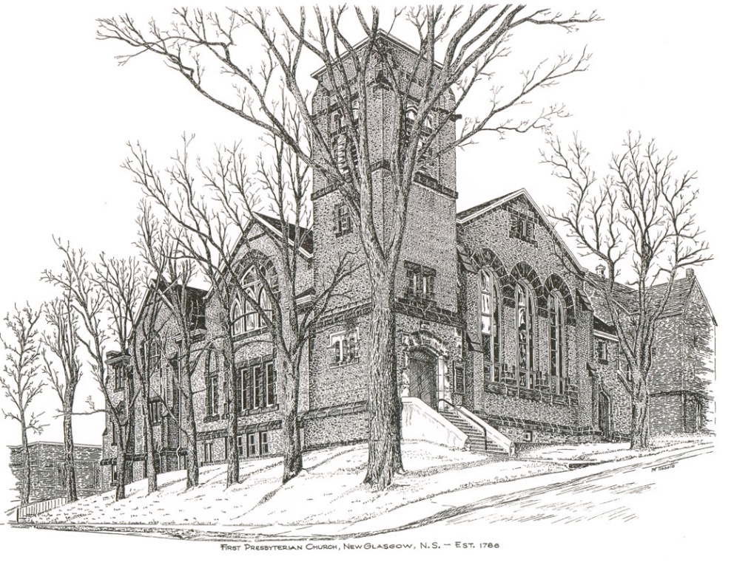

FIRST PRESBYTERIAN CHURCH
208 MacLean St., New Glasgow, NS
902-752-5691
First.church@ns.aliantzinc.ca
Reverend Andrew MacDonald
902-331-0322
yick96@hotmail.com

October 1st, 2023
18th Sunday After Pentecost
THE APPROACH

** Please Rise **
Musical Prelude
Welcome and Announcements
**Lighting the Christ Candle:
One: I saw no temple in the city, for its temple is the Lord God the Almighty and the Lamb. And the city has no need of sun or moon to shine on it, for the glory of God is its light, and its lamp is the Lamb. The nations will walk by its light, and the kings of the earth will bring their glory into it. Its gates will never be shut by day—and there will be no night there. People will bring into it the glory and the honour of the nations.
ALL: The LORD is my light and my salvation— whom shall I fear? The LORD is the stronghold of my life— of whom shall I be afraid? (Light the candle)
One: Let us now prepare our hearts to worship almighty God.
**Musical Introit - “Dance with the Spirit”
Dance with the spirit early in the morning
Walk with the spirit throughout the long day
Work and hope for the new day abornin’
Listen to the spirit to show you the way (repeat)

**Call to Worship
**Hymn #46 –“We will tell each generation”

1 We will tell each generation
all that you, our God, have done;
how you called and led our nation,
chose us out to be your own:

2 Tell the time of our rebelling –
how we wandered from your way,
how your law our love compelling
taught us humbly to obey;

3 Tell how once, when spite and terror
threatened to engulf our land,
you defended us with vigour,
saved us by a mighty hand.

4 Tell the grace that falls from heaven,
angels’ food as faith’s reward;
tell how sins may be forgiven
through the mercy of the Lord.

Prayer of Adoration, Confession and Lord’s Prayer

Our Father which art in heaven, hallowed be thy name.

Thy kingdom come, thy will be done in earth,

as it is in heaven.

Give us this day our daily bread.

And forgive us our debts, as we forgive our debtors.

And lead us not into temptation, but deliver us from evil:

For thine is the kingdom, and the power, and the glory,

forever. Amen.
Assurance of Pardon
Passing the Peace
**Hymn #530 – “I come with joy”

- I come with joy, a child of God,
forgiven, loved and free,
the life of Jesus to recall,
in love laid down for me,
in love laid down for me.

- I come with Christians far and near,
to find, as all are fed,
the new community of love
in Christ’s communion bread,
in Christ’s communion bread.

- As Christ breaks bread and bids us share,
each proud division ends.
The love that made us, makes us one,
and strangers now are friends,
and strangers now are friends.

- The Spirit of the risen Christ.
unseen, but ever near,
it is such friendship better known,
alive among us here,
alive among us here.

- Together met, together bound
by all that God has done,
we’ll go with joy, to give the world
the love that makes us one,
the love that makes us one.

Children’s Time
Prayer of Illumination
First Lesson: Exodus 17:1-7
Epistle Lesson: Philippians 2:1-13
Responsive Psalm 25:1-9
ONE: To you, O Lord, I lift up my soul. O my God, in you I trust; do not let me be put to shame; do not let my enemies exult over me.
ALL: Do not let those who wait for you be put to shame; let them be ashamed who are wantonly treacherous.
ONE: Make me to know your ways, O Lord; teach me your paths.
ALL: Lead me in your truth, and teach me, for you are the God of my salvation; for you I wait all day long.
One: Be mindful of your mercy, O Lord, and of your steadfast love, for they have been from of old.
ALL: Do not remember the sins of my youth or my transgressions; according to your steadfast love remember me, for your goodness’ sake, O Lord!
One: Good and upright is the Lord; therefore he instructs sinners in the way.
All: He leads the humble in what is right, and teaches the humble his way.

Gloria Patri

Glory be to the Father, and to the Son, and to the Holy Ghost.

As it was in the beginning,

is now will be, forever.

Amen, amen, amen.

Gospel Reading: Matthew 21:23-32
Anthem: Trumpet Solo - Brent MacQuarrie - “Gabriel’s Oboe”
Sermon: “By Whose Authority!”
**Reaffirmation of Faith – Apostles’ Creed

I believe in God, the Father Almighty, maker of Heaven and earth; and in Jesus Christ, His only Son, Our Lord, who was conceived by the Holy Ghost, born of the Virgin Mary,
suffered under Pontius Pilate, was crucified, died, and was buried. He descended into Hell. On the third day He arose again from the dead; He ascended into Heaven, and sits
at the right hand of God, the Father Almighty; from thence He shall come to judge the quick and the dead.
I believe in the Holy Ghost, the holy Catholic Church,
the communion of saints, the forgiveness of sins, the resurrection of the body, and the life everlasting. Amen.

**Hymn #528 – “Jesus calls us here to meet him”
1 Jesus calls us here to meet him
as, through word and song and prayer,
we affirm God’s promised presence
where his people live and care.
Praise the God who keeps His promise;
praise the Son who calls us friends;
praise the Spirit who, among us,
to our hopes and fears attends.

2 Jesus calls us to confess him
Word of Life and Lord of all,
sharer of our flesh and frailness
saving all who fail or fall.
Tell his holy human story;
tell his tales that all may hear;
tell the world that Christ in glory
came to earth to meet us here.

3 Jesus calls us to each other:
found in him are no divides.
Race and class and sex and language:
such are barriers he derides.
Join the hands of friend and stranger;
join the hands of age and youth;
join the faithful and the doubter
in their common search for truth.

4 Jesus calls us to his table
rooted firm in time and space,
where the church in earth and heaven
finds a common resting place.
Share the bread and wine, his body;
share the love of which we sing;
share the feast for saints and sinners
hosted by our Lord and King.

Offertory
**Doxology
Praise God from whom all blessings Flow. Praise Him all creatures here below. Praise Him above Ye Heavenly Host. Praise Father, Son, and Holy Ghost. Amen.

Offertory Prayer
Prayers of the People: The People Respond
ONE: God our Maker,
ALL: Make us a sharing people.

**Hymn #775 – “Sent forth by your blessing”

1 Sent forth by your blessing,
our true faith confessing,
your people, O God, from your table take leave.
The supper has ended: oh now be extended
the fruits of your service in all who believe.
The seed of your teaching,
our hungry souls reaching,
shall blossom in action for all humankind.
Your grace shall incite us,
your love shall unite us
to work for your kingdom,
your purpose to find.

2 With praise and thanksgiving
to God ever-living
the task of our everyday life we will face,
our faith ever sharing, in love ever caring,
embracing as neighbours
all those of each race.
One feast that has fed us,
one light that has led us, unite us as one
in your life that we share.
Then may all the living,
with praise and thanksgiving
give honour to Christ and his name that we bear.

**Benediction
Coral Response: Threefold Amen
Recessional

* * * * * * * * * * * * *

Minister: Rev. Andrew MacDonald (c) 902-331-0322
Organist: Clare Grieves
Office hours: Tues. to Fri. – 10 -1pm
Rev. MacDonald office hours -Tues. to Thurs. 10-2 or by appointment

Mission Statement: But he’s already made it plain how to live, what to do, what God is looking for in men and women. It’s quite simple. Do what is fair and just to your neighbor, be compassionate and loyal in your love, and don’t take yourself too seriously – take God seriously. Micah 6: 8-The Message

ANNOUNCEMENTS

All are welcome at First Presbyterian Church. We hope you experience the love of God and of this congregation as we worship, celebrate, and serve one another.

PASTORAL CARE:
In order to provide support to the people of First Church, when you or a loved one is sick or in hospital, we encourage you to contact the church (902-752-5691), Reverend Andrew (902-331-0322) or Cathy Lewis, Chair of the Pastoral Care Team (902-759-9649), to inform us directly. It is also important that you inform the hospital that you would welcome a visit from your minister and/or your Elder.
UPCOMING EVENTS
- Mon., Oct. 2 – 6:30 p.m. – The Board of Managers will meet
- Sun., Oct. 22nd – 7:00 p.m. – St. Andrew’s Presbyterian, Westville is hosting a “Fall Evening Concert”, featuring Special Guest Choir, the Alcorns and other invited musicians. Social time following in the church hall. Everyone welcome!
Notice: Access to the church driveway may be blocked due to continuing brick work being done on this side of the church.
Hymn requests: The “Request A Hymn” box has been placed on the piano for suggestions. If you have any special hymns you would like to hear, please leave a note in the box or email your request to Clare at: cgrieves24@gmail.com
Thanksgiving Sun., Oct 8th. We are decorating our sanctuary for Thanksgiving and welcome donated food items which will later be given to the Pictou County Food Bank. If you would like to contribute, please leave your items on the communion table at the front of the church.

SCRIPTURE READERS & USHERS:
Scripture reader: Brent MacQuarrie
Ushers: Main Door (Office) – Cathy Lewis and Phyllis O’Brien
James St. – Ruth-Anne MacIntosh
MacLean St. (Main Entrance steps) – Ellen Jardine
Early Christian Educators: Lynne Ann and Lois MacLellan

GEDDIE SPAGEDDIE
Saturday, October 14
4-6 pm
FIRST CHURCH HALL
PRINCE STREET, PICTOU
Admission by free-will offering to support a
much needed water filtration system at the Camp.
Everyone welcome.
(vegetarian option available)

