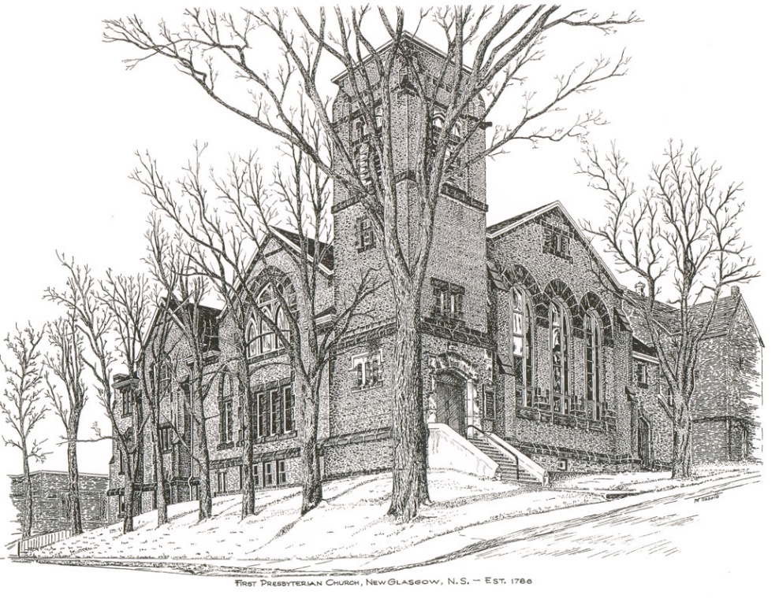

FIRST PRESBYTERIAN CHURCH
208 MacLean St., New Glasgow, NS
902-752-5691
First.church@ns.aliantzinc.ca
Reverend Andrew MacDonald
902-331-0322
yick96@hotmail.com

October 15th, 2023
20th Sunday After Pentecost
THE APPROACH

** Please Rise **
Musical Prelude
Welcome and Announcements
**Lighting the Christ Candle:
One: Jesus said: ‘You are the light of the world. A city built on a hill cannot be hidden. No one after lighting a lamp puts it under the bushel basket, but on the lampstand, and it gives light to all in the house. In the same way, let your light shine before others, so that they may see your good works and give glory to your Father in heaven.
ALL: You, LORD, You light my lamp; the Lord my God illumines my darkness. (Light the candle)
One: Let us now prepare our hearts to worship almighty God.
**Musical Introit - “Dance with the Spirit”
Dance with the spirit early in the morning
Walk with the spirit throughout the long day
Work and hope for the new day abornin’
Listen to the spirit to show you the way (repeat)

**Call to Worship
**Hymn #477 –“Your hand O God, has guided” vs. 1,2,4
1 Your hand, O God, has guided
your flock from age to age;
the wondrous tale is written
full clear on every page;
our forefathers knew your goodness,
and we their deed record,
and both of this bear witness,
One church, one faith, one Lord

2 Your heralds brought glad tidings
to greatest, as to least;
they summoned all to hasten
to share the great King’s feast,
and this was all their teaching,
in every deed and word,
to all alike proclaiming,
One church, one faith, one Lord.

4 Your mercy will not fail us,
nor leave your work undone;
with your right hand to help us,
the victory shall be won,
and then by earth and heaven
your name shall be adored,
and this shall be their anthem,
One church, one faith, one Lord.

Prayer of Adoration, Confession and Lord’s Prayer

Our Father which art in heaven, hallowed be thy name.

Thy kingdom come, thy will be done in earth,

as it is in heaven.

Give us this day our daily bread.

And forgive us our debts, as we forgive our debtors.

And lead us not into temptation, but deliver us from evil:

For thine is the kingdom, and the power, and the glory,

forever. Amen.
Assurance of Pardon
Passing the Peace
**Hymn #421 – “Rejoice in the Lord” (repeat)
Rejoice in the Lord always, and again I say, Rejoice!
Rejoice in the Lord always, and again I say, Rejoice!
Rejoice! Rejoice! and again I say, Rejoice!
Rejoice! Rejoice! and again I say, Rejoice!

Children’s Time
Prayer of Illumination
First Lesson: Hebrews 4:12-16
Epistle Lesson: Philippians 4:1-9
Responsive Psalm 106:1-6, 19-23
ONE: Praise the Lord! O give thanks to the Lord, for he is good; for his steadfast love endures for ever.
ALL: Who can utter the mighty doings of the Lord, or declare all his praise? Happy are those who observe justice, who do righteousness at all times.
ONE: Remember me, O Lord, when you show favour to your people; help me when you deliver them; that I may see the prosperity of your chosen ones, that I may rejoice in the gladness of your nation, that I may glory in your heritage.
ALL: Both we and our ancestors have sinned; we have committed iniquity, have done wickedly.
ONE: They made a calf at Horeb and worshipped a cast image.
ALL: They exchanged the glory of God for the image of an ox that eats grass.
ONE: They forgot God, their Saviour, who had done great things in Egypt, wondrous works in the land of Ham, and awesome deeds by the Red Sea.
ALL: Therefore, he said he would destroy them—had not Moses, his chosen one, stood in the breach before him, to turn away his wrath from destroying them.
**Gloria Patri

Glory be to the Father, and to the Son, and to the Holy Ghost.

As it was in the beginning,

is now will be, forever. Amen, amen, amen.

Gospel Reading: Mark 10:17-31
Anthem: “Like A Shepherd”
Sermon: “Give All, Gain More!”
**Reaffirmation of Faith – Apostles’ Creed

I believe in God, the Father Almighty, maker of Heaven and earth; and in Jesus Christ, His only Son, Our Lord, who was conceived by the Holy Ghost, born of the Virgin Mary,
suffered under Pontius Pilate, was crucified, died, and was buried. He descended into Hell. On the third day He arose again from the dead; He ascended into Heaven, and sits
at the right hand of God, the Father Almighty; from thence He shall come to judge the quick and the dead.
I believe in the Holy Ghost, the holy Catholic Church,
the communion of saints, the forgiveness of sins, the resurrection of the body, and the life everlasting. Amen.

**Hymn #497 – “Word of God, across the ages”
1 Word of God, across the ages
comes your message to our life,
source of hope, forever present
in our toil and fears and strife,
constant witness to God’s mercy,
still our grace, whate’er befall,
guide unfailing, strength eternal,
offered freely to us all.

2 Story of our wondrous journey
from the shadows of the night,
garnered truth of sage and prophet,
guiding forward into light,
words and deeds of Christ our teacher,
pointing to the life and way,
still appealing, still inspiring,
in the struggles of our day.

3 In the tongues of all the peoples
may the message bless and heal,
as devout and patient scholars
more and more its depth reveal.
Bless, O God, to wise and simple,
all your truth of ageless worth,
till all lands receive the witness
and your knowledge fills the earth.

Offertory
**Doxology
Praise God from whom all blessings Flow. Praise Him all creatures here below. Praise Him above Ye Heavenly Host. Praise Father, Son, and Holy Ghost. Amen.

Offertory Prayer
Prayers of the People:
**Hymn #485 – “Saviour, like a shepherd lead us”
1 Saviour, like a shepherd lead us:
much we need your tender care;
in your pleasant pastures feed us;
for our use your folds prepare:
blessed Jesus, blessed Jesus!
You have bought us; yours we are.
Blessed Jesus, blessed Jesus!
You have bought us; yours we are.

2 We are yours; in love befriend us;
be the guardian of our way;
keep your flock from sin, defend us;
seek us when we go astray:
blessed Jesus, blessed Jesus!
Hear your children when we pray.
Blessed Jesus, blessed Jesus!
Hear your children when we pray.

3 Let us always seek your favour;
let us always do your will.
Jesus Christ our only Saviour,
with yourself our spirits fill:
blessed Jesus, blessed Jesus!
You have loved us, love us still.
Blessed Jesus, blessed Jesus!
You have loved us, love us still.

**Benediction
Coral Response: Threefold Amen
Recessional

ANNOUNCEMENTS

All are welcome at First Presbyterian Church. We hope you experience the love of God and of this congregation as we worship, celebrate, and serve one another.

PASTORAL CARE:
In order to provide support to the people of First Church, when you or a loved one is sick or in hospital, we encourage you to contact the church (902-752-5691), Reverend Andrew (902-331-0322) or Cathy Lewis, Chair of the Pastoral Care Team (902-759-9649), to inform us directly. It is also important that you inform the hospital that you would welcome a visit from your minister and/or your Elder.
UPCOMING EVENTS
- Sun., Oct. 22nd – 7:00 p.m. – St. Andrew’s Presbyterian, Westville is hosting a “Fall Evening Concert”, featuring Special Guest Choir, the Alcorns and other invited musicians. Social time following in the church hall. Everyone welcome!
- Sat., Oct. 21st - 9a.m-1p.m. – A Christmas Craft Sale will be held in Bethel Church Hall, Pictou Landing. Many vendors with lots of unique ideas for everyone on your list.
Admission is free will donation to Food Bank.
Monthly Coffee Hour: We will be having coffee after service today. Please stay and join us if you can. Keeping it simple, we serve cookies or muffins, something easy, with tea and coffee. If you would like to host sometime, please contact Cathy Lewis at 902-759-9649. Cathy will help with set up or answer any questions you have. We are currently looking for volunteers for November and December.
Hymn requests: The “Request A Hymn” box has been placed on the piano for suggestions. If you have any special hymns you would like to hear, please leave a note in the box or email your request to Clare at: cgrieves24@gmail.com
SCRIPTURE READERS & USHERS:
Scripture reader: Kevin Reid
Ushers: Main Door (Office) – Cathy Lewis and Phyllis O’Brien
James St. – Ruth-Anne MacIntosh
MacLean St. (Main Entrance steps) – Ellen Jardine
Early Christian Educators: Lynne Ann and Lois MacLellan

* * * * * * * * * * * * * * * * *

Minister: Rev. Andrew MacDonald (c) 902-331-0322
Organist: Clare Grieves
Office hours: Tues. to Fri. – 10 -1pm
Rev. MacDonald office hours -Tues. to Thurs. 10-2 or by appointment
Mission Statement: But he’s already made it plain how to live, what to do, what God is looking for in men and women. It’s quite simple. Do what is fair and just to your neighbor, be compassionate and loyal in your love, and don’t take yourself too seriously – take God seriously. Micah 6: 8-The Message

