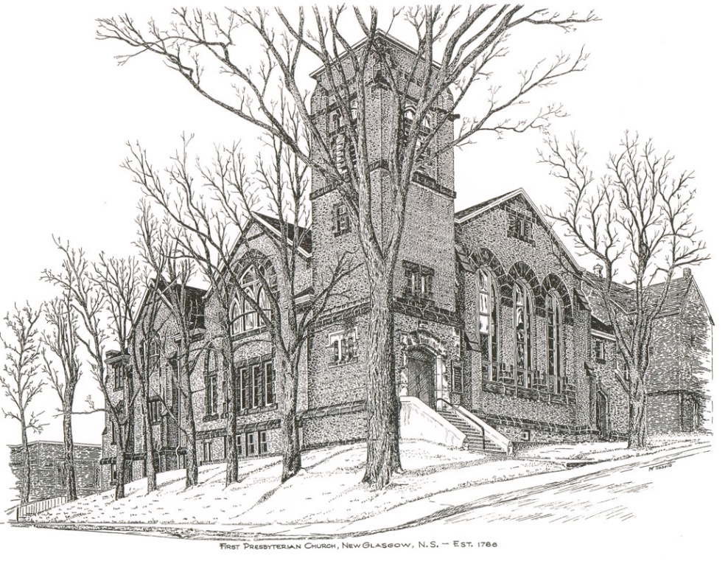

FIRST PRESBYTERIAN CHURCH
208 MacLean St., New Glasgow, NS
902-752-5691
First.church@ns.aliantzinc.ca
Reverend Andrew MacDonald
902-331-0322
yick96@hotmail.com

October 22nd, 2023
21st Sunday After Pentecost
THE APPROACH

** Please Rise **
Musical Prelude
Welcome and Announcements
**Lighting the Christ Candle:
One: One: Where can I go from your spirit? Or where can I flee from your presence? If I ascend to heaven, you are there; if I make my bed in Sheol, you are there. If I take the wings of the morning and settle at the farthest limits of the sea, even there your hand shall lead me, and your right hand shall hold me fast. If I say, ‘Surely the darkness shall cover me, and the light around me become night’, even the darkness is not dark to you; the night is as bright as the day, for darkness is as light to you.
ALL: O Come Lord, and light our path, show us Your way!
(Light the candle)
One: Let us now prepare our hearts to worship almighty God.
**Musical Introit - “Dance with the Spirit”
Dance with the spirit early in the morning
Walk with the spirit throughout the long day
Work and hope for the new day abornin’
Listen to the spirit to show you the way (repeat)

**Call to Worship
**Hymn #422 – “Sing a new song unto the Lord”
CHORUS:
Sing a new song unto the Lord;
let your song be heard from mountain’s height.
Sing a new song unto the Lord,
singing hallelujah!

1 For God’s people dance for joy.
Oh come before the Lord,
play for the Lord on glad tambourines,
and let your trumpet sound.

2 Rise, O children, from your sleep;
your Saviour now has come.
He has turned your sorrow to joy,
and filled your soul with song.

3 Glad my soul for I have seen
the glory of the Lord.
The trumpet sounds, the dead shall be raised,
I know my Saviour lives!

Prayer of Adoration, Confession and Lord’s Prayer

Our Father which art in heaven, hallowed be thy name.

Thy kingdom come, thy will be done in earth,

as it is in heaven.

Give us this day our daily bread.

And forgive us our debts, as we forgive our debtors.

And lead us not into temptation, but deliver us from evil:

For thine is the kingdom, and the power, and the glory,

forever. Amen.

Assurance of Pardon
Passing the Peace
**Hymn #229 – “Jesu, Jesu, fill us with your love”
Refrain: Jesu, Jesu, fill us with your love;
Show us how to serve
The neighbour we have from you.

1 Kneels at the feet of his friends,
silently washes their feet,
master who acts as a slave to them.

2 Neighbours are rich and poor,
varied in colour and race,
neighbours are near and far away.

3 These are the ones we should serve;
these are the ones we should love;
all are neighbours to us and you.

4 Kneel at the feet of our friends,
silently washing their feet;
this is the way we should live with you.

Children’s Time
Prayer of Illumination
First Lesson: Exodus 33:12-23
Epistle Lesson: 1 Thessalonians 1:1-10
Responsive Psalm 99
ONE: The Lord is king; let the peoples tremble!
ALL: He sits enthroned upon the cherubim; let the earth quake!
ONE: The Lord is great in Zion; he is exalted over all the peoples.
ALL: Let them praise your great and awesome name. Holy is he!
ONE: Mighty King, lover of justice, you have established equity; you have executed justice and righteousness in Jacob.
ALL: Extol the Lord our God; worship at his footstool. Holy is he!
ONE: Moses and Aaron were among his priests, Samuel also was among those who called on his name.
ALL: They cried to the Lord, and he answered them.
ONE: He spoke to them in the pillar of cloud; they kept his decrees, and the statutes that he gave them.
ALL: O Lord our God, you answered them; you were a forgiving God to them, but an avenger of their wrongdoings.
ONE: Extol the Lord our God, and worship at his holy mountain; for the Lord our God is holy.
**Gloria Patri

Glory be to the Father, and to the Son, and to the Holy Ghost. As it was in the beginning, is now will be, forever.

Amen, amen, amen.

Gospel Reading: Matthew 22:15-22
Anthem
Sermon: “Perseverance is Key!”
**Reaffirmation of Faith – Apostles’ Creed

I believe in God, the Father Almighty, maker of Heaven and earth; and in Jesus Christ, His only Son, Our Lord, who was conceived by the Holy Ghost, born of the Virgin Mary,
suffered under Pontius Pilate, was crucified, died, and was buried. He descended into Hell. On the third day He arose again from the dead; He ascended into Heaven, and sits
at the right hand of God, the Father Almighty; from thence He shall come to judge the quick and the dead.
I believe in the Holy Ghost, the holy Catholic Church,
the communion of saints, the forgiveness of sins, the resurrection of the body, and the life everlasting. Amen.

**Hymn #661 – “We give thee but thine own” vs. 1,3,5
1 We give thee but thine own,
whate’er the gift may be;
all that we have is thine alone,
a trust, O God, from thee.

3 To comfort and to bless,
to find a balm for woe,
to tend the lonely in distress
is angels’ work below.

5 and we believe thy word,
though dim our faith may be:
whate’er for thine we do, O Lord,
we do it unto thee.

Offertory
**Doxology
Praise God from whom all blessings Flow. Praise Him all creatures here below. Praise Him above Ye Heavenly Host. Praise Father, Son, and Holy Ghost. Amen.

Offertory Prayer
Prayers of the People:
**Hymn #626 – “Lord of all power” vs. 1,3,4

1 Lord of all power, I give you my will,
in joyful obedience your tasks fulfil.
Your bondage is freedom,
your service is song,
and, held in our keeping,
my weakness is strong.

3 Lord of all bounty, I give you my heart;
I praise and adore you for all you impart:
your love to inspire me,
your counsel to guide,
your presence to cheer me,
whatever betide.

4 Lord of all being, I give you my all.
If e’er I disown you, I stumble and fall;
but, sworn in glad service
your word to obey,
I walk in your freedom
to the end of the way.

**Benediction
Coral Response: Threefold Amen
Recessional

ANNOUNCEMENTS

All are welcome at First Presbyterian Church. We hope you experience the love of God and of this congregation as we worship, celebrate, and serve one another.

PASTORAL CARE:
In order to provide support to the people of First Church, when you or a loved one is sick or in hospital, we encourage you to contact the church (902-752-5691), Reverend Andrew (902-331-0322) or Cathy Lewis, Chair of the Pastoral Care Team (902-759-9649), to inform us directly. It is also important that you inform the hospital that you would welcome a visit from your minister and/or your Elder.
A donation has been made to the Sunday School in loving memory of Lilian Ross by Clarice Campbell.
THANK YOU!!
Reverend Andrew would like to extend his sincere thanks to all those who helped with hosting a very successful Synod this week. In particular, thank you to:
- Larry and Sharon for the long hours before and during Synod, ensuring everything was in place for the meetings, for coffee breaks etc;
- Jane for covering registration;
- Michael Fraser for his late nights cleaning up after everyone was gone;
- David Johnstone for the many tasks he handled registration night and all day/night Tuesday;
- The Circle of Friends for the delicious lunch on Tuesday. It was thoroughly enjoyed by all the guests - we had many compliments about the lunch!
- Marilyn for organizing the lunch and for manning the coffee station Monday during registration;
- Cathy Lewis for covering the Tuesday morning coffee shift;
- Clare and the choir for their inspiring music; and
- Clare and Don and friends for the entertainment during the dinner Tuesday night.
Hosting Synod was a big job and was successful because of all of you!

UPCOMING EVENTS
- Today - We will be worshiping with the residents of Ivey’s Terrace this afternoon.
- Tonight – 7:00 p.m. – St. Andrew’s Presbyterian, Westville is hosting a “Fall Evening Concert”, featuring Special Guest Choir, the Alcorns and other invited musicians. Social time following in the church hall. Everyone welcome!
Monthly Coffee Hour: Our next coffee hour will be Sun., Nov. 19th following service. We keep it simple, serving cookies or muffins, something easy, with tea and coffee. If you would like to host sometime, please contact Cathy Lewis at 902-759-9649. Cathy will help with setting up or answer any questions you have. We are currently looking for volunteers for November and December.
Hymn requests: The “Request A Hymn” box has been placed on the piano for suggestions. If you have any special hymns you would like to hear, please leave a note in the box or email your request to Clare at: cgrieves24@gmail.com
SCRIPTURE READERS & USHERS:
Scripture reader: Sharon Mason
Ushers: Main Door (Office) – Cathy Lewis and Phyllis O’Brien
James St. – Ruth-Anne MacIntosh
MacLean St. (Main Entrance steps) – Ellen Jardine
Early Christian Educators: Lynne Ann and Lois MacLellan

*******************

Minister: Rev. Andrew MacDonald (c) 902-331-0322
Organist: Clare Grieves
Office hours: Tues. to Fri. – 10 -1pm
Rev. MacDonald office hours -Tues. to Thurs. 10-2 or by appointment

Mission Statement: But he’s already made it plain how to live, what to do, what God is looking for in men and women. It’s quite simple. Do what is fair and just to your neighbor, be compassionate and loyal in your love, and don’t take yourself too seriously – take God seriously. Micah 6: 8-The Message

