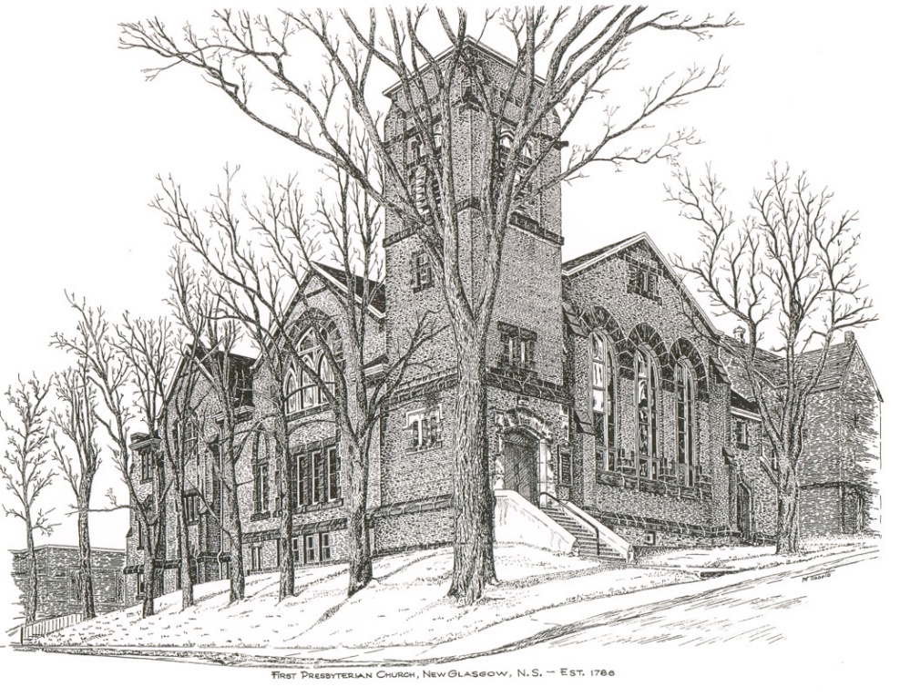

FIRST PRESBYTERIAN CHURCH
208 MacLean St., New Glasgow, NS
902-752-5691
First.church@ns.aliantzinc.ca
Reverend Andrew MacDonald
902-331-0322
yick96@hotmail.com

October 29th, 2023
22nd Sunday after Pentecost
Reformation and Communion Sunday
THE APPROACH

(**Please Rise)

Musical Prelude
Welcome and Announcements

**Lighting the Christ Candle:
ONE: Lord, may this candle which we light illuminate all our difficulties and decisions. May this candle be a fire that burns away all our pride, selfishness and all our temptations. May this candle be a flame that warms our hearts and helps us to love one another better.
ALL: Jesus Christ is the light that shines throughout the world, bringing hope and love to all believers. Let us cause his light to shine through us and make the world a better place
(Light the candle)
One: Let us now open our hearts to worship God almighty.

**Musical Introit - “Dance with the Spirit”
Dance with the spirit early in the morning
Walk with the spirit throughout the long day
Work and hope for the new day abornin’
Listen to the spirit to show you the way (repeat)

**Call to Worship

**Hymn #374 – “Oh for a thousand tongues to sing” vs.1,2,5
1 Oh for a thousand tongues to sing
my great Redeemer’s praise,
the glories of my God and King,
the triumphs of God’s grace.

2 Jesus, the name that charms our fears,
and bids our sorrows cease -
‘tis music in the sinner’s ears;
,tis life and health and peace.

5 My gracious Master and my God,
assist me to proclaim,
and spread through all the earth abroad
the honours of thy name.

Prayer of Adoration, Confession and Assurance of Pardon
Passing the Peace
**Hymn #479 - “The Church’s one foundation”

1 The church’s one foundation
is Jesus Christ our Lord;
we are his new creation
by water and the word;
from heaven he came and sought us
that we might ever be
his living servant people
by his own death set free.

2 Called forth from every nation,
yet one o’er all the earth,
our charter of salvation,
one Lord, one faith, one birth,
one holy name professing
and at one table fed,
to one hope we are pressing,
by Christ’s own Spirit led.

3 Though with a scornful wonder,
the world sees us oppressed,
by schisms rent asunder,
by heresies distressed,
yet saints their watch are keeping;
their cry goes up, How long?
But soon the night of weeping
shall be the morn of song.

4 Mid toil and tribulation
and tumult of our war,
we wait the consummation
of peace forevermore,
till with the vision glorious
our longing eyes are blest,
and the great church victorious
shall be the church at rest.

5 We now on earth have union
with God the Three-in-One,
and share, through faith, communion
with those whose rest is won -
O happy ones and holy!
Lord, give us grace that we,
like them, the meek and lowly,
on high may dwell with thee.

Children’s Time
Prayer of Illumination
First Lesson: Deuteronomy 34:1-12
Second Lesson: 1 Thessalonians 2:1-8
Responsive Psalm 1
ONE: Happy are those who do not follow the advice of the wicked, or take the path that sinners tread, or sit in the seat of scoffers; but their delight is in the law of the Lord, and on his law they meditate day and night.
ALL: They are like trees planted by streams of water, which yield their fruit in its season, and their leaves do not wither.
ONE: In all that they do, they prosper.

ALL: The wicked are not so, but are like chaff that the wind drives away.
ONE: Therefore the wicked will not stand in the judgement, nor sinners in the congregation of the righteous; for the Lord watches over the way of the righteous, but the way of the wicked will perish.

**Gloria Patri
Glory be to the Father, and to the Son, and to the Holy Ghost. As it was in the beginning, is now and ever shall be,
world without end.
Amen, Amen.

Gospel Lesson: Matthew 22:34-46
Anthem
Sermon: “Nearing the End of the Journey!”
**Hymn: #676 - “Jesus, lover of my soul”
- Jesus, lover of my soul,
let me to thy bosom fly,
while the nearer waters roll,
while the tempest still is high:
hide me, O my Saviour, hide,
till the storm of life is past,
safe into the haven guide;
oh receive my soul at last.

- Other refuge have I none;
hangs my helpless soul on thee.
Leave, ah! leave me not alone;
still support and comfort me.
All my trust on thee is stayed;
all my help from thee I bring;
cover my defenseless head
with the shadow of thy wing.

- Thou, O Christ, art all I want;
more than all in thee I find:
raise the fallen, cheer the faint,
heal the sick and lead the blind.
Just and holy is thy name;
I am all unrighteousness;
false and full of sin I am;
thou art full of truth and grace.

- Plenteous grace with thee is found,
grace to cover all my sin;
let the healing streams abound;
make and keep me pure within:
thou of life the fountain art,
freely let me take of thee;
spring thou up within my heart,
rise to all eternity.

Offertory
**Doxology
Offertory Prayer

HOLY COMMUNION

Invitation to the Lord’s Supper

The Invitation

Communion Hymn #315 - “A mighty fortress is our God” vs. 1,3

- A mighty fortress is our God a refuge never failing,
our helper sure amid the flood of mortal ills prevailing. For still our ancient foe yet seeks to work us woe with craft and power great, and, armed with cruel hate, on earth has not an equal.
- And though this world, with evil filled, should threaten to undo us,we will not fear, for God has willed the truth to triumph through us: the powers of death and hell our God will surely quell; their rate we can endure, for look! their doom is sure: one little word will fell them.

**Affirmation of Faith - Apostle’s Creed

I believe in God, the Father Almighty, maker of Heaven and earth; and in Jesus Christ, His only Son, Our Lord, who was conceived by the Holy Ghost, born of the Virgin Mary,
suffered under Pontius Pilate, was crucified, died, and was buried. He descended into Hell. On the third day He arose again from the dead; He ascended into Heaven, and sits
at the right hand of God, the Father Almighty; from thence He shall come to judge the quick and the dead.
I believe in the Holy Ghost, the holy Catholic Church,
the communion of saints, the forgiveness of sins, the resurrection of the body, and the life everlasting. Amen.

Great Prayer of Thanksgiving: BoP #564

The Lord be with you.
And also with you.
Lift up you hearts.
We lift them up to the Lord.
Let us give thanks to the Lord our God.
It is right to give God thanks and praise.

Prayer ending with
. . . we join with the whole creation
to lift our hearts in joyful praise.

Holy, Holy, Holy Lord,
God of power and might,
heaven and earth are full of your glory.
Hosanna in the highest.

Blessed is he who comes
in the name of the Lord.
Hosanna in the highest.

Prayer ending with
. . . proclaim the mystery of the faith

Christ has died.
Christ is risen.
Christ will come again.

Prayer ending with … and the people say

Amen.

The Sacrament of Holy Communion

**Communion Hymn #315 -“A mighty fortress is our God” vs. 4

- That Word above all earthly powers – no thanks to them! – abiding, ensures that all God’s gifts are ours, through Christ in us residing, whose summons rings above all goods, all earthly love. Earth’s powers waste away; God’s word endures always, whose reign will last forever.

Benediction

Recessional
* * * * * * * * * * * * *
Minister: Rev. Andrew MacDonald (c) 902-331-0322
Organist: Clare Grieves
Office hours: Tues. to Fri. – 10 -1pm
Rev. MacDonald office hours -Tues. to Thurs. 10-2 or by appointment

Mission Statement: But he’s already made it plain how to live, what to do, what God is looking for in men and women. It’s quite simple. Do what is fair and just to your neighbor, be compassionate and loyal in your love, and don’t take yourself too seriously – take God seriously. Micah 6: 8-The Message
ANNOUNCEMENTS

All are welcome at First Presbyterian Church. We hope you experience the love of God and of this congregation as we worship, celebrate, and serve one another.

PASTORAL CARE:
In order to provide support to the people of First Church, when you or a loved one is sick or in hospital, we encourage you to contact the church (902-752-5691), Reverend Andrew (902-331-0322) or Cathy Lewis, Chair of the Pastoral Care Team (902-759-9649), to inform us directly. It is also important that you inform the hospital that you would welcome a visit from your minister and/or your Elder.
CONDOLENCES
We send our sincere condolences to Jean and Norm McComb on the passing of Jean’s brother, Martin Pitts.
CONGRATULATONS!
Congratulations are extended to Russell MacIntosh and his staff at Century Saw & Marine for their long-time business presence and contributions to the community. They were recently inducted into the New Glasgow Small Business Wall of Fame during BDC Small Business Week.
UPCOMING EVENTS
Sat., Nov. 4th, 10a.m. – 12 noon - The Women's Club of First Presbyterian Church, Pictou, will hold their annual Christmas Coffee Party in the Church Hall. Admission $8.00. Come and enjoy fellowship, good food and get in the Christmas spirit!
Sun., Nov. 5th at 2 p.m. - First Presbyterian Church Stellarton is celebrating their 98th Anniversary with a “Celebration of Music”. Featuring Sam Graham, Ray Stewart and Erika Sloan, Amelia Parker, Joon Ki Kim, Janice Alcorn, Randy and Cecily Gilby, Don Haggart, Ann Holton-Melong & Family and John Spyder MacDonald. Free-will offering. Lunch to follow in the Church Hall. Everyone welcome!

Sun., Nov. 19th - The next coffee hour will follow morning service.

Sat., Nov. 25th – 7p.m. – Plans are underway by the Board of Managers for a “Musical/Variety Show”. Details to follow.
Hymn requests: The “Request A Hymn” box has been placed on the piano for suggestions. If you have any special hymns you would like to hear, please leave a note in the box or email your request to Clare at: cgrieves24@gmail.com
SCRIPTURE READERS & USHERS:
Scripture reader: Jennifer Thibeau
Ushers: Main Door (Office) – Cathy Lewis and Phyllis O’Brien
James St. – Ruth-Anne MacIntosh
MacLean St. (Main Entrance steps) – Ellen Jardine
Early Christian Educators: Lynne Ann and Lois MacLellan

