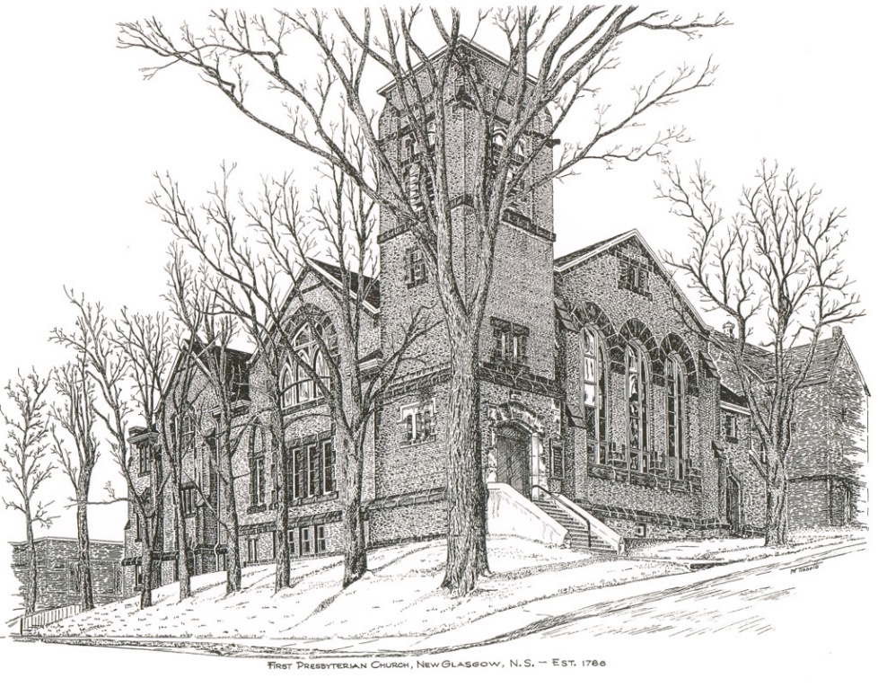

FIRST PRESBYTERIAN CHURCH
208 MacLean St., New Glasgow, NS
902-752-5691
First.church@ns.aliantzinc.ca
Reverend Andrew MacDonald
902-331-0322
yick96@hotmail.com

September 17th, 2023
16th Sunday After Pentecost
237th Anniversary Service
Communion Sunday
THE APPROACH

Musical Prelude
Welcome and Announcements

**Lighting the Christ Candle: (Please rise if you are able)
ONE: Lord, may this candle which we light illuminate all our difficulties and decisions. May this candle be a fire that burns away all our pride, selfishness and all our temptations. May this candle be a flame that warms our hearts and helps us to love one another better.
ALL: Jesus Christ is the light that shines throughout the world, bringing hope and love to all believers. Let us cause his light to shine through us and make the world a better place
(Light the candle)
One: Let us now open our hearts to worship God almighty.

Introit : Dance with the Spirit

Dance with the Spirit early in the morning
Walk with the Spirit throughout the long day
Work and hope for the new life abornin',
Listen to the Spirit to show you the way
REPEAT

Call to Worship
**Hymn #314 – “God is love: come heaven, adoring”
1 God is love: come heaven, adoring;
God is love: come earth, rejoice.
Come creation, voices soaring,
sing exulting with one voice.
God who laid the earth’s foundation,
God who spread the heavens above,
God who breathes through all creation -
God is love, eternal love.

2 God is love, whose arms enfolding
all the world in one embrace,
with unfailing grasp are holding
every child of every race,
and when human hearts are breaking
under sorrow’s iron rod,
all the sorrow, all the aching
wrings with pain the heart of God.

3 God is love, and though with blindness
sin afflicts all human life,
God’s eternal lovingkindness
guides us through all earthly strife.
Sin and death and hell shall never
o’er us final triumph gain;
God is love: so love forever
o’er the universe must reign.

Prayer of Adoration, Confession and Assurance of Pardon
Passing the Peace
**Hymn #645 -- “Follow me, the Master said” vs. 1,3,4
1 Follow me, the Master said:
we will follow Jesus.
By his word and Spirit led,
we will follow Jesus.
Still for us he lives to plead,
at the throne will intercede,
offers help in time of need;
we will follow Jesus.

3. Though the way may dark appear,
we will follow Jesus.
He will make our pathway clear;
we will follow Jesus.
In our daily round of care,
as we plead with God in prayer,
with the cross which we must bear,
we will follow Jesus.

4. Ever keep the end in view;
we will follow Jesus.
All his promises are true;
we will follow Jesus.
When this earthly course is run,
and the Master says, Well done!
life eternal we have won;
we will follow Jesus.

Children’s Time
Prayer of Illumination
First Lesson: Hebrews 12:1-3
Second Lesson: Romans 8:12-25
Responsive Psalm 86:11-17
One: Teach me your way, O Lord, that I may walk in your truth; give me an undivided heart to revere your name.
All: I give thanks to you, O Lord my God, with my whole heart, and I will glorify your name for ever.
One: For great is your steadfast love towards me; you have delivered my soul from the depths of Sheol.

All: O God, the insolent rise up against me; a band of ruffians seeks my life, and they do not set you before them.
One: But you, O Lord, are a God merciful and gracious, slow to anger and abounding in steadfast love and faithfulness.
All: Turn to me and be gracious to me; give your strength to your servant; save the child of your serving-maid.
One: Show me a sign of your favour, so that those who hate me may see it and be put to shame, because you, Lord, have helped me and comforted me.

**Gloria Patri - "Glory to the Father"

Glory to the Father, and to the Son and to the Holy Spirit: as it was in the beginning, is now, and will be forever.
Amen. Amen. Amen.

Gospel Lesson: Matthew 13:24-30, 36-43
Anthem – “Gabriel’s Oboe” by Ennio Morricone
Trumpet: Brent MacQuarrie; Piano: Clare Mason Grieves

Sermon: “Surrounded by that great Cloud of Witnesses!”
**Hymn: #630 - “When we are living”

- When we are living, it is in Christ Jesus,
and when we’re dying, it is in the Lord.
Both in our living and in our dying,
we belong to God; we belong to God.

- Through all our living, we our fruits must give.
Good works of service are for offering.
When we are giving, or when receiving,
we belong to God; we belong to God.

- ‘Mid times of sorrow and in times of pain,
when sensing beauty or in love’s embrace,
whether we suffer, or sing rejoicing,
we belong to God; we belong to God.

- Across this wide world, we shall always find
those who are crying with no peace of mind,
but when we help them, or when we feed them,
we belong to God; we belong to God.

Offertory
**Doxology
Praise God from whom all blessings Flow. Praise Him all creatures here below. Praise Him above Ye Heavenly Host. Praise Father, Son, and Holy Ghost. Amen.

Offertory Prayer
HOLY COMMUNION

Invitation to the Lord’s Supper
The Invitation
**Communion Hymn #546 -“Here is bread: here is wine”-vs.1

Here is bread, here is wine,
Christ is with us, He is with us.
Break the bread, drink the wine,
Christ is with us here.

**Affirmation of Faith - Apostle’s Creed

I believe in God, the Father Almighty, maker of Heaven and earth; and in Jesus Christ, His only Son, Our Lord, who was conceived by the Holy Ghost, born of the Virgin Mary,
suffered under Pontius Pilate, was crucified, died, and was buried. He descended into Hell. On the third day He arose again from the dead; He ascended into Heaven, and sits
at the right hand of God, the Father Almighty; from thence He shall come to judge the quick and the dead.
I believe in the Holy Ghost, the holy Catholic Church,
the communion of saints, the forgiveness of sins, the resurrection of the body, and the life everlasting. Amen.

Great Prayer of Thanksgiving: BoP #564
The Sacrament of Holy Communion
**Communion Hymn #546-“Here is bread: here is wine”vs.2-3

Here is grace, here is peace,
Christ is with us, He is with us.
Know His grace, find peace,
feast on Jesus here.
In this bread there is healing,
in this cup there's life forever.
In this moment, by the Spirit,
Christ is with us here.
Here we are, joined as one,
Christ is with us, He is with us.
We'll proclaim, 'til he comes,
Jesus crucified.
Benediction

Recessional
* * * * * * * * * * * * *
Minister: Rev. Andrew MacDonald (c) 902-331-0322
Organist: Clare Grieves
Office hours: Tues. to Fri. – 10 -1pm
Rev. MacDonald office hours -Tues. to Thurs. 10-2 or by appointment

Mission Statement: But he’s already made it plain how to live, what to do, what God is looking for in men and women. It’s quite simple. Do what is fair and just to your neighbor, be compassionate and loyal in your love, and don’t take yourself too seriously – take God seriously. Micah 6: 8-The Message

* * * * * * * * * * * * * * *
ANNOUNCEMENTS

All are welcome at First Presbyterian Church. We hope you experience the love of God and of this congregation as we worship, celebrate, and serve one another.

PASTORAL CARE:
In order to provide support to the people of First Church, when you or a loved one is sick or in hospital, we encourage you to contact the church (902-752-5691), Reverend Andrew (902-331-0322) or Cathy Lewis, Chair of the Pastoral Care Team (902-759-9649), to inform us directly. It is also important that you inform the hospital that you would welcome a visit from your minister and/or your Elder.
UPCOMING EVENTS

- Today – We will gather for coffee after our anniversary service today. Please join us if you can.
- Today - 3:00 p.m. – A celebration of the Sacrament of Baptism will be held at First Church for Abigail Lynn Turnbull, daughter of Carly-Ann Foote and Jared Turnbull. All are welcome.
- Thurs., Sept. 21st - the Worship & Music Committee will meet at 6:00 p.m. in the Session Room
- Sun., Sept. 24th – We will be doing the worship service at High Crest Home next Sunday at 2:30 p.m.
Hymn requests: The “Request A Hymn” box has been placed on the piano for suggestions. If you have any special hymns you would like to hear, please leave a note in the box or email your request to Clare at: cgrieves24@gmail.com
SCRIPTURE READERS & USHERS:
Scripture reader: Brent MacQuarrie
Ushers: Main Door (Office) – Sherry Green and Ian Semple
James St. – Ruth-Anne MacIntosh
MacLean St. (Main Entrance steps) – Ellen Jardine
Early Christian Educators: Lynne Ann and Lois MacLellan

