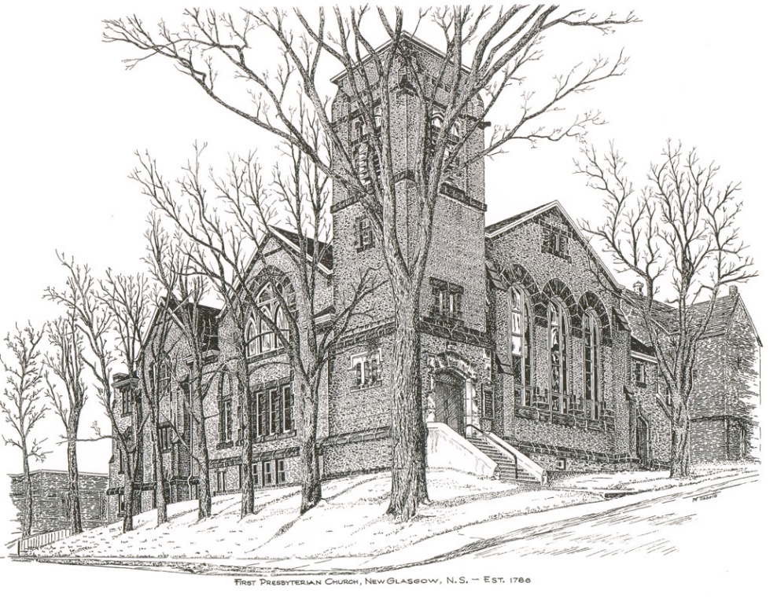

FIRST PRESBYTERIAN CHURCH
208 MacLean St., New Glasgow, NS
902-752-5691
First.church@ns.aliantzinc.ca
Reverend Andrew MacDonald
902-331-0322
yick96@hotmail.com

September 24th, 2023
17th Sunday After Pentecost
THE APPROACH

** Please Rise **
Musical Prelude
Welcome and Announcements
**Lighting the Christ Candle:
One: Jesus said: “You are going to have the light just a little while longer. Walk while you have the light, before darkness overtakes you. Whoever walks in the dark does not know where they are going. Believe in the light while you have the light, so that you may become children of light.”
ALL: Every good and perfect gift is from above, coming down from the Father of the heavenly lights, who does not change like shifting shadows. (Light the candle)
One: Let us now prepare our hearts to worship almighty God.
**Musical Introit - # “Dance with the Spirit”
Dance with the spirit early in the morning
Walk with the spirit throughout the long day
Work and hope for the new day abornin’
Listen to the spirit to show you the way (repeat)

**Call to Worship
**Hymn #688 –“As water to the thirsty”
- As water to the thirsty
as beauty to the eyes,
as strength that follows weakness,
as truth instead of lies,
as songtime and springtime
and summertime to be,
so is my Lord,
my living Lord,
so is my Lord to me.

- Like calm in place of clamour,
like peace that follows pain,
like meeting after parting,
like sunshine after rain,
like moonlight and starlight
and sunlight on the sea,
so is my Lord,
my living Lord,
so is my Lord to me.

- As sleep that follows fever,
as gold instead of grey,
as freedom after bondage,
as sunrise to the day,
as home to the traveler
and all we long to see,
so is my Lord,
my living Lord,
so is my Lord to me.

Prayer of Adoration, Confession and Lord’s Prayer

Our Father which art in heaven, hallowed be thy name.

Thy kingdom come, thy will be done in earth,

as it is in heaven.

Give us this day our daily bread.

And forgive us our debts, as we forgive our debtors.

And lead us not into temptation, but deliver us from evil:

For thine is the kingdom, and the power, and the glory,

forever. Amen.
Assurance of Pardon
Passing the Peace
**Hymn #763 – “To show by touch and word”
- To show by touch and word devotion to the earth,
to hold in full regard all life that comes to birth
we need, O God, the will to find the good you had of old in mind.

- Renew our minds to choose the things that matter most,
our hearts to long for truth till pride-of-self is lost.
For every challenge that we face, we need your guidance and your grace.

- Let love from day to day be yardstick, rule and norm,
and let our lives portray your word in human form.
Now come with us that we may have your wits about us where we live.

Children’s Time
Prayer of Illumination
First Lesson: Exodus 16:2-15
Epistle Lesson: Philippians 1:21-30
Responsive Psalm 145.1-8
One: I will extol you, my God and King, and bless your name for ever and ever.
All: Every day I will bless you and praise your name for ever and ever.
One: Great is the Lord, and greatly to be praised; his greatness is unsearchable.
All: One generation shall laud your works to another and shall declare your mighty acts.
One: On the glorious splendour of your majesty, and on your wondrous works, I will meditate.
All: The might of your awesome deeds shall be proclaimed, and I will declare your greatness.
One: They shall celebrate the fame of your abundant goodness and shall sing aloud of your righteousness.
All: The Lord is gracious and merciful, slow to anger and abounding in steadfast love.
Gloria Patri

Glory be to the Father, and to the Son, and to the Holy Ghost.

As it was in the beginning, is now will be, forever.

Amen, amen, amen.

Gospel Reading: Matthew 20:1-16
Anthem: “Give it all to Jesus”
Sermon: “The First Will Be Last!”
**Reaffirmation of Faith – Apostles’ Creed

I believe in God, the Father Almighty, maker of Heaven and earth; and in Jesus Christ, His only Son, Our Lord, who was conceived by the Holy Ghost, born of the Virgin Mary,
suffered under Pontius Pilate, was crucified, died, and was buried. He descended into Hell. On the third day He arose again from the dead; He ascended into Heaven, and sits
at the right hand of God, the Father Almighty; from thence He shall come to judge the quick and the dead.
I believe in the Holy Ghost, the holy Catholic Church,
the communion of saints, the forgiveness of sins, the resurrection of the body, and the life everlasting. Amen.

**Hymn #651 – “Guide me, O thou great Redeemer”
1 Guide me, O thou great Redeemer,
pilgrim through this barren land;
I am weak, but thou art mighty;
hold me with thy powerful hand:
bread of heaven, bread of heaven,
feed me now and evermore;
feed me now and evermore.

2 Open now the crystal fountain,
whence the healing stream doth flow;
let the fire and cloudy pillar
lead me all my journey through:
strong deliverer, strong deliverer,
be thou still my strength and shield,
be thou still my strength and shield.

3 When I tread the verge of Jordan,
bid my anxious fears subside;
death of death, and hell’s destruction,
land me safe on Canaan’s side:
songs of praises, songs of praises,
I will ever give to thee;
I will ever give to thee.

Offertory
**Doxology
Praise God from whom all blessings Flow. Praise Him all creatures here below.
Praise Him above Ye Heavenly Host.
Praise Father, Son, and Holy Ghost.
Amen.

Offertory Prayer
Prayers of the People: The People Respond
ONE: God our Maker
ALL: Make us a sharing people.
**Hymn #787– “The kingdom of God is justice and joy”
- The kingdom of God
is justice and joy
for Jesus restores
what sin would destroy;
God’s power and glory
in Jesus we know,
and here and hereafter
the kingdom shall grow.

- The kingdom of God
is mercy and grace;
the prisoners are freed,
the sinners find place,
the outcast are welcomed,
God’s banquet to share,
and hope is awakened
in place of despair.

- The kingdom of God
is challenge and choice;
believe the good news;
repent and rejoice!
His love for us sinners
brought Christ to his cross,
our crisis of judgement
for gain or for loss.

- God’s kingdom is come,
the gift and the goal,
in Jesus begun,
in heavens made whole;
the heirs of the kingdom
shall answer his call,
and all things cry, “Glory!”
to God all in all.

**Benediction
Coral Response: Threefold Amen
Recessional
* * * * * * * * * * * * *
Minister: Rev. Andrew MacDonald (c) 902-331-0322
Organist: Clare Grieves
Office hours: Tues. to Fri. – 10 -1pm
Rev. MacDonald office hours -Tues. to Thurs. 10-2 or by appointment

Mission Statement: But he’s already made it plain how to live, what to do, what God is looking for in men and women. It’s quite simple. Do what is fair and just to your neighbor, be compassionate and loyal in your love, and don’t take yourself too seriously – take God seriously. Micah 6: 8-The Message

SCRIPTURE READERS & USHERS:
Scripture reader: Lynne Ann MacLellan
Ushers: Main Door (Office) – Sherry Green and Ian Semple
James St. – Ruth-Anne MacIntosh
MacLean St. (Main Entrance steps) – Ellen Jardine
Early Christian Educators: Lynne Ann and Lois MacLellan

ANNOUNCEMENTS

All are welcome at First Presbyterian Church. We hope you experience the love of God and of this congregation as we worship, celebrate, and serve one another.

PASTORAL CARE:
In order to provide support to the people of First Church, when you or a loved one is sick or in hospital, we encourage you to contact the church (902-752-5691), Reverend Andrew (902-331-0322) or Cathy Lewis, Chair of the Pastoral Care Team (902-759-9649), to inform us directly. It is also important that you inform the hospital that you would welcome a visit from your minister and/or your Elder.
A donation has been received in memory of Lilian Ross from Phoebe Fraser.
UPCOMING EVENTS

- Today – 2:30 p.m. – We will worship with the residents of High Crest Home (Forbes St.) today.
- Mon., Sept. 25th – Access to the church driveway may be blocked due to brick work being done on this side of the church. This may last at least a week.
Hymn requests: The “Request A Hymn” box has been placed on the piano for suggestions. If you have any special hymns you would like to hear, please leave a note in the box or email your request to Clare at: cgrieves24@gmail.com

