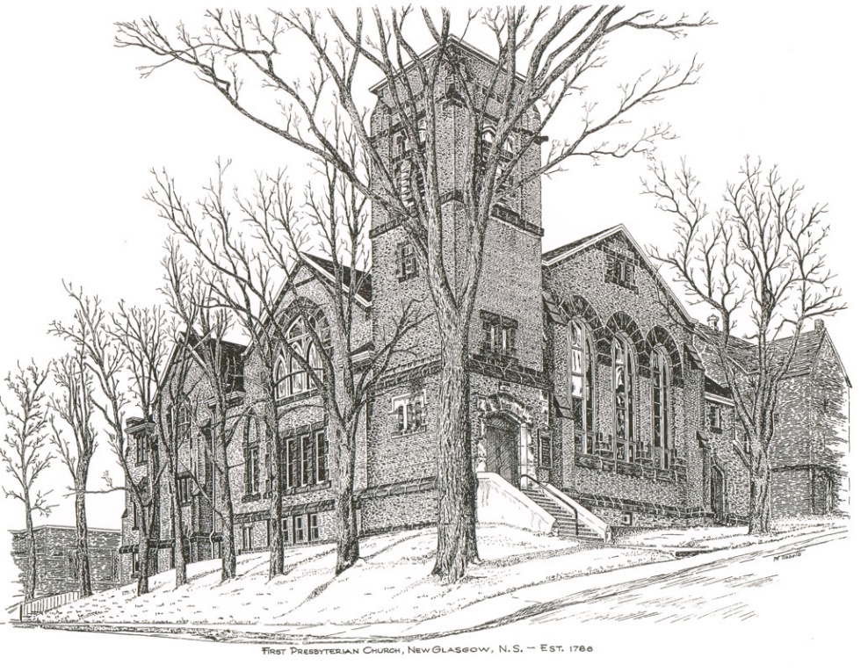

FIRST PRESBYTERIAN CHURCH
208 MacLean St., New Glasgow, NS
902-752-5691
First.church@ns.aliantzinc.ca
Reverend Andrew MacDonald
902-331-0322
yick96@hotmail.com

November 19th, 2023
25th Sunday After Pentecost
THE APPROACH

** Please Rise **
Musical Prelude
Welcome and Announcements
**Lighting the Christ Candle:
One: For you are all children of light and children of the day; we are not of the night or of darkness. So then, let us not fall asleep as others do, but let us keep awake and be sober; for those who sleep sleep at night, and those who are drunk get drunk at night. But since we belong to the day, let us be sober.
ALL: For God has destined us not for wrath but for obtaining salvation through our Lord Jesus Christ, who died for us, so that whether we are awake or asleep we may live with him.
(Light the candle)
One: Let us now prepare our hearts to worship almighty God.
**Musical Introit - “Change my heart O God”
**Call to Worship
**Hymn #298 – “Glory be to God the Father” vs.1,2,3

1 Glory be to God the Father,
glory be to God the Son,
glory be to God the Spirit,
God almighty, Three-in-One!
Glory, glory, glory, glory,
while eternal ages run.

2 Glory to the One who loved us,
washed us from each sin and stain,
glory to the One who bought us,
raised us up to serve and reign.
Glory, glory, glory, glory,
to the Lamb that once was slain.

3 Glory, blessing, praise eternal!
angel choirs their hymns prolong;
Honour, riches, power, dominion!
echoes all creation’s song.
Glory, glory, glory, glory,
praises to our God belong.

Prayer of Adoration, Confession and Lord’s Prayer

Our Father which art in heaven, hallowed be thy name.

Thy kingdom come, thy will be done in earth,

as it is in heaven.

Give us this day our daily bread.

And forgive us our debts, as we forgive our debtors.

And lead us not into temptation, but deliver us from evil:

For thine is the kingdom, and the power, and the glory,

forever. Amen.
Assurance of Pardon
Passing the Peace
**Hymn #645 – “Follow me, the Master said” vs.1,3,4
1. Follow me, the Master said:
we will follow Jesus.
By his word and Spirit led,
we will follow Jesus.
Still for us he lives to plead,
at the throne will intercede,
offers help in time of need;
we will follow Jesus.

3. Though the way may dark appear,
we will follow Jesus.
He will make our pathway clear;
we will follow Jesus.
In our daily round of care,
as we plead with God in prayer,
with the cross which we must bear,
we will follow Jesus.

4. Ever keep the end in view;
we will follow Jesus.
All his promises are true;
we will follow Jesus.
When this earthly course is run,
and the Master says, Well done!
life eternal we have won;
we will follow Jesus.

Children’s Time
Prayer of Illumination
First Lesson: Judges 4:1-7
Epistle Lesson: 1 Thessalonians 5:1-11
Responsive Psalm 34

ONE: To you I lift up my eyes, O you who are enthroned in the heavens!
ALL: As the eyes of servants look to the hand of their master, as the eyes of a maid to the hand of her mistress, so our eyes look to the Lord our God, until he has mercy upon us.

ONE: Have mercy upon us, O Lord, have mercy upon us, for we have had more than enough of contempt.
ALL: Our soul has had more than its fill of the scorn of those who are at ease, of the contempt of the proud.

**Gloria Patri

Glory be to the Father, and to the Son, and to the Holy Ghost. As it was in the beginning, is now will be, forever. Amen, amen, amen.

Gospel Reading: Matthew 25:14-30
Anthem: “O Lord, how the refuge of each generation”
Sermon: “Children of the Light!”
**Reaffirmation of Faith – Apostles’ Creed

I believe in God, the Father Almighty, maker of Heaven and earth; and in Jesus Christ, His only Son, Our Lord, who was conceived by the Holy Ghost, born of the Virgin Mary,
suffered under Pontius Pilate, was crucified, died, and was buried. He descended into Hell. On the third day He arose again from the dead; He ascended into Heaven, and sits
at the right hand of God, the Father Almighty; from thence He shall come to judge the quick and the dead.
I believe in the Holy Ghost, the holy Catholic Church,
the communion of saints, the forgiveness of sins, the resurrection of the body, and the life everlasting. Amen.

**Hymn #784 – “Thy Kingdom come – on bended knee” vs.1,3,5
1. Thy kingdom come! On bended knee
the passing ages pray;
and faithful souls have yearned to see
on earth that kingdom's day.
3. And lo, already on the hills
the flags of dawn appear;
gird up your loins, ye prophet souls,
proclaim the day is near:
5. When knowledge, hand in hand with peace,
shall walk the earth abroad:
the day of perfect righteousness,
the promised day of God.
Offertory
**Doxology
Praise God from whom all blessings Flow. Praise Him all creatures here below. Praise Him above Ye Heavenly Host. Praise Father, Son, and Holy Ghost. Amen.

Offertory Prayer
Prayers of the People:
**Hymn #563 – “Let us talents and tongues employ”
Let us talents and tongues employ,
reaching out with a shout of joy:
bread is broken, the wine is poured,
Christ is spoken and seen and heard.
Jesus lives again; earth can breathe again.
Pass the Word around: loaves abound!
Christ is able to make us one,
at his table he set the tone,
teaching people to live to bless,
love in word and in deed express.
Jesus lives again; earth can breathe again.
Pass the Word around: loaves abound!
Jesus calls us in, sends us out
bearing fruit in a world of doubt,
gives us love to tell, bread to share:
God (Immanuel) everywhere!
Jesus lives again; earth can breathe again.
Pass the Word around: loaves abound!
**Benediction
Coral Response: Threefold Amen
Recessional

* * * * * * * * * * * * *
Minister: Rev. Andrew MacDonald (c) 902-331-0322
Organist: Clare Grieves
Office hours: Tues. to Fri. – 10 -1pm
Rev. MacDonald office hours -Tues. to Thurs. 10-2 or by appointment

Mission Statement: But he’s already made it plain how to live, what to do, what God is looking for in men and women. It’s quite simple. Do what is fair and just to your neighbor, be compassionate and loyal in your love, and don’t take yourself too seriously – take God seriously. Micah 6: 8-The Message
ANNOUNCEMENTS

All are welcome at First Presbyterian Church. We hope you experience the love of God and of this congregation as we worship, celebrate, and serve one another.

PASTORAL CARE:
In order to provide support to the people of First Church, when you or a loved one is sick or in hospital, we encourage you to contact the church (902-752-5691), Reverend Andrew (902-331-0322) or Cathy Lewis, Chair of the Pastoral Care Team (902-759-9649), to inform us directly. It is also important that you inform the hospital that you would welcome a visit from your minister and/or your Elder.
UPCOMING EVENTS
Today – The Board of Managers will hold a brief meeting after service.
Coffee Hour – Please join us for coffee hour following the service this morning.

Today – 2:30 p.m. – We will be worshipping with the residents of Valley View Villa this afternoon.
Tues., Nov. 21st – 7p.m. – The River John Local Community Health Board is hosting a Wellness Workshop at St. David’s Presbyterian Church, Toney River with guest speaker, Tammy Langille of Fulton’s Drug Store, River John. Tammy will be speaking on “The Changing Role of a Pharmacist”. Everyone welcome. Light refreshments will be served.

Fri., Nov. 24th – 3:30-5p.m. – Ella Russell will celebrate her birthday and well-deserved retirement!! Please join us in passing on best wishes to Ella in the Lower Hall. In lieu of gifts, donations to the Pictou County Food Bank would be appreciated.

Sat., Nov. 25th - 7p.m. – Please join us for our “Second Annual Talent Show”, featuring John Spyder MacDonald, Ray Stewart, Brenda and Brian Bowden, The Alcorns, Don Haggart and many more. Light lunch to follow. Free will offering. All welcome!

Sun., Nov. 26th – 2p.m. – Lower Hall – Mark Thibeau will be leading a video bible study entitled “In the Footsteps of the Saviour” (a Max Lucado series). There will be 6 sessions beginning Nov. 26th, every Sunday including Dec. 10th and in the new year from Jan. 7th to Jan. 21st, 2024. Sessions will be approximately 45 minutes to an hour and
will be held in the Lower Hall. If you are interested, there will be a sign-up list in the office.

Sun., Dec. 3rd - 2:30 p.m. – The Trinitarians Choir presents “Nowell!! Sing Nowell!!” at Trinity United Church, New Glasgow. Admission – Donation at the door.

Sun., Dec. 10th – 3:00 p.m. – First Presbyterian Church, Hopewell is hosting a “Christmas Carol Song Service”. All welcome. Free will offering at the door.

SCRIPTURE READERS & USHERS:
Scripture Reader – Sharon Mason
Ushers: Main Door (Office) – Ian Semple
James St. – Ruth-Anne MacIntosh
MacLean St. (Main Entrance steps) – Ellen Jardine
Early Christian Educators: Lynne Ann and Lois MacLellan

**If you have a notice for the bulletin, please ensure it is submitted to the office by 9:00 a.m. Thursday morning.

* * * * * * * * * * * * * * * * * *

ANNOUNCEMENTS

All are welcome at First Presbyterian Church. We hope you experience the love of God and of this congregation as we worship, celebrate, and serve one another.

PASTORAL CARE:
In order to provide support to the people of First Church, when you or a loved one is sick or in hospital, we encourage you to contact the church (902-752-5691), Reverend Andrew (902-331-0322) or Cathy Lewis, Chair of the Pastoral Care Team (902-759-9649), to inform us directly. It is also important that you inform the hospital that you would welcome a visit from your minister and/or your Elder.

UPCOMING EVENTS
Today – The Board of Managers will hold a brief meeting after service.
Coffee Hour – Please join us for coffee hour following the service this morning.

Today – 2:30 p.m. – We will be worshipping with the residents of Valley View Villa this afternoon.
Tues., Nov. 21st – 7p.m. – The River John Local Community Health Board is hosting a Wellness Workshop at St. David’s Presbyterian Church, Toney River with guest speaker, Tammy Langille of Fulton’s Drug Store, River John. Tammy will be speaking on “The Changing Role of a Pharmacist”. Everyone welcome. Light refreshments will be served.

Fri., Nov. 24th – 3:30-5p.m. – Ella Russell will celebrate her birthday and well-deserved retirement!! Please join us in passing on best wishes to Ella in the Lower Hall. In lieu of gifts, donations to the Pictou County Food Bank would be appreciated.

Sat., Nov. 25th - 7p.m. – Please join us for our “Second Annual Talent Show”, featuring John Spyder MacDonald, Ray Stewart, Brenda and Brian Bowden, The Alcorns, Don Haggart and many more. Light lunch to follow. Free will offering. All welcome!

Sun., Nov. 26th – 2p.m. – Lower Hall – Mark Thibeau will be leading a video bible study entitled “In the Footsteps of the Saviour” (a Max Lucado series). There will be 6 sessions beginning Nov. 26th, every Sunday including Dec. 10th and in the new year from Jan. 7th to Jan. 21st, 2024. Sessions will be approximately 45 minutes to an hour and
will be held in the Lower Hall. If you are interested, there will be a sign-up list in the office.

Sun., Dec. 3rd - 2:30 p.m. – The Trinitarians Choir presents “Nowell!! Sing Nowell!!” at Trinity United Church, New Glasgow. Admission – Donation at the door.

Sun., Dec. 10th – 3:00 p.m. – First Presbyterian Church, Hopewell is hosting a “Christmas Carol Song Service”. All welcome. Free will offering at the door.

.
Thursday, Nov. 30th – 6:00 p.m. – We will be decorating the church for the Christmas Season. Cookies with apple cider and tea will be served. If you are available, please join us. We appreciate all the help we can get!
SCRIPTURE READERS & USHERS:
Scripture Reader – Sharon Mason
Ushers: Main Door (Office) – Ian Semple
James St. – Ruth-Anne MacIntosh
MacLean St. (Main Entrance steps) – Ellen Jardine
Early Christian Educators: Lynne-Ann and Lois MacLellan

**If you have a notice for the bulletin, please ensure it is submitted to the office by 9:00 a.m. Thursday morning.

