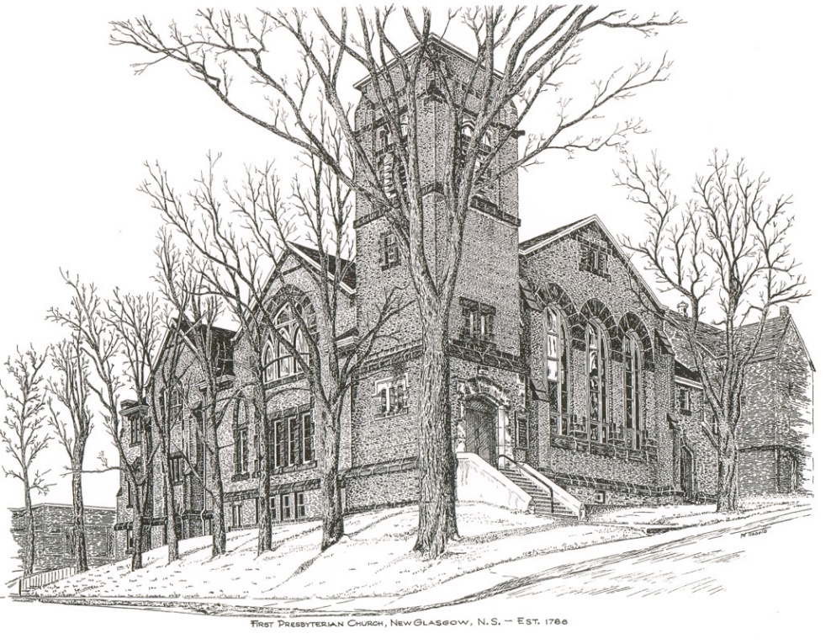

FIRST PRESBYTERIAN CHURCH
208 MacLean St., New Glasgow, NS
902-752-5691
First.church@ns.aliantzinc.ca
Reverend Andrew MacDonald
902-331-0322
yick96@hotmail.com

November 26th, 2023
26th Sunday After Pentecost
THE APPROACH

** Please Rise **
Musical Prelude
Welcome and Announcements
**Lighting the Christ Candle:
One: ‘How often is the lamp of the wicked put out? How often does calamity come upon them? How often does God distribute pains in his anger? How often are they like straw before the wind,
and like chaff that the storm carries away? With the loyal you show yourself loyal; with the blameless you show yourself blameless; with the pure you show yourself pure; and with the crooked you show yourself perverse. For you deliver a humble people, but the haughty eyes you bring down.
ALL: It is you who light my lamp; the Lord, my God, lights up my darkness. This God—his way is perfect; the promise of the Lord proves true; he is a shield for all who take refuge in him.
(Light the candle)
One: Let us now prepare our hearts to worship almighty God.
**Musical Introit - “Change my heart O God”
**Call to Worship
**Hymn #205 – “O love, how deep, how broad, how high” vs.1,3,5,6
1 O love, how deep, how broad, how high,
how passing thought and fantasy,
that God, the Son of God, should take
our mortal form for mortals’ sake.

3 For us he prayed; for us he taught;
for us his daily works he wrought:
by words and signs and actions, thus
still seeking not himself, but us.

5 For us he rose from death again;
for us he went on high to reign;
for us he sent his Spirit here
to guide, to strengthen and to cheer.

6 All glory to our Lord and God
for love so deep, so high, so broad,
the Trinity whom we adore
forever and forevermore.

Prayer of Adoration, Confession and Lord’s Prayer

Our Father which art in heaven, hallowed be thy name.

Thy kingdom come, thy will be done in earth,

as it is in heaven.

Give us this day our daily bread.

And forgive us our debts, as we forgive our debtors.

And lead us not into temptation, but deliver us from evil:

For thine is the kingdom, and the power, and the glory,

forever. Amen.
Assurance of Pardon
Passing the Peace
**Hymn #476 – “Amigos de Cristo/friends of the Lord”
Refrain:
Amigos de Cristo;
we’re friends of the Lord;
amigos de Cristo;
we’re friends of the Lord,
for we’ve been forgiven,
and we’ve been restored;
amigos de Cristo;
and we’re friends of the Lord.

- Friends of the covenant
renewed each morn;
baptized and loving it,
we’ve been reborn.
Gift of the dove is ours forevermore.
Amigos de Cristo;
we’re friends of the Lord.

- Born of a family
the young and old,
we’ll be on hand to see
new life unfold.
We understand the need to be made whole.
Amigos de Cristo;
we’re friends of the Lord.

Children’s Time
Prayer of Illumination
First Lesson: Ezekiel 34:11-16,20-24
Epistle Lesson: Ephesians 1:15-23
Responsive Psalm 95:1-7
ONE: O come, let us sing to the Lord; let us make a joyful noise to the rock of our salvation!
ALL: Let us come into his presence with thanksgiving; let us make a joyful noise to him with songs of praise!
ONE: For the Lord is a great God, and a great King above all gods.
ALL: In his hand are the depths of the earth; the heights of the mountains are his also.
ONE: The sea is his, for he made it, and the dry land, which his hands have formed.

ALL: O come, let us worship and bow down, let us kneel before the Lord, our Maker!
ONE: For he is our God, and we are the people of his pasture, and the sheep of his hand.

ALL: O that today you would listen to his voice!

**Gloria Patri

Glory be to the Father, and to the Son, and to the Holy Ghost. As it was in the beginning, is now will be, forever. Amen, amen, amen.

Gospel Reading: Matthew 25:31-46
Anthem: “Loving and Forgiving”
Sermon: “What will you be?”
**Reaffirmation of Faith – Apostles’ Creed

I believe in God, the Father Almighty, maker of Heaven and earth; and in Jesus Christ, His only Son, Our Lord, who was conceived by the Holy Ghost, born of the Virgin Mary,
suffered under Pontius Pilate, was crucified, died, and was buried. He descended into Hell. On the third day He arose again from the dead; He ascended into Heaven, and sits
at the right hand of God, the Father Almighty; from thence He shall come to judge the quick and the dead.
I believe in the Holy Ghost, the holy Catholic Church,
the communion of saints, the forgiveness of sins, the resurrection of the body, and the life everlasting. Amen.

**Hymn #672 – “Jesus calls us, o’er the tumult” vs. 1,2,4,5
1 Jesus calls us, o’er the tumult
of our life’s wild restless sea;
day be day his voice still calls us
saying, Christian, follow me.

2 As of old Saint Andrew heard it
by the Galilean lake,
turned from home and work and kindred,
leaving all for Jesus’ sake.

4 In our joys and in our sorrows,
days of toil and hours of ease,
Jesus calls, in cares and pleasures,
Christian, love me more than these.

5 Jesus calls us: by your mercies,
Saviour, may we hear your call,
give our hearts in glad obedience,
serve and love you best of all.

Offertory
**Doxology
Praise God from whom all blessings Flow. Praise Him all creatures here below. Praise Him above Ye Heavenly Host. Praise Father, Son, and Holy Ghost. Amen.

Offertory Prayer
Prayers of the People:
**Hymn #433 – “All creatures of our God and King” vs. 1,4,5
1 All creatures of our God and King
lift up your voice and with us sing:
sing praises, hallelujah!
O brother sun with golden beam,
O sister moon with silver gleam,
sing praises, sing praises,
hallelujah, hallelujah, hallelujah!

4 Dear mother earth, who day by day
brings forth your blessings on our way:
sing praises, hallelujah!
All flowers and fruit that in your grow,
let them God’s glory also show:
sing praises, sing praises,
hallelujah, hallelujah, hallelujah!

5 Let everyone of tender heart,
forgiving others, take their part:
sing praises, hallelujah!
Al who long pain and sorrow bear,
give God your burdens and your care,
sing praises, sing praises,
hallelujah, hallelujah, hallelujah!

**Benediction
Coral Response: Threefold Amen
Recessional
* * * * * * * * * * * * *

Minister: Rev. Andrew MacDonald (c) 902-331-0322
Organist: Clare Grieves
Office hours: Tues. to Fri. – 10 -1pm
Rev. MacDonald office hours -Tues. to Thurs. 10-2 or by appointment

Mission Statement: But he’s already made it plain how to live, what to do, what God is looking for in men and women. It’s quite simple. Do what is fair and just to your neighbor, be compassionate and loyal in your love, and don’t take yourself too seriously – take God seriously. Micah 6: 8-The Message

ANNOUNCEMENTS

All are welcome at First Presbyterian Church. We hope you experience the love of God and of this congregation as we worship, celebrate, and serve one another.

PASTORAL CARE:
In order to provide support to the people of First Church, when you or a loved one is sick or in hospital, we encourage you to contact the church (902-752-5691), Reverend Andrew (902-331-0322) or Cathy Lewis, Chair of the Pastoral Care Team (902-759-9649), to inform us directly. It is also important that you inform the hospital that you would welcome a visit from your minister and/or your Elder.
UPCOMING EVENTS
The Video Bible Study, “In the Footsteps of the Saviour” presented by Mark Thibeau, will be postponed til Spring. Details will be announced at that time.

Thursday, Nov. 30th – 6:00 p.m. – We will be decorating the church for the Christmas Season. Cookies with apple cider and tea will be served. If you are available, please join us. We appreciate all the help we can get!
The Worship and Music Team will be featuring special music by guest musicians prior to morning services during the 4 Sundays of Advent. Refreshments (tea, coffee, cookies) will be served at the rear of the Sanctuary between 10:30a.m. and the beginning of our 11a.m. service. Please plan to come to church a little early to enjoy this informal time of fellowship, music and refreshments.
Sun., Dec. 3rd - 2:30 p.m. – The Trinitarians Choir presents “Nowell!! Sing Nowell!!” at Trinity United Church, New Glasgow. Admission – Donation at the door.

Sun., Dec. 10th – 3:00 p.m. – First Presbyterian Church, Hopewell is hosting a “Christmas Carol Song Service”. All welcome. Free will offering at the door.

Happy Birthday to Fannie Porter! Fannie is
celebrating her birthday today, we wish her
all the best!

SCRIPTURE READERS & USHERS:
Scripture Reader – Mark Thibeau
Ushers: Main Door (Office) – Brent MacQuarrie & Robyn MacLeod
James St. – Ruth-Anne MacIntosh
MacLean St. (Main Entrance steps) – Ellen Jardine
Early Christian Educators: Lynne Ann and Lois MacLellan

**If you have a notice for the bulletin, please ensure it is submitted to the office by 9:00 a.m. Thursday morning.

