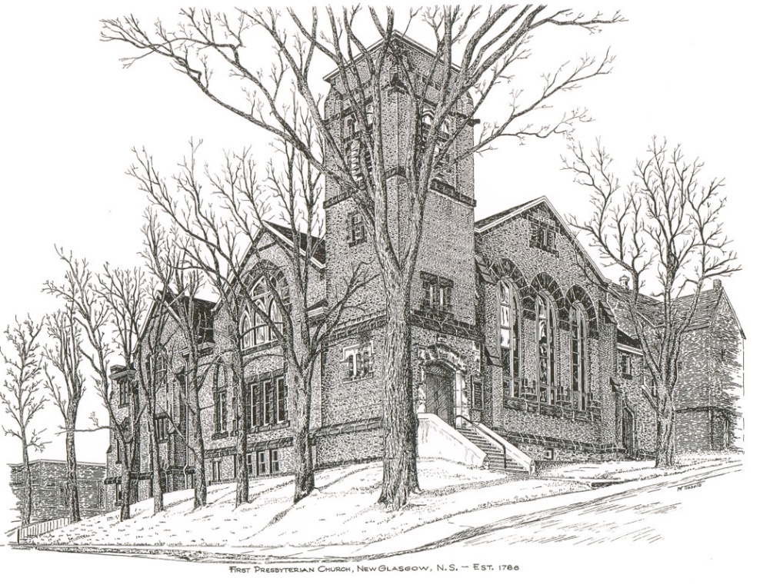

FIRST PRESBYTERIAN CHURCH
208 MacLean St., New Glasgow, NS
902-752-5691
First.church@ns.aliantzinc.ca
Reverend Andrew MacDonald
902-331-0322
yick96@hotmail.com

November 5th, 2023
23rd Sunday After Pentecost
THE APPROACH

** Please Rise **
Musical Prelude
Welcome and Announcements
**Lighting the Christ Candle:
One: With the loyal you show yourself loyal; with the blameless you show yourself blameless; with the pure you show yourself pure; and with the crooked you show yourself perverse. For you deliver a humble people, but the haughty eyes you bring down.
ALL: It is you who light my lamp; the Lord, my God, lights up my darkness.
(Light the candle)
One: Let us now prepare our hearts to worship almighty God.
**Musical Introit - “Change my heart O God”
**Call to Worship
**Hymn # 764– “There’s a spirit in the air” vs. 1,4,6

- There’s a spirit in the air,
telling Christians everywhere:
“Praise the love that Christ revealed,
living, working, in our world!”

4. Still the Spirit gives us light,
seeing wrong and setting right:
God in Christ has come to stay.
Live tomorrow’s life today!

6. May the Spirit fill our praise,
guide our thoughts and change our ways,
God in Christ has come to stay.
Live tomorrow’s life today!

Prayer of Adoration, Confession and Lord’s Prayer

Our Father which art in heaven, hallowed be thy name.

Thy kingdom come, thy will be done in earth,

as it is in heaven.

Give us this day our daily bread.

And forgive us our debts, as we forgive our debtors.

And lead us not into temptation, but deliver us from evil:

For thine is the kingdom, and the power, and the glory,

forever. Amen.

Assurance of Pardon
Passing the Peace
**Hymn #375 – “Fairest Lord Jesus” vs. 1,3,4
1. Fairest Lord Jesus,
Lord of all creation,
Jesus, of God and Mary the Son:
thee will I cherish,
thee will I honour,
O thou my soul’s delight and crown.

3. Fair is the sunshine,
fairer still the moonlight,
fair is the shimmering, starry sky:
Jesus shines brighter,
Jesus shines clearer,
than all the heavenly host on high.

4. All fairest beauty
heavenly and earthly,
wondrously Jesus, is found in thee;
none can be nearer,
fairer or dearer,
than thou, my Saviour, art to me.

Children’s Time
Prayer of Illumination
First Lesson: Isaiah 2:2-4
Epistle Lesson: Revelation 7:9-17
Responsive Psalm 34
ONE: I will bless the Lord at all times; his praise shall continually be in my mouth.
ALL: My soul makes its boast in the Lord; let the humble hear and be glad.
ONE: O magnify the Lord with me, and let us exalt his name together.
ALL: I sought the Lord, and he answered me, and delivered me from all my fears.
ONE: Look to him, and be radiant; so your faces shall never be ashamed.
ALL: This poor soul cried, and was heard by the Lord, and was saved from every trouble.
ONE: The angel of the Lord encamps around those who fear him, and delivers them.
ALL: O taste and see that the Lord is good; happy are those who take refuge in him.
ONE: O fear the Lord, you his holy ones, for those who fear him have no want.
ALL: The young lions suffer want and hunger, but those who seek the Lord lack no good thing.
ONE: The Lord redeems the life of his servants; none of those who take refuge in him will be condemned.

**Gloria Patri

Glory be to the Father, and to the Son, and to the Holy Ghost. As it was in the beginning, is now will be, forever. Amen, amen, amen.

Gospel Reading: Matthew 5:1-12
Anthem
Sermon: “Blessed are the Peacemakers!”

**Reaffirmation of Faith – Apostles’ Creed

I believe in God, the Father Almighty, maker of Heaven and earth; and in Jesus Christ, His only Son, Our Lord, who was conceived by the Holy Ghost, born of the Virgin Mary,
suffered under Pontius Pilate, was crucified, died, and was buried. He descended into Hell. On the third day He arose again from the dead; He ascended into Heaven, and sits
at the right hand of God, the Father Almighty; from thence He shall come to judge the quick and the dead.
I believe in the Holy Ghost, the holy Catholic Church,
the communion of saints, the forgiveness of sins, the resurrection of the body, and the life everlasting. Amen.

**Hymn #749 – “Be still, my soul” vs. 1,3,4

- Be still my soul, the Lord is on thy side;
bear patiently the cross of grief or pain;
leave to thy God to order and provide;
in every change God faithful will remain.
Be still my soul: thy best, thy heavenly Friend
through thorny ways leads to a joyful end.

3. Be still my soul; when dearest friends depart,
and all is darkened in the vale of tears,
then shalt thou better know God’s love, God’s heart,
who comes to soothe thy sorrow and thy fears.
Be still my soul: thy Jesus can repay
from his own fullness all death takes away.

4. Be still my soul, the hour is hastening on
when we shall be forever with the Lord.
when disappointment, grief and fear are gone,
sorrow forgot, love’s purest joys restored.
Be still my soul: when change and tears are past,
all safe and blessed we shall meet at last.

Offertory
**Doxology
Praise God from whom all blessings Flow. Praise Him all creatures here below. Praise Him above Ye Heavenly Host. Praise Father, Son, and Holy Ghost. Amen.

Offertory Prayer
Prayers of the People:
**Hymn #611 – “For all the saints” – vs. 1,2,6
1. For all the saints who from their labours rest,
who thee by faith before the world confessed,
thy name, O Jesus, be forever blest.
Hallelujah, hallelujah!

2. Thou wast their rock, their fortress and their might,
thou, Lord, their captain in the well-fought fight,
thou in the darkness drear their one true light.
Hallelujah, hallelujah!

6. The golden evening brightens in the west;
soon, soon to faithful warriors cometh rest;
sweet is the calm of paradise the blest.
Hallelujah, hallelujah!

**Benediction
Coral Response: Threefold Amen
Recessional
* * * * * * * * * * * * *
Minister: Rev. Andrew MacDonald (c) 902-331-0322
Organist: Clare Grieves
Office hours: Tues. to Fri. – 10 -1pm
Rev. MacDonald office hours -Tues. to Thurs. 10-2 or by appointment

Mission Statement: But he’s already made it plain how to live, what to do, what God is looking for in men and women. It’s quite simple. Do what is fair and just to your neighbor, be compassionate and loyal in your love, and don’t take yourself too seriously – take God seriously. Micah 6: 8-The Message
ANNOUNCEMENTS

All are welcome at First Presbyterian Church. We hope you experience the love of God and of this congregation as we worship, celebrate, and serve one another.

PASTORAL CARE:
In order to provide support to the people of First Church, when you or a loved one is sick or in hospital, we encourage you to contact the church (902-752-5691), Reverend Andrew (902-331-0322) or Cathy Lewis, Chair of the Pastoral Care Team (902-759-9649), to inform us directly. It is also important that you inform the hospital that you would welcome a visit from your minister and/or your Elder.
UPCOMING EVENTS
Mon., Nov. 6th – 6:30 p.m. – The Board of Managers will meet.
Sun., Nov. 12th -12:15 p.m. – Beginning our winter meeting hours, Session will meet after service.
Today - 2 p.m. - First Presbyterian Church Stellarton is celebrating their 98th Anniversary with a “Celebration of Music”. Featuring Sam Graham, Ray Stewart and Erika Sloan, Amelia Parker, Joon Ki Kim, Janice Alcorn, Randy and Cecily Gilby, Don Haggart, Ann Holton-Melong & Family and John Spyder MacDonald. Free-will offering. Lunch to follow in the Church Hall. Everyone welcome!

Sun., Nov. 19th - The next coffee hour will follow morning service.

Sat., Nov. 25th - 7p.m. – Plans are well underway for our “Second Annual Talent Show”, featuring John Spyder MacDonald, Ray Stewart, Brenda and Brian Bowden, The Alcorns, Don Haggart and many more. Light lunch to follow. Free will offering. All welcome!

Sun., Dec. 3rd - 2:30 p.m. – The Trinitarians Choir presents “Nowell!! Sing Nowell!!” at Trinity United Church , New Glasgow. Admission – Donation at the door.

Happy Birthday to Sandy MacIntosh! Sandy will celebrate his birthday Thurs., Nov. 9th.
SCRIPTURE READERS & USHERS:
Scripture reader: Lynne-Anne MacLellan
Ushers: Main Door (Office) – Brent MacQuarrie &
Robyn MacLeod
James St. – Ruth-Anne MacIntosh
MacLean St. (Main Entrance steps) – Ellen Jardine
Early Christian Educators: Lynne Ann and Lois MacLellan

