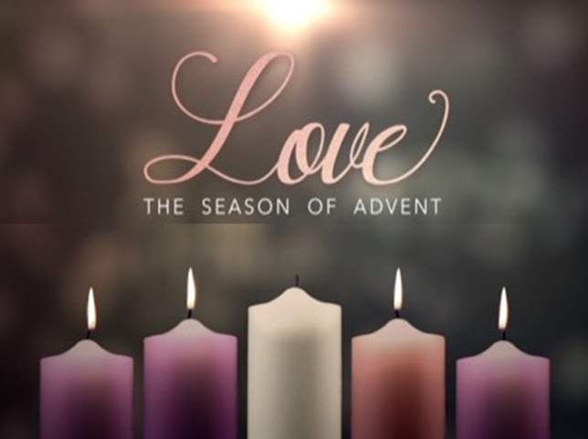

FIRST PRESBYTERIAN CHURCH
208 MacLean St., New Glasgow, NS
902-752-5691
First.church@ns.aliantzinc.ca
Reverend Andrew MacDonald
902-331-0322
yick96@hotmail.com

December 24th, 2023
Fourth Sunday In Advent
LOVE
THE APPROACH
**PLEASE RISE**
MUSICAL PRELUDE
WELCOME AND ANNOUNCEMENTS
**MUSICAL INTROIT - #109 "All Earth is Waiting" vs 4
CALL TO WORSHIP
**HYMN #121 – “Long ago, prophets knew” vs. 1,2,4
PRAYERS OF APPROACH AND LORD’S PRAYER
ASSURANCE OF PARDON
PASSING THE PEACE
LIGHTING THE ADVENT CANDLE: Love
Brent MacQuarrie and Sara Fullerton
**HYMN: #119 “Hope is A Star” Vs. 4
CHILDREN’S TIME
PRAYER OF ILLUMINATION
FIRST LESSON: 2 Samuel 7:1-11,16
EPISTLE LESSON: Romans 16:25-27
RESPONSIVE PSALM: Psalm 89:1-4, 20-26
**GLORIA PATRI
GOSPEL LESSON: Luke 1:26-38
ANTHEM – “Christmas Medley”
SERMON: “LOVE!”
**REAFFIRMATION OF FAITH—APOSTLES CREED
**HYMN: #138 - “While Shepherds watched” vs. 1,3,4,6
OFFERTORY
**DOXOLOGY
OFFERTORY PRAYER
PRAYERS OF THE PEOPLE
**HYMN: #156 - “The angel Gabriel from heaven” vs. 1,2,3,4
**BENEDICTION
**CORAL RESPONSE: THREEFOLD AMEN
**RECESSIONAL
* * * * * * * * * * * * *
Minister: Rev. Andrew MacDonald (c) 902-331-0322
Organist: Clare Grieves
Office hours: Tues. to Fri. – 10 -1pm
Rev. MacDonald office hours -Tues. to Thurs. 10-2 or by appointment

Mission Statement: But he’s already made it plain how to live, what to do, what God is looking for in men and women. It’s quite simple. Do what is fair and just to your neighbor, be compassionate and loyal in your love, and don’t take yourself too seriously – take God seriously. Micah 6: 8-The Message
Apostles Creed

I believe in God, the Father Almighty, maker of Heaven and earth; and in Jesus Christ, His only Son, Our Lord, who was conceived by the Holy Ghost, born of the Virgin Mary,
suffered under Pontius Pilate, was crucified, died, and was buried. He descended into Hell. On the third day He arose again from the dead; He ascended into Heaven, and sits
at the right hand of God, the Father Almighty; from thence He shall come to judge the quick and the dead.
I believe in the Holy Ghost, the holy Catholic Church,
the communion of saints, the forgiveness of sins, the resurrection of the body, and the life everlasting. Amen.

The Lord’s Prayer

Our Father which art in heaven, hallowed be thy name.

Thy kingdom come, thy will be done in earth,

as it is in heaven.

Give us this day our daily bread.

And forgive us our debts, as we forgive our debtors.

And lead us not into temptation, but deliver us from evil:

For thine is the kingdom, and the power, and the glory,

forever. Amen.

Gloria Patri

Glory be to the Father, and to the Son, and to the Holy Ghost. As it was in the beginning, is now and ever shall be, world without end. Amen, amen.

Doxology

Praise God from whom all blessings flow. Praise Him all creatures here below. Praise Him above Ye Heavenly Host. Praise Father, Son, and Holy Ghost. Amen.

