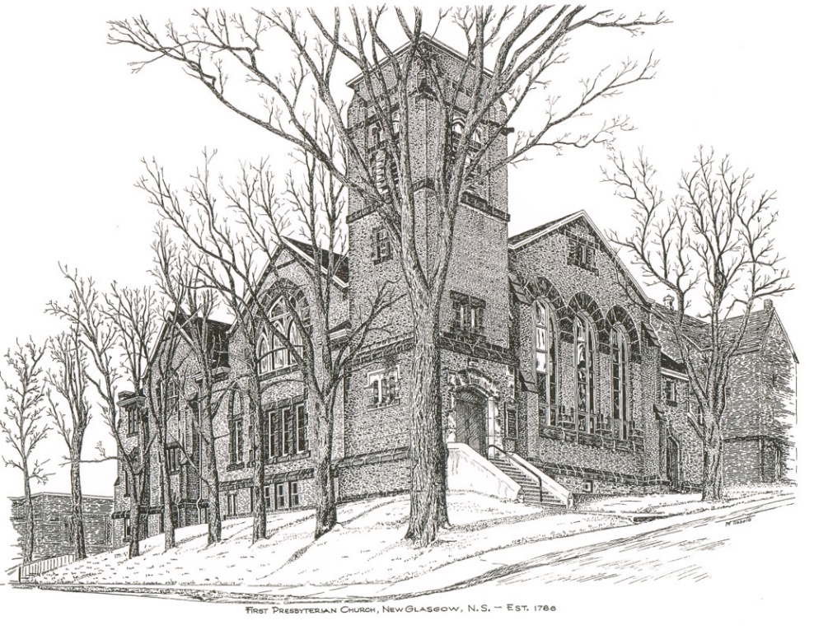

FIRST PRESBYTERIAN CHURCH
208 MacLean St., New Glasgow, NS
902-752-5691
First.church@ns.aliantzinc.ca
Reverend Andrew MacDonald
902-331-0322
yick96@hotmail.com

December 31st, 2023
1st Sunday after Christmas
Communion Sunday
THE APPROACH
(**- Please Rise)
Musical Prelude
Welcome and Announcements

**Lighting the Christ Candle:
ONE: Lord, may this candle which we light illuminate all our difficulties and decisions. May this candle be a fire that burns away all our pride, selfishness and all our temptations. May this candle be a flame that warms our hearts and helps us to love one another better.
ALL: Jesus Christ is the light that shines throughout the world, bringing hope and love to all believers. Let us cause his light to shine through us and make the world a better place
(Light the candle)
One: Let us now open our hearts to worship God almighty.

**Musical Introit
**Call to Worship
**Hymn #141 – “Good Christians all rejoice”
1 Good Christians, all rejoice
with heart and soul and voice;
now give heed to what we say:
Jesus Christ is born today,
ox and ass before him bow,
and he is in the manger now.
Christ is born today;
Christ is born today.

2 Good Christians, all rejoice
with heart and soul and voice;
now you hear of endless bliss:
Jesus Christ was born for this.
He has opened heaven’s door,
and we are blest forevermore.
Christ was born for this;
Christ was born for this.

3 Good Christians, all rejoice
with heart and soul and voice;
now you need not fear the grave:
Jesus Christ was born to save,
calls you one and calls you all
to gain the everlasting hall.
Christ was born to save;
Christ was born to save.

Prayer of Adoration, Confession and Assurance of Pardon
Passing the Peace
**Hymn #150 - “Jesus, our brother, kind and good” vs.1,2,3

- Jesus, our brother, kind and good,
was humbly born in a stable rude,
and the friendly beasts around him stood,
Jesus, our brother, kind and good.
- “I,” said the donkey, shaggy and brown,
“I carried his mother uphill and down;
I carried his mother to Bethlehem town;
I,” said the donkey, shaggy and brown.

3. “I,” said the cow, all white and red,
I gave him my manger for his bed;
I gave him hay to pillow his head;
I,” said the cow, all white and red.

Children’s Time
Prayer of Illumination
First Lesson: Isaiah 61:10-62:3
Second Lesson: Galatians 4:4-7
Responsive Psalm 148
ONE: Praise the Lord! Praise the Lord from the heavens; praise him in the heights! Praise him, all his angels; praise him, all his host!
ALL: Praise him, sun and moon; praise him, all you shining stars!
ONE: Praise him, you highest heavens, and you waters above the heavens! Let them praise the name of the Lord, for he commanded and they were created.
ALL: He established them for ever and ever; he fixed their bounds, which cannot be passed.
ONE: Praise the Lord from the earth, you sea monsters and all deeps, fire and hail, snow and frost, stormy wind fulfilling his command!
ALL: Mountains and all hills, fruit trees and all cedars! Wild animals and all cattle, creeping things and flying birds!
ONE: Kings of the earth and all peoples, princes and all rulers of the earth! Young men and women alike, old and young together!
ALL: Let them praise the name of the Lord, for his name alone is exalted; his glory is above earth and heaven.
ONE: He has raised up a horn for his people, praise for all his faithful, for the people of Israel who are close to him.
ALL: Praise the Lord!

**Gloria Patri
Glory be to the Father, and to the Son, and to the Holy Ghost. As it was in the beginning, is now and ever shall be, world without end. Amen, Amen.

Gospel Lesson: Luke 2:22-40
Anthem – “Candle of Hope”
Sermon: “You Better Watch Out!”
**Hymn: #161 - “What child is this”
1 What child is this, who, laid to rest,
on Mary’s lap is sleeping?
Whom angels greet with anthems sweet,
while shepherds watch are keeping?
This, this is Christ the King,
whom shepherds guard and angels sing;
haste, haste to bring him laud,
the babe, the son of Mary.

2 Why lies he in such mean estate,
where ox and ass are feeding?
Good Christians, fear, for sinners here
the silent Word is pleading.
Nails, spear shall pierce him through,
the cross be borne for me, for you.
Hail, hail the Word made flesh,
the babe, the son of Mary.

3 so bring him incense, gold and myrrh;
come, peasant, king, to own him.
The King of kings salvation brings;
let loving hearts enthrone him.
Raise, raise the song on high;
the virgin sings her lullaby.
Joy, joy for Christ is born,
the babe, the son of Mary.

Offertory
**Doxology
Offertory Prayer

HOLY COMMUNION

Invitation to the Lord’s Supper
The Invitation
Communion Hymn #146 - “Angels from the realm of glory”
vs. 1,2
1 Angels from the realms of glory,
wing your flight o’er all the earth;
ye who sang creation’s story,
now proclaim Messiah’s birth.

Come and worship, come and worship,
worship Christ, the new-born King.

2 Shepherds in the field abiding,
watching o’er your flocks by night,
God with us is now residing;
yonder shines the infant Light.

**Affirmation of Faith - Apostle’s Creed

I believe in God, the Father Almighty, maker of Heaven and earth; and in Jesus Christ, His only Son, Our Lord, who was conceived by the Holy Ghost, born of the Virgin Mary,
suffered under Pontius Pilate, was crucified, died, and was buried. He descended into Hell. On the third day He arose again from the dead; He ascended into Heaven, and sits
at the right hand of God, the Father Almighty; from thence He shall come to judge the quick and the dead.
I believe in the Holy Ghost, the holy Catholic Church,
the communion of saints, the forgiveness of sins, the resurrection of the body, and the life everlasting. Amen.

Great Prayer of Thanksgiving: BoP #564
The Sacrament of Holy Communion
**Communion Hymn 146 - “Angels from the realm of glory”
vs. 5
Though an infant now we view him,
he shall fill his Father’s throne,
gather all the nations to him;
every knee shall then bow down.

Benediction

Recessional
* * * * * * * * * * * * *

Minister: Rev. Andrew MacDonald (c) 902-331-0322
Organist: Clare Grieves
Office hours: Tues. to Fri. – 10 -1pm
Rev. MacDonald office hours -Tues. to Thurs. 10-2 or by appointment

Mission Statement: But he’s already made it plain how to live, what to do, what God is looking for in men and women. It’s quite simple. Do what is fair and just to your neighbor, be compassionate and loyal in your love, and don’t take yourself too seriously – take God seriously. Micah 6: 8-The Message

ANNOUNCEMENTS

All are welcome at First Presbyterian Church. We hope you experience the love of God and of this congregation as we worship, celebrate, and serve one another.

PASTORAL CARE:
In order to provide support to the people of First Church, when you or a loved one is sick or in hospital, we encourage you to contact the church (902-752-5691), Reverend Andrew (902-331-0322) or Cathy Lewis, Chair of the Pastoral Care Team (902-759-9649), to inform us directly. It is also important that you inform the hospital that you would welcome a visit from your minister and/or your Elder.
UPCOMING EVENTS
Sun., Jan. 7, 2024 , 3:00 pm - Trinity United Church - The Carillon Singers, an ensemble of female musicians, present their annual “Old Christmas” concert to end the Christmas Season. A variety of winter melodies and carols will guide you from the depths of Winter’s darkness into the radiant light of a new year. Tickets - $15- available at Chediac’s Furniture in New Glasgow, by email at thecarillonsingers@gmail.com or at the door. Children 12 and under are free.
Pictou County Fuel Fund – The ‘PCFF’ provides short term assistance to those facing the prospect of an unheated home during the winter months. If you or someone you know needs heating assistance, call 1-902-616-4328 (heat) or visit the website www.PictouCountyFuelFund.ca

Thank you to Ron and Sharon Mason for the poinsettias placed in the sanctuary for the Christmas Services (2 red and 2 white) in memory of their parents, Lloyd & Joyce Mason and Bill and Betty Wilson.
Birthday greetings are extended to Phoebe Fraser, she will celebrate her birthday, Sat., Jan. 6th. Happy Birthday Phoebe!

SCRIPTURE READERS & USHERS:
Scripture Reader – Brent MacQuarrie
Ushers: Main Door (Office) – Jane and Keith MacDonald
James St. – Ruth-Anne MacIntosh
MacLean St. (Main Entrance steps) – Ellen Jardine
Early Christian Educators: Lynne Ann and Lois MacLellan

