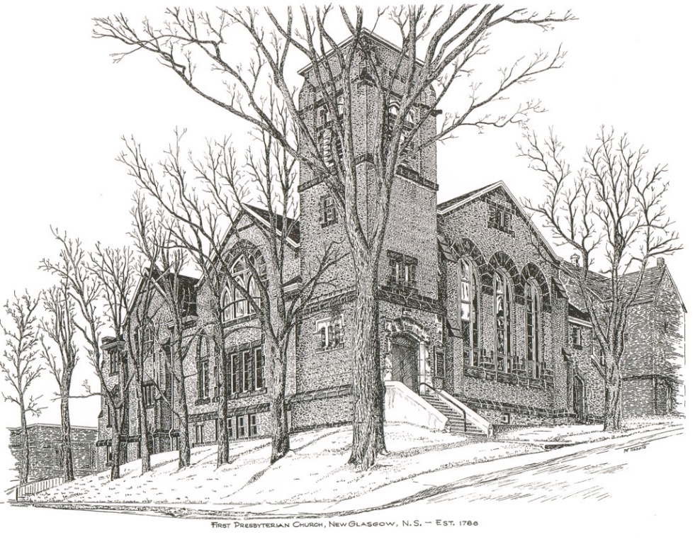

FIRST PRESBYTERIAN CHURCH
208 MacLean St., New Glasgow, NS
902-752-5691
First.church@ns.aliantzinc.ca
Reverend Andrew MacDonald
902-331-0322
yick96@hotmail.com

January 14th, 2024
2nd Sunday after Epiphany
THE APPROACH
** Please Rise **
Musical Prelude
Welcome and Announcements
**Lighting the Christ Candle:
One: In the beginning when God created the heavens and the earth, the earth was a formless void and darkness covered the face of the deep, while a wind from God swept over the face of the waters. Then God said, ‘Let there be light’; and there was light. And God saw that the light was good.
ALL: ‘Jesus said, “I am the light of the world. Whoever follows me will never walk in darkness but will have the light of life.” (Light the candle)
One: Let us now prepare our hearts to worship almighty God.
**Musical Introit - #662 – “Those who wait on the Lord”

2. Those who serve the suffering world
shall renew their strength;
they shall rise up on wings like eagles;
they shall run and not be weary;
they shall walk and not faint:
help us, Lord; help us, Lord in your way.

**Call to Worship
**Hymn #634 – “Will you come and follow me” vs. 1-4
1 Will you come and follow me
if I but call your name?
Will you go where you don’t know
and never be the same?
Will you let my love be shown;
will you let my name be known;
will you let my life be grown
in you and you in me?

2 Will you leave yourself behind
if I but call your name?
Will you care for cruel and kind
and never be the same?
Will you risk the hostile stare
should your life attract or scare?
Will you let me answer prayer
in you and you in me?

3 Will you let the blinded see
if I but call your name?
Will you set the prisoner free
and never be the same?
Will you kiss the leper clean,
and do such as this unseen,
and admit to what I mean
in you and you in me?

4 Will you love the “you” you hide
if I but call your name?
Will you quell the fear inside
and never be the same?
Will you use the faith you’ve found
to reshape the world around,
through my sight and touch and sound
in you and you in me?

Prayer of Adoration, Confession and Lord’s Prayer

Our Father which art in heaven, hallowed be thy name.

Thy kingdom come, thy will be done in earth,

as it is in heaven.

Give us this day our daily bread.

And forgive us our debts, as we forgive our debtors.

And lead us not into temptation, but deliver us from evil:

For thine is the kingdom, and the power, and the glory,

forever. Amen.

Assurance of Pardon
Passing the Peace
**Hymn #500 – “Open my eyes, that I may see” vs. 1-3
1 Open my eyes that I may see
glimpses of truth thou hast for me;
place in my hands the wonderful key
that shall unclasp and set me free.
Silently now I wait for thee,
ready, my God, thy will to see;
open my eyes; illumine me,
Spirit divine!

2 Open my ears that I may hear
voices of truth thou sendest clear,
and while the wave-notes fall on my ear,
everything false will disappear.
Silently now I wait for thee,
ready, my God, thy will to see;
open my ears: illumine me,
Spirit divine!

3 Open my mouth, and let me bear
gladly the warm truth everywhere;
open my heart, and let me prepare
love with thy children thus to share.
Silently now I wait for thee,
ready, my God, thy will to see;
open my heart, illumine me,
Spirit divine!

Children’s Time
Prayer of Illumination
First Lesson: 1 Samuel 3:1-10
Epistle Lesson: 1 Corinthians 6:12-20

Responsive Psalm 139
ONE: O Lord, you have searched me and known me. You know when I sit down and when I rise up; you discern my thoughts from far away.
ALL: You search out my path and my lying down, and are acquainted with all my ways. Even before a word is on my tongue, O Lord, you know it completely.
ONE: You hem me in, behind and before, and lay your hand upon me. Such knowledge is too wonderful for me; it is so high that I cannot attain it.
ALL: For it was you who formed my inward parts; you knit me together in my mother’s womb. I praise you, for I am fearfully and wonderfully made.
ONE: Wonderful are your works; that I know very well. My frame was not hidden from you, when I was being made in secret, intricately woven in the depths of the earth.
ALL: Your eyes beheld my unformed substance.
In your book were written all the days that were formed for me, when none of them as yet existed.
ONE: How weighty to me are your thoughts, O God! How vast is the sum of them!
ALL: I try to count them—they are more than the sand; I come to the end—I am still with you.

**Gloria Patri

Glory be to the Father, and to the Son, and to the Holy Ghost. As it was in the beginning, is now will be, forever. Amen, amen, amen.
Gospel Reading: John 1:43-51
Anthem: “Give it to Jesus”
Sermon: “Speak Lord!”
**Reaffirmation of Faith – Apostles’ Creed

I believe in God, the Father Almighty, maker of Heaven and earth; and in Jesus Christ, His only Son, Our Lord, who was conceived by the Holy Ghost, born of the Virgin Mary,
suffered under Pontius Pilate, was crucified, died, and was buried. He descended into Hell. On the third day He arose again from the dead; He ascended into Heaven, and sits
at the right hand of God, the Father Almighty; from thence He shall come to judge the quick and the dead.
I believe in the Holy Ghost, the holy Catholic Church,
the communion of saints, the forgiveness of sins, the resurrection of the body, and the life everlasting. Amen.

**Hymn #767 – “Lord, speak to me” vs. 1-4

1 Lord, speak to me, that I may speak
in living echoes of your tone;
as you have sought, so let me seek
your erring children lost and lone.

2 Oh lead me, Lord, that I may lead
the wandering and the wavering feet;
oh feed me, Lord, that I may feed
your hungering ones with manna sweet.
3 Oh teach me, Lord, that I may teach
the precious truths that you impart,
and wing my words, that they may reach
the hidden depths of many a heart.

4 Oh fill me with your fullness, Lord,
until my heart shall overflow
in kindling thought and glowing word,
your love to tell, your praise to show.

Offertory
**Doxology
Praise God from whom all blessings Flow. Praise Him all creatures here below. Praise Him above Ye Heavenly Host. Praise Father, Son, and Holy Ghost. Amen.

Offertory Prayer
Prayers of the People:
**Hymn #350 – “To God be the glory” vs. 1-3

1 To God be the glory,
who great things has done!
God so loved the world!
-freely sending the Son,
who yielded his life an atonement for sin,
and opened the lifegate that all may go in.

CHORUS Praise the Lord! Praise the Lord!
Let the earth hear God’s voice!
Praise the Lord! Praise the Lord!
Let the people rejoice!
Oh come to the Father
through Jesus the Son,
and give God the glory,
who great things has done.

2 Oh perfect redemption,
the purchase of blood
to every believer the promise of God,
that when the offender, repenting, believes,
through Jesus’ atonement, full pardon receives!

3 Great things god has taught us,
great things God has done
and great our rejoicing through Jesus the Son,
but purer and higher and greater will be
our wonder, our gladness, when Jesus we see!

**Benediction
Coral Response: Threefold Amen
Recessional

Minister: Rev. Andrew MacDonald (c) 902-331-0322
Organist: Clare Grieves
Office hours: Tues. to Fri. – 10 -1pm
Rev. MacDonald office hours -Tues. to Thurs. 10-2 or by appointment

Mission Statement: But he’s already made it plain how to live, what to do, what God is looking for in men and women. It’s quite simple. Do what is fair and just to your neighbor, be compassionate and loyal in your love, and don’t take yourself too seriously – take God seriously. Micah 6: 8-The Message

ANNOUNCEMENTS

All are welcome at First Presbyterian Church. We hope you experience the love of God and of this congregation as we worship, celebrate, and serve one another.

PASTORAL CARE:
In order to provide support to the people of First Church, when you or a loved one is sick or in hospital, we encourage you to contact the church (902-752-5691), Reverend Andrew (902-331-0322) or Cathy Lewis, Chair of the Pastoral Care Team (902-759-9649), to inform us directly. It is also important that you inform the hospital that you would welcome a visit from your minister and/or your Elder.

UPCOMING EVENTS

JANUARY MEETINGS:
- Today – 12:15 p.m. – Session will meet after service today
- Sun., Jan. 21st – 1:15 p.m. (approx.) - Elders will meet after coffee hour
- Sun., Jan. 28th – 12:15 p.m. – The Board of Managers will meet after service
- Sun., Jan. 21st – Coffee hour, hosted by Marilyn Johnstone.
Sat., Jan. 27th – 6:00p.m. – Merigomish School House – The Carillon Singers present their annual toast to Scotland’s favorite son. “A Robbie Burns Evening”. Featuring music, poems, dancing, and a traditional Scottish meal along with guest musicians, “Heather’s Kitchen”. This is a 19+ event, cash bar available. Tickets - $40 each, can be purchased at LBR Variety, Chediac Furniture, from any Carillon or by emailing thecarillonsingers@gmail.com Doors open at 5:30, opening toast promptly at 6:00 p.m. Scottish dress encouraged!

REMINDER – It is time to start preparing and submitting your reports for the Annual Meeting. The meeting date will be announced soon.

Thank you to everyone who helped remove all the Christmas decorations, your help is greatly appreciated!

SCRIPTURE READERS & USHERS:
Scripture Reader – Sharon Mason
Ushers: Main Door (Office) – Fran Savage & Evie MacLellan
James St. – Ruth-Anne MacIntosh
MacLean St. (Main Entrance steps) – Ellen Jardine
Early Christian Educators: Lynne Ann and Lois MacLellan

Bulletin Notices - If you have a notice for the bulletin, please ensure it is submitted to the office by 9:00 a.m. Thursday morning.

