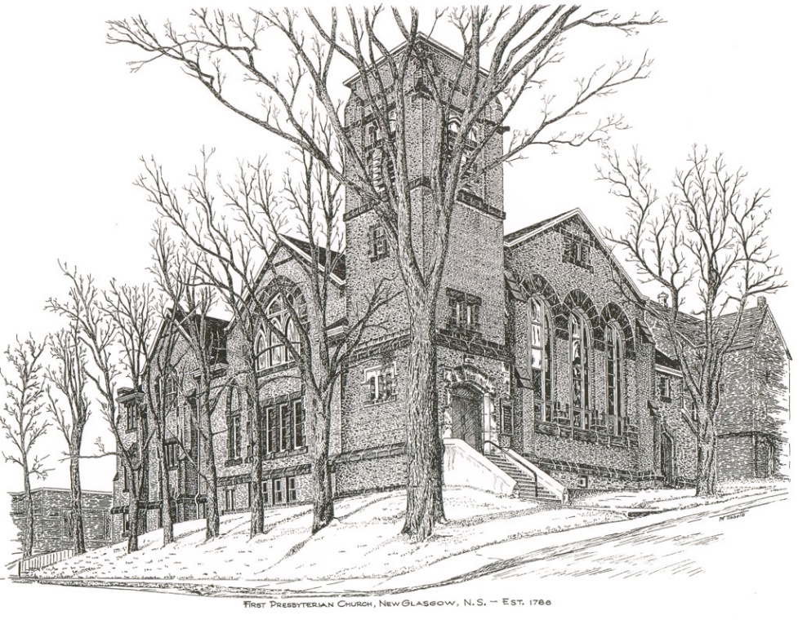

FIRST PRESBYTERIAN CHURCH
208 MacLean St., New Glasgow, NS
902-752-5691
First.church@ns.aliantzinc.ca
Reverend Andrew MacDonald
902-331-0322
yick96@hotmail.com

January 7th 2024
1st Sunday after Epiphany
THE APPROACH
** Please Rise **
Musical Prelude
Welcome and Announcements
**Lighting the Christ Candle:
One: ‘Master, now you are dismissing your servant in peace,
according to your word; for my eyes have seen your salvation,
which you have prepared in the presence of all peoples, a light for revelation to the Gentiles and for glory to your people Israel.’
ALL: It is you who light my lamp; the Lord, my God, lights up my darkness. This God—his way is perfect; the promise of the Lord proves true; he is a shield for all who take refuge in him.
(Light the candle)
One: Let us now prepare our hearts to worship almighty God.
**Musical Introit #662 - “Those who wait on the Lord” vs.1
1 Those who wait on the Lord
shall renew their strength;
they shall rise up on wings as eagles;
they shall run and not be weary;
they shall walk and not faint:
help us, Lord; help us, Lord, in your way.

**Call to Worship
**Hymn #635 – “Brother, sister, let me serve you” vs.1-4
1 Brother, sister, let me serve you;
let me be as Christ to you;
pray that I may have the grace
to let you be my servant too.

2 We are pilgrims on a journey,
and companions on the road;
we are here to help each other
walk the mile and bear the load.

3 I will hold the Christ-light for you
in the night-time of your fear;
I will hold my hand out to you,
speak the peace you long to hear.

4 I will weep when you are weeping;
when you laugh I’ll laugh with you;
I will share your joy and sorrow,
till we’ve seen this journey through.

Prayer of Adoration, Confession and Lord’s Prayer

Our Father which art in heaven, hallowed be thy name.

Thy kingdom come, thy will be done in earth,

as it is in heaven.

Give us this day our daily bread.

And forgive us our debts, as we forgive our debtors.

And lead us not into temptation, but deliver us from evil:

For thine is the kingdom, and the power, and the glory,

forever. Amen.

Assurance of Pardon
Passing the Peace
**Hymn #307 – “God the sparrow, God of the whale”
1 God of the sparrow
God of the whale
God of the swirling stars
How does the creature say Awe
How does the creature say Praise

2 God of the earthquake
God of the storm
God of the trumpet blast
How does the creature say Woe
How does the creature say Save

3 God of the rainbow
God of the cross
God of the empty grave
How does the creature say Grace
How does the creature say Thanks

4 God of the hungry
God of the sick
God of the prodigal
How does the creature say Care
How does the creature say Life

5 God of the neighbour
God of the foe
God of the pruning hook
How does the creature say Love
How doe the creature say Peace

6 God of the ages
God near at hand
God of the loving heart
How do your children say Joy
How do your children say Home

Children’s Time
Prayer of Illumination
First Lesson: Genesis 1:1-5
Epistle Lesson: Acts 19:1-7

Responsive Psalm 29
ONE: Ascribe to the Lord, O heavenly beings, ascribe to the Lord glory and strength. Ascribe to the Lord the glory of his name; worship the Lord in holy splendour.
ALL: The voice of the Lord is over the waters; the God of glory thunders, the Lord, over mighty waters. The voice of the Lord is powerful; the voice of the Lord is full of majesty.
ONE: The voice of the Lord breaks the cedars; the Lord breaks the cedars of Lebanon. He makes Lebanon skip like a calf, and Sirion like a young wild ox.
ALL: The voice of the Lord flashes forth flames of fire. The voice of the Lord shakes the wilderness; the Lord shakes the wilderness of Kadesh.
ONE: The voice of the Lord causes the oaks to whirl, and strips the forest bare; and in his temple all say, ‘Glory!’
ALL: The Lord sits enthroned over the flood; the Lord sits enthroned as king for ever. May the Lord give strength to his people! May the Lord bless his people with peace!
**Gloria Patri

Glory be to the Father, and to the Son, and to the Holy Ghost. As it was in the beginning, is now will be, forever. Amen, amen, amen.

Gospel Reading: Mark 1:4-11
Anthem: “Shout joyfully”
Sermon: “Washed Clean!”
**Reaffirmation of Faith – Apostles’ Creed

I believe in God, the Father Almighty, maker of Heaven and earth; and in Jesus Christ, His only Son, Our Lord, who was conceived by the Holy Ghost, born of the Virgin Mary,
suffered under Pontius Pilate, was crucified, died, and was buried. He descended into Hell. On the third day He arose again from the dead; He ascended into Heaven, and sits
at the right hand of God, the Father Almighty; from thence He shall come to judge the quick and the dead.
I believe in the Holy Ghost, the holy Catholic Church,
the communion of saints, the forgiveness of sins, the resurrection of the body, and the life everlasting. Amen.

**Hymn #176 – “Songs of thankfulness and praise” – vs.1,3,5
1 Songs of thankfulness and praise
Jesus, Lord, to you we raise,
God revealed by guiding star
to the sages from afar,
branch of royal David’s stem,
in your birth at Bethlehem:
anthems be to you addressed,
God in Christ made manifest.

3 God revealed in making whole
weakening limbs and fainting soul,
God revealed in valiant fight
quelling all the devil’s might,
God revealed in gracious will,
ever bringing good from ill,
anthems be to you addressed,
God in Christ made manifest.

5 Grant us grace to see you, Lord,
mirrored in your holy word;
may we imitate you still
and obey your perfect will,
that we like to you may be,
at your great Ephipany:
may your glory be confessed,
God in Chist made manifest.

Offertory
**Doxology
Praise God from whom all blessings Flow. Praise Him all creatures here below. Praise Him above Ye Heavenly Host. Praise Father, Son, and Holy Ghost. Amen.

Offertory Prayer
Prayers of the People

**Hymn #172 – “As with gladness men of old” vs. 1,2,4,5
1 As with gladness men of old
did the guiding star behold;
as with joy they hailed its light,
leading onward, beaming bright;
so, most gracious Lord, may we
evermore be led to thee.

2 As with joyful steps they sped,
Saviour, to thy lowly bed,
there to bend the knee before
thee, whom heaven and earth adore,
so may we with willing feet
ever seek thy mercy seat.

4 Holy Jesus, every day
keep us in the narrow way,
and when earthly things are past,
bring our ransomed souls at last
where they need no star to guide,
where no clouds of glory hide.

5 In that heavenly country bright
need they no created light:
thou its light, its joy, its crown,
thou its sun which goes not down;
there forever may we sing
hallelujahs to our King.

* * * * * * * * * * * * *
Minister: Rev. Andrew MacDonald (c) 902-331-0322
Organist: Clare Grieves
Office hours: Tues. to Fri. – 10 -1pm
Rev. MacDonald office hours -Tues. to Thurs. 10-2 or by appointment

Mission Statement: But he’s already made it plain how to live, what to do, what God is looking for in men and women. It’s quite simple. Do what is fair and just to your neighbor, be compassionate and loyal in your love, and don’t take yourself too seriously – take God seriously. Micah 6: 8-The Message

* * * * * * * * * * * *

ANNOUNCEMENTS

All are welcome at First Presbyterian Church. We hope you experience the love of God and of this congregation as we worship, celebrate, and serve one another.

PASTORAL CARE:
In order to provide support to the people of First Church, when you or a loved one is sick or in hospital, we encourage you to contact the church (902-752-5691), Reverend Andrew (902-331-0322) or Cathy Lewis, Chair of the Pastoral Care Team (902-759-9649), to inform us directly. It is also important that you inform the hospital that you would welcome a visit from your minister and/or your Elder.
A generous donation has been received from Betty Smith, Pictou, along with her Christmas greetings to the congregation of First Church.
UPCOMING EVENTS
JANUARY MEETINGS:
- Tues., Jan. 9th – 6:00 p.m. – We will be hosting an “Undecorating of the Church” party! Any help would be greatly appreciated. If you are available, please join us.
- Sun., Jan. 14th – 12:15 p.m. – Session will meet after service
- Sun., Jan. 21st – 1:15 p.m. (approx.) - Elders will meet after coffee hour
- Sun., Jan. 28th – 12:15 p.m. – The Board of Managers will meet after service
Sun., Jan. 21st – Coffee hour, hosted by Marilyn Johnstone.
Today - 3:00 pm - Trinity United Church - The Carillon Singers, an ensemble of female musicians, present their annual “Old Christmas” concert to end the Christmas Season. A variety of winter melodies and carols will guide you from the depths of Winter’s darkness into the radiant light of a new year. Tickets - $15- available at Chediac’s Furniture in New Glasgow, by email at thecarillonsingers@gmail.com or at the door. Children 12 and under are free.
Birthday greetings are extended to Ralph Foote who will celebrate his birthday Fri., Jan. 12th. Happy Birthday Ralph!

SCRIPTURE READERS & USHERS:
Scripture Reader – Kevin Reid
Ushers: Main Door (Office) – Fran Savage & Evie MacLellan
James St. – Ruth-Anne MacIntosh
MacLean St. (Main Entrance steps) – Ellen Jardine
Early Christian Educators: Lynne Ann and Lois MacLellan

Bulletin Notices - If you have a notice for the bulletin, please ensure it is submitted to the office by 9:00 a.m. Thursday morning.

