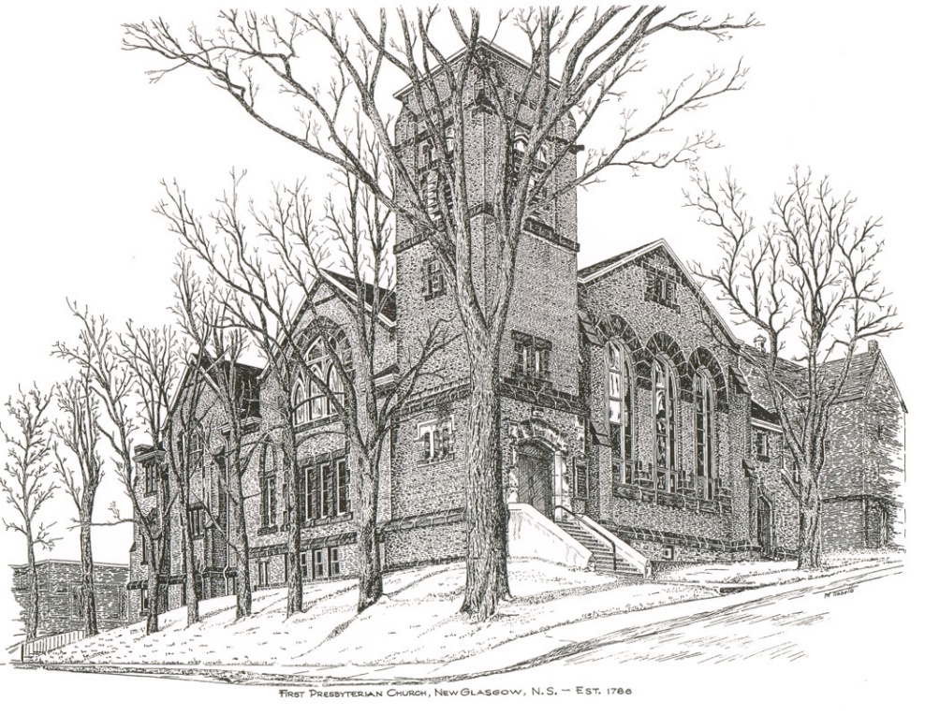

FIRST PRESBYTERIAN CHURCH
208 MacLean St., New Glasgow, NS
902-752-5691
First.church@ns.aliantzinc.ca
Reverend Andrew MacDonald
902-331-0322
yick96@hotmail.com

February 18th, 2024
1st Sunday in Lent

THE APPROACH
** Please Rise **
Musical Prelude
Welcome and Announcements
**Lighting the Christ Candle:
One: On this first Sunday of Lent, we find Jesus in the wilderness, facing temptation. And forty days in the wilderness is a long time.
All: We too experience wilderness times of temptation, challenge and change.
One: Yet even in the wilderness and among the wild beasts the angels cared for Jesus.
All: As we make our way in the wilderness, we hear the good news that we are not alone —that the reign of God has come near in Christ. (Light the candle)
One: Let us now prepare our hearts to worship almighty God.
**Musical Introit - #777 - “Send me, Lord”
**Call to Worship
**Hymn #712 – “Arise, your light is come”

Prayer of Adoration, Confession and Lord’s Prayer

Our Father which art in heaven, hallowed be thy name.

Thy kingdom come, thy will be done in earth,

as it is in heaven.

Give us this day our daily bread.

And forgive us our debts, as we forgive our debtors.

And lead us not into temptation, but deliver us from evil:

For thine is the kingdom, and the power, and the glory,

forever. Amen.

Assurance of Pardon
Passing the Peace
**Hymn #25 – “As longs the hart”
Children’s Time
Prayer of Illumination
First Lesson: Genesis 9:8-17
Epistle Lesson: 1 Peter 3:18-22
Responsive Psalm 25:1-10

ONE: To you, O Lord, I lift up my soul. O my God, in you I trust; do not let me be put to shame; do not let my enemies exult over me.
ALL: Do not let those who wait for you be put to shame; let them be ashamed who are wantonly treacherous.
ONE: Make me to know your ways, O Lord; teach me your paths. Lead me in your truth, and teach me, for you are the God of my salvation; for you I wait all day long.
ALL: Be mindful of your mercy, O Lord, and of your steadfast love, for they have been from of old.
ONE: Do not remember the sins of my youth or my transgressions; according to your steadfast love remember me, for your goodness’ sake, O Lord!
ALL: Good and upright is the Lord; therefore he instructs sinners in the way. He leads the humble in what is right, and teaches the humble his way.
ONE: All the paths of the Lord are steadfast love and faithfulness, for those who keep his covenant and his decrees.
**Gloria Patri

Glory be to the Father, and to the Son, and to the Holy Ghost! As it was in the beginning is now and ever shall be. World without end. Amen, amen!

Gospel Reading: Mark 1:9-15
Anthem
Sermon: “One In Christ!”
**Reaffirmation of Faith – Apostles’ Creed

I believe in God, the Father Almighty, maker of Heaven and earth; and in Jesus Christ, His only Son, Our Lord, who was conceived by the Holy Ghost, born of the Virgin Mary,
suffered under Pontius Pilate, was crucified, died, and was buried. He descended into Hell. On the third day He arose again from the dead; He ascended into Heaven, and sits
at the right hand of God, the Father Almighty; from thence He shall come to judge the quick and the dead.
I believe in the Holy Ghost, the holy Catholic Church,
the communion of saints, the forgiveness of sins, the resurrection of the body, and the life everlasting. Amen.

**Hymn #367 -- “Jesus, the very thought of thee”
Offertory
**Doxology
Praise God from whom all blessings Flow. Praise Him all creatures here below. Praise Him above Ye Heavenly Host. Praise Father, Son, and Holy Ghost. Amen.

Offertory Prayer
Prayers of the People: The People Respond

**Hymn #671 – “I heard the voice of Jesus say”

**Benediction
Coral Response: Threefold Amen
Recessional
* * * * * * * * * * * * *
Minister: Rev. Andrew MacDonald (c) 902-331-0322
Organist: Clare Grieves
Office hours: Tues. to Fri. – 10 -1pm
Rev. MacDonald office hours -Tues. to Thurs. 10-2 or by appointment

Mission Statement: But he’s already made it plain how to live, what to do, what God is looking for in men and women. It’s quite simple. Do what is fair and just to your neighbor, be compassionate and loyal in your love, and don’t take yourself too seriously – take God seriously. Micah 6: 8-The Message

ANNOUNCEMENTS

All are welcome at First Presbyterian Church. We hope you experience the love of God and of this congregation as we worship, celebrate, and serve one another.

PASTORAL CARE:
In order to provide support to the people of First Church, when you or a loved one is sick or in hospital, we encourage you to contact the church (902-752-5691), Reverend Andrew (902-331-0322) or Cathy Lewis, Chair of the Pastoral Care Team (902-759-9649), to inform us directly. It is also important that you inform the hospital that you would welcome a visit from your minister and/or your Elder.
UPCOMING EVENTS
Today – Session will meet following service.
Coffee Hour – The Choir is hosting coffee hour after service today. Please join us if you can.

We wish Natalie MacDonald a very happy birthday! Though we missed her birthday due to the snowstorm, we hope she had a great day!

We also extend belated birthday wishes to Marion MacNeil and Bill MacDonald who celebrated their birthdays on Valentine’s Day!

We also send our best wishes to Lee Searle who celebrated her birthday Feb. 15th.

Mar. 3rd - Annual Reports Due – If you have not already done so, please submit your reports for the Annual Report by Mar. 3rd. The Annual Meeting is scheduled for Mar. 17th.
Message from Atlantic Synod - Canada Youth is back, under a new name: LIFT (Living In Faith Together). LIFT is a national gathering for high school students (grade 9-12), young adults (19-25), and leaders (18+). It will be held July 3-7, 2024, hosted at Brock University in St. Catharines, ON (just outside Niagara Falls). The theme this year is 'Audacious Hope' and is based
on the Bible Verse 2 Corinthians 3.12. We are hoping to send a group from the Atlantic Synod. Please fill out this “interest form” for yourself or potential participants from your congregation so the planning team can work on arrangements, including transportation and financial assistance. The form does not require you to go on LIFT but is to help us with some logistics in planning. https://forms.gle/7F9KSnwxhtsWcgqWA
Bulletin Notices - If you have a notice for the bulletin, please ensure it is submitted to the office by 9:00 a.m. Thursday morning.
SCRIPTURE READERS & USHERS:
Scripture Reader – Kevin Reid
Ushers: Main Door (Office) – Jane Williams
James St. – Ruth-Anne MacIntosh
MacLean St. (Main Entrance steps) – Ellen Jardine
Early Christian Educators: Lynne Ann and Lois MacLellan

