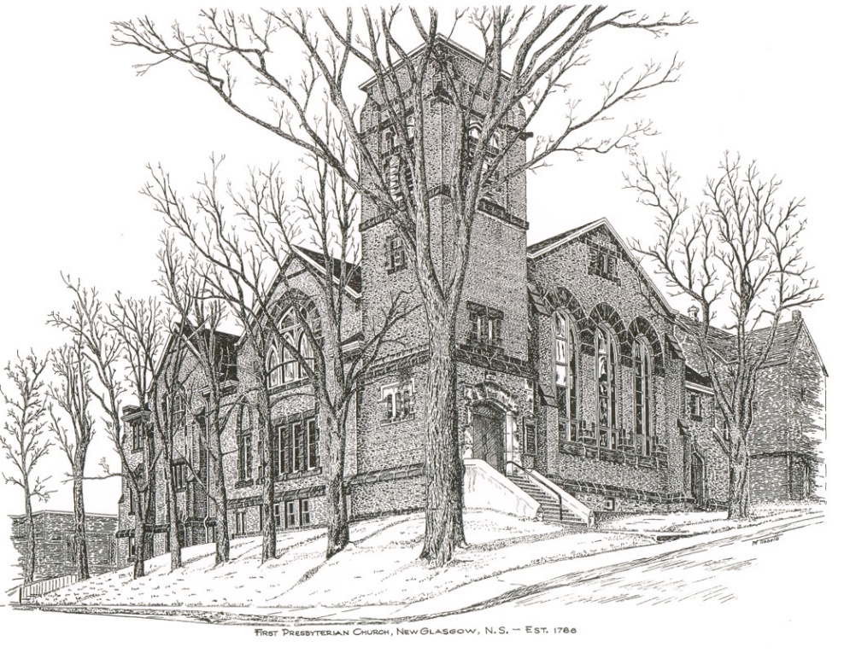

FIRST PRESBYTERIAN CHURCH
208 MacLean St., New Glasgow, NS
902-752-5691
First.church@ns.aliantzinc.ca
Reverend Andrew MacDonald
902-331-0322
yick96@hotmail.com

February 4th, 2024
5th Sunday after Epiphany
PWS&D Sunday
THE APPROACH
** Please Rise **
Musical Prelude
Welcome and Announcements
**Lighting the Christ Candle:
One: Arise, shine; for your light has come, and the glory of the Lord has risen upon you. For darkness shall cover the earth, and thick darkness the peoples; but the Lord will arise upon you, and his glory will appear over you. Nations shall come to your light, and kings to the brightness of your dawn.
ALL: Then you shall see and be radiant; your heart shall thrill and rejoice, because the abundance of the sea shall be brought to you, the wealth of the nations shall come to you. They shall bring gold and frankincense and shall proclaim the praise of the Lord. (Light the candle)
One: Let us now prepare our hearts to worship almighty God.
**Musical Introit - #27 - “As the deer”
**Call to Worship
**Hymn #90 – “Up from the depths I cry to God”
Prayer of Adoration, Confession and Lord’s Prayer
Assurance of Pardon
Passing the Peace
**Hymn #571 – “Lord, I want to be a Christian” vs.1,2,3
Children’s Time
Prayer of Illumination
First Lesson: Isaiah 40:21-31
Epistle Lesson: 1 Corinthians 9:16-23
Responsive Psalm 147:1-11,20 (INSERT)
**Gloria Patri
Gospel Reading: Mark 1:29-39
Anthem: “I have called you by your name”
Sermon: “Servant To All!”
**Reaffirmation of Faith – Apostles’ Creed
**Hymn #475 - “I am the church! You are the church!” vs.1,2,4
Offertory
**Doxology
Offertory Prayer
Prayers of the People: The People Respond

**Hymn #470 – “You that know the Lord is gracious”
**Benediction
Coral Response: Threefold Amen
Recessional
* * * * * * * * * * * * *
Minister: Rev. Andrew MacDonald (c) 902-331-0322
Organist: Clare Grieves
Office hours: Tues. to Fri. – 10 -1pm
Rev. MacDonald office hours -Tues. to Thurs. 10-2 or by appointment

Mission Statement: But he’s already made it plain how to live, what to do, what God is looking for in men and women. It’s quite simple. Do what is fair and just to your neighbor, be compassionate and loyal in your love, and don’t take yourself too seriously – take God seriously. Micah 6: 8-The Message
Apostles Creed

I believe in God, the Father Almighty, maker of Heaven and earth; and in Jesus Christ, His only Son, Our Lord, who was conceived by the Holy Ghost, born of the Virgin Mary,
suffered under Pontius Pilate, was crucified, died, and was buried. He descended into Hell. On the third day He arose again from the dead; He ascended into Heaven, and sits
at the right hand of God, the Father Almighty; from thence He shall come to judge the quick and the dead.
I believe in the Holy Ghost, the holy Catholic Church,
the communion of saints, the forgiveness of sins, the resurrection of the body, and the life everlasting. Amen.

The Lord’s Prayer

Our Father which art in heaven, hallowed be thy name.

Thy kingdom come, thy will be done in earth,

as it is in heaven.

Give us this day our daily bread.

And forgive us our debts, as we forgive our debtors.

And lead us not into temptation, but deliver us from evil:

For thine is the kingdom, and the power, and the glory,

forever. Amen.

Gloria Patri

Glory be to the Father, and to the Son, and to the Holy Ghost! As it was in the beginning is now and ever shall be. World without end. Amen, amen!

Doxology

Praise God from whom all blessings Flow. Praise Him all creatures here below. Praise Him above Ye Heavenly Host. Praise Father, Son, and Holy Ghost. Amen.

