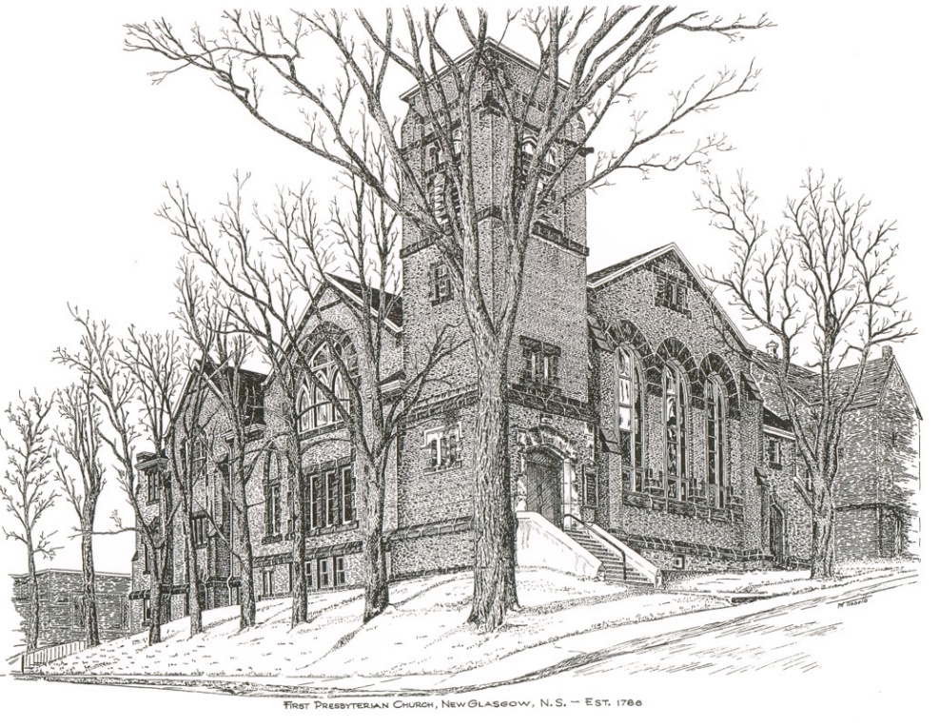

FIRST PRESBYTERIAN CHURCH
208 MacLean St., New Glasgow, NS
902-752-5691
First.church@ns.aliantzinc.ca
Reverend Andrew MacDonald
902-331-0322
yick96@hotmail.com

April 21st, 2024
4th Sunday of Easter

THE APPROACH

Musical Prelude
Welcome and Announcements

Lighting the Christ Candle: Please rise

One: For it is you who light my lamp; the LORD my God lightens my darkness. Arise, shine, for your light has come, and the glory of the Lord has risen upon you. This is the message we have heard from him and proclaim to you, that God is light, and in him is no darkness at all.
All: Do not gloat over me, my enemy! Though I have fallen, I will rise. Though I sit in darkness, the LORD will be my light. The Lord is my light and my salvation whom shall I fear? The Lord is the stronghold of my life of whom shall I be afraid? The light shines in the darkness, and the darkness has not overcome it. (Light the candle)

One: Let us now prepare our hearts to worship almighty God.

Musical Introit - #575 - "Lead me, Lord"

Lead me, Lord, lead me in your righteousness;
make your way plain before my face,
for it is you, and you, God only,
who makes me dwell in safety.

Call to Worship

Hymn #485 – “Savior, like a shepherd lead us”

1 Saviour, like a shepherd lead us:
much we need your tender care;
in your pleasant pastures feed us;
for our use your folds prepare:
blessed Jesus, blessed Jesus!
You have bought us; yours we are.
Blessed Jesus, blessed Jesus!
You have bought us; yours we are.

2 We are yours; in love befriend us;
be the guardian of our way;
keep your flock from sin, defend us;
seek us when we go astray:
blessed Jesus, blessed Jesus!
Hear your children when we pray.
Blessed Jesus, blessed Jesus!
Hear your children when we pray.

3 Let us always seek your favour;
let us always do your will.
Jesus Christ our only Saviour,
with yourself our spirits fill:
blessed Jesus, blessed Jesus!
You have loved us, love us still.
Blessed Jesus, blessed Jesus!
You have loved us, love us still.

Prayer of Adoration, Confession and Assurance of Pardon
Passing the Peace
Hymn #11 – “The Lord’s my shepherd”

1 The Lord’s my shepherd, I’ll not want,
He makes me down to lie
in pastures green; He leadeth me
the quiet waters by.

2 My soul he doth restore again,
and me to walk doth make
within the paths of righteousness
e’en for his own name’s sake.

3 Yea, though I walk in death’s dark vale,
yet will I fear none ill,
for thou art with me, and thy rod
and staff me comfort still.

4 My table thou hast furnished
in presence of my foes;
my head thou dost with oil anoint
and my cup overflows.

5 Goodness and mercy all my life
shall surely follow me
and in God’s house forevermore
my dwelling place shall be.

Children’s Time
Prayer of Illumination
First Lesson: Acts 4:5-12
Second Lesson: 1 John 3:16-24
Responsive Psalm 23
ONE: The Lord is my shepherd, I shall not want. He makes me lie down in green pastures; he leads me beside still waters; he restores my soul. He leads me in right paths for his name’s sake.
ALL: Even though I walk through the darkest valley, I fear no evil;
for you are with me; your rod and your staff—they comfort me.
ONE: You prepare a table before me in the presence of my enemies;
you anoint my head with oil; my cup overflows.
ALL: Surely goodness and mercy shall follow me all the days of my life, and I shall dwell in the house of the Lord my whole life long.

Gloria Patri

Glory be to the Father
and to the Son, and to the Holy Ghost!
As it was in the beginning is now and ever shall be.
World without end. Amen, amen.
Gospel Lesson: John 10:11-18
Anthem: #361 - “A Stranger, knocking on a door”
Sermon: “The Good Shepherd”
Hymn: #262 – “Come to us, beloved Stranger”
- Come to us, beloved Stranger,
as you came that Easter day.
Walk with us to our Emmaus,
for we need you still today.
Come to us when we are broken,
when our dearest hopes are lost,
speak to us the prophet's message
you fulfilled upon the cross.
2. Stay with us and give us blessing,
that our hopes again may rise.
Offer us your broken body;
open our unseeing eyes.
Come to us, God's love embodied;
touch our hearts with burning flame.
Risen Christ, once dead, now living,
come to us through joy, through pain.
3. We would never fail to see you
as you walk with us each day.
As a friend and not a stranger
you would join us on our way.
Help us trust that through your mercy
we can doubt and fear transcend,
and to others be a blessing.
Keep us faithful till life's end!

Offeratory

Doxology #79

Praise God from whom all blessings flow. Praise Him all creatures here below. Praise Him above Ye Heavenly Host. Praise Father, Son, and Holy Ghost. Amen.

Offertory Prayer
Prayers of the People: (The People Respond)

ONE: Lord, in your mercy,
ALL: Hear our prayer.

Hymn: #699 – “All the way my Savior leads me”

1 All the way my Saviour leads me;
what have I to ask beside?
Can I doubt his tender mercy
who through life has been my guide?
Heavenly peace, divinest comfort,
here by faith in him to dwell;
for I know whate’er befall me,
Jesus doeth all things well.

2 All the way my Saviour leads me,
cheers each winding path I tread,
give me grace for every trial,
feeds me with the living bread.
Though my weary steps may falter
and my soul athirst may be,
gushing from the rock before me,
lo, a spring of joy I see.

3 All the way my Saviour leads me,
oh the fullness of his love!
Perfect rest for me is promised
in my Father’s house above.
When my spirit, clothed, immortal,
wings its flight to realms of day,
this my song through endless ages,
“Jesus led me all the way!”

**Benediction
Coral Response: “Go Now in Peace” (Don Besig)

Go now in peace
Never be afraid
God will go with you each hour of every day

Go now in faith
Steadfast, strong, and true.
Know He will guide you in all you do.

Go now in love,
And show you believe
Reach out to others
So all the world can see.

God will be there
Watching from above
Go now in peace,
In faith, and in love
Amen, amen, amen.
Recessional

* * * * * * * * * ** * * * * * * * * * *

ANNOUNCEMENTS

All are welcome at First Presbyterian Church. We hope you experience the love of God and of this congregation as we worship, celebrate, and serve one another.

PASTORAL CARE:
In order to provide support to the people of First Church, when you or a loved one is sick or in hospital, we encourage you to contact the church (902-752-5691), Reverend Andrew (902-331-0322) or Cathy Lewis, Chair of the Pastoral Care Team (902-759-9649), to inform us directly. It is also important that you inform the hospital that you would welcome a visit from your minister and/or your Elder.
UPCOMING EVENTS
Today to May 19th – Mark Thibeau is leading a 6-week video Bible Study titled “In the Footsteps of the Saviour – Following Jesus through the Holy Land”, hosted by Max Lucado. These sessions will take place weekly in the Lower Hall at 2:00 p.m. If you are interested in attending, please sign up on the form outside the office door.
Today – Coffee Hour after service.
NOTE: - Coffee hour is the 3rd Sunday of the month. If possible, please bring a donation for the Food Bank Cart that day. Next Coffee Hour/Food Bank Sunday will be next Sunday, May 19th following morning service.
Today – 2:30 p.m. – We will be worshipping with the residents of Riverview Residential. Everyone welcome.
Sat., April 27th – 10a.m.-2p.m. – An ‘Elder Workshop’, sponsored by the Presbytery of Pictou, Life and Mission Committee, will take place at First Presbyterian, New Glasgow, Upper Hall. All elders strongly encouraged to attend. Bring a lunch; tea and coffee will be provided.
Fri., May 17th – The Board of Managers is hosting a “Beans and Brown Bread” take out. Tickets are available from any Board member or the office. Cost - $10/person. Pickup: 10 a.m. - Noon

Sun., May 5th – 7p.m. – St. Andrew’s Presbyterian Church, Westville, is hosting an “Evening of Music Concert”, featuring the combined choirs of Thorburn and Little Harbour Presbyterian Churches; Brass United Quintet, the Westville Salvation Army Worship Team and more. Free will offering; refreshments and fellowship to follow. All welcome!!
Sun. May 26th 12:15 p.m. – Trinity United is hosting a “Neighbourhood Churches Block Party”. Lunch will be provided by the congregation of Trinity in their auditorium. You are invited to join them to share lunch, meet old and new friends and celebrate the joy of our faith. If you would like to attend, please let Jane know by Wed., May 23rd so she can provide numbers to Trinity for catering purposes.
Camp Geddie Wish List – Camp Geddie has issued a request for donation of supplies for the upcoming season; everything from dish detergent to Ziplock bags! Please see the blue posters on the office window and in the Upper Hall for details. All donations appreciated.

SCRIPTURE READERS & USHERS:
Scripture Reader: Brent MacQuarrie
Ushers: Main Door (Office) – Ian Semple
James St. – Ruth-Anne MacIntosh
MacLean St. (Main Entrance steps) – Ellen Jardine
EARLY CHRISTIAN EDUCATORS: Lynne Ann and Lois MacLellan

Mission Statement: But he’s already made it plain how to live, what to do, what God is looking for in men and women. It’s quite simple. Do what is fair and just to your neighbor, be compassionate and loyal in your love, and don’t take yourself too seriously – take God seriously. Micah 6: 8-The Message

