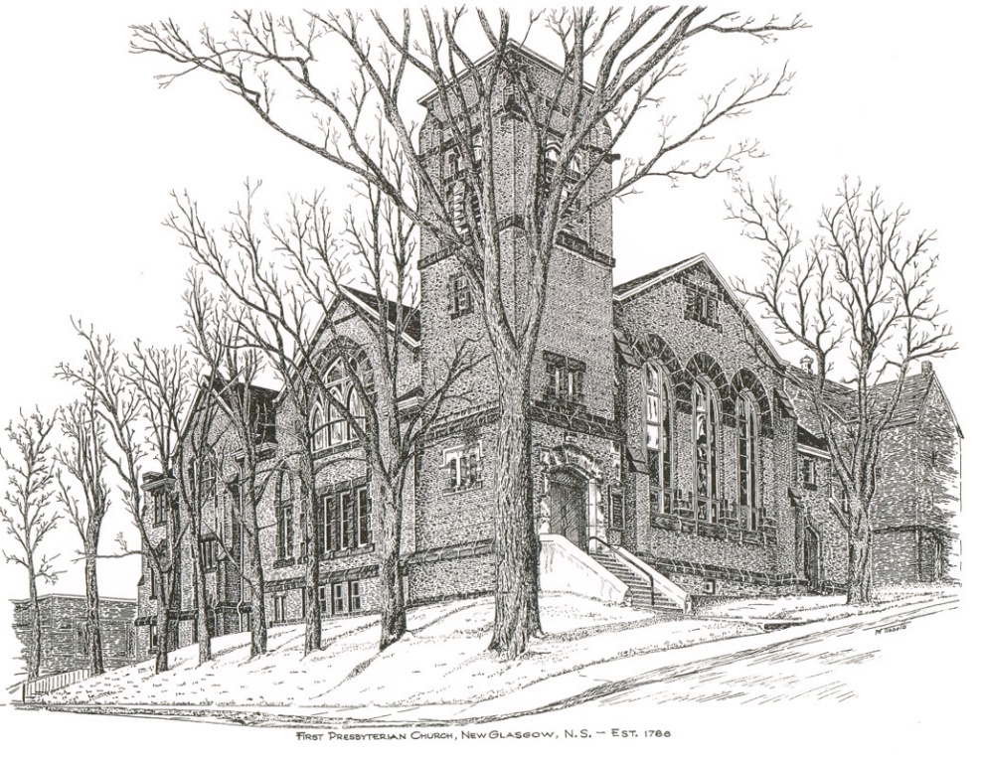

FIRST PRESBYTERIAN CHURCH
208 MacLean St., New Glasgow, NS
902-752-5691
First.church@ns.aliantzinc.ca
Reverend Andrew MacDonald
902-331-0322
yick96@hotmail.com

April 28th, 2024
5th Sunday of Easter
Mission Awareness Sunday

THE APPROACH

Musical Prelude
Welcome and Announcements

Lighting the Christ Candle: Please rise

One: The Lord is my light and my salvation; whom shall I fear?
The Lord is the stronghold of my life; of whom shall I be afraid?
All: In the dark, thieves break into houses, but by day they shut themselves in; they want nothing to do with the light. The people who walked in darkness have seen a great light; those who dwelt in a land of deep darkness, on them has light shined. (Light the candle)

One: Let us now prepare our hearts to worship almighty God.

Musical Introit - #575 - "Lead me, Lord"

Lead me, Lord, lead me in your righteousness;
make your way plain before my face,
for it is you, and you, God only,
who makes me dwell in safety.

Call to Worship
ONE: Grace, Mercy, and Peace, from God our father and the Lord Jesus Christ. Like spring breaking through winter’s power.
ALL: God’s resurrecting power breaks into our lives in surprising ways.
ONE: Like the vine that supports blossoms and fruit,
ALL: God’s Word upholds the church in strength.
ONE: Let us worship God who makes all things new.
ALL: We will praise God who brings growth and renewal to all life.

Hymn #46 – “We will tell each generation”

1 We will tell each generation
all that you, our God, have done;
how you called and led our nation,
chose us out to be your own:

2 Tell the time of our rebelling –
how we wandered from your way,
how your law our love compelling
taught us humbly to obey;

3 Tell how once, when spite and terror
threatened to engulf our land,
you defended us with vigour,
saved us by a mighty hand.

4 Tell the grace that falls from heaven,
angels’ food as faith’s reward;
tell how sins may be forgiven
through the mercy of the Lord.

Prayer of Adoration, Confession and Assurance of Pardon
Passing the Peace

Hymn #704 – “Teach me, God, to wonder”

- Teach me, God, to wonder; teach me, God, to see;
let your world of beauty capture me.

Refrain:
Praise to you be given; love for you be lived,
life be celebrated; joy you give.

- Let me, God, be open; let me loving be;
let your world of people speak to me.

- Let me, God, be ready; let me be awake,
in your world of loving, my place take.

- Teach me, God, to know you, hear you when you speak, see you in my neighbor when we meet.

Children’s Time
Prayer of Illumination
First Lesson: Acts 8:26-40
Second Lesson: 1 John 4:7-21
Responsive Psalm 22:25-31

ONE: From you comes my praise in the great congregation; my vows I will pay before those who fear him.
ALL: The poor shall eat and be satisfied; those who seek him shall praise the Lord. May your hearts live for ever!
ONE: All the ends of the earth shall remember and turn to the Lord; and all the families of the nations shall worship before him.
ALL: For dominion belongs to the Lord, and he rules over the nations.
ONE: To him, indeed, shall all who sleep in the earth bow down; before him shall bow all who go down to the dust, and I shall live for him.
ALL: Posterity will serve him; future generations will be told about the Lord, and proclaim his deliverance to a people yet unborn, saying that he has done it.
Gloria Patri
Glory be to the Father
and to the Son, and to the Holy Ghost!
As it was in the beginning is now and ever shall be.
World without end. Amen, amen.
Gospel Lesson: John 15:1-8
Anthem
Sermon: “God is Love!”
Hymn: #772 – “Christ for the world we sing” (Tune 291)
1 “Christ for the world” we sing;
the world to Christ we bring
with loving zeal,
the poor and all that mourn,
the faint and over-borne,
sin-sick and sorrow-worn,
for Christ to heal.

2 “Christ for the world” we sing;
the world to Christ we bring
with fervent prayer,
the wayward and the lost,
by restless passions tossed,
redeemed at countless cost
from dark despair.

3 “Christ for the world” we sing;
the world to Christ we bring
with one accord,
with us the work to share,
with us reproach to dare,
with us the cross to bear
for Christ our Lord.
4 “Christ for the world” we sing;
the world to Christ we bring
with joyful song;
the new-born souls whose days,
reclaimed to live always,
inspired with hope and praise,
to Christ belong.

Offeratory

Doxology #79

Praise God from whom all blessings flow. Praise Him all creatures here below. Praise Him above Ye Heavenly Host. Praise Father, Son, and Holy Ghost. Amen.

Offertory Prayer

Prayers of the People: (The People Respond)

Hymn: #258 – “Thine be the glory”

1 Thine be the glory, risen, conquering son,
endless is the victory thou o’er death hast won;
angels in bright raiment rolled the stone away,
kept the folded grave clothes, where the body lay

REFRAIN:
Thine be the glory, risen, conquering son,
endless is the victory thou o’er death has won
2 Lo! Jesus meets us, risen from the tomb;
lovingly he greets us, scatters fear and gloom;
let the church with gladness hymns of triumph sing,
for her Lord now liveth; death hast lost its sting.

3 No more we doubt thee, glorious prince of life,
life is nought without thee: aid us in our strife;
make us more than conquerors,
through thy deathless love:
bring us safe through Jordan to thy home above.

**Benediction
Coral Response: “Go Now in Peace” (Don Besig)
Go now in peace
Never be afraid
God will go with you each hour of every day

Go now in faith
Steadfast, strong, and true.
Know He will guide you in all you do.

Go now in love,
And show you believe
Reach out to others
So all the world can see.

God will be there
Watching from above
Go now in peace,
In faith, and in love
Amen, amen, amen.
Recessional
*************
ANNOUNCEMENTS

All are welcome at First Presbyterian Church. We hope you experience the love of God and of this congregation as we worship, celebrate, and serve one another.

PASTORAL CARE
In order to provide support to the people of First Church, when you or a loved one is sick or in hospital, we encourage you to contact the church (902-752-5691), Reverend Andrew (902-331-0322) or Cathy Lewis, Chair of the Pastoral Care Team (902-759-9649), to inform us directly. It is also important that you inform the hospital that you would welcome a visit from your minister and/or your Elder.
CONDOLENCES
Our condolences are extended to the family and friends of Dorothy Elizabeth (Skinner) Ostroski, daughter of the late John and Muriel Skinner (members of First Presbyterian); sister of Colin, David and Wade Skinner and their families; and to her husband Brian and son Jared.

UPCOMING EVENTS
Today to May 19th – Mark Thibeau is leading a 6-week video Bible Study titled “In the Footsteps of the Saviour – Following Jesus through the Holy Land”, hosted by Max Lucado. These sessions will take place weekly in the Lower Hall at 2:00 p.m. If you are interested in attending, please sign up on the form outside the office door.
NOTE: - Coffee hour is the 3rd Sunday of the month. If possible, please bring a donation for the Food Bank Cart that day. Next Coffee Hour/Food Bank Sunday will be next Sunday, May 19th following morning service.
Sat., May 4th - Cursillo Reunion at the Sister Catherine Steele Center, Lourdes. Time: 1:00 PM - Feel free to bring a treat to share.
Musical instruments welcome. Contact: Barb 902-759-131 or Linda 902-752-6923. Hope to see you for a time of fun, music and fellowship.

Fri., May 17th – The Board of Managers is hosting a “Beans and Brown Bread” take out. Tickets are available from any Board member or the office. Cost - $10/person. Pickup - 10 a.m. - Noon
Sun., May 5th – 7p.m. – St. Andrew’s Presbyterian Church, Westville, is hosting an “Evening of Music Concert”, featuring the combined choirs of Thorburn and Little Harbour Presbyterian Churches; Brass United Quintet, the Westville Salvation Army Worship Team and more. Free will offering; refreshments and fellowship to follow. All welcome!!
Sun. May 26th 12:15 p.m. – Trinity United is hosting a “Neighbourhood Churches Block Party”. Lunch will be provided by the congregation of Trinity in their auditorium. You are invited to join them to share lunch, meet old and new friends and celebrate the joy of our faith. If you would like to attend, please let Jane know by Wed., May 23rd so she can provide numbers to Trinity for catering purposes.
Camp Geddie Wish List – Camp Geddie has issued a request for donation of supplies for the upcoming season; everything from dish detergent to Ziplock bags! Please see the blue posters on the office window and in the Upper Hall for details. All donations appreciated.
SCRIPTURE READERS & USHERS:
Scripture Reader: Mark Thibeau
Anthem: Keith MacDonald & Justin Savage
Ushers: Main Door (Office) – Ian Semple
James St. – Ruth-Anne MacIntosh
MacLean St. (Main Entrance steps) – Ellen Jardine
EARLY CHRISTIAN EDUCATORS: Lynne Ann and Lois MacLellan

Apostles Creed

I believe in God, the Father Almighty, maker of Heaven and earth; and in Jesus Christ, His only Son, Our Lord, who was conceived by the Holy Ghost, born of the Virgin Mary,
suffered under Pontius Pilate, was crucified, died, and was buried. He descended into Hell. On the third day He arose again from the dead; He ascended into Heaven, and sits
at the right hand of God, the Father Almighty; from thence He shall come to judge the quick and the dead.
I believe in the Holy Ghost, the holy Catholic Church,
the communion of saints, the forgiveness of sins, the resurrection of the body, and the life everlasting. Amen.

The Lord’s Prayer

Our Father which art in heaven, hallowed be thy name.

Thy kingdom come, thy will be done in earth,

as it is in heaven.

Give us this day our daily bread.

And forgive us our debts, as we forgive our debtors.

And lead us not into temptation, but deliver us from evil:

For thine is the kingdom, and the power, and the glory,

forever. Amen.

Mission Statement: But he’s already made it plain how to live, what to do, what God is looking for in men and women. It’s quite simple. Do what is fair and just to your neighbor, be compassionate and loyal in your love, and don’t take yourself too seriously – take God seriously. Micah 6: 8-The Message

