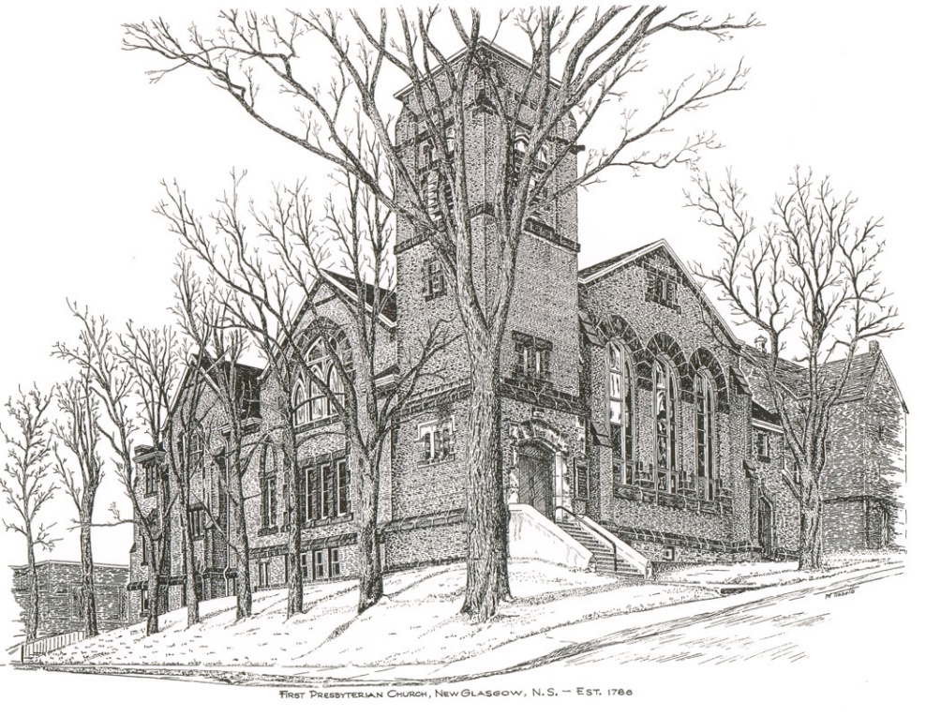

FIRST PRESBYTERIAN CHURCH
208 MacLean St., New Glasgow, NS
902-752-5691
First.church@ns.aliantzinc.ca
Reverend Andrew MacDonald
902-331-0322
yick96@hotmail.com

June 7th, 2024
3rd Sunday after Pentecost

THE APPROACH

**Please Rise
Musical Prelude
Welcome and Announcements

**Lighting the Christ Candle: Please rise

One: To this day I have had the help that comes from God, and so I stand here testifying both to small and great, saying nothing but what the prophets and Moses said would come to pass: that the Christ must suffer and that, by being the first to rise from the dead, he would proclaim light both to all people.
All: Commit your way to the Lord; trust in him, and he will act. He will bring forth your righteousness as the light, and your justice as the noonday. (Light the candle)
One: Let us now prepare our hearts to worship almighty God.

Musical Introit - #501 - "Live in charity"
Live in charity and steadfast love,
live in charity; God will dwell with you.
Call to Worship
Hymn #214 – “All glory, laud and honour” vs.1,3,4

Chorus All glory, laud and honour
to thee, Redeemer, King,
to whom the lips of children
made sweet hosannas ring!

1. Thou art the King of Israel,
thou David’s royal son,
who in the Lord’s name comest,
the King and blessed one.

3 To thee before thy passion
they sang their hymns of praise;
to thee, now high exalted,
our melody we raise.

4 Thou didst accept their praises;
accept the prayers we bring,
who in all good delightest,
thou good and gracious King.

Prayer of Adoration, Confession and the Lord’s Prayer

Our Father which art in heaven, Hallowed be thy name.

Thy kingdom come, thy will be done in earth,

as it is in heaven.

Give us this day our daily bread.

And forgive us our debts, as we forgive our debtors.

And lead us not into temptation, but deliver us from evil:

For thine is the kingdom, and the power, and the glory,

forever. Amen.
Assurance of Pardon
Passing the Peace
Hymn #328 - “This is my Father’s world”

1 This is my Father’s world,
and to my listening ears
all nature sings, and round me rings
the music of the spheres.
This is my Father’s world:
I rest me in the thought;
of rocks and trees, of skies and seas
God’s hands the wonders wrought.

2 This is my Maker’s world;
the birds their carols raise;
the morning’s light, the lily white,
declare their Maker’s praise.
This is my Maker’s world;
God shines in all that’s fair;
in the rustling grass God’s footsteps pass,
God speaks to me everywhere.

3 This is my Saviour’s world;
O let me not forget
that though the wrong seems oft so strong,
God is the Ruler yet.
This is my Saviour’s world;
the battle is not done;
Jesus, who died, shall be satisfied,
the earth and heaven are one.

Children’s Time
Prayer of Illumination
First Lesson: Genesis 3:8-15
Second Lesson: 2 Corinthians 4:13-5:1
Responsive Psalm 130
ONE: Out of the depths I cry to you, O Lord. Lord, hear my voice! Let your ears be attentive to the voice of my supplications!
ALL: If you, O Lord, should mark iniquities, Lord, who could stand? But there is forgiveness with you, so that you may be revered.
ONE: I wait for the Lord, my soul waits, and in his word I hope; my soul waits for the Lord more than those who watch for the morning, more than those who watch for the morning.
ALL: O Israel, hope in the Lord! For with the Lord there is steadfast love, and with him is great power to redeem. It is he who will redeem Israel from all its iniquities.
**Gloria Patri
Glory be to the Father
and to the Son, and to the Holy Ghost!
As it was in the beginning is now and ever shall be.
World without end. Amen, amen.

Gospel Lesson: Mark 3:20-35
Anthem: “Let us build a house” - Marty Haugen
Sermon: "Not made with human hands!"
Reaffirmation of Faith (Apostles Creed)
Hymn: #630 – “When we are living” vs.1,3,4
- When we are living, it is in Christ Jesus,
and when we’re dying, it is in the Lord.
Both in our living and in our dying,
we belong to God; we belong to God.

3. ‘Mid times of sorrow and in times of pain,
when sensing beauty or in love’s embrace,
whether we suffer, or sing rejoicing,
we belong to God; we belong to God.

4. Across this wide world, we shall always find
those who are crying with no peace of mind,
but when we help them, or when we feed them,
we belong to God; we belong to God.

Offertory
**Doxology #79
Praise God from whom all blessings Flow. Praise Him all creatures here below. Praise Him above Ye Heavenly Host. Praise Father, Son, and Holy Ghost. Amen.

Offertory Prayer
Prayers of the People: (The People Respond)
ONE: God of grace and compassion,
ALL: Embrace the world you love.
Hymn: #648 – “I’m gonna live so God can use me”

1 I’m gonna live so God can use
me anywhere, Lord, anytime!
I’m gonna live so God can use me
anywhere, Lord, anytime!

2 I’m gonna work so God can use me
anywhere, Lord, anytime!
I’m gonna work so God can use me
anywhere, Lord, anytime!

3 I’m gonna pray so God can use me
anywhere, Lord, anytime!
I’m gonna pray so God can use me
anywhere, Lord, anytime!

4 I’m gonna sing so God can use me
anywhere, Lord, anytime!
I’m gonna sing so God can use me
anywhere, Lord, anytime!

**Benediction
Coral Response: “Go Now in Peace” (Don Besig)
Go now in peace Never be afraid God will go with you each hour of every day
Go now in faith Steadfast, strong, and true. Know He will guide you in all you do.
Go now in love, And show you believe Reach out to others So all the world can see.
God will be there Watching from above Go now in peace, In faith, and in love, Amen, amen, amen.
Recessional

Mission Statement: But he’s already made it plain how to live, what to do, what God is looking for in men and women. It’s quite simple. Do what is fair and just to your neighbor, be compassionate and loyal in your love, and don’t take yourself too seriously – take God seriously. Micah 6: 8-The Message

***********************
ANNOUNCEMENTS

All are welcome at First Presbyterian Church. We hope you experience the love of God and of this congregation as we worship, celebrate, and serve one another.

PASTORAL CARE:
In order to provide support to the people of First Church, when you or a loved one is sick or in hospital, we encourage you to contact the church (902-752-5691), Reverend Andrew (902-331-0322) or Cathy Lewis, Chair of the Pastoral Care Team (902-759-9649), to inform us directly. It is also important that you inform the hospital that you would welcome a visit from your minister and/or your Elder.
UPCOMING EVENTS
Mon., June 10th – 6:30p.m. – The Board of Managers will meet.

Tues., June 11th - 6:30p.m – Session will meet.

Tues., June 11th, at 7:00 p.m. - Merigomish United Church presents “The Bessie Carruthers Study Club”. This musical play stars pianist, Jennifer King and mezzo-soprano, Suzanne Campbell. A playful and amusing look back at women’s’ struggles to obtain voting rights, the Campbell/King duo presents an evening of singing, formidable piano skills plus an audience sing-along. Tickets available at the door ($25) or in advance ($20) by calling Vickie MacDonald at 902-926-2556.

Mon., June 17th, 6-8p.m. – The Kirk is hosting a “Coffee House for Camp Geddie” – coffee, tea, dessert and bake table; cost $5.00, children under 12-free. Tickets are available from church members or at the door.
A thank you note has been received from the New Glasgow Music Festival Committee for the ongoing support of First Church for what was their 86th Festival.
THANK YOU!
We extend our thanks to Josie Baillie, a Grade 12 student at North Nova Education Centre, for her volunteer work for First Church. As part of her graduate year, Josie was required to perform 10 hours of volunteer service which she did for us. She removed all the old church directories from the hymn books in the sanctuary and replaced them with the updated version along with inserting PAR cards and envelopes for visitors.
For her second project, Josie helped with painting all the black handrails at the entrances to the church. She did a great job, we appreciate the work she did for us. Thank you Josie; congratulations on your graduation, we wish you all the best in your next adventure!
SCRIPTURE READERS & USHERS:
Scripture Reader: Mark Thibeau
Ushers: Main Door (Office) - John Zinck
James St. – Ruth-Anne MacIntosh
MacLean St. (Main Entrance steps) – Ellen Jardine
EARLY CHRISTIAN EDUCATORS: Lynne Ann and Lois MacLellan

