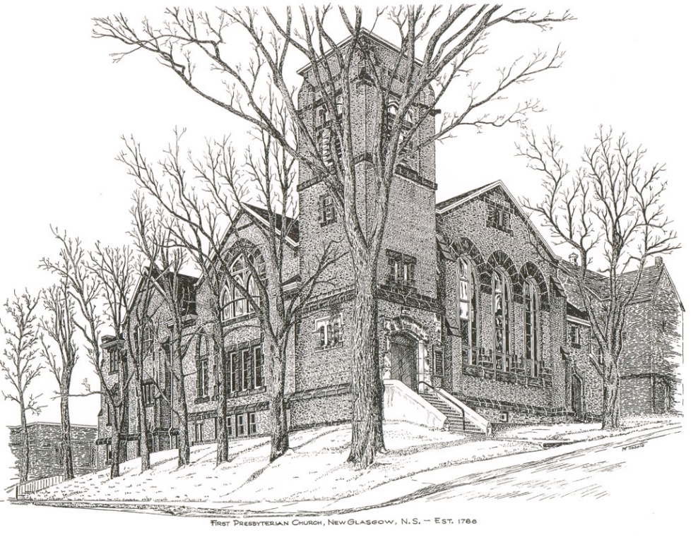

FIRST PRESBYTERIAN CHURCH
208 MacLean St., New Glasgow, NS
902-752-5691
First.church@ns.aliantzinc.ca
Reverend Andrew MacDonald
902-331-0322
yick96@hotmail.com

May 12th, 2024
7th Sunday of Easter
Christian Family Sunday
Mother’s Day

THE APPROACH

Musical Prelude
Welcome and Announcements

Lighting the Christ Candle: Please rise

One: But you are a chosen race, a royal priesthood, a holy nation, a people for his own possession, that you may proclaim the excellencies of him who called you out of darkness into his marvelous light.
All: For God, who said, “Let light shine out of darkness,” has shone in our hearts to give the light of the knowledge of the glory of God in the face of Jesus Christ. (Light the candle)

One: Let us now prepare our hearts to worship almighty God.

Musical Introit - #575 - "Lead me, Lord"

Lead me, Lord, lead me in your righteousness;
make your way plain before my face,
for it is you, and you, God only,
who makes me dwell in safety.

Call to Worship
Hymn #457 – “Now thank we all our God”

1 Now thank we all our God
with heart and hand and voices,
who wondrous things has done,
in whom God’s world rejoices,
who from our mother’s arms
has blessed us on our way
with countless gifts of love,
and still is ours today.

2 Oh may this bounteous God
through all our life be near us,
with ever-joyful hearts
and blessed peace to cheer us,
and keep us all with grace,
and guide us when perplexed,
and free us from all ills
in this world and the next.

3 All praise and thanks to God
who reigns in highest heaven,
the Father and the Son
and Spirit now be given,
the one eternal God,
whom heaven and earth adore,
for thus it was, is now
and shall be evermore.

Confirmation of New Member
Prayer of Adoration, Confession and the Lord’s Prayer
Assurance of Pardon
Passing the Peace
Hymn #521 – “Child of blessing, child of promise”
- Child of blessing, child of promise,
baptized with the Spirit's sign,
with this water God has sealed you
unto love and grace divine.

- Child of love, our love's expression,
love's creation, loved indeed!
Fresh from God, refresh our spirits,
into joy and laughter lead.

- Child of joy, our dearest treasure,
God's you are; from God you came.
Back to God we humbly give you:
live as one who bears Christ's name.

- Child of God, your loving Parent,
learn to know whose child you are.
Grow to laugh and sing and worship,
trust and love God more than all.
Sacrament of Baptism
Children’s Time
Prayer of Illumination
First Lesson: Acts 1:15-17, 21-26
Second Lesson: 1 John 5 9:13

Responsive Psalm 1:

ONE: Happy are those who do not follow the advice of the wicked, or take the path that sinners tread, or sit in the seat of scoffers; but their delight is in the law of the Lord, and on his law they meditate day and night.
ALL: They are like trees planted by streams of water, which yield their fruit in its season, and their leaves do not wither. In all that they do, they prosper.

ONE: The wicked are not so, but are like chaff that the wind drives away.
ALL: Therefore the wicked will not stand in the judgement, nor sinners in the congregation of the righteous; for the Lord watches over the way of the righteous, but the way of the wicked will perish.

Gloria Patri
Gospel Lesson: John 17:6-19
Anthem: “Oh a song must rise”
Sermon: "Not of this world!"
Hymn: #763 – “To show by touch and word”

- To show by touch and word devotion to the earth,
to hold in full regard all life that comes to birth
we need, O God, the will to find the good you had of old in mind.

- Renew our minds to choose the things that matter most,
our hearts to long for truth till pride-of-self is lost.
For every challenge that we face, we need your guidance and your grace.

- Let love from day to day be yardstick, rule and norm,
and let our lives portray your word in human form.
Now come with us that we may have your wits about us where we live.

Offertory

Doxology #79

Praise God from whom all blessings Flow. Praise Him all creatures here below. Praise Him above Ye Heavenly Host. Praise Father, Son, and Holy Ghost. Amen.

Offertory Prayer

Prayers of the People: (The People Respond)

Hymn: #410 – “Joyful, joyful we adore Thee”

1 Joyful, joyful we adore you,
God of glory, God of love.
Hearts unfold like flowers before you,
opening to the sun above.
Melt the clouds of sin and sadness,
drive the dark of doubt away;
giver of immortal gladness,
fill us with the light of day.

2 All your works with joy surround you;
earth and heaven reflect your rays;
stars and angels sing around you,
center of unbroken praise.
Field and forest, vale and mountain,
flowery meadow, flashing sea,
chanting bird and flowing fountain,
join to praise you joyfully.

3 You are giving and forgiving,
ever blessing, ever blessed,
wellspring of the joy of living,
ocean depth of happy rest.
God Creator, Christ our Saviour,
all are yours who live in love.
Teach us how to love our neighbour;
lift us to your joy above.

4 Morning stars, awake the chorus;
mortals, join with every part,
for what joy is set before us
as Christ’s love joins heart to heart!
Ever singing, march we onward,
victors in the midst of strife;
joyful music leads us sunward,
in the triumph song of life.

**Benediction
Coral Response: “Go Now in Peace” (Don Besig)
Go now in peace
Never be afraid
God will go with you each hour of every day

Go now in faith
Steadfast, strong, and true.
Know He will guide you in all you do.

Go now in love,
And show you believe
Reach out to others
So all the world can see.
God will be there
Watching from above
Go now in peace,
In faith, and in love
Amen, amen, amen.
Recessional

Mission Statement: But he’s already made it plain how to live, what to do, what God is looking for in men and women. It’s quite simple. Do what is fair and just to your neighbor, be compassionate and loyal in your love, and don’t take yourself too seriously – take God seriously. Micah 6: 8-The Message

ANNOUNCEMENTS

All are welcome at First Presbyterian Church. We hope you experience the love of God and of this congregation as we worship, celebrate, and serve one another.
To all the Moms, Grandmothers, Godmothers, Stepmoms, we wish you a Happy Mother’s Day!

CONDOLENCES
We express our sincere sympathy to the family of Alvin Sinclair. Alvin was a long-time member of First Presbyterian having served as an Elder since 1966; he will be greatly missed.

UPCOMING EVENTS
Sacrament of Baptism: Today we welcome through the Sacrament of Baptism, Nathan James Chisholm, son of Tianna and Daniel.
Today to May 19th – Mark Thibeau continues his video Bible Study titled “In the Footsteps of the Saviour – Following Jesus through the Holy Land”, hosted by Max Lucado. These sessions take place in the Lower Hall at 2:00 p.m. All welcome.
Tues., May 14th, 6:30 p.m. – Session will meet.
Fri., May 17th – The Board of Managers “Beans and Brown Bread” take out has been a huge success! If you have not yet placed your order, please contact any Board member or the office, no later than Mon., May 13th. Cost - $10/person. Pickup - 10 a.m. – Noon. Thank you for your support! BOARD MEMBERS - IF YOU HAVE NOT DONE SO ALREADY, PLEASE CONTACT THE OFFICE WITH THE NUMBER OF ORDERS YOU HAVE RECEIVED.
Coffee hour is the 3rd Sunday of the month. If possible, please bring a donation for the Food Bank Cart that day. Next Coffee Hour/Food Bank Sunday will be next Sunday, May 19th following morning service.
Sun. May 26th 12:15 p.m. – Trinity United is hosting a “Neighbourhood Churches Block Party”. Lunch will be provided by the congregation of Trinity in their auditorium. You are invited to join them to share lunch, meet old and new friends and celebrate the joy of our faith. If you would like to attend, please let Jane know by Wed., May 23rd so she can provide numbers to Trinity for catering purposes.
Fri., May 31st – 7:30p.m. – Glasgow Square: The Carillon singers will host their “Spring Concert – Goddess Remembered” celebrating 30 years of ‘Women in Song’. Doors open at 7; cocktail reception and light hors d’oeuvres. Bar service available. Tickets - $30.00, available by contacting any Carillon member, at Chediac Furniture or by emailing thecarillonsingers@gmail.com
Sun., June 2nd – 3p.m. – Trinity United Church -The Trinitarians Spring Concert “It’s All Right!” – Featuring the Trinitarians and guests Leah Hagerman (clarinet), Bethany Krawiec (flute and violin); Alex Lank (percussion and piano) and Leah and Robert MacPherson (voice). Free will donation.
Camp Geddie Wish List – Camp Geddie has issued a request for donation of supplies for the upcoming season; everything from dish detergent to Ziplock bags! Please see the blue posters on the office window and in the Upper Hall for details. All donations appreciated.
SCRIPTURE READERS & USHERS:
Scripture Reader: Sharon Mason
Ushers: Main Door (Office) – Cathy Lewis
James St. – Ruth-Anne MacIntosh
MacLean St. (Main Entrance steps) – Ellen Jardine
EARLY CHRISTIAN EDUCATORS: Lynne Ann and Lois MacLellan

