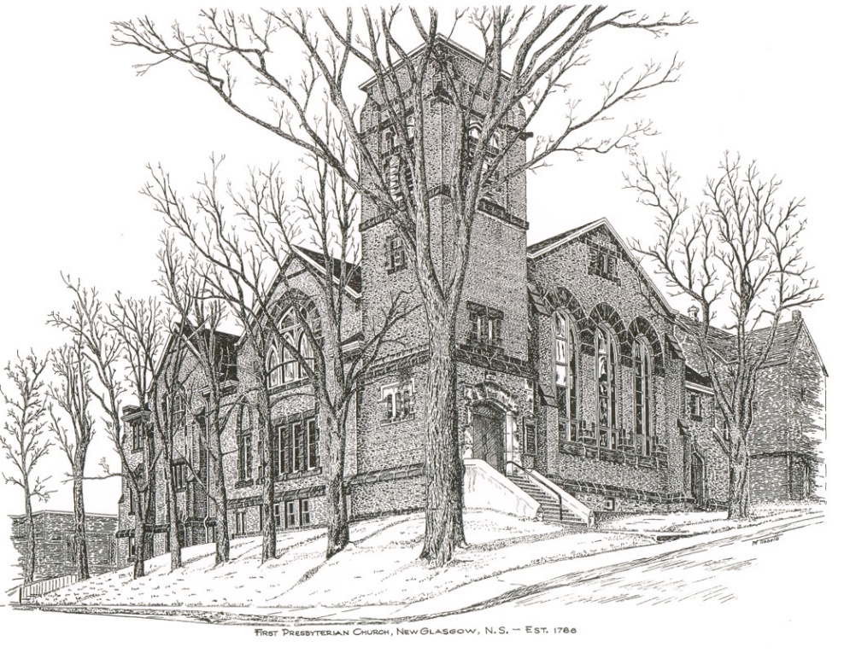

FIRST PRESBYTERIAN CHURCH
208 MacLean St., New Glasgow, NS
902-752-5691
First.church@ns.aliantzinc.ca
Reverend Andrew MacDonald
902-331-0322
yick96@hotmail.com

May 19th, 2024
Day of Pentecost

THE APPROACH

Musical Prelude
Welcome and Announcements

Lighting the Christ Candle: Please rise

One: Do all things without grumbling or disputing, that you may be blameless and innocent, children of God without blemish in the midst of a crooked and twisted generation, among whom you shine as lights in the world, holding fast to the word of life, so that in the day of Christ I may be proud that I did not run in vain or labor in vain.
All: The night is far gone; the day is at hand. So then let us cast off the works of darkness and put on the armor of light. (Light the candle)

One: Let us now prepare our hearts to worship almighty God.

Musical Introit - #501 - "Live in charity"
Live in charity and steadfast love,
live in charity; God will dwell with you.

Call to Worship

Hymn #293 – “Come, thou almighty King”

- Come, thou almighty King;
help us thy name to sing;
help us to praise.
Father, all glorious,
O’er all victorious,
come and reign over us, Ancient of Days.

2 Come, thou incarnate Word;
gird on thy mighty sword;
our prayer attend;
come, and thy people bless,
and give thy word success;
Spirit of holiness, on us descend.

3 Come, holy Comforter;
thy sacred witness bear
in this glad hour!
Thou who almighty art,
now rule in every heart,
and neer from us depart, Spirit of power.

4 To the great One-in-Three
eternal praises be
hence evermore!
His sovereign majesty
may we in glory see,
and to eternity love and adore.
Prayer of Adoration, Confession and the Lord’s Prayer

Our Father which art in heaven, Hallowed be thy name.

Thy kingdom come, thy will be done in earth,

as it is in heaven.

Give us this day our daily bread.

And forgive us our debts, as we forgive our debtors.

And lead us not into temptation, but deliver us from evil:

For thine is the kingdom, and the power, and the glory,

forever. Amen.

Assurance of Pardon
Passing the Peace
Hymn #530 – “I come with joy” vs. 1-4,5

- I come with joy, a child of God,
forgiven, loved and free,
the life of Jesus to recall,
in love laid down for me,
in love laid down for me.

4. The Spirit of the risen Christ.
unseen, but ever near,
it is such friendship better known,
alive among us here,
alive among us here.

- Together met, together bound
by all that God has done,
we’ll go with joy, to give the world
the love that makes us one,
the love that makes us one.

Children’s Time
Prayer of Illumination
First Lesson: Ezekiel 37:1-14
Second Lesson: Acts 2:1-21
Responsive Psalm 104:24-34, 35b

ONE: O Lord, how manifold are your works! In wisdom you have made them all; the earth is full of your creatures.
ALL: Yonder is the sea, great and wide, creeping things innumerable are there, living things both small and great.
ONE: There go the ships, and Leviathan that you formed to sport in it.
ALL: These all look to you to give them their food in due season; when you give to them, they gather it up; when you open your hand, they are filled with good things.
ONE: When you hide your face, they are dismayed; when you take away their breath, they die and return to their dust.
ALL: When you send forth your spirit, they are created; and you renew the face of the ground.
ONE: May the glory of the Lord endure for ever; may the Lord rejoice in his works— who looks on the earth and it trembles, who touches the mountains and they smoke.
ALL: I will sing to the Lord as long as I live; I will sing praise to my God while I have being.
ONE: May my meditation be pleasing to him, for I rejoice in the Lord.
ALL: Let sinners be consumed from the earth, and let the wicked be no more.
ONE: Bless the Lord, O my soul.
ALL: Praise the Lord!
Gloria Patri
Glory be to the Father
and to the Son, and to the Holy Ghost!
As it was in the beginning is now and ever shall be.
World without end. Amen, amen.
Gospel Lesson: John 15:26-27; 16:4b-15
Anthem: “Come O Holy Spirit”
Sermon: "Pentecost Flames!"
Hymn: #385 – “Like the murmur of the dove’s song”
1 Like the murmur of the dove’s song,
like the challenge of her flight,
like the vigour of the wind’s rush,
like the new flame’s eager might:
come, Holy Spirit, come.

2 To the member’s of Christ’s body,
to the branches of the Vine,
to the church in faith assembled,
to her midst as gift and sign:
come, Holy Spirit, come.

3 With the healing of division,
with the ceaseless voice of prayer,
with the power to love and witness,
with the peace beyond compare:
come, Holy Spirit, come.

Offertory

Doxology #79

Praise God from whom all blessings Flow. Praise Him all creatures here below. Praise Him above Ye Heavenly Host. Praise Father, Son, and Holy Ghost. Amen.

Offertory Prayer

Prayers of the People: (The People Respond)
ONE: Wind of the Spirit, blow through us
ALL: And renew our faith and hope.

Hymn: #284 – “Revive your work, O Lord” vs. 1, 4-6

1. Revive your work, O Lord:
your mighty arm make bare;
speak with the voice that wakes the dead,
and make your people hear.

4. Revive your work, O Lord:
exalt your precious name,
and by the Holy Spirit come
and set our love aflame.

5. Revive your work, O Lord:
give power unto your word;
grant that your living gospel may
in living faith be heard.

6. Revive your work, O Lord:
give pentecostal showers;
the glory shall be all your own;
the blessing, Lord, be ours.

**Benediction
Coral Response: “Go Now in Peace” (Don Besig)
Go now in peace
Never be afraid
God will go with you each hour of every day

Go now in faith
Steadfast, strong, and true.
Know He will guide you in all you do.

Go now in love,
And show you believe
Reach out to others
So all the world can see.
God will be there
Watching from above
Go now in peace,
In faith, and in love
Amen, amen, amen.
Recessional

Mission Statement: But he’s already made it plain how to live, what to do, what God is looking for in men and women. It’s quite simple. Do what is fair and just to your neighbor, be compassionate and loyal in your love, and don’t take yourself too seriously – take God seriously.
Micah 6: 8-The Message

ANNOUNCEMENTS

All are welcome at First Presbyterian Church. We hope you experience the love of God and of this congregation as we worship, celebrate, and serve one another.

PASTORAL CARE:
In order to provide support to the people of First Church, when you or a loved one is sick or in hospital, we encourage you to contact the church (902-752-5691), Reverend Andrew (902-331-0322) or Cathy Lewis, Chair of the Pastoral Care Team (902-759-9649), to inform us directly. It is also important that you inform the hospital that you would welcome a visit from your minister and/or your Elder.
UPCOMING EVENTS
Today:
- 12:00 p.m. - We will be hosting Coffee hour after service, please join us if you can. Next Coffee Hour/Food Bank Sunday will be June 16th.
- 2:00 p.m. – Today is the final session of the video Bible Study led by Mark Thibeau. **Thank you Mark for your leadership and dedication to the Congregation in providing these important bible study sessions.
- 2:30 p.m. – We will be worshipping with the residents of Glen Haven Manor. Everyone welcome.
Sun. May 26th 12:15 p.m. – Trinity United is hosting a “Neighbourhood Churches Block Party”. Lunch will be provided by the congregation of Trinity in their auditorium. You are invited to join them to share lunch, meet old and new friends and celebrate the joy of our faith. If you would like to attend, please let Jane know by Wed., May 22nd so she can provide numbers to Trinity for catering purposes.
Fri., May 31st – 7:30p.m. – Glasgow Square: The Carillon singers will host their “Spring Concert – Goddess Remembered” celebrating 30 years of ‘Women in Song’. Doors open at 7; cocktail reception and light hors d’oeuvres. Bar service available. Tickets - $30.00, available by contacting any Carillon member, at Chediac Furniture or by emailing thecarillonsingers@gmail.com
Sun., June 2nd – 3p.m. – Trinity United Church -The Trinitarians Spring Concert “It’s All Right!” – Featuring the Trinitarians and guests Leah Hagerman (clarinet), Bethany Krawiec (flute and violin); Alex Lank (percussion and piano) and Leah and Robert MacPherson (voice). Free will donation.
Mon., June 17th, 6-8p.m. – The Kirk is hosting a “Coffee House for Camp Geddie” – coffee, tea, dessert and bake table; cost $5.00, children under 12-free. Tickets are available from church members or at the door.
Camp Geddie Wish List – Camp Geddie has issued a request for donation of supplies for the upcoming season; everything from dish detergent to Ziplock bags! Please see the blue posters on the office window and in the Upper Hall for details. All donations appreciated.
Today, we honor Hendrika vanVeld as she celebrates her birthday. Happy Birthday Hendrika!

SCRIPTURE READERS & USHERS:
Scripture Reader: Jennifer Thibeau
Ushers: Main Door (Office) – Cathy Lewis
James St. – Ruth-Anne MacIntosh
MacLean St. (Main Entrance steps) – Ellen Jardine
EARLY CHRISTIAN EDUCATORS: Lynne Ann and Lois MacLellan

*****************

**Important Information: Included with today’s bulletin is a copy of the latest Financial Report for your review. As you will see, our situation has not improved since discussions at the Annual Meeting.

Apostles Creed

I believe in God, the Father Almighty, maker of Heaven and earth; and in Jesus Christ, His only Son, Our Lord, who was conceived by the Holy Ghost, born of the Virgin Mary,
suffered under Pontius Pilate, was crucified, died, and was buried. He descended into Hell. On the third day He arose again from the dead; He ascended into Heaven, and sits
at the right hand of God, the Father Almighty; from thence He shall come to judge the quick and the dead.
I believe in the Holy Ghost, the holy Catholic Church,
the communion of saints, the forgiveness of sins, the resurrection of the body, and the life everlasting. Amen.

