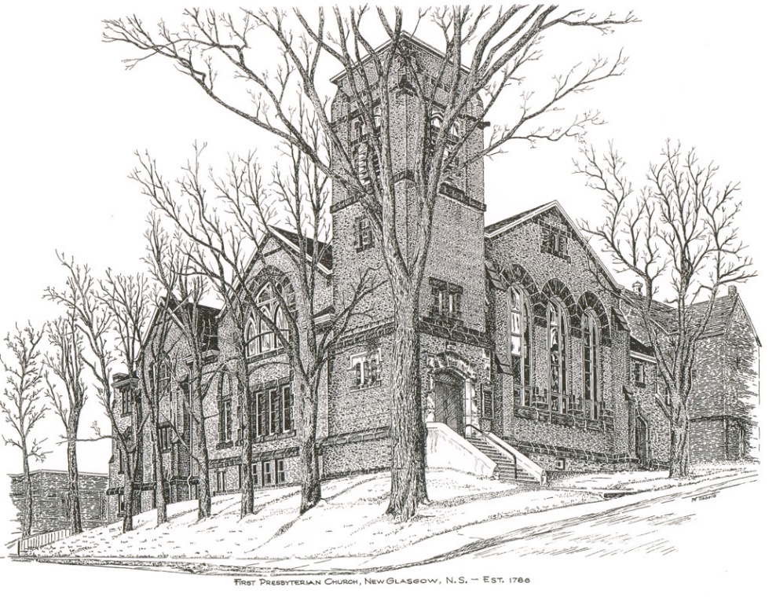

JANE OFF SICK – ANDREW INSERTED HYMNS FOR PRINTING ETC.

FIRST PRESBYTERIAN CHURCH
208 MacLean St., New Glasgow, NS
902-752-5691
First.church@ns.aliantzinc.ca
Reverend Andrew MacDonald
902-331-0322
yick96@hotmail.com

May 26th, 2024
1st Sunday After Pentecost

THE APPROACH

Musical Prelude
Welcome and Announcements

Lighting the Christ Candle: Please rise

One: ‘For God so loved the world that he gave his only Son, so that everyone who believes in him may not perish but may have eternal life.
All: But if we walk in the light, as he is in the light, we have fellowship with one another, and the blood of Jesus his Son cleanses us from all sin.
(Light the candle)
One: Let us now prepare our hearts to worship almighty God.

Musical Introit - #501 - "Live in charity"
Live in charity and steadfast love,
live in charity; God will dwell with you.

Call to Worship

Hymn #399 – “Spirit, Spirit of gentleness” vs. 1-3
Refrain:
Spirit, spirit of gentleness,
Blow through the wilderness, calling and free.
Spirit, Spirit of restlessness, stir me from placidness,
Wind, wind on the Sea.

- You moved on the waters; you called to the deep;
Then you coaxed up the mountains from the valley of sleep,
And over the aeons you called to each thing;
Wake from your slumbers and rise on your wings.

2 You swept through the desert, you stung with the sand,
And you goaded your people with a law and a land,
And when they were blinded with their idols and lies,
Then you spoke through your prophets to open their eyes.

3 You sang in the stable, you cried from a hill;
Then you whispered in silence when the whole world was still,
And down in the city you called once again,
When you blew through your people on the rush of the wind.

Prayer of Adoration, Confession and the Lord’s Prayer

Our Father which art in heaven, Hallowed be thy name.

Thy kingdom come, thy will be done in earth,

as it is in heaven.

Give us this day our daily bread.

And forgive us our debts, as we forgive our debtors.

And lead us not into temptation, but deliver us from evil:

For thine is the kingdom, and the power, and the glory,

forever. Amen.
Assurance of Pardon
Passing the Peace
Hymn– “Tell me the stories of Jesus” Shaun McLean

Children’s Time
Prayer of Illumination
First Lesson: Isaiah 6:1-8
Second Lesson: Romans 8:12-17
Responsive Psalm 29
ONE: Ascribe to the Lord, O heavenly beings, ascribe to the Lord glory and strength. Ascribe to the Lord the glory of his name; worship the Lord in holy splendour.
ALL: The voice of the Lord is over the waters; the God of glory thunders, the Lord, over mighty waters. The voice of the Lord is powerful; the voice of the Lord is full of majesty.
ONE: The voice of the Lord breaks the cedars; the Lord breaks the cedars of Lebanon. He makes Lebanon skip like a calf, and Sirion like a young wild ox.
ALL: The voice of the Lord flashes forth flames of fire.
The voice of the Lord shakes the wilderness; the Lord shakes the wilderness of Kadesh.
ONE: The voice of the Lord causes the oaks to whirl, and strips the forest bare; and in his temple all say, ‘Glory!’
ALL: The Lord sits enthroned over the flood; the Lord sits enthroned as king for ever. May the Lord give strength to his people! May the Lord bless his people with peace!

Gloria Patri
Glory be to the Father
and to the Son, and to the Holy Ghost!
As it was in the beginning is now and ever shall be.
World without end. Amen, amen.
Gospel Lesson: John 3:1-17
Anthem: “Blessed Assurance” -Shaun McLean
Sermon: "Healing!"
Hymn: #462 – “All my hope on God is founded” vs. 1-2
1 All my hope on God is founded
Who does still my trust renew;
Through all change and chance God guides me,
Only good and only true.
Love unknown, God’s alone,
Calls my heart to be God’s own.

2 Human pride and earthly glory,
Sword and crown, betray all trust;
What our care and toil establish,
Tower and temple, fall to dust,
But God’s power, hour by hour,
Is my temple and my tower.

Offertory

Doxology #79

Praise God from whom all blessings Flow. Praise Him all creatures here below. Praise Him above Ye Heavenly Host. Praise Father, Son, and Holy Ghost. Amen.

Offertory Prayer

Prayers of the People: (The People Respond)

Hymn: #482 – “Christ is made the sure foundation”

1. Christ is made the sure foundation,
Christ the head and cornerstone,
Chosen of the Lord, and precious,
Binding all the church in one,
Holy Zion’s help forever,
And her confidence alone.

2. All within that holy city
Dearly loved of God on high,
In exultant jubilation
Pour perpetual melody,
God the One-In-Three adoring
In glad hymns eternally.

3. To this temple, where we call thee;
Come, O Lord of hosts, today;
With thy faithful lovingkindness,
Hear thy servants as they pray,
Any thy fullest benediction
Shed within its walls always.

4. Here bestow on all thy servants
What they ask of thee to gain,
What they gain from thee forever
With the blessed to retain,
And hereafter in thy glory
Evermore with thee to reign.

5. Laud and honour to the Father,
Laud and honour to the Son,
Laud and honour to the Spirit,
Ever Three, and ever One,
One in might and one in glory,
While unending ages run.

**Benediction
Coral Response: “Go Now in Peace” (Don Besig)
Go now in peace never be afraid, God will go with you each hour of every day.

Go now in faith steadfast, strong, and true. Know He will guide you in all you do.

Go now in love, and show you believe reach out to others so all the world can see. God will be there watching from above.
Go now in peace, In faith, and in love. Amen, amen, amen.

Recessional

Mission Statement: But he’s already made it plain how to live, what to do, what God is looking for in men and women. It’s quite simple. Do what is fair and just to your neighbor, be compassionate and loyal in your love, and don’t take yourself too seriously – take God seriously.
Micah 6: 8-The Message

ANNOUNCEMENTS

All are welcome at First Presbyterian Church. We hope you experience the love of God and of this congregation as we worship, celebrate, and serve one another.

PASTORAL CARE:
In order to provide support to the people of First Church, when you or a loved one is sick or in hospital, we encourage you to contact the church (902-752-5691), Reverend Andrew (902-331-0322) or Cathy Lewis, Chair of the Pastoral Care Team (902-759-9649), to inform us directly. It is also important that you inform the hospital that you would welcome a visit from your minister and/or your Elder.

UPCOMING EVENTS
Today - 12:15 p.m. – Trinity United is hosting a “Neighbourhood Churches Block Party”. Lunch will be provided by the congregation of Trinity in their auditorium. You are invited to join them to share lunch, meet old and new friends and celebrate the joy of our faith.

Workdays at Camp Geddie - On May 28th and 29th a work crew from Halifax will be at the Camp to replace the siding on the Margaret MacDougall Lodge. At the same time there will be other tasks to complete, such as a general spring clean-up, fallen trees to block up, screen doors to install, etc. Any help would be greatly appreciated. For further information, please contact John Reeves, 902-921-1460.

Fri., May 31st – 7:30p.m. – Glasgow Square: The Carillon singers will host their “Spring Concert – Goddess Remembered” celebrating 30 years of ‘Women in Song’. Doors open at 7; cocktail reception and light hors d’oeuvres. Bar service available. Tickets - $30.00, available by contacting any Carillon member, at Chediac Furniture or by emailing thecarillonsingers@gmail.com
Sun., June 2nd – 3p.m. – Trinity United Church -The Trinitarians Spring Concert “It’s All Right!” – Featuring the Trinitarians and guests Leah Hagerman (clarinet), Bethany Krawiec (flute and violin); Alex Lank (percussion and piano) and Leah and Robert MacPherson (voice). Free will donation.
Mon., June 17th, 6-8p.m. – The Kirk is hosting a “Coffee House for Camp Geddie” – coffee, tea, dessert and bake table; cost $5.00, children under 12-free. Tickets are available from church members or at the door.

Camp Geddie Wish List – Camp Geddie has issued a request for donation of supplies for the upcoming season; everything from dish detergent to Ziplock bags! Please see the blue posters on the office window and in the Upper Hall for details. All donations appreciated.
Loch Broom Church Summer Job Opportunity – ‘Interpretive Guide’ – for post secondary students or Grade 12 furthering post secondary education. Responsibilities include greeting visitors and answering questions; keeping building and grounds in order, including mowing when needed etc. Salary - $16/hour plus 4% vacation pay. JOB BEGINS JUNE 10TH. Send resumes to:
Loch Broom Log Church
1360 Loch Broom Loop
Loch Broom, NS B0K 2A0
e-mail: lblogchurch@eastlink.ca or marlemariep@gmail.com

THANK YOU!!
Thank You to all of you who supported the Board of Managers ‘Beans and Brown Bread’ takeout. It was a very successful fundraiser; we raised $1360.00!
Birthday wishes are extended to Austin Sutton who will celebrate his birthday Wed., May 29th and to Rosalyn MacDonald who will celebrate her birthday Fri., May 31st. Best wishes to both of you!
Happy Anniversary to Austin and Marsha Sutton who will celebrate their 55th wedding anniversary, Fri., May 31st – best wishes!!
SCRIPTURE READERS & USHERS:
Scripture Reader: Clarice Campbell
Ushers: Main Door (Office) – Cathy Lewis
James St. – Ruth-Anne MacIntosh
MacLean St. (Main Entrance steps) – Ellen Jardine
EARLY CHRISTIAN EDUCATORS: Lynne Ann and Lois MacLellan
*****************
Apostles Creed

I believe in God, the Father Almighty, maker of Heaven and earth; and in Jesus Christ, His only Son, Our Lord, who was conceived by the Holy Ghost, born of the Virgin Mary,
suffered under Pontius Pilate, was crucified, died, and was buried. He descended into Hell. On the third day He arose again from the dead; He ascended into Heaven, and sits
at the right hand of God, the Father Almighty; from thence He shall come to judge the quick and the dead.
I believe in the Holy Ghost, the holy Catholic Church,
the communion of saints, the forgiveness of sins, the resurrection of the body, and the life everlasting. Amen.

