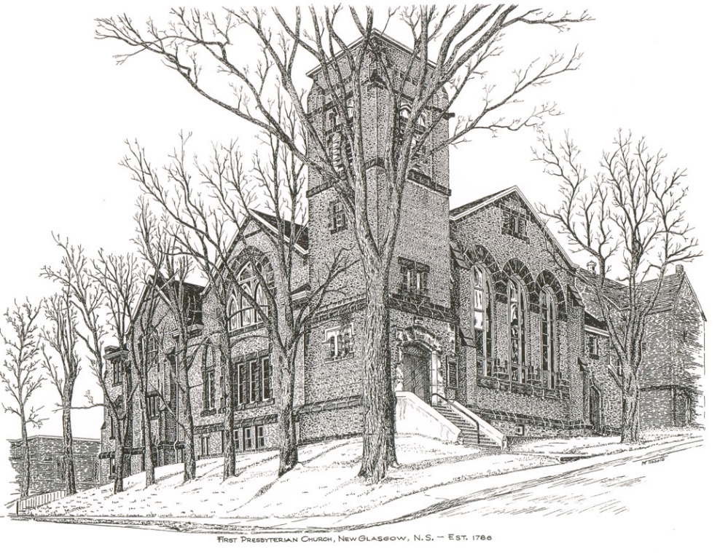

FIRST PRESBYTERIAN CHURCH
208 MacLean St., New Glasgow, NS
902-752-5691
First.church@ns.aliantzinc.ca
Reverend Andrew MacDonald
902-331-0322
yick96@hotmail.com

May 5th, 2024
6th Sunday of Easter

THE APPROACH

Musical Prelude
Welcome and Announcements

Lighting the Christ Candle: Please rise

One: With the loyal you show yourself loyal; with the blameless you show yourself blameless; with the pure you show yourself pure; and with the crooked you show yourself perverse. For you deliver a humble people, but the haughty eyes you bring down.
All: It is you who light my lamp; the Lord, my God, lights up my darkness. (Light the candle)

One: Let us now prepare our hearts to worship almighty God.

Musical Introit - #575 - "Lead me, Lord"
Lead me, Lord, lead me in your righteousness;
make your way plain before my face,
for it is you, and you, God only,
who makes me dwell in safety.

Call to Worship
Hymn #314 – “God is love: come heaven, adoring”

1 God is love: come heaven, adoring;
God is love: come earth, rejoice.
Come creation, voices soaring,
sing exulting with one voice.
God who laid the earth’s foundation,
God who spread the heavens above,
God who breathes through all creation -
God is love, eternal love.

2 God is love, whose arms enfolding
all the world in one embrace,
with unfailing grasp are holding
every child of every race,
and when human hearts are breaking
under sorrow’s iron rod,
all the sorrow, all the aching
wrings with pain the heart of God.

3 God is love, and though with blindness
sin afflicts all human life,
God’s eternal lovingkindness
guides us through all earthly strife.
Sin and death and hell shall never
o’er us final triumph gain;
God is love: so love forever
o’er the universe must reign.

Prayer of Adoration, Confession and Assurance of Pardon

Our Father which art in heaven, Hallowed be thy name.

Thy kingdom come, thy will be done in earth,

as it is in heaven.

Give us this day our daily bread.

And forgive us our debts, as we forgive our debtors.

And lead us not into temptation, but deliver us from evil:

For thine is the kingdom, and the power, and the glory,

forever. Amen.

Passing the Peace

Hymn #377 – “Come, children, join to sing”

Come, children, join to sing - Hallelujah, amen!
Praise to our sovereign king hallelujah, amen!
Let all with heart and voice
saved by God’s gracious choice,
now in this place rejoice - Hallelujah, amen!

Come, lift your hearts on high - Hallelujah, amen!
Let praises fill the sky Hallelujah, amen!
Christ calls his people’s friends;
lost, out-cast he defends
with love that never ends - Hallelujah, amen!

Loud now our voices raise Hallelujah, amen!
No power can still our praise - Hallelujah, amen!
On heaven’s blessed shore,
God’s goodness we’ll adore
singing for-evermore - Hallelujah, amen!

Children’s Time

Prayer of Illumination
First Lesson: Acts 10:44-48
Second Lesson: 1 John 5:1-6

Responsive Psalm: Psalm 98

ONE: O sing to the Lord a new song, for he has done marvellous things.
ALL: His right hand and his holy arm have gained him victory.
ONE: The Lord has made known his victory; he has revealed his vindication in the sight of the nations.
ALL: He has remembered his steadfast love and faithfulness to the house of Israel.
ONE: All the ends of the earth have seen the victory of our God.
ALL: Make a joyful noise to the Lord, all the earth; break forth into joyous song and sing praises.
ONE: Sing praises to the Lord with the lyre, with the lyre and the sound of melody.
ALL: With trumpets and the sound of the horn make a joyful noise before the King, the Lord.
ONE: Let the sea roar, and all that fills it; the world and those who live in it.
ALL: Let the floods clap their hands; let the hills sing together for joy at the presence of the Lord, for he is coming to judge the earth.
ONE: He will judge the world with righteousness, and the peoples with equity.
Gloria Patri
Glory be to the Father
and to the Son, and to the Holy Ghost!
As it was in the beginning is now and ever shall be.
World without end. Amen, amen.

Gospel Lesson: John 15:9-17
Anthem: “All you got to do is pray”
Sermon: "The Children of God"
Hymn: #627 – “Not for tongues of heaven’s angels”
1 Not for tongues of heaven’s angels,
not for wisdom to discern,
not for faith that masters mountains,
for this better gift we yearn:
may love ours, O Lord.

2 Love is humble; love is gentle;
love is tender, true and kind;
love is gracious, ever patient,
generous of heart and mind:
may love be ours, O Lord.

3 Never jealous, never selfish,
love will not rejoice in wrong;
never boastful, nor resentful,
love believes and suffers long:
may love be ours, O Lord.

4 In the day this world is fading
faith and hope will play their part,
but when Christ is seen in glory
love shall reign in every heart:
may love be ours, O Lord.

Offertory

Doxology #79

Praise God from whom all blessings Flow. Praise Him all creatures here below. Praise Him above Ye Heavenly Host. Praise Father, Son, and Holy Ghost. Amen.

Offertory Prayer

Prayers of the People: (The People Respond)

Hymn: #764 – “There’s a spirit in the air” vs. 1, 4-6

- There’s a spirit in the air,
telling Christians everywhere:
“Praise the love that Christ revealed,
living, working, in our world!”

4. Still the Spirit gives us light,
seeing wrong and setting right:
God in Christ has come to stay.
Live tomorrow’s life today!

5. When a stranger’s not alone,
where the homeless find a home,
praise the love that Christ revealed,
living, working, in our world.

6. May the Spirit fill our praise,
guide our thoughts and change our ways,
God in Christ has come to stay.
Live tomorrow’s life today!

**Benediction
Coral Response: “Go Now in Peace” (Don Besig)
Go now in peace
Never be afraid
God will go with you each hour of every day

Go now in faith
Steadfast, strong, and true.
Know He will guide you in all you do.

Go now in love,
And show you believe
Reach out to others
So all the world can see.

God will be there
Watching from above
Go now in peace,
In faith, and in love
Amen, amen, amen.
Recessional

Mission Statement: But he’s already made it plain how to live, what to do, what God is looking for in men and women. It’s quite simple. Do what is fair and just to your neighbor, be compassionate and loyal in your love, and don’t take yourself too seriously – take God seriously. Micah 6: 8-The Message

ANNOUNCEMENTS

All are welcome at First Presbyterian Church. We hope you experience the love of God and of this congregation as we worship, celebrate, and serve one another.

PASTORAL CARE
In order to provide support to the people of First Church, when you or a loved one is sick or in hospital, we encourage you to contact the church (902-752-5691), Reverend Andrew (902-331-0322) or Cathy Lewis, Chair of the Pastoral Care Team (902-759-9649), to inform us directly. It is also important that you inform the hospital that you would welcome a visit from your minister and/or your Elder.
UPCOMING EVENTS
Today to May 19th – Mark Thibeau continues his video Bible Study titled “In the Footsteps of the Saviour – Following Jesus through the Holy Land”, hosted by Max Lucado. These sessions take place in the Lower Hall at 2:00 p.m. All welcome.
Tonight – 7p.m. – St. Andrew’s Presbyterian Church, Westville, is hosting an “Evening of Music Concert”, featuring the combined choirs of Thorburn and Little Harbour Presbyterian Churches, Brass United Quintet, the Westville Salvation Army Worship Team and more. Free will offering; refreshments and fellowship to follow. All welcome!!
Fri., May 17th – The Board of Managers is hosting a “Beans and Brown Bread” take out. Tickets are available from any Board member or the office. Cost - $10/person. Pickup - 10 a.m. – Noon
Coffee hour is the 3rd Sunday of the month. If possible, please bring a donation for the Food Bank Cart that day. Next Coffee Hour/Food Bank Sunday will be next Sunday, May 19th following morning service.
Thurs., May 9th – 6p.m. – Pictou County Palliative Care presents “Living with Grief. Pre-registration please admin@PCPCares.org as our location, River Run Cafe, New Glasgow, has limited capacity. There is no cost for the evening.
About our facilitator: Matthew Fillier graduated from Memorial University with a B.A. double major in Social Cultural Anthropology and Religious Studies. An ordained minister in the United Church of Canada for the last 16 years, he has pastored congregations in Cape Breton and the Halifax Area, from small rural communities to the largest of city churches. Matthew was the youngest president elected of the Maritime Conference including the churches of New Brunswick, PEI, Nova Scotia and Bermuda, and focused on interfaith and secular community partnerships with Muslim, Jewish, and Mi’kmaw communities as well as charities, nonprofits, and local businesses. Pastoring hundreds of families has enabled him to walk with people in the most tender, private, and privileged parts of their human experience. He has worked extensively with children, youth, adults and seniors who have faced almost every type of loss imaginable.
Sat., May 11th 10 a.m.– First Church Prince St., Pictou is hosting their annual “Spring Geranium Coffee Party” in the church hall. Admission - $8.00. Featuring pantry table, crafts, geraniums, and petunias etc. Everyone welcomes to come and enjoy brunch!
Camp Geddie Wish List – Camp Geddie has issued a request for donation of supplies for the upcoming season; everything from dish detergent to Ziplock bags! Please see the blue posters on the office window and in the Upper Hall for details. All donations appreciated.
Happy Birthday to Edna Fraser who will celebrate her birthday Thursday, May 9th. Happy Birthday Edna!!

SCRIPTURE READERS & USHERS:
Scripture Reader: Kevin Reid
Ushers: Main Door (Office) – Jane MacDonald
James St. – Ruth-Anne MacIntosh
MacLean St. (Main Entrance steps) – Ellen Jardine
EARLY CHRISTIAN EDUCATORS: Lynne Ann and Lois MacLellan

