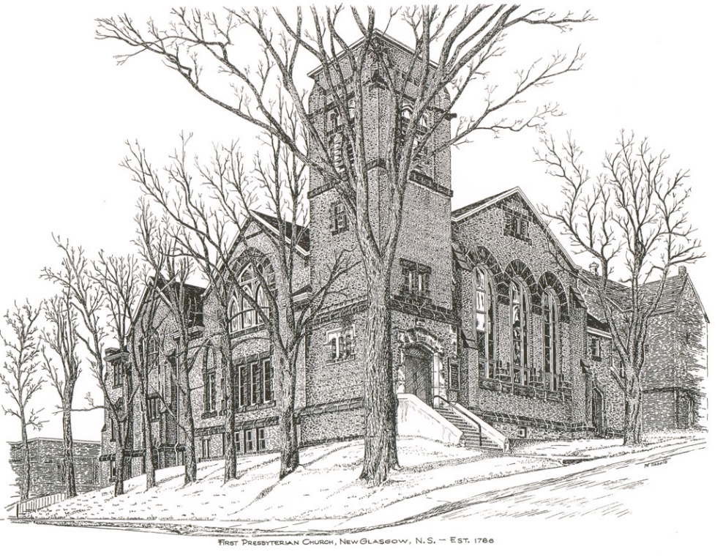

FIRST PRESBYTERIAN CHURCH
208 MacLean St., New Glasgow, NS
902-752-5691
First.church@ns.aliantzinc.ca
Reverend Andrew MacDonald
902-331-0322
yick96@hotmail.com

July 21st, 2024
9th Sunday after Pentecost
THE APPROACH

**Please rise**
Musical Prelude
Welcome and Announcements

**Lighting the Christ Candle: Please rise
One: This is the message we have heard from him and proclaim to you, that God is light, and in him is no darkness at all. If we say we have fellowship with him while we walk in darkness, we lie and do not practice the truth. But if we walk in the light, as he is in the light, we have fellowship with one another, and the blood of Jesus his Son cleanses us from all sin. If we say we have no sin, we deceive ourselves, and the truth is not in us. If we confess our sins, he is faithful and just to forgive us our sins and to cleanse us from all unrighteousness.
All: And those who are wise shall shine like the brightness of the sky above; and those who turn many to righteousness, like the stars forever and ever. (Light the candle)
One: Let us now prepare our hearts to worship almighty God.

**Musical Introit - #575 - "Lead me, Lord"
Lead me, Lord, lead me in your righteousness;
make your way plain before my face,
for it is you, and you, God only,
who makes me dwell in safety.

**Call to Worship
**Hymn #585 – “Christ, you call us all to service”
- Christ, you call us all to service
call us all who follow you;
plant in us a deep commitment
all your work and will to do.
Fire a passion for your justice;
in us kindle love of peace;
help us heal the brokenhearted;
to the captive bring release.

- Teach us how to work together,
brother, sister, side by side,
equal partners in the struggle,
in the cause of truth allied.
To each one some gift is given –
man or woman, young or old;
help us use each skill and talent,
your great purpose to unfold.

- Let us be a servant people,
reconciling, ending strife,
seeking ways more just of sharing
and or ordering human life.
Fill us with a glowing vision
of this world as it should be;
send us forth to change that vision
into blest reality.

Prayer of Adoration, Confession and the Lord’s Prayer

Our Father which art in heaven, Hallowed be thy name.

Thy kingdom come, thy will be done in earth,

as it is in heaven.

Give us this day our daily bread.

And forgive us our debts, as we forgive our debtors.

And lead us not into temptation, but deliver us from evil:

For thine is the kingdom, and the power, and the glory,

forever. Amen.

Assurance of Pardon
Passing the Peace
**Hymn 475 - “I am the church! You are the church!”
Refrain:
I am the church! You are the church!
We are the church together!
All who follow Jesus,
all around the world!
Yes, we're the church together!
1. The church is not a building;
the church is not a steeple;
the church is not a resting place;
the church is a people.
(Refrain)
2. We're many kinds of people,
with many kinds of faces,
all colours and all ages, too
from all times and places.
(Refrain)
3. Sometimes the church is marching;
sometimes it's bravely burning,
sometimes it's riding, sometimes hiding;
always it's learning.
(Refrain)
4. And when the people gather,
there's singing and there's praying;
there's laughing and there's crying sometimes,
all of it saying:
(Refrain)
5. At Pentecost some people
received the Holy Spirit
and told the Good News through the world
to all who would hear it.
(Refrain)
Children’s Time
Prayer of Illumination
First Lesson: 2 Samuel 7:1-14
Epistle Lesson: Ephesians 2:11-22
Responsive Psalm 89:20-37
ONE: I have found my servant David; with my holy oil I have anointed him; my hand shall always remain with him; my arm also shall strengthen him.
ALL: The enemy shall not outwit him, the wicked shall not humble him.
ONE: I will crush his foes before him and strike down those who hate him. My faithfulness and steadfast love shall be with him; and in my name his horn shall be exalted. I will set his hand on the sea and his right hand on the rivers.
ALL: He shall cry to me, “You are my Father, my God, and the Rock of my salvation!” I will make him the firstborn, the highest of the kings of the earth.
ONE: For-ever I will keep my steadfast love for him, and my covenant with him will stand firm. I will establish his line for ever, and his throne as long as the heavens endure.
If his children forsake my law and do not walk according to my ordinances, if they violate my statutes and do not keep my commandments, then I will punish their transgression with the rod and their iniquity with scourges;
but I will not remove from him my steadfast love, or be false to my faithfulness.
ALL: I will not violate my covenant, or alter the word that went forth from my lips. Once and for all I have sworn by my holiness; I will not lie to David.
ONE: His line shall continue for ever, and his throne endure before me like the sun.
ALL: It shall be established for ever like the moon,
an enduring witness in the skies.’
**Gloria Patri
Glory be to the Father
and to the Son, and to the Holy Ghost!
As it was in the beginning is now and ever shall be.
World without end. Amen, amen.

Gospel Lesson: Mark 6:30-34, 53-56
Anthem
Sermon: "Compassion for all!"
**Reaffirmation of Faith (Apostles Creed)

I believe in God, the Father Almighty, maker of Heaven and earth; and in Jesus Christ, His only Son, Our Lord, who was conceived by the Holy Ghost, born of the Virgin Mary,
suffered under Pontius Pilate, was crucified, died, and was buried. He descended into Hell. On the third day He arose again from the dead; He ascended into Heaven, and sits
at the right hand of God, the Father Almighty; from thence He shall come to judge the quick and the dead.
I believe in the Holy Ghost, the holy Catholic Church,
the communion of saints, the forgiveness of sins, the resurrection of the body, and the life everlasting. Amen.

**Hymn: #688 – “As water to the thirsty”
- As water to the thirsty
as beauty to the eyes,
as strength that follows weakness,
as truth instead of lies,
as songtime and springtime
and summertime to be,
so is my Lord,
my living Lord,
so is my Lord to me.

- Like calm in place of clamour,
like peace that follows pain,
like meeting after parting,
like sunshine after rain,
like moonlight and starlight
and sunlight on the sea,
so is my Lord,
my living Lord,
so is my Lord to me.

- As sleep that follows fever,
as gold instead of grey,
as freedom after bondage,
as sunrise to the day,
as home to the traveler
and all we long to see,
so is my Lord,
my living Lord,
so is my Lord to me.

Offertory

**Doxology #79
Praise God from whom all blessings Flow. Praise Him all creatures here below. Praise Him above Ye Heavenly Host. Praise Father, Son, and Holy Ghost. Amen.

Offertory Prayer
Prayers of the People: (The People Respond)
**Hymn: #471 – “We are one in the spirit”
1 We are one in the Spirit
we are one in the Lord,
we are one in the Spirit,
we are one in the Lord,
and we pray that all unity
will one day be restored
and they’ll know we are Christians
by our love, by our love
and they’ll know we are Christians by our love.

2 We will walk with each other,
we will walk hand in hand,
we will walk with each other,
we will wall hand in hand,
and together we’ll spread the news
that God is in our land,
and they’ll know we are Christians
by our love, by our love,
and they’ll know we are Christians by our love.

3 We will work with each other,
we will work side by side,
we will work with each other,
we will work side by side,
and we’ll guard each one’s dignity
and save each one’s pride,
and they’ll know we are Christians
by our love, by our love,
and they’ll know we are Christians by our love.

4 All praise to the Father,
from whom all things come,
and all praise to Christ Jesus,
who is God’s only Son,
and all praise to the Spirit,
who makes us one,
and they’ll know we are Christians
by our love, by our love,
and they’ll know we are Christians by our love.
**Benediction
**Coral Response: “Go Now in Peace” (Don Besig)
Go now in peace Never be afraid God will go with you each hour of every day
Go now in faith Steadfast, strong, and true. Know He will guide you in all you do.
Go now in love, And show you believe Reach out to others So all the world can see.
God will be there Watching from above Go now in peace, In faith, and in love, Amen, amen, amen.
Recessional

ANNOUNCEMENTS

All are welcome at First Presbyterian Church. We hope you experience the love of God and of this congregation as we worship, celebrate, and serve one another.

We welcome all visitors along with our friends from St. Andrew’s Presbyterian Church, “The Kirk”, as they continue to worship with us for the month of July. Thank you for joining us today; please stay for the BBQ after service if you can.

NOTICE: Reverend Andrew will be on vacation starting tomorrow, July 22nd. We welcome Rev. Helena Human who will lead us in worship next Sunday, July 28th.
PASTORAL CARE
In order to provide support to the people of First Church, when you or a loved one is sick or in hospital, we encourage you to contact the church (902-752-5691), Reverend Andrew (902-331-0322) or Cathy Lewis, Chair of the Pastoral Care Team (902-759-9649), to inform us directly. It is also important that you inform the hospital that you would welcome a visit from your minister and/or your Elder.

UPCOMING EVENTS

BBQ – After service today, and before we close for summer vacation in August, we are hosting a BBQ and potluck in the Upper Hall. Everyone welcome; hope you can join us!
Sun., July 28th –2:30p.m. – We will worship with the residents of Ivey’s Terrace.
Chair Yoga - Chair Yoga is being offered here at First Church, in the Upper Hall, Wednesdays 1-2p.m. For more information contact Monica Beltram at info@monicafit.ca
BIRTHDAYS

Happy Birthday to Hank VanVeld and Vivian MacDonald. Hank celebrates his birthday, Tuesday, July 23rd. Vivian will celebrate her birthday, Friday, July 26th. We wish you both a great day!

SCRIPTURE READERS & USHERS:
Scripture Reader: Mark Thibeau
Ushers: Main Door (Office) - Chet Fleming
James St. – Ruth-Anne MacIntosh
MacLean St. (Main Entrance steps) – Ellen Jardine
EARLY CHRISTIAN EDUCATORS: Lynne Ann and Lois MacLellan
Church Finances
The Managers and Trustees wish to inform the congregation that church offerings have continued to decline over the past several months. While it is expected offerings do decline during the summer months, this is now a regular occurrence. This is largely due to our congregation getting smaller and smaller. Fundraising along with ongoing efforts to reduce expenses have helped to support our financial situation but obviously not to the extent necessary.
As a result, the Trustees, in response to requests from the Church Treasurer, have transferred funds from church investments in order to meet these current and ongoing financial obligations. Such transfers have now occurred more than once.
This past week, $30,000 has been transferred to the church operating account to see us through the summer months. This information is provided to illustrate the seriousness of our current financial status as our investments will not last forever.
As always, your ideas and thoughts on this matter are welcomed. So, feel free to share by contacting the Minister or members of the Board of Managers or Trustees.

Mission Statement: But he’s already made it plain how to live, what to do, what God is looking for in men and women. It’s quite simple. Do what is fair and just to your neighbor, be compassionate and loyal in your love, and don’t take yourself too seriously – take God seriously. Micah 6: 8-The Message

